AI & Machine Learning — Task 6
Deep Learning Fundamentals & Neural Network Implementation

1. Dataset and Preprocessing
The Breast Cancer Wisconsin (Diagnostic) dataset from scikit-learn was used. It contains 569 samples and 30 features. The data was split into 80% training and 20% testing data using random_state=42. StandardScaler was fitted on the training data and then applied to both training and test data.

2. Neural Network
Architecture: Input (30 features) → Dense(16, ReLU) → Dense(8, ReLU) → Dense(1, Sigmoid).
The model was compiled with the Adam optimizer and binary cross-entropy loss, then trained for 50 epochs with batch size 16 and a 20% validation split.

3. Evaluation
Test Loss: 0.0941
Test Accuracy: 0.9737 (97.37%)
Confusion Matrix: [[40, 3], [0, 71]]

4. Training Performance
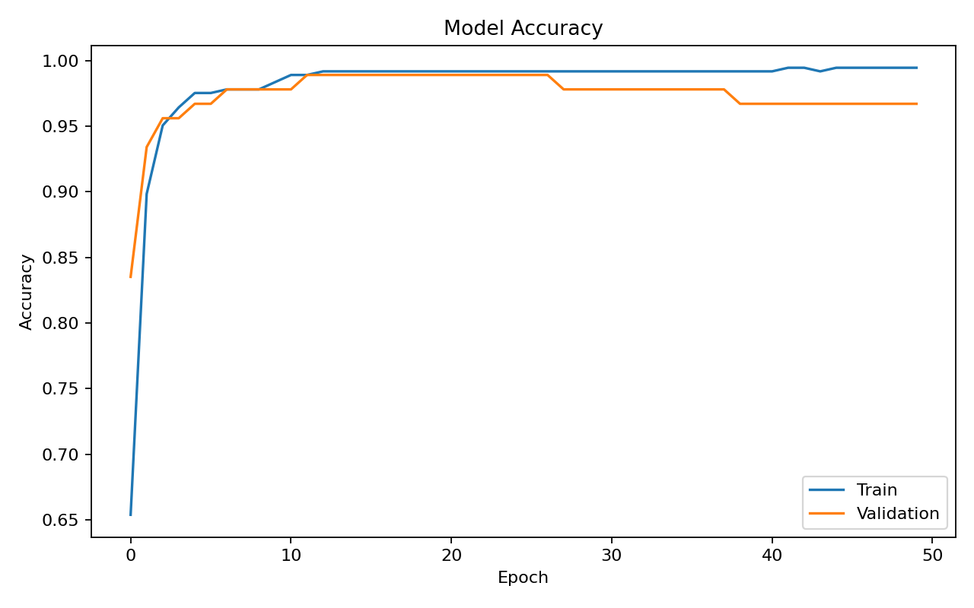
Figure 1: Training vs Validation Accuracy
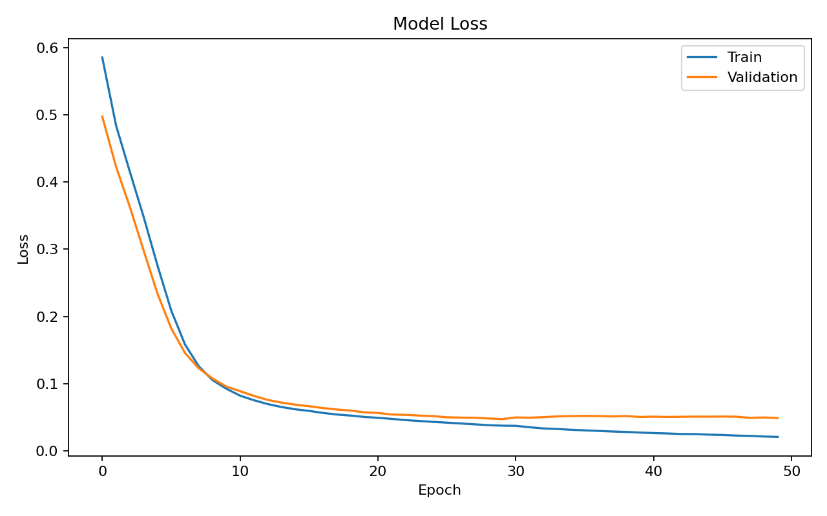
Figure 2: Training vs Validation Loss

5. Comparison with Traditional ML Models
Model | Test Accuracy | Test Log Loss
Logistic Regression | 97.37% | 0.0777
Random Forest | 96.49% | 0.1118
Neural Network (ANN) | 97.37% | 0.0941

6. Observations
- The ANN achieved 97.37% test accuracy on the selected test split.
- Logistic Regression achieved the same test accuracy, while Random Forest was slightly lower.
- ReLU provides non-linearity in the hidden layers and sigmoid produces the binary-class probability.
- Training and validation curves are included to inspect learning behavior and possible overfitting.
- The comparison shows that a neural network is not automatically superior to traditional ML models; performance depends on the dataset and model configuration.

7. Execution Note
The notebook has been corrected so Parts F–J are executed and their outputs are saved inside the notebook. TensorFlow was unavailable in the execution environment, so Keras 3 with the PyTorch backend was used for the completed run. The notebook retains the TensorFlow installation instruction and the requested Keras ANN architecture.

