Ferns & Petals (FNP) Sales Analysis Dashboard
Project Report | Microsoft Excel
This project analyzes the Ferns & Petals (FNP) gifting sales dataset and presents key business metrics through an interactive Excel dashboard. The dashboard is designed to make it easier to review revenue performance, product trends, occasion-based sales, city-wise order distribution, and delivery performance.

1. Project Objectives
- Measure overall revenue, order volume, average delivery time, and average customer spending.
- Review monthly revenue patterns across 2023.
- Identify products and product categories contributing the most revenue.
- Compare revenue across gifting occasions.
- Explore city-wise order distribution and customer purchasing patterns.
- Present the findings in a dashboard that can be explored using filters and a date timeline.

2. Tools and Approach
Tool used: Microsoft Excel. The dashboard uses summary charts, KPI cards, a slicer for occasion, and an order-date timeline. The visuals allow the user to filter the report and inspect sales performance from different perspectives. The analysis is based on the provided FNP dataset and the accompanying problem statement.

3. Key Performance Indicators
Metric | Dashboard Value
Total Orders | 1,000
Total Revenue | ₹35,20,984
Average Delivery Time | 5.53 days
Average Customer Spending | ₹3,520.98

4. Main Observations
- Revenue and orders: The dashboard reports total revenue of ₹35,20,984 across 1,000 orders.
- Delivery performance: Average delivery time is 5.53 days. This metric can be used as a baseline when reviewing delivery efficiency.
- Monthly sales: Revenue varies considerably by month. February and August show prominent peaks, while March and November also appear comparatively strong in the displayed chart.
- Product/category performance: Colors is the highest-revenue label in the category chart. Soft Toys and Sweets are also among the stronger contributors. The product chart highlights Magnam Set, Quia Gift, Dolores Gift, Harum Pack, and Deserunt Box among the leading products shown.
- Occasion performance: Anniversary and Raksha Bandhan show relatively high revenue in the occasion chart. All Occasions and Holi also contribute substantial revenue.
- City-wise orders: The city chart compares order counts across ten cities, making it possible to identify locations with relatively higher order volume.
- Interactive analysis: The occasion slicer and order-date timeline help users narrow the dashboard to a selected occasion or period.

5. Dashboard Preview
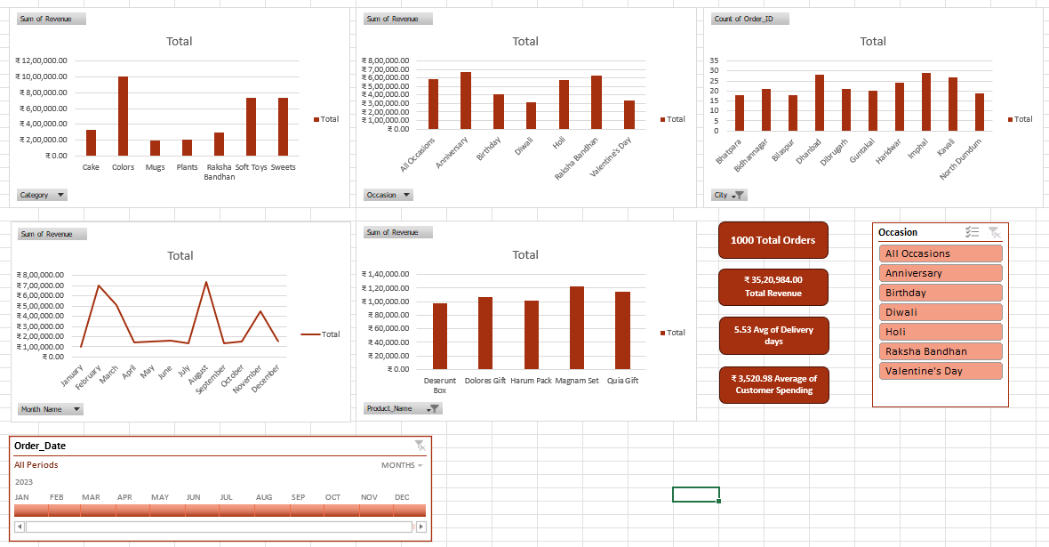
Figure 1. Excel dashboard created for FNP sales analysis.

6. Conclusion
The FNP Sales Analysis Dashboard converts transaction data into a concise visual summary of business performance. It brings together revenue, order volume, delivery time, monthly trends, product performance, occasion-based revenue, and city-wise order counts in one view. The results can support decisions around seasonal promotions, product focus, inventory planning, and delivery operations. Further analysis could add a dedicated visual for order quantity versus delivery time and a product-by-occasion comparison to make those two questions easier to assess directly.

