**Digital Forensics Lab Report: 10**

Date: 02-11-2022

|  |  |
| --- | --- |
| Name: | Vedant H. Patel |
| Roll No: | 19BCP138 |
| Subject Code: | 20CP411P |
| Subject Name: | Digital Forensics Lab |

**Aim/Purpose:** Study of Hash and Hack Analysis Tools.

**Tool Names:** WinHEX, Garrykesler, hashmefile ignoreware.

## Step 1: Download and Install HashMyFiles

* Visit <https://hashmyfiles.soft112.com/modal-download.html> and Download HashMyFiles as ZIP. Extract the zip file to get the .exe file.

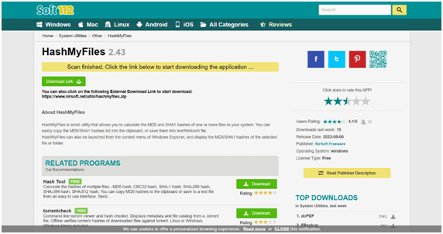

* Open the Application and open any file.

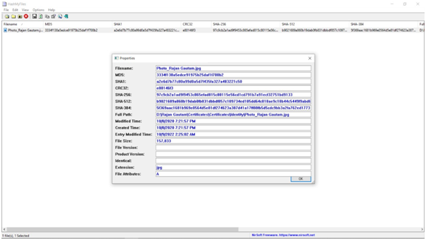

* Access Garrykesler from this URL <https://www.garykessler.net/library/file_sigs.html>

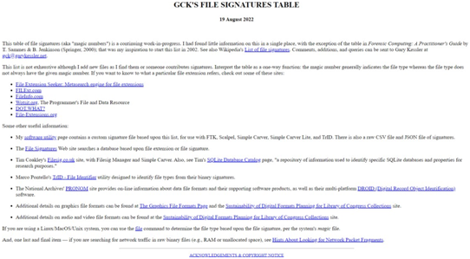

* Check Hex Value for .JPG file in GCK’s file. As per them Hex value for JPG image is ‘FF D8 FF E1 xx xx 45 78’.

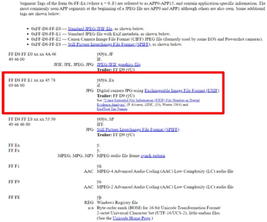

* Open the same file using WinHEX. We can see the same HEX value in the editor which shows the file is .JPG file.

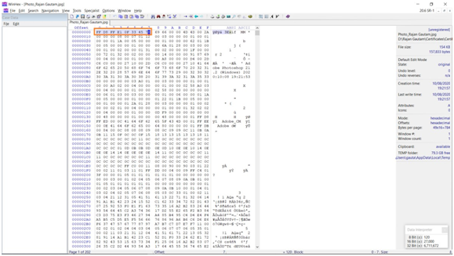

* The image was edited with Adobe photoshop, that also we can verify from the HEX Code.

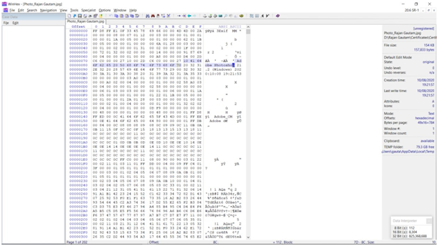

* When I updated the file using Paint and check the Hash value, I found the change in Hash Value also.

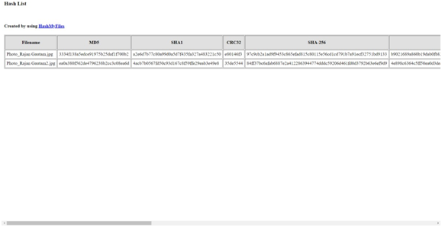

## Conclusion:

* The integrity of files can be checked using HEX Code analysis.