**Digital Forensics Lab Report: 2**

Date: 03-08-2022

|  |  |
| --- | --- |
| Name: | Vedant H. Patel |
| Roll No: | 19BCP138 |
| Subject Code: | 20CP411P |
| Subject Name: | Digital Forensics Lab |

**Aim/Purpose:** Study of a Profile Generation using OSINT Techniques.

**Tool Names:** Have I been Pawned, True Caller, Teams.

**What is OSINT?**

* Open Source Intelligence
* Used for gathering publicly available target information.

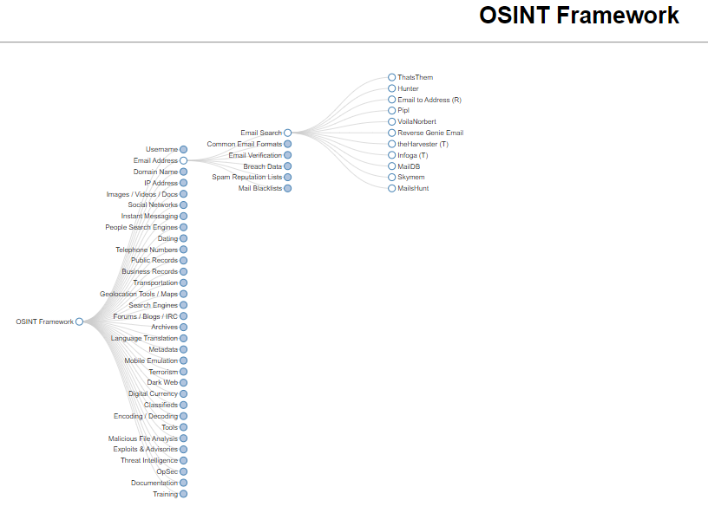

**Target:** Dr. Amitava Choudhury

* **Prior Known Information:** Works in PDEU, Gandhinagar
* **Photos:**



* **Designation:** Assistant Professor
* **University:** PDEU, Gandhinagar
* **Department:** Departments of Mathematics, School of Technology
* **Work Email:** [**Amitava.Choudhury@sot.pdpu.ac.in**](mailto:Amitava.Choudhury@sot.pdpu.ac.in)
* **Mobile No.:** +91 89026 91510
* **Sim Company:** BSNL
* **Sim Address:** Kolkata, India

**Sources:**

**#1:** <https://orsp.pdpu.ac.in/adminfacviewprofile.aspx?facid=amitava.choudhury>

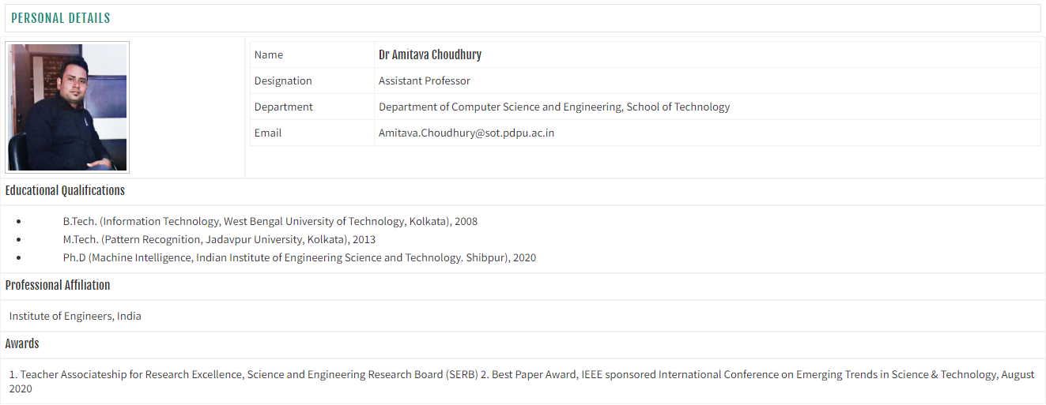

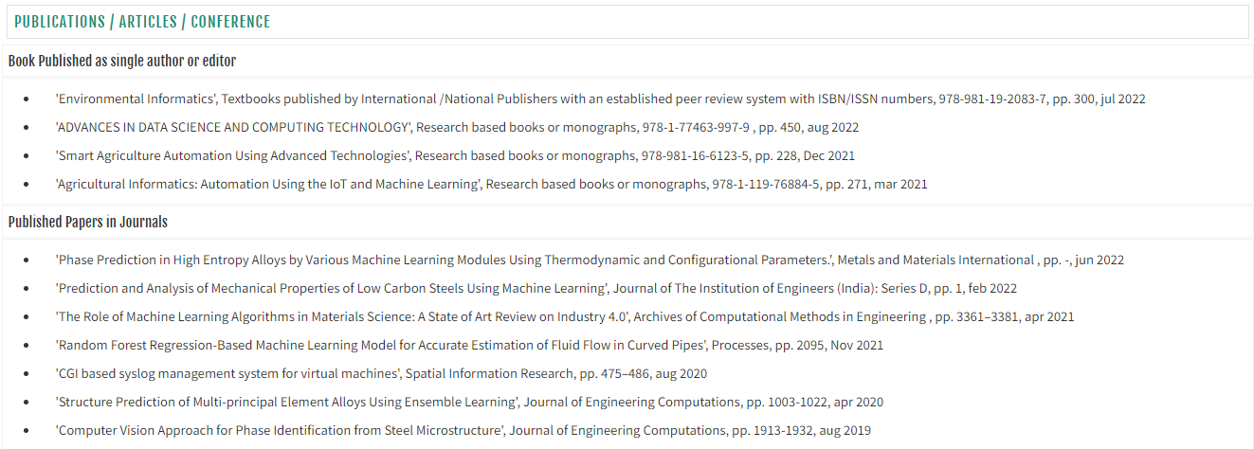

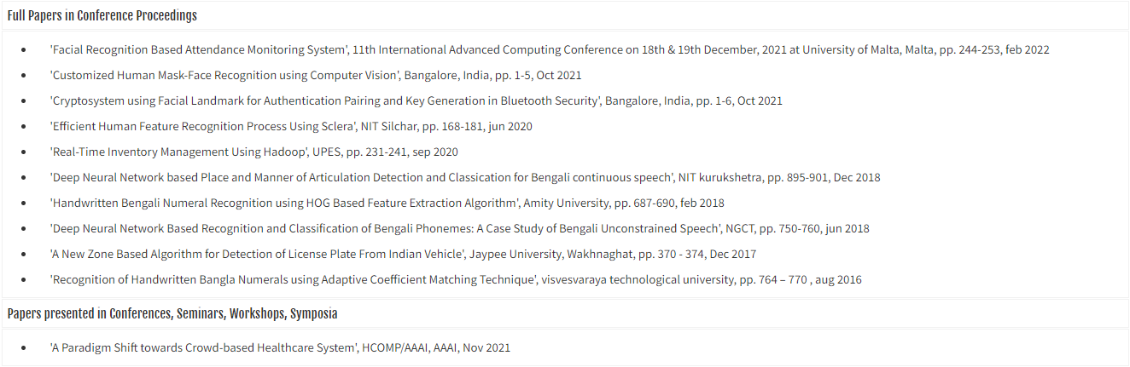

**#2:** <https://sot.pdpu.ac.in/sot-faculty.html>

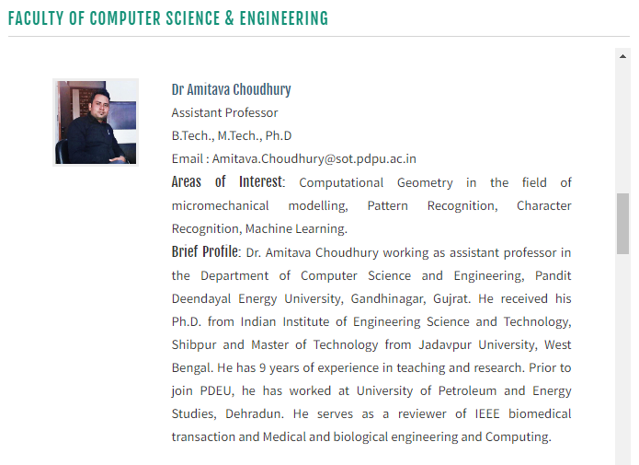

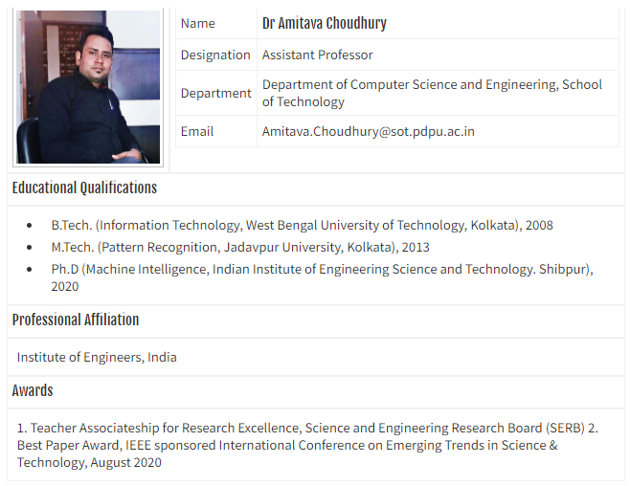

**#3:** Microsoft Teams

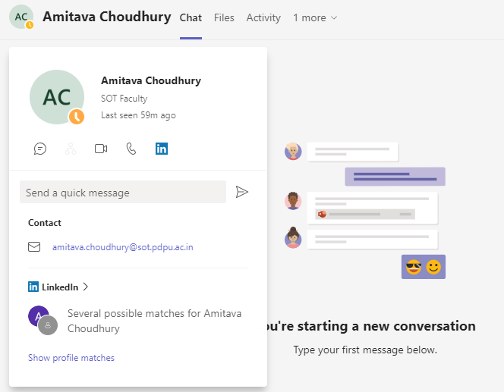

**#4:** [**https://www.truecaller.com/search/in/89026%2091510**](https://www.truecaller.com/search/in/89026%2091510)

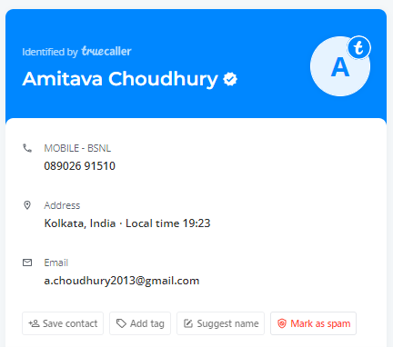

**#5:** <https://www.linkedin.com/in/amitava-choudhury-ds/>



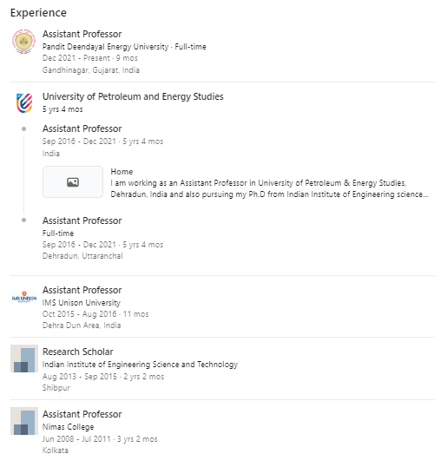





**#6:** <https://whocalld.com/?p=%2B91+89026+91510>

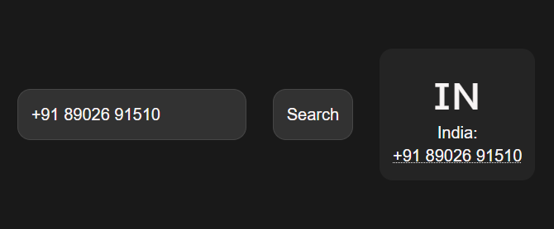

**#7:** [**https://freecarrierlookup.com/**](https://freecarrierlookup.com/)

