**Digital Forensics Lab Report: 6**

Date: 07-09-2022

|  |  |
| --- | --- |
| Name: | Vedant H. Patel |
| Roll No: | 19BCP138 |
| Subject Code: | 20CP411P |
| Subject Name: | Digital Forensics Lab |

**Aim/Purpose:** Study of a Data Recovery from Computer Systems, Mobile Devices and other electronic peripherals.

**Tool Names:** Recuva Data Recovery Tool, EaseUS Data Recovery Tool

**Task 1:** Explore Recuva Data Recovery Tool

**Steps:**

1. Go to <https://recuva.en.softonic.com/> and download the recuva tool.

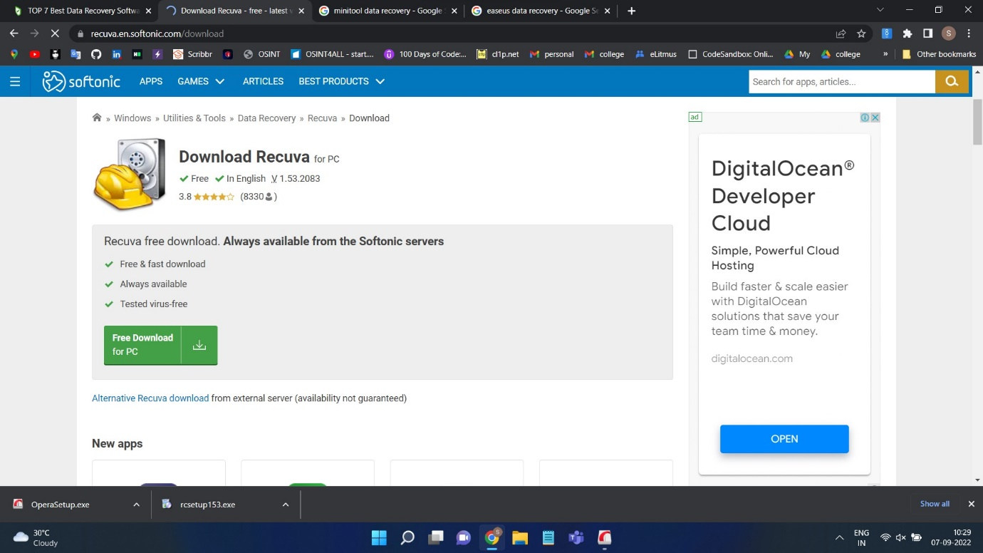

1. After Installing setup start installation process.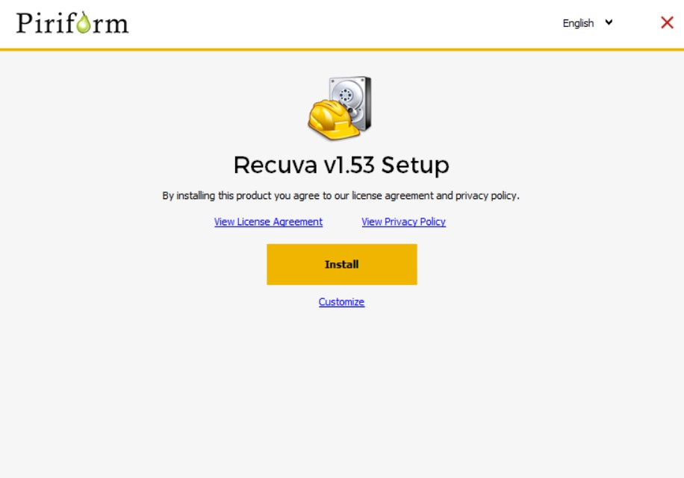

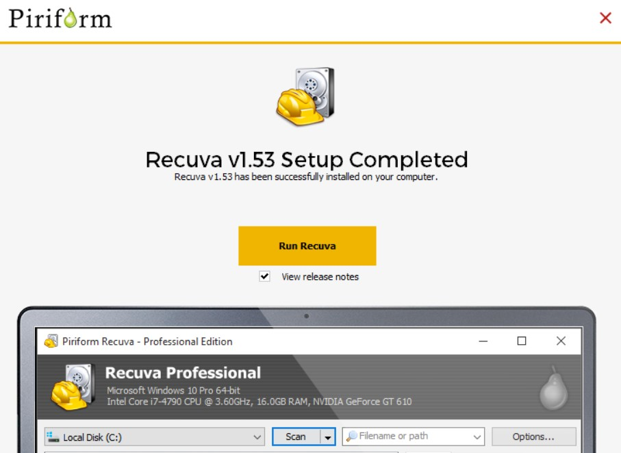

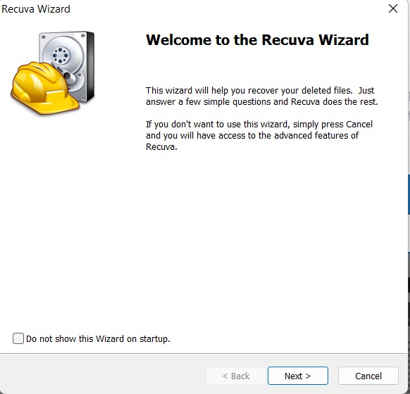

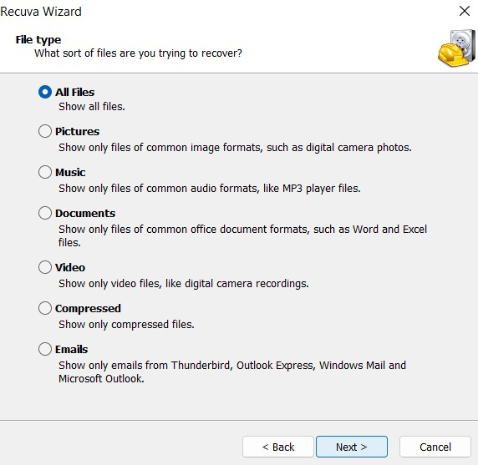

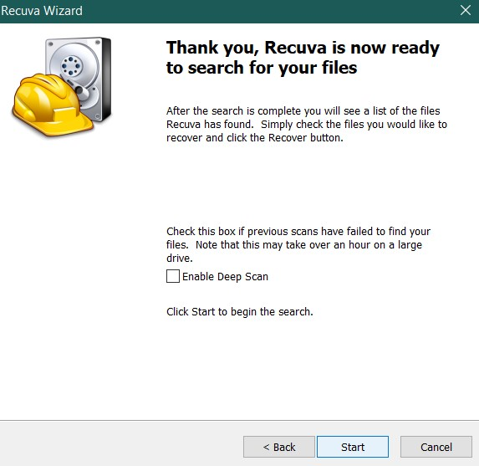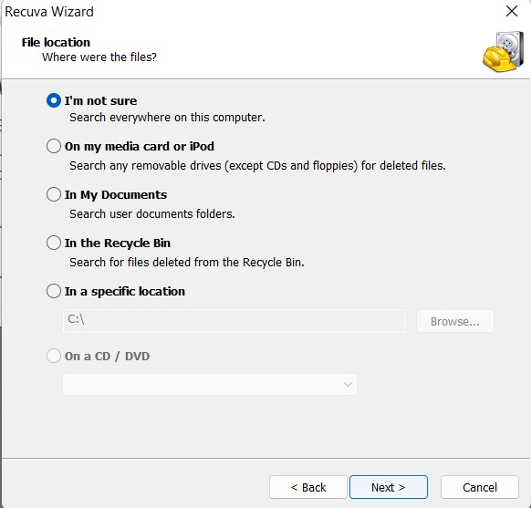

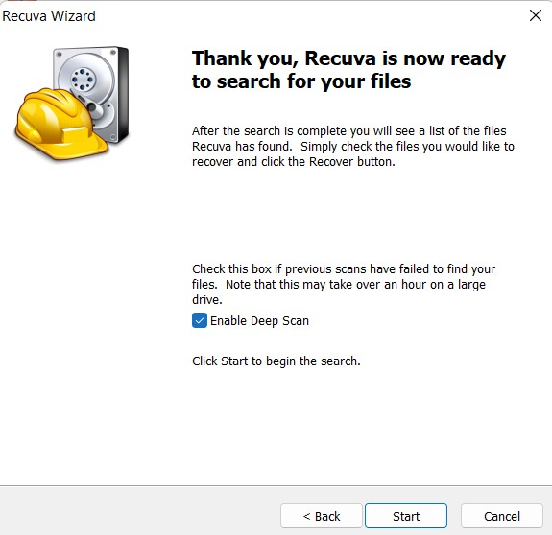

1. After Initializing the process of data recovery. You will be able to see scanning as below:

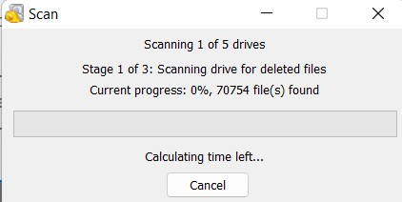

1. After Completion of data recovery scanning, you will be able to explore following results.

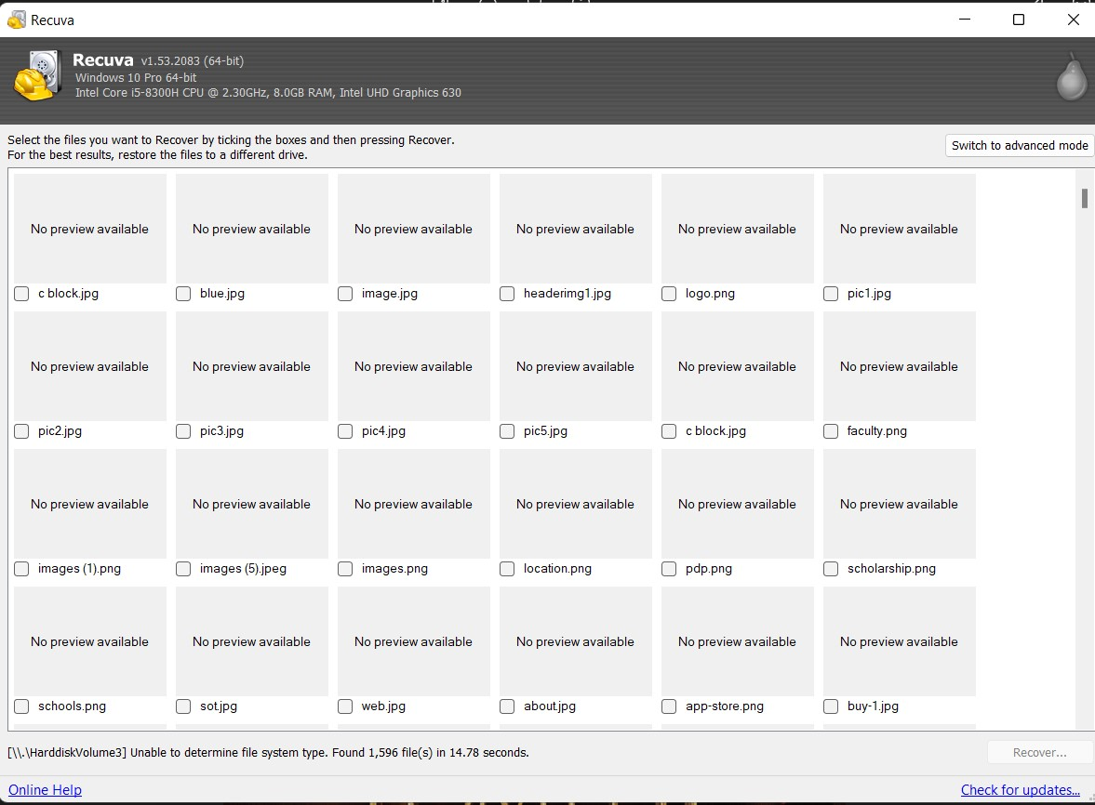

1. Now select the files/images that you want to recover

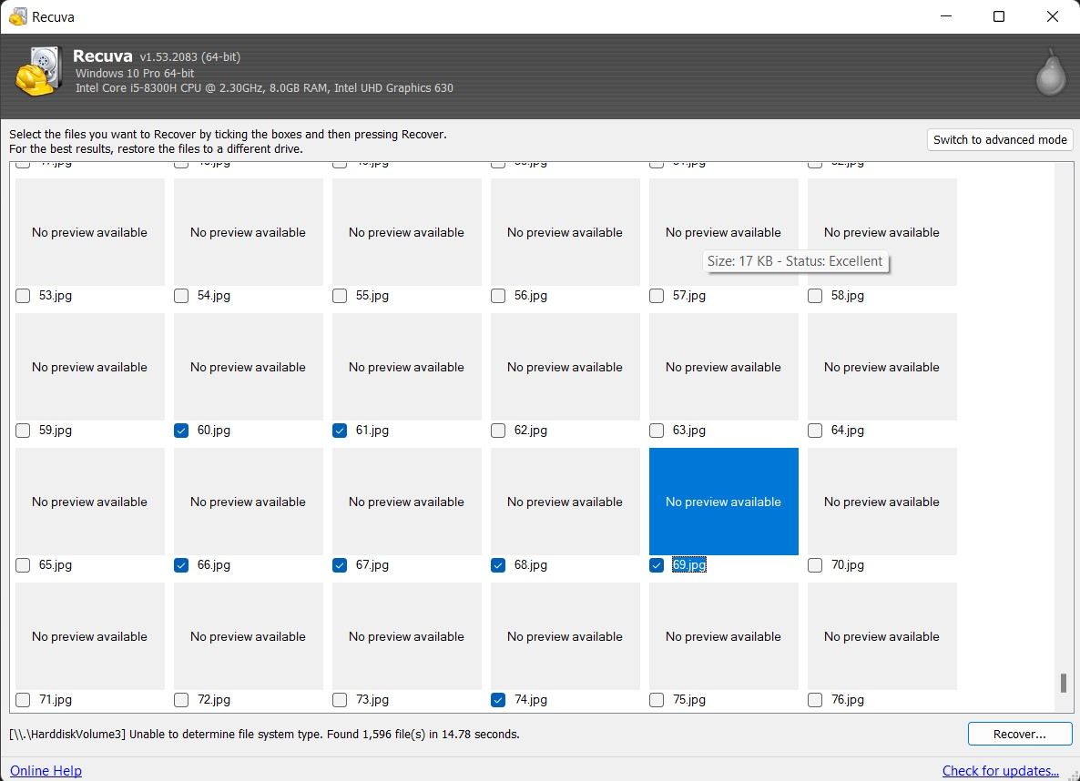

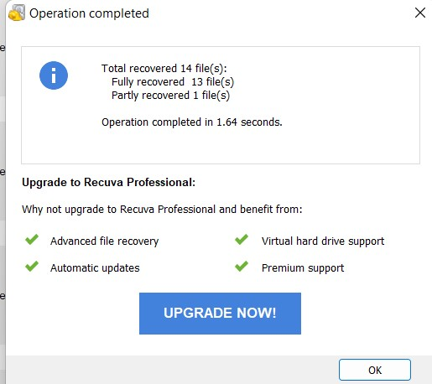

1. Select the file path for restoring the files

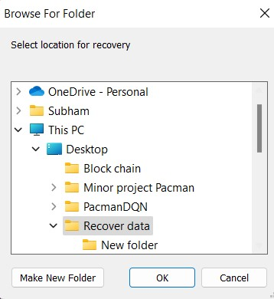

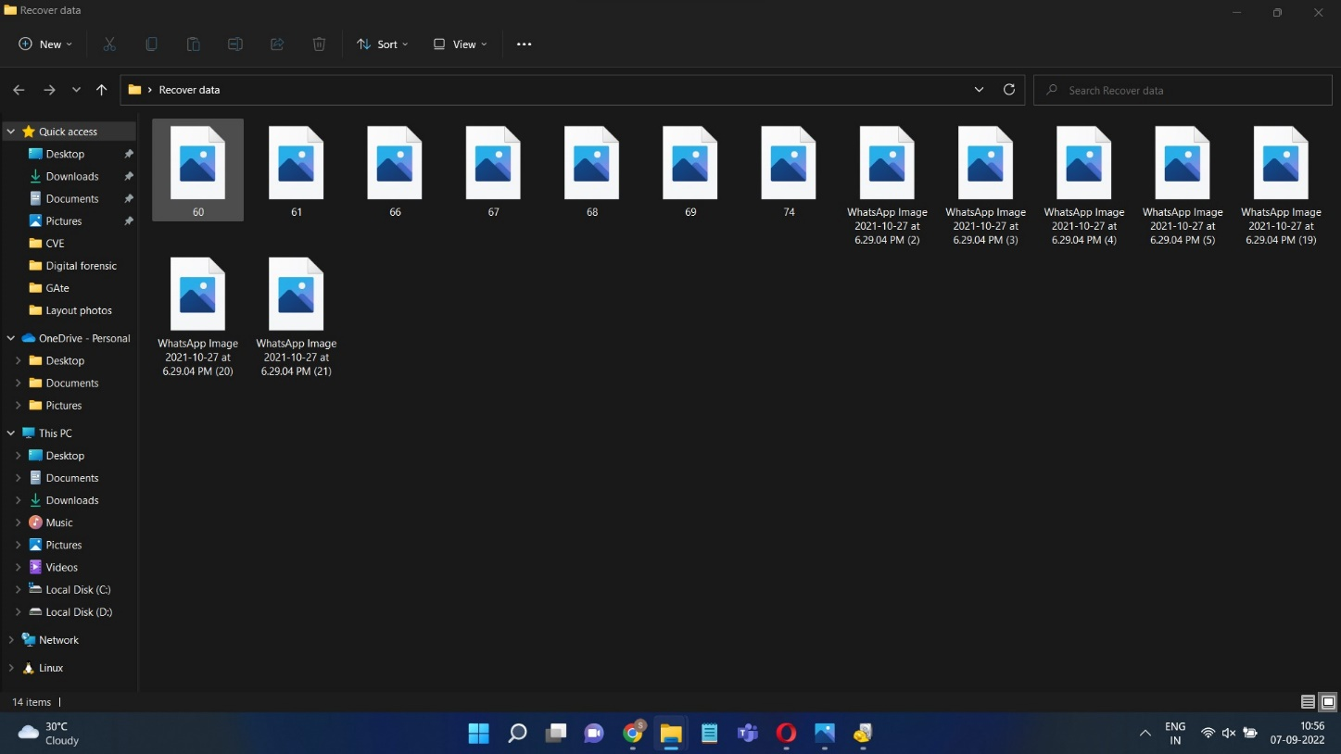

**Deleted File/Image:**

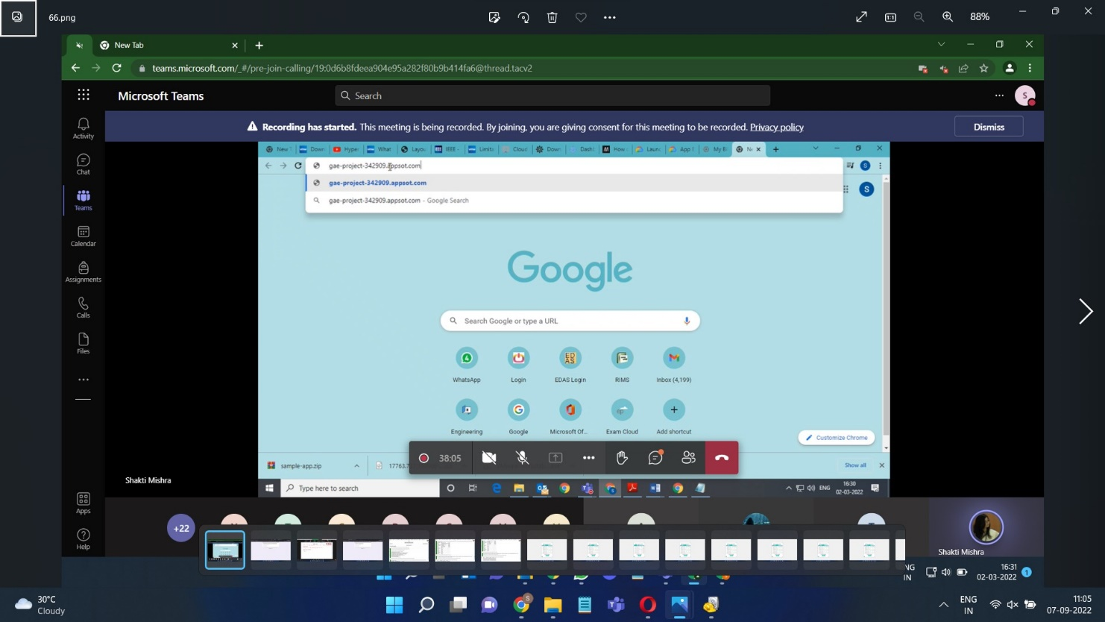

**Task 2: Minitool**

**Steps:**

1. Go to <https://www.minitool.com/data-recovery-software/> and download the Mini tool

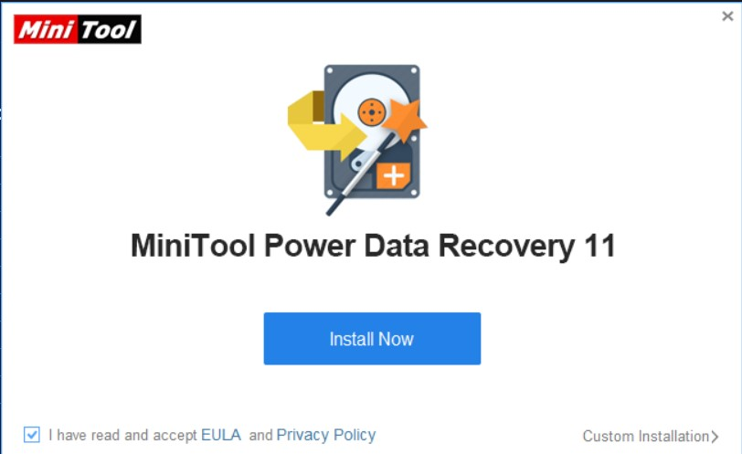

1. After Installing setup of the tool, following procedure will be followed to install the tool.

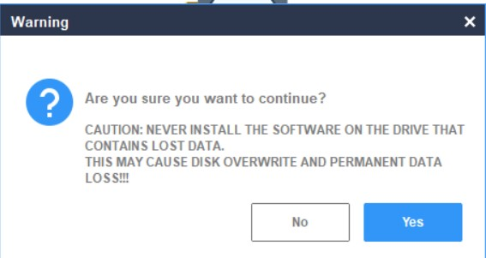

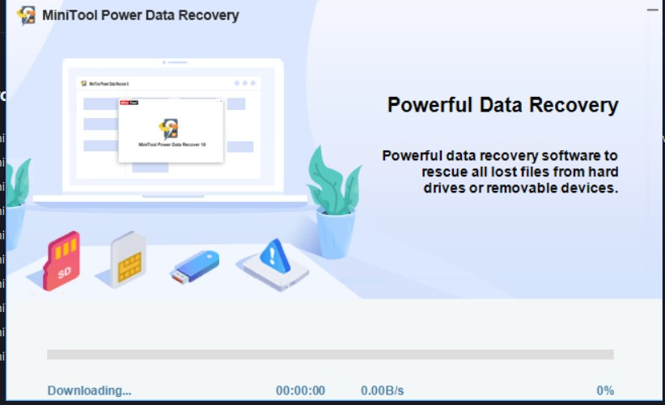

1. After completion of the installation of the tool, we can see preview of whole data file system of PC and select in which partition or folder we want to do data recovery scanning.

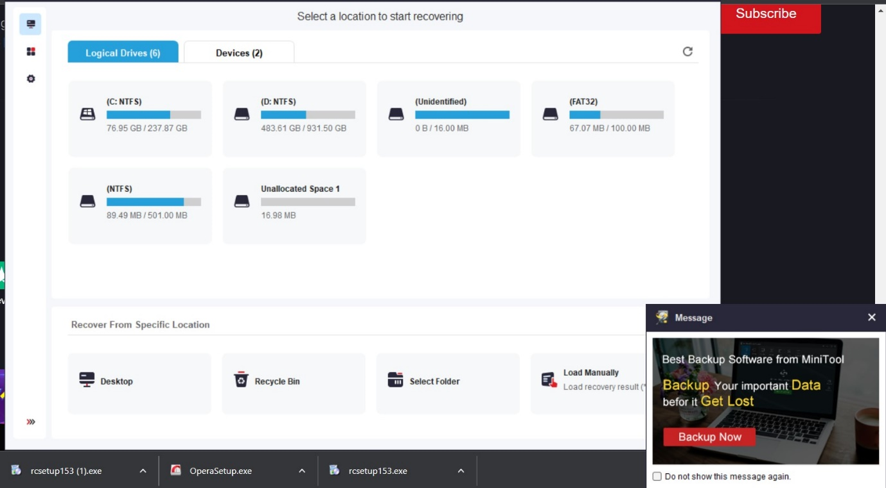

1. Choose in which folder you want to perform the scanning. It will show different previews of deleted files as well as existing files.

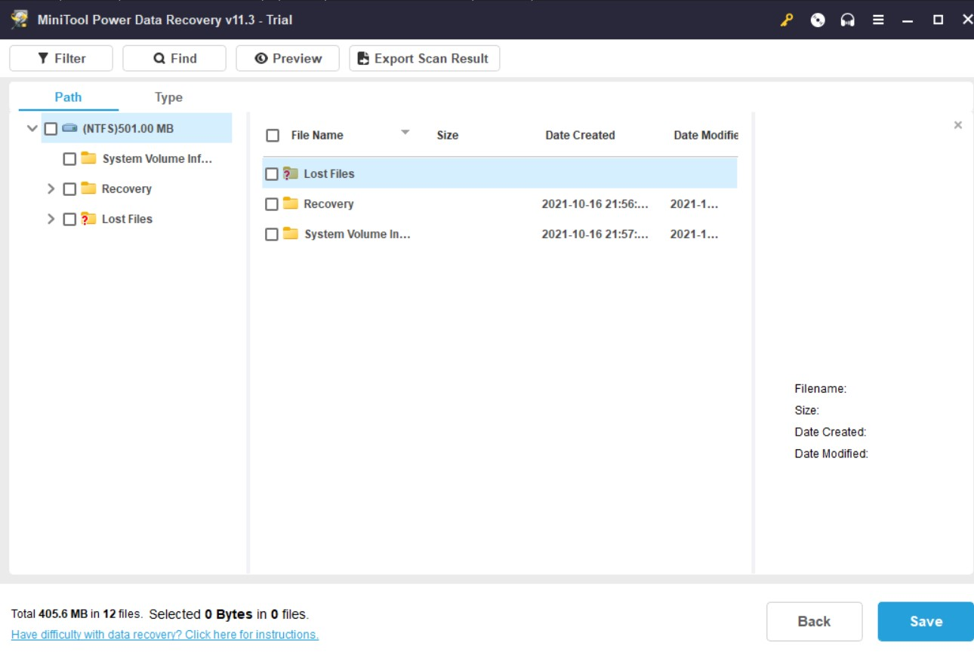

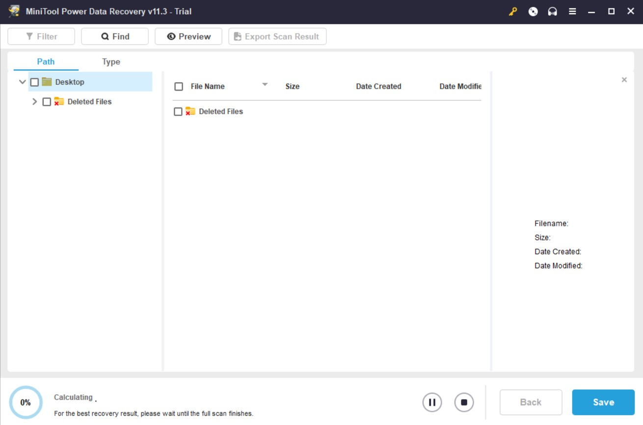

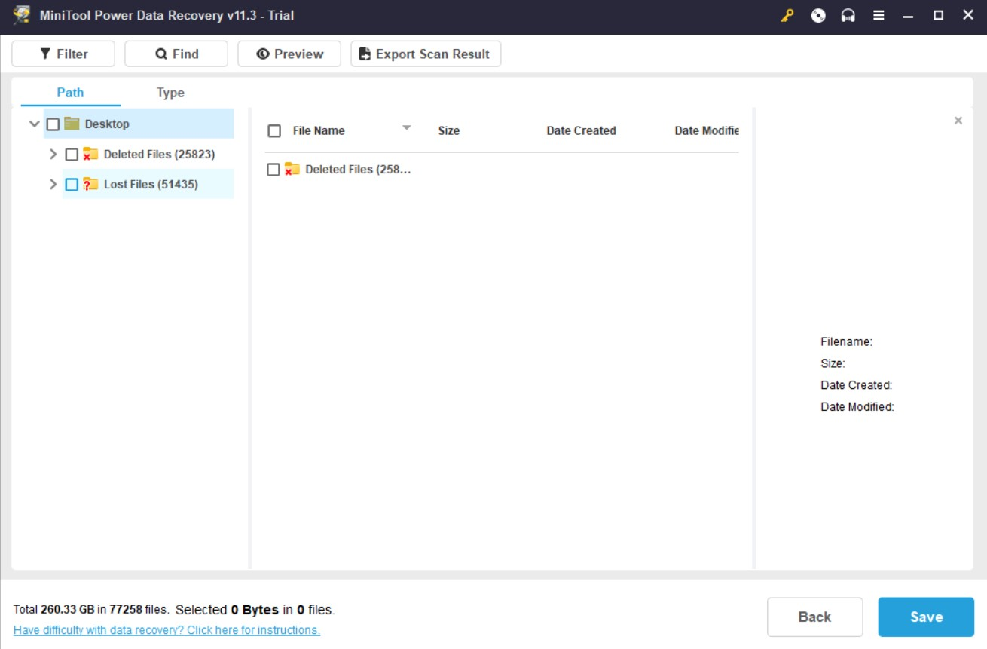

1. By clicking on “Save” you get your Recovered files.

