**Digital Forensics Lab Report: 7**

Date: 14-09-2022

|  |  |
| --- | --- |
| Name: | Vedant H. Patel |
| Roll No: | 19BCP138 |
| Subject Code: | 20CP411P |
| Subject Name: | Digital Forensics Lab |

**Aim/Purpose:** Study of Email Forensics Tools.

**Tool Names:** Emailtracker Pro, politemail.com, cyberforensics.in, ipaddresslocation.org, pointofmail.com(Any 2 tools/website).

**Task 1:** CyberForensics.in

**Steps:**

1. Open [CyberForensics.in](http://cyberforensics.in/Default.aspx).
2. Select “Image URL” if you want to insert the image url or “Upload File” if you want to select the file from your local machine.
3. Then Click on upload url and upload image.
4. Then you get all data regarding images like ICC+, metadata, etc.

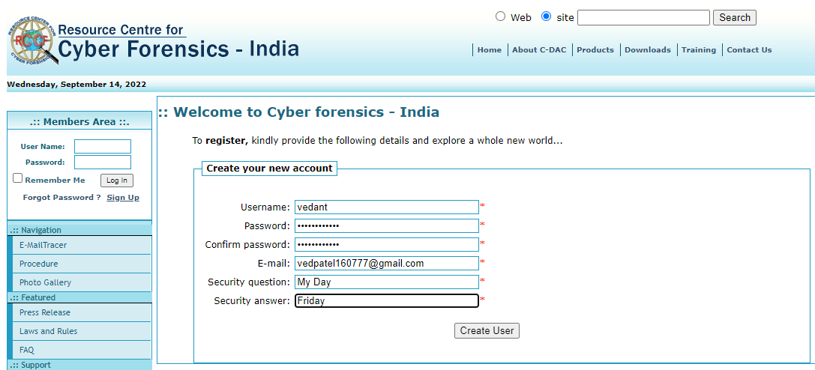

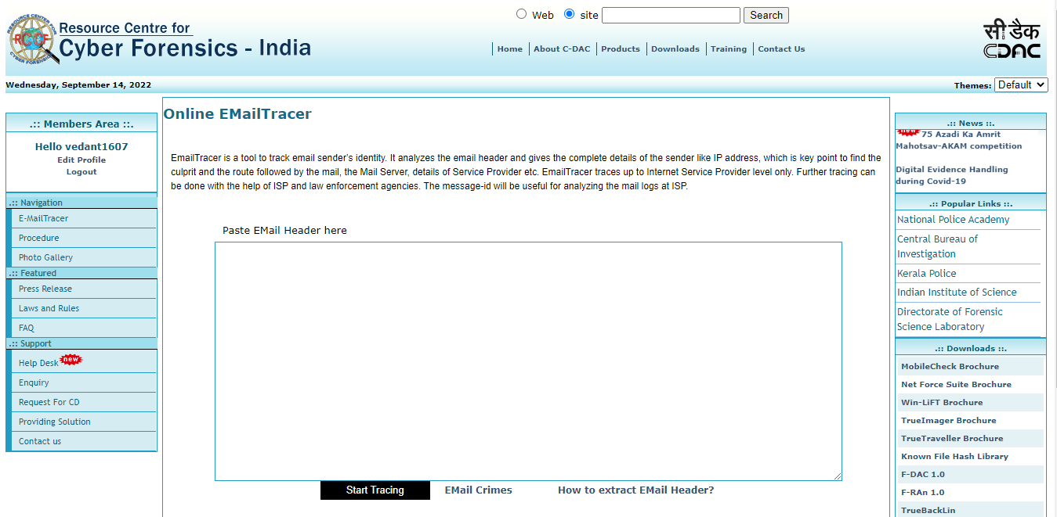

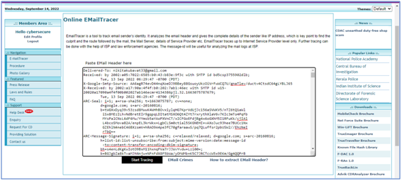

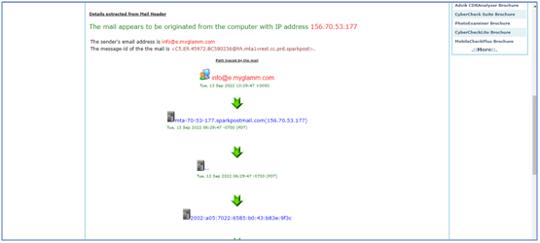

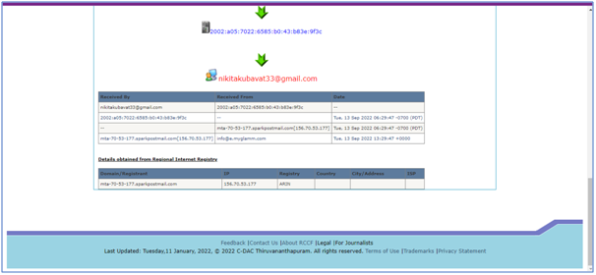

**Analysis:**

1. We can trace email easily. We can get all extracted details from email-header.

**Task 2:** Using Pointofmail

**Steps:**

1. Go to <https://www.pointofmail.com/>
2. Create an account or login if you have already created account to use email tracer tool
3. After login go to pointofmail
4. It will take you to another page and ask to enter email header
5. Enter any email header of email you want to trace
6. Click on start tracing
7. It will show all the details of email such as sender email id, ip address, message id and path tracing info



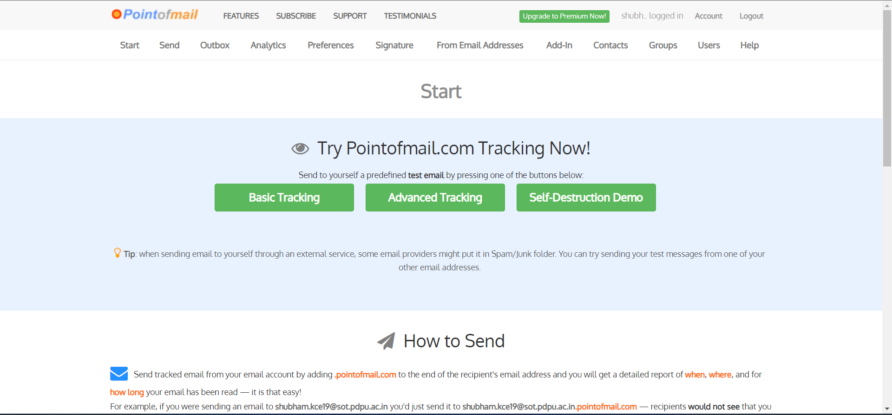

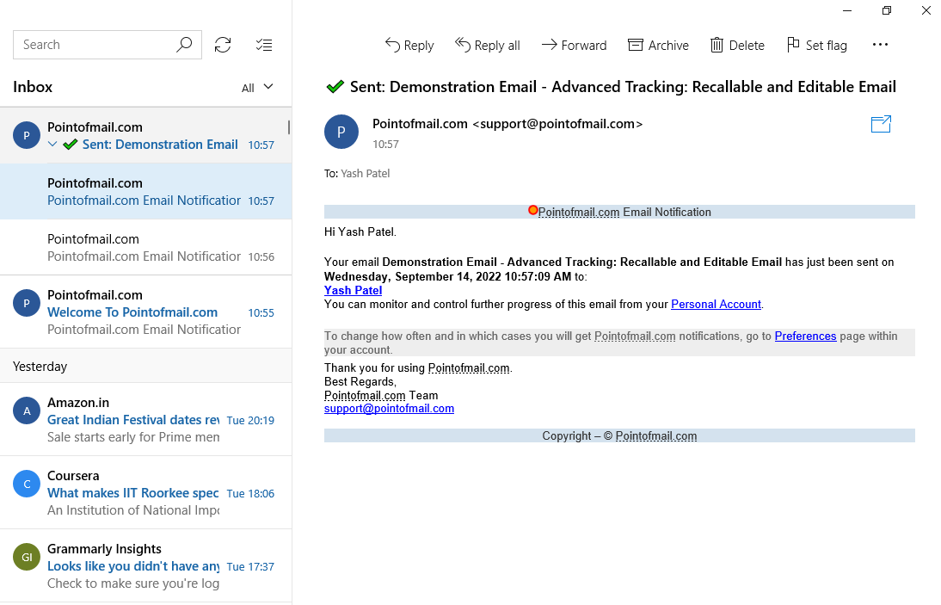

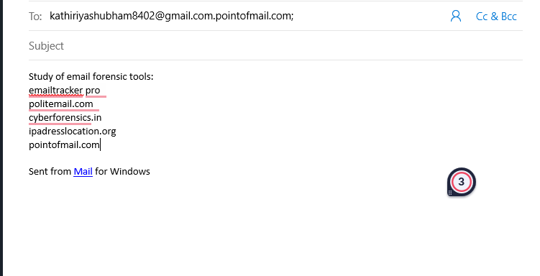

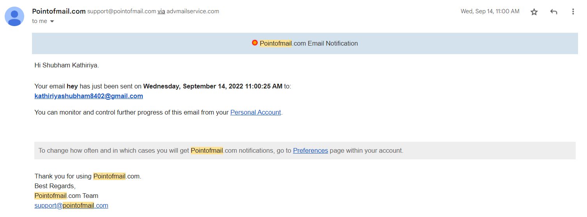

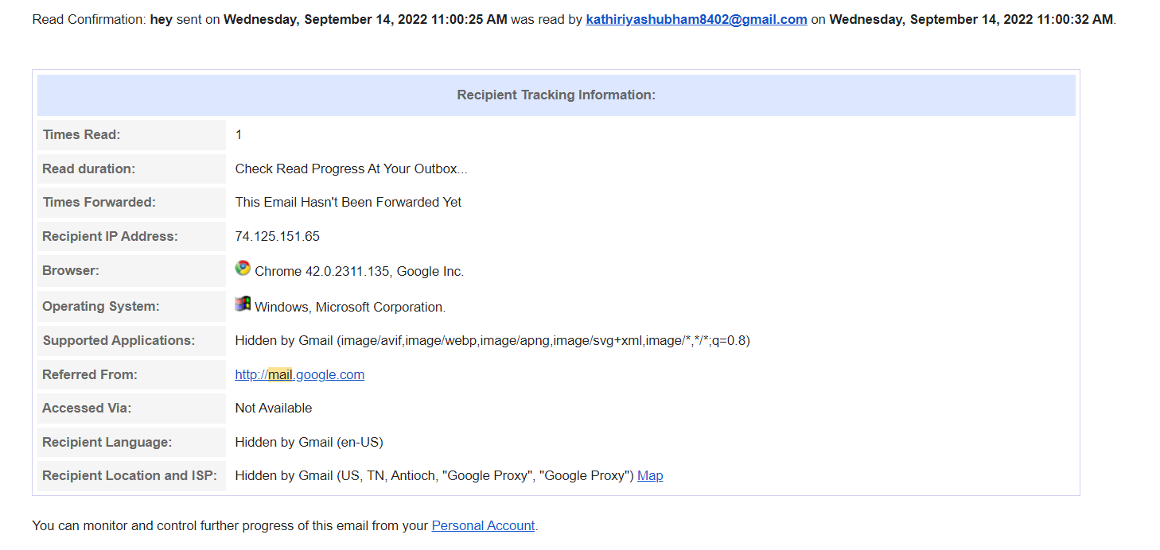

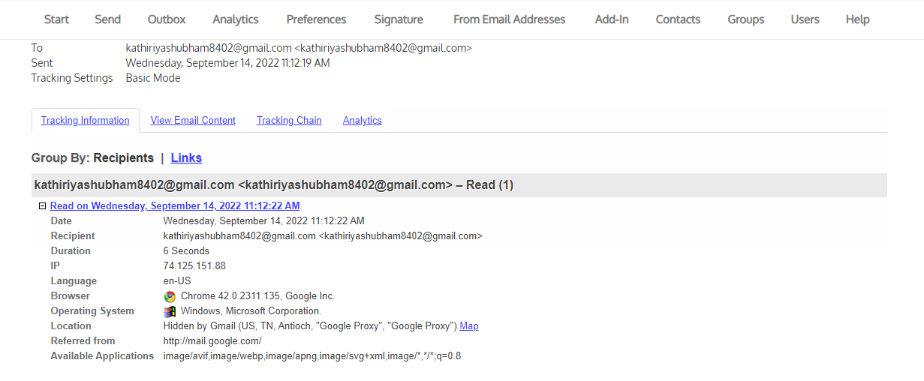

**Analysis:**

By using this tool, we can trace email. We can also find the location of Ip address and Ip related information.