**Digital Forensics Lab Report: 8**

Date: 27-10-2022

|  |  |
| --- | --- |
| Name: | Vedant H. Patel |
| Roll No: | 19BCP138 |
| Subject Code: | 20CP411P |
| Subject Name: | Digital Forensics Lab |

**Aim/Purpose:** To create a disk image of a pen drive and studying it using Autopsy

**Task 1:** FTK Imager

Step 1: Open Access Data FTK Imager and create a disk image of the pen drive.

* Select Physical Drive

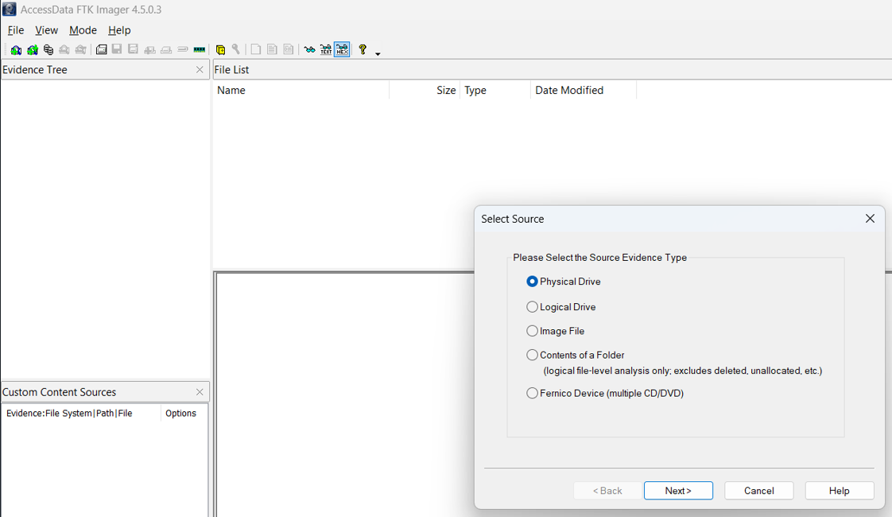

* Select Pen drive

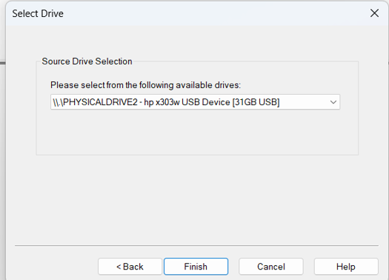

* Select the file format

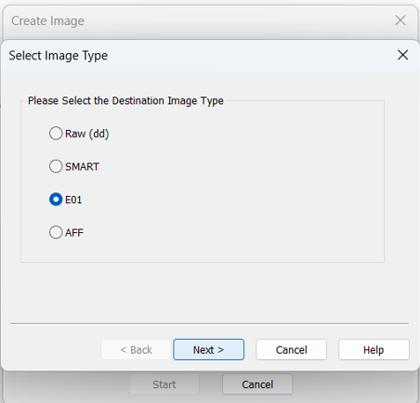

* Fill the following details

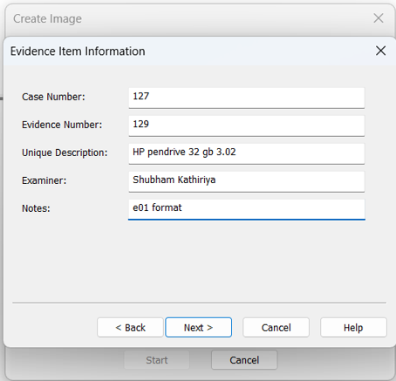

* Write the destination where you want to store and Click on the add

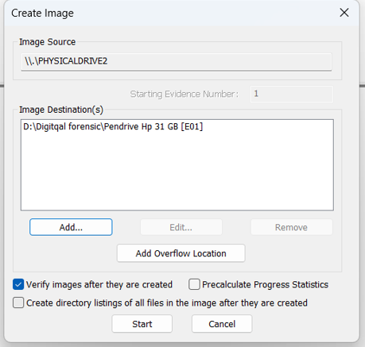

* Click on start button and then process will take place

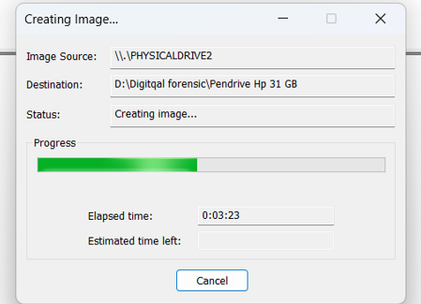

* Now after some time file has been created at your selected destination.
* Created file

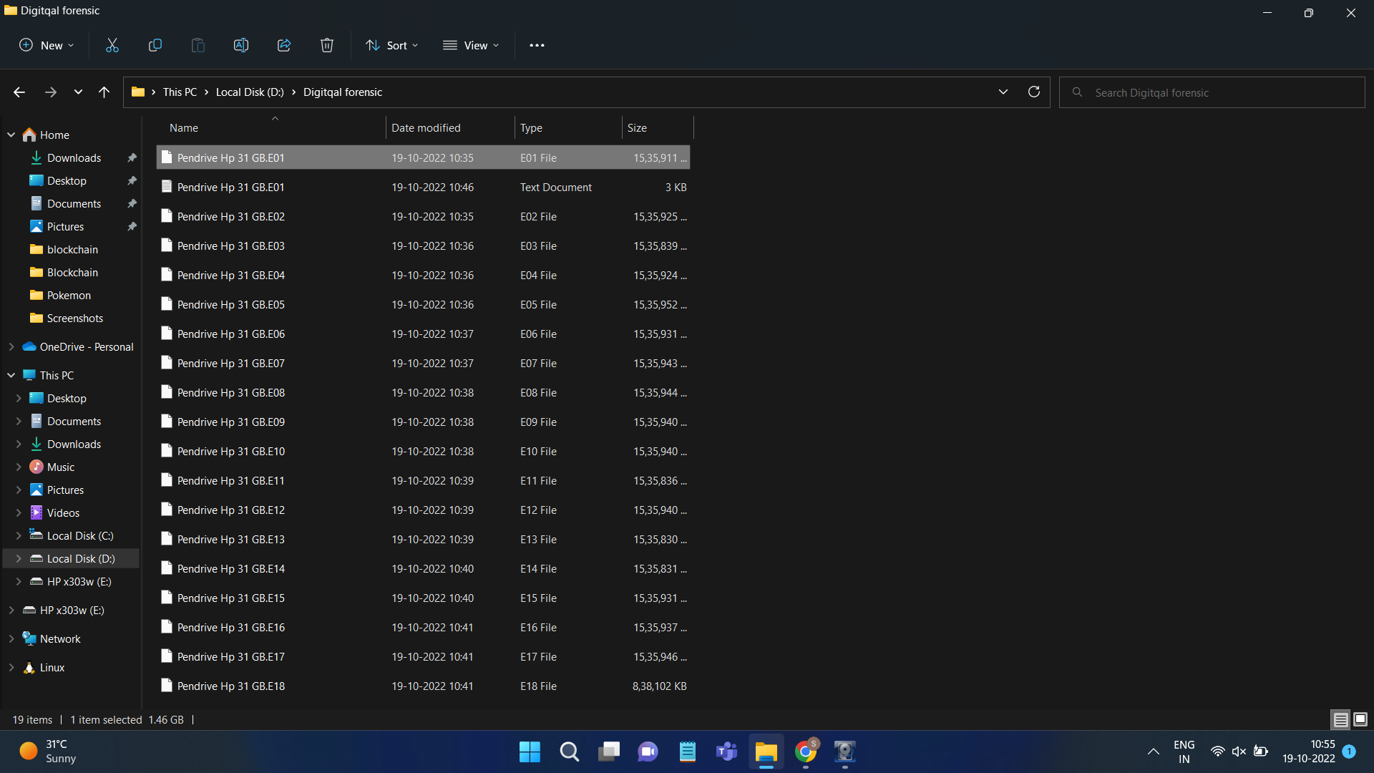

Step 2: Once the Disk image is created, open that disk image file in the Autopsy software.

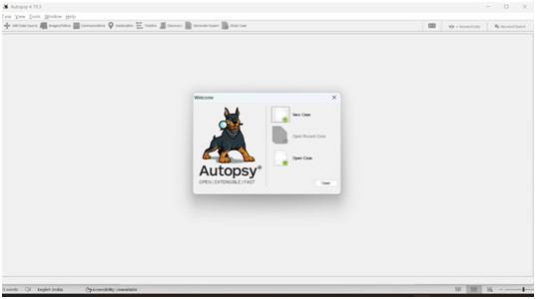

Select the following options.

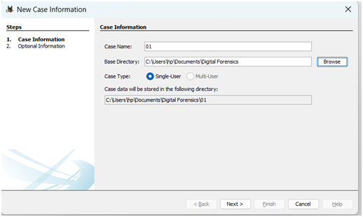

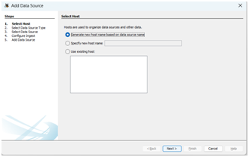

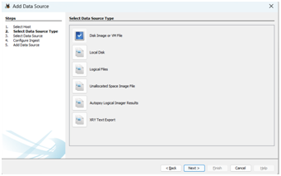

Select the FTK file that you have created priviously

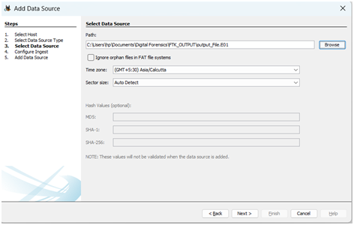

Click on “Next” button and then you can found the following details

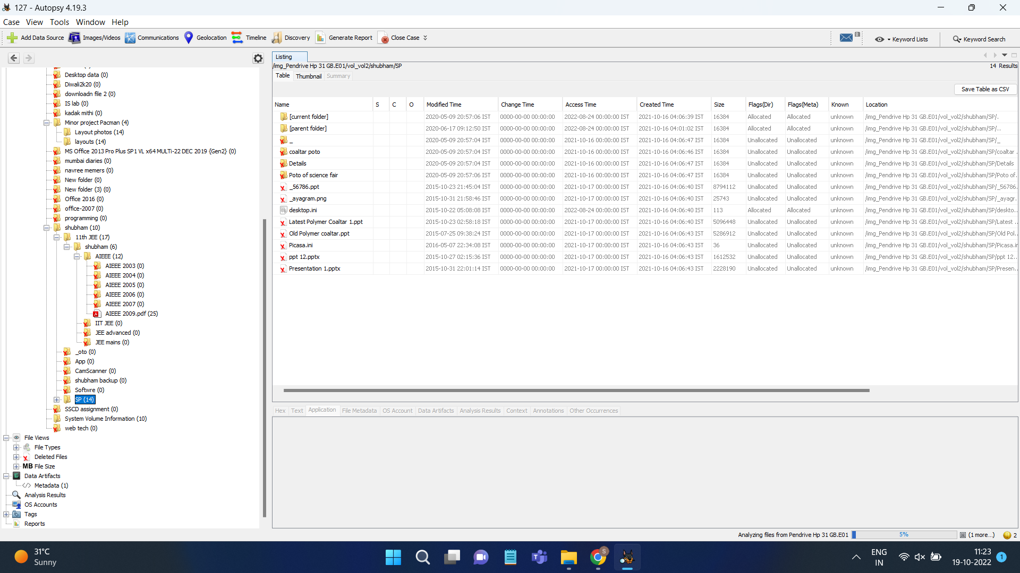

You can see the files as per below

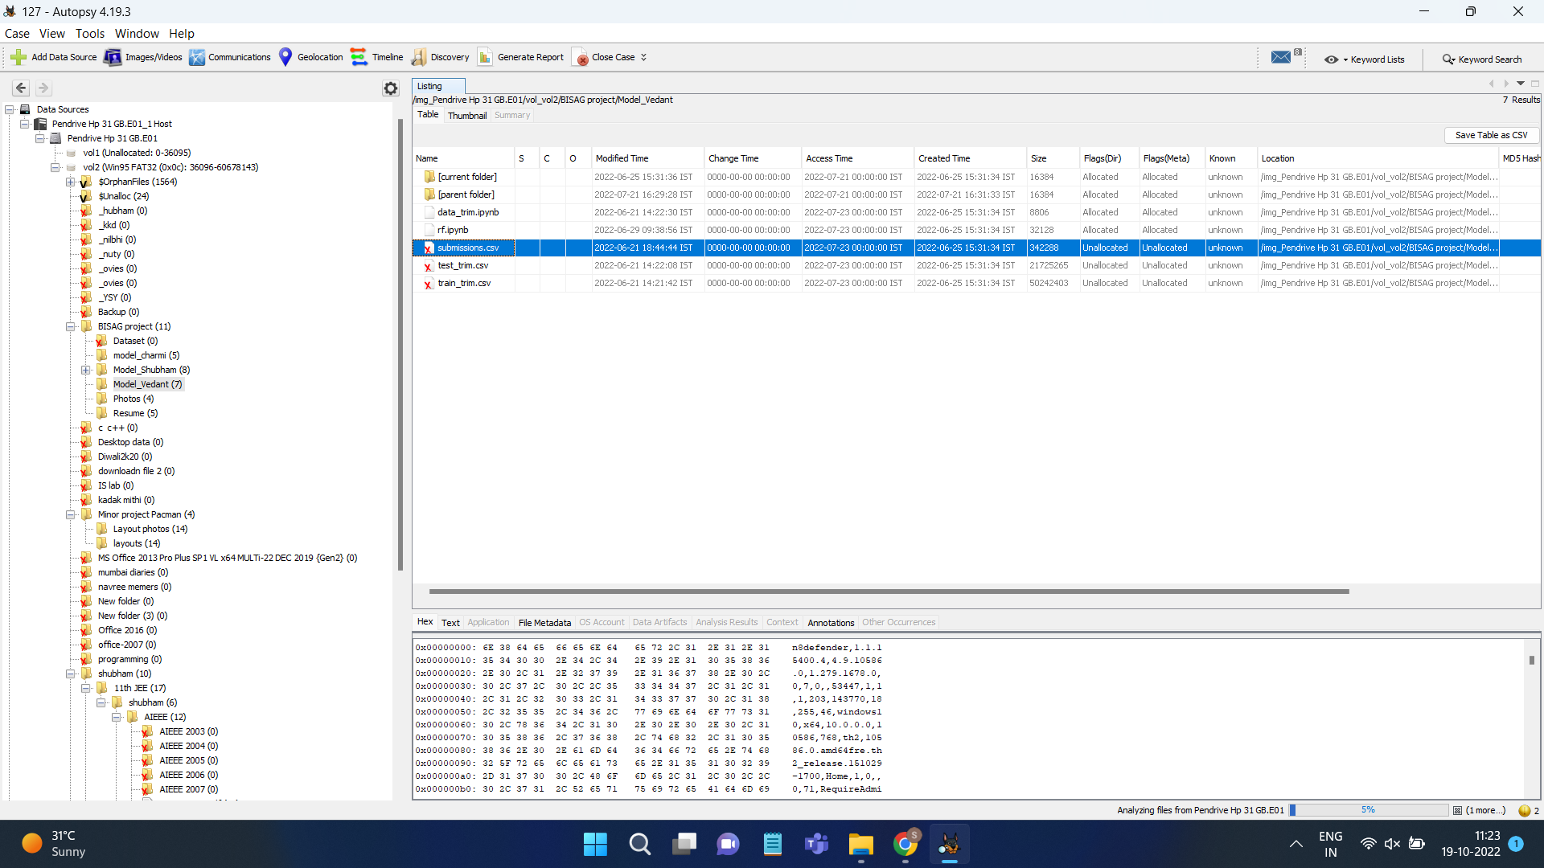

You can find the photos.

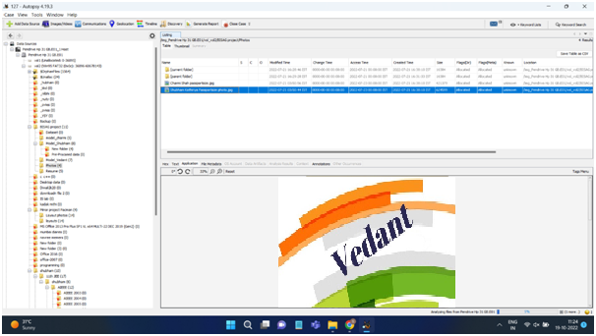

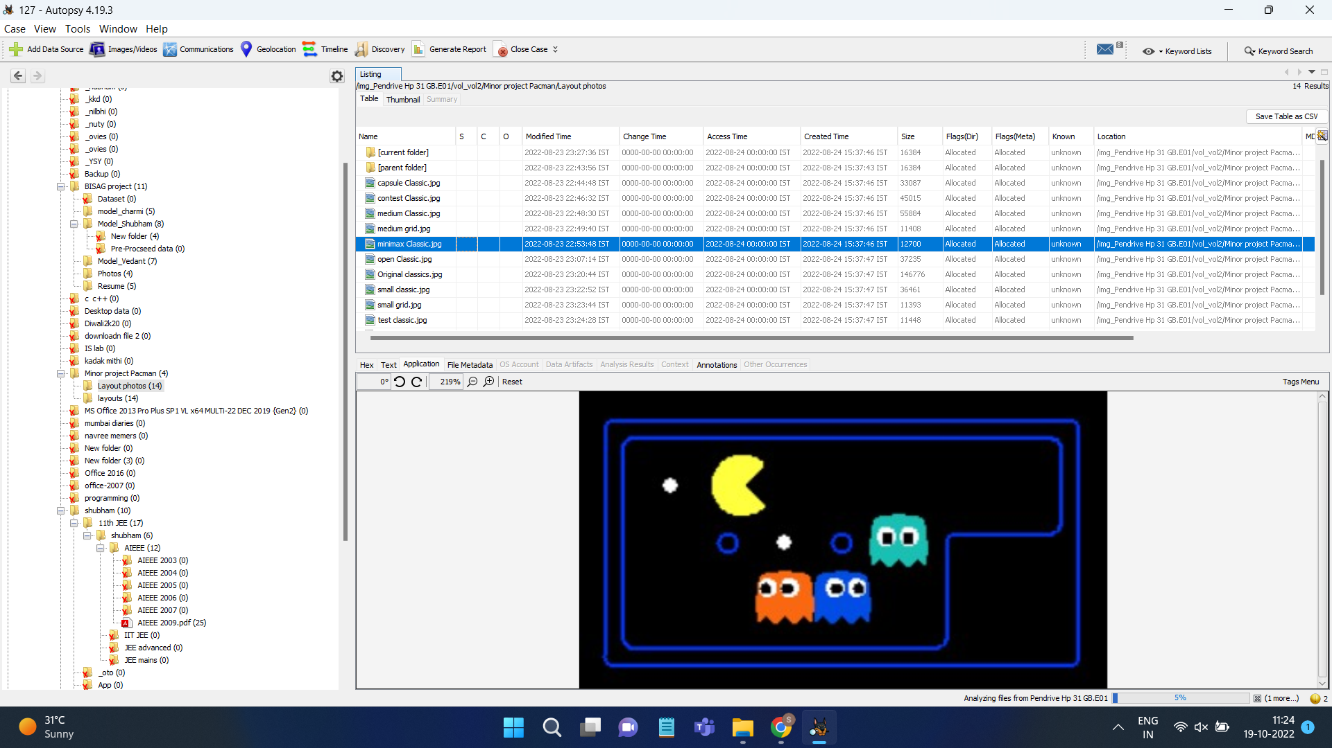

You can also see the metadata of the files

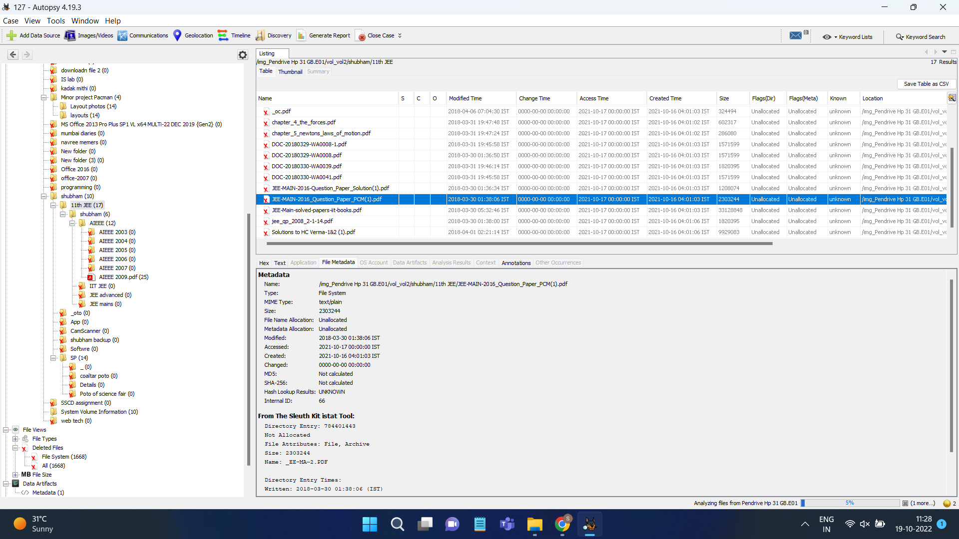

You can create the final report as given option click on the “generate report”

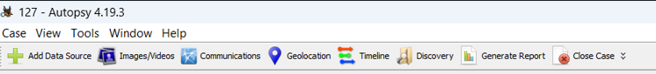

You can see the .txt file

