**Digital Forensics Lab Report: 9**

Date: 26-10-2022

|  |  |
| --- | --- |
| Name: | Vedant H. Patel |
| Roll No: | 19BCP138 |
| Subject Code: | 20CP411P |
| Subject Name: | Digital Forensics Lab |

**Aim/Purpose:** Study of Volatile Forensics Tool.

**Tool Names:** Magnet RAM Capture, Balkasoft RAM Capture, WinHex

# Step 1: Download Magnet RAM Capture

* Visit [https://support.magnetforensics.com/s/article/Acquire-Memory-with-MAGNET-RAM-](https://support.magnetforensics.com/s/article/Acquire-Memory-with-MAGNET-RAM-Capture) [Capture](https://support.magnetforensics.com/s/article/Acquire-Memory-with-MAGNET-RAM-Capture) and click on Software and Download
* You will have to download Magnet RAM Capture from the list of Software available in <https://support.magnetforensics.com/s/software-and-downloads?productTag=free-tools>
* You have to request access before downloading it.

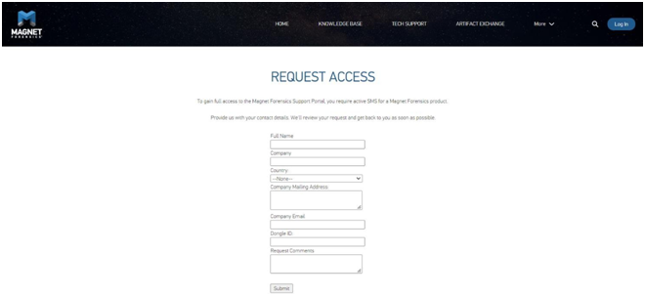

* You will get a link to download the file.

Step 2: Download BelkasoftSoftware

* Visit <https://belkasoft.com/get>

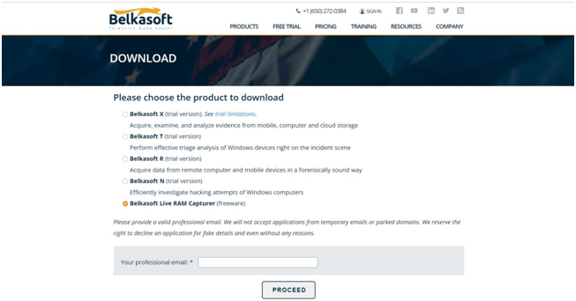

* Give your email and complete the form.

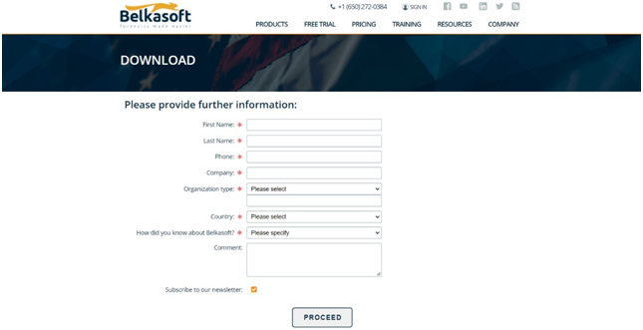

# Step 3: Download and Install WinHEX

* Visit <http://www.winhex.com/winhex/hex-editor.html>and download and install.

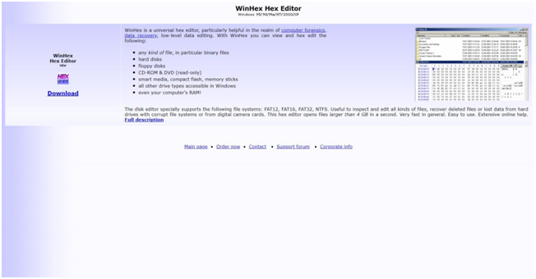

* Open the application

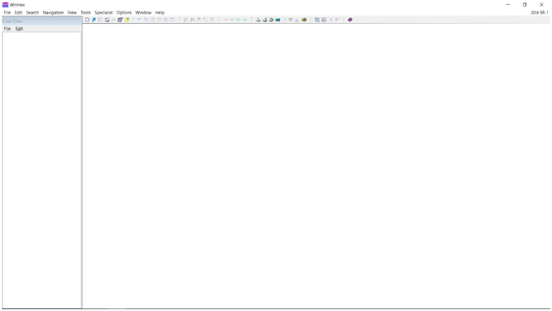

# Step 4: Make Image File and Open in WinHEX

* Open Magnet RAM Capture, choose a directory and file name and click on start.
* Once completed, a raw file will be created.

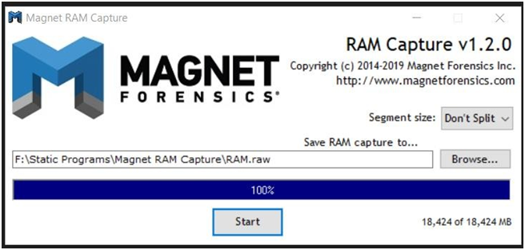

* Open the created raw file using WinHEX.

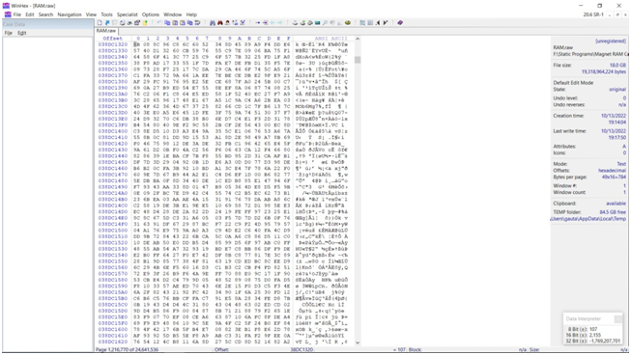

# Findings:

1. Found the my address in website

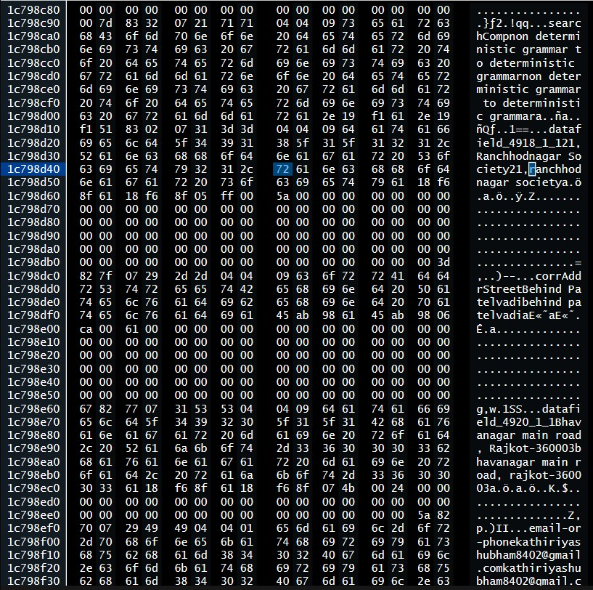

1. I found the userID and password of my riot account for Valorant

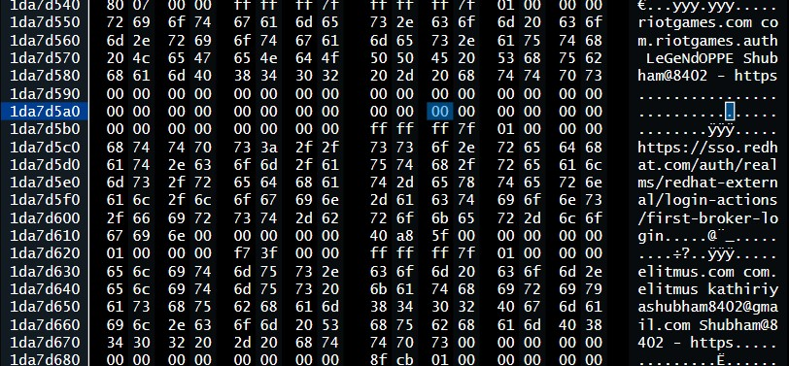

1. Found the download record which downloaded through chrome

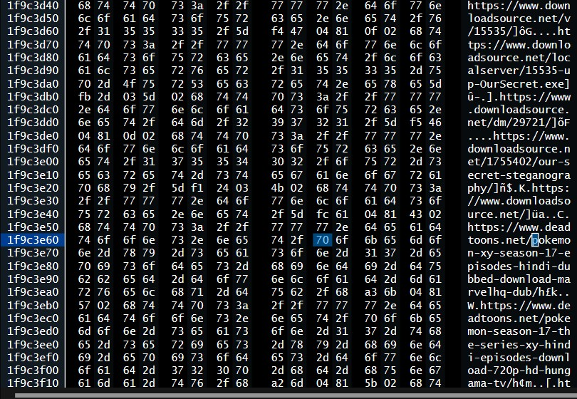

1. I found chrome history of previous window

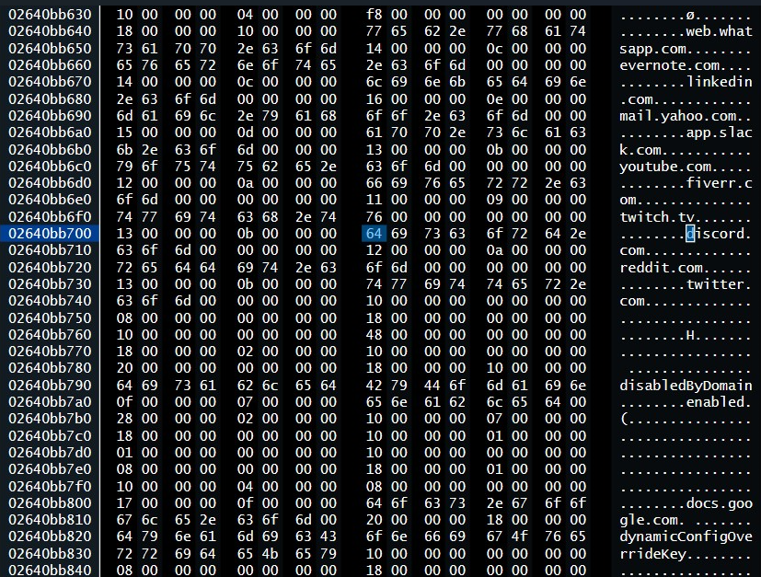

1. Found whatsapp number

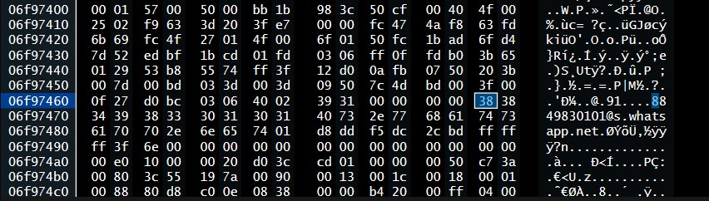

1. Found Instagram History

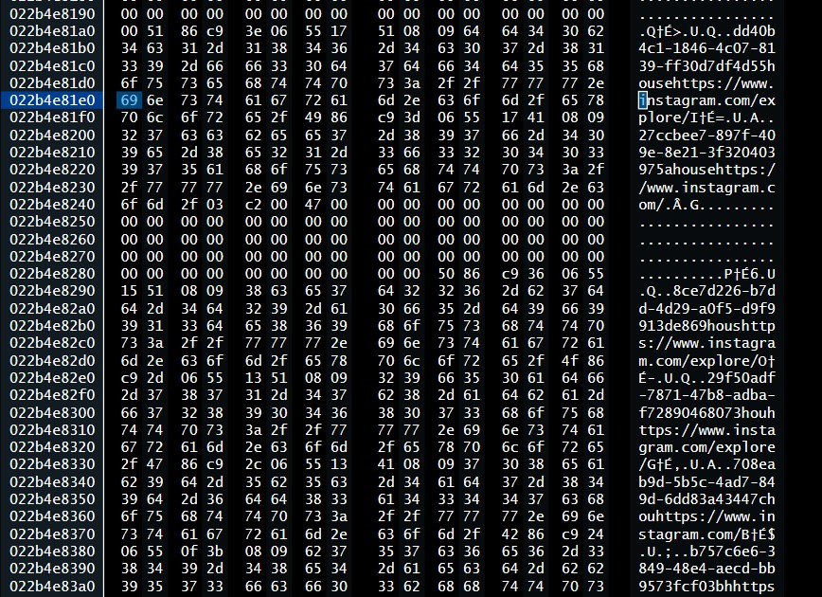

1. Found my friends emailid

