The End-to-End AWS Production Infrastructure:
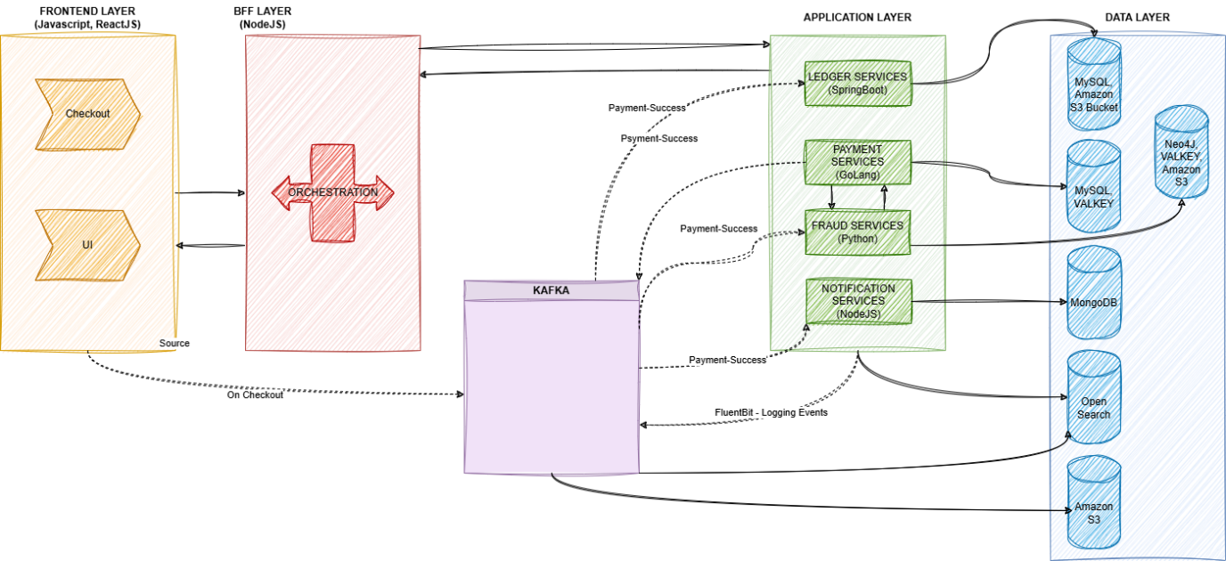

Frontend Layer:
This layer mainly holds presentation which is UI/UX part. This is the layer which directlyt interacts with the customer/end user of the system.
It will mainly contain user inputs such as card details, upi details, net banking details based on mode of transaction selected.
Tech Stack: JavaScript, ReactJS

BFF Layer:
This layer acts as backend for frontend and takes care of orchestration of services between Frontend Layer and Application Layer.
It interacts with multiple backend services and helps to aggregate, format and present data for frontnend.
Tech Stack: NodeJS

Application Layer:
This layer mainly contains core business domain logic. To ensure this each subdomain is separated into microservices. This ensures system is not tightly coupled and avoid catastrophic chain reaction of failures when one service is impacted.

Data Layer:
This layer mainly contains database which suits the behaviour of each microservices. It can be structure, unstructured, nosql, etc.

Coming to Application Layer which contains multiple microservices which are having separate data storage and access requirements:
1. Ledger Services: holds the bookeeping logic for the transaction and to ensure entries are correctly posted in appropriate Ledger.
Database:
1. MySQL, Oracle 12c: Since the data will grow as the volume, structured databse with ACID properties is preferrable.
2. Amazon S3: To keep main database lightweight, separate cold stroage databse is used.

Payment Services:
1. MySQL for payment details storage
2. Valkey -- faster in-memory databse to hold amount and session details

Fraud Service:
1. Neo4j - this is graphical database used to co-relate multiple aspects for fraud identification
2. Valkey - high performing in-memory database for quick search on blacklists, fraud identification
3. Amazon S3 - to hold historical data

Notification Services:
MongoDB - to hold multiple nnon structured data to store it in ultiple format based on application requirements

Loging Mechanism:
OpenSearch - this provides indexing of multiple audit and log data from independent microservices and helps user to easily identify and search.

To ensure each system are not synchronously dependent and tightly coupled with each other an event driven mechanism is recommended.
This will not create chain reaction of failures when any particular service is impacted.

Event Driven Mechanism : Kafka
This is used to asynchronously store and communicate the events to separtate queues.
Buffer mechanism of Kafka helps to store and process. This helps when extremely high volume of transactions are reached.
Kafka mainly acts based on producers and consumers of the events.

