MINIPROJECT LOGBOOK

GROUP MEMBERS

1. Hriday Keswani

2. Viren Keswani

3. Vedant Jumle

Supervisor

Prof. Manisha dumbre

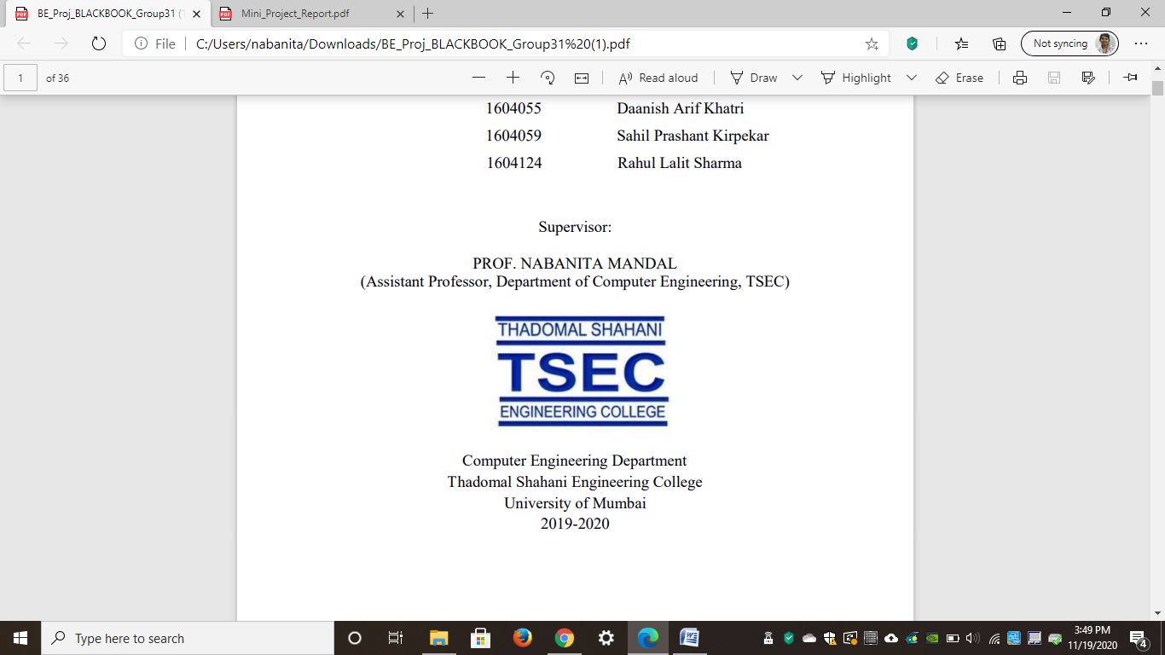

Computer Engineering Department
Thadomal Shahani Engineering College
Bandra(w), Mumbai - 400 050
University of Mumbai
(AY 2021-22)

STUDENT INFORMATION

Project Title: Image manipulation using Generative Machine Learning

 | Student 1 | Student 2 | Student 3
Roll No | 88 | 89 | 74
Name | Hriday Keswani | Viren Keswani | Vedant Jumle
Class with Division | C-2 | C-2 | C-2
Contact No. | 9167997968 | 8779755306 | 8879480965
E-mail | hridaykeswani@gmail.com | virenkeswani@gmail.com | vedantjumle@gmail.com
Address | 6-B,121, | Flat No 92, Bld. Number 12, | 514/J-4 RBI Officer's Quarters
Address | Seva Samiti Nagar, | Kamdhenu Hari Om Nagar, | Gokuldham,
Address | Sion East, | Mulund East | Goregaon East
Address | Pin: 400037 | Pin:400081 | Pin:400063

DECLARATION

I declare that this project represents my ideas in my own words and wherever others' ideas or words have been included, I have adequately cited and referenced the original sources. I also declare that I have adhered to all principles of academic honesty and integrity and have not misrepresented or fabricated or falsified any idea/data/fact/source in my project work. I promise to maintain minimum 75% attendance, as per the University of Mumbai norms. I understand that any violation of the above will be cause for disciplinary action by the Institute.

Yours Faithfully

1.

2.

3.

(Signature of Students)

Letter of Acceptance

I undersigned, Prof. Manisha Dumbre working in Computer Engineering department, willing to guide the project titled Image manipulation using Generative Machine Learning ________________

for the mini project-I Semester III /IV respectively for the academic year 2020-21. The names of the students are:
1. Hriday Keswani

2. Viren Keswani

3. Vedant Jumle

(Project Guide) (Mini Project Coordinator) (HOD Computer)

.

SCHEDULE FOR MINI PROJECT

Date | Week | Contents | Remark | Guide Sign
10/01/2022 | 1 | Teams were formed
17/01/2022 | 2 | Topic was decided
24/01/2022 | 3 | Neural style Transfer was implemented
31/01/2022 | 4 | Searched datasets for implementation of DC GAN and trained it for a week
07/02/2022 | 5 | Changed the data set for DC GAN
14/02/2022 | 6 | Trained the dataset for 400 epochs and increased image resolution to 128x128
 | 7
 | 8
 | 9
 | 10
 | 11
 | 12

PROGRESS/ATTENDANCE REPORT

Title of the Project:
Image manipulation using Generative Machine Learning
Name of Student 1: Hriday Keswani
Name of Student 2: Viren Keswani
Name of Student 3: Vedant Jumle
Name of the Supervisor: Manisha Dumbre

Sr. No | Date | Attendance |  |  | Progress/Suggestion
 |  | 1 | 2 | 3
1 | 10/01/2022 | P | P | P
2 | 17/01/2022 | P | A | P
3 | 24/01/2022 | A | P | P
4 |  | - | - | -
5 |  | - | - | -

6
7
8
9
10
11
12

Sign of the Supervisor

