MINIPROJECT LOGBOOK

GROUP MEMBERS

1. Vedant Jumle

2. Mandar Kasangottuwar

3. Heer Kapadia

Supervisor

Prof. Manisha Dumbre

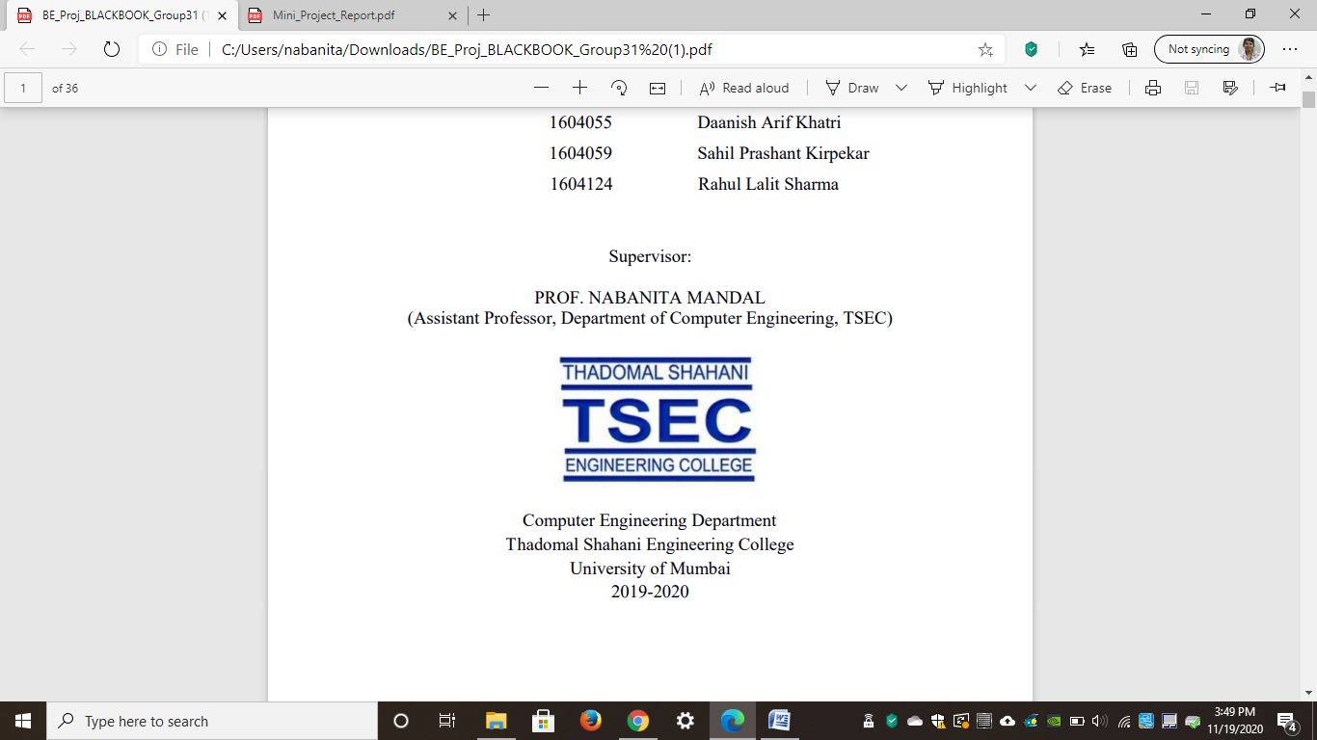

Computer Engineering Department
Thadomal Shahani Engineering College
Bandra(w), Mumbai - 400 050
University of Mumbai
(AY 2021-22)

STUDENT INFORMATION

Project Title:

 | Student 1 | Student 2 | Student 3
Roll No | 2003074 | 2003083 | 2003081
Name | Vedant Jumle | Mandar Kasangottuwar | Heer Kapadia
Class with Division | C21 | C21 | C21
Contact No. | +918879480965 | +919769226107 | +919167452952
E-mail | vedantjumle@gmail.com | Mskasan30@gmail.com | heerkapadia04@gmail.com
Address | 514/J-4, RBI officer quarters | B-601, Princeton, Hiranandani Estate, GB road | A/302, Paras Nagar
Address | Gokuldham | Thane West | Shankar lane, Kandivali West
Address | Goregaon East |  | Mumbai 400067
Address | Mumbai - 400063

DECLARATION

I declare that this project represents my ideas in my own words and wherever others' ideas or words have been included, I have adequately cited and referenced the original sources. I also declare that I have adhered to all principles of academic honesty and integrity and have not misrepresented or fabricated or falsified any idea/data/fact/source in my project work. I promise to maintain minimum 75% attendance, as per the University of Mumbai norms. I understand that any violation of the above will be cause for disciplinary action by the Institute.

Yours Faithfully

1. Vedant Jumle

2. Mandar Kasangottuwar

3. Heer Kapadia

(Signature of Students)

Letter of Acceptance

I undersigned, Prof. Manisha Dumbre working in Computer Engineering department, willing to guide the project titled X86_64 – An AI based system for diagnosing plant diseases

for the mini project-I Semester III /IV respectively for the academic year 2020-21. The names of the students are:
1. Vedant Jumle

2. Mandar Kasangottuwar

3. Heer Kapadia

(Project Guide) (Mini Project Coordinator) (HOD Computer)

.

SCHEDULE FOR MINI PROJECT

Date | Week | Contents | Remark | Guide Sign
06/09/2021 | 1 | Ideation, and studying about ML
20/09/2021 | 2 | Dataset was found
27/09/2021 | 3 | Minimal progress since 2/3 members were participating in hackathon
04/10/2021 | 4 | Project outline was decided
11/10/2021 | 5 | Literature Review was finished and brainstorming about optimal Neural Architecture was done.
19/10/2021 | 6 | Model training and evaluation was finished.
 | 7
 | 8
 | 9
 | 10
 | 11
 | 12

PROGRESS/ATTENDANCE REPORT

Title of the Project: X86_64 – An AI based system for diagnosing plant diseases
Name of Student 1: Vedant Jumle
Name of Student 2: Mandar Kasangottuwar
Name of Student 3: Heer Kapadia
Name of the Supervisor: Prof. Manisha Dumbre

Sr. No | Date | Attendance |  |  | Progress/Suggestion
 |  | 1 | 2 | 3
1 |  | P | P | P
2 |  | P | P | P
3 |  | P | P | P
4 |  | P | P | P
5 |  | P | P | P

6 |  | P | P | P
7
8
9
10
11
12

Sign of the Supervisor

