MINIPROJECT LOGBOOK

GROUP MEMBERS

1. Hriday Keswani

2. Viren Keswani

3. Atharva Kadam

Supervisor

Prof. Manisha dumbre

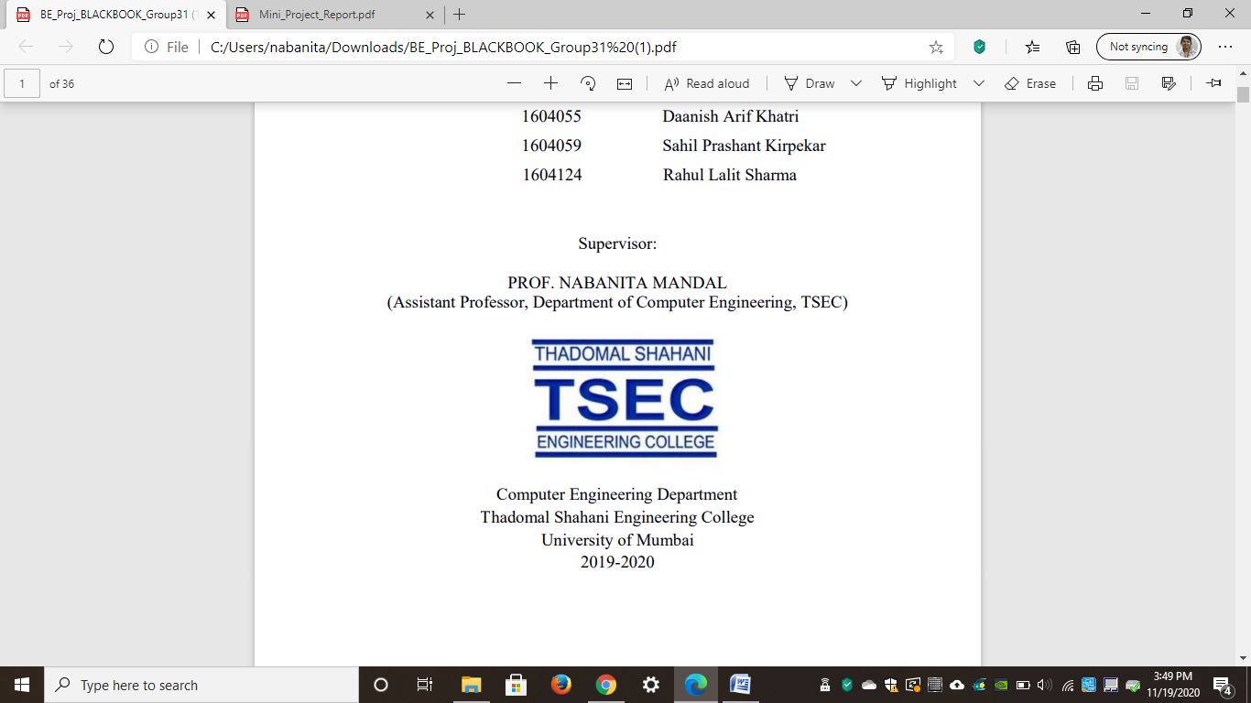

Computer Engineering Department
Thadomal Shahani Engineering College
Bandra(w), Mumbai - 400 050
University of Mumbai
(AY 2021-22)

STUDENT INFORMATION

Project Title: Custom PC builder

 | Student 1 | Student 2 | Student 3
Roll No | 88 | 89 | 75
Name | Hriday Keswani | Viren Keswani | Atharva Kadam
Class with Division | C-2 | C-2 | C-2
Contact No. | 9167997968 | 8779755306 | 8928106363
E-mail | hridaykeswani@gmail.com | virenkeswani@gmail.com | atharva19sk@gmail.com
Address | 6-B,121, | Flat No 92, Bld. Number 12, | B-601 Hari Heights CHS,
Address | Seva Samiti Nagar, | Kamdhenu Hari Om Nagar, | Plot No.23,Sec-09 Ulwe
Address | Sion East, | Mulund East | Panvel, Raigad,
Address | Pin: 400037 | Pin:400081 | Pin:410206

DECLARATION

I declare that this project represents my ideas in my own words and wherever others' ideas or words have been included, I have adequately cited and referenced the original sources. I also declare that I have adhered to all principles of academic honesty and integrity and have not misrepresented or fabricated or falsified any idea/data/fact/source in my project work. I promise to maintain minimum 75% attendance, as per the University of Mumbai norms. I understand that any violation of the above will be cause for disciplinary action by the Institute.

Yours Faithfully

1.

2.

3.

(Signature of Students)

Letter of Acceptance

I undersigned, Prof. Manisha Dumbre working in Computer Engineering department, willing to guide the project titled PC Builder

for the mini project-I Semester III /IV respectively for the academic year 2020-21. The names of the students are:
1. Hriday Keswani

2. Viren Keswani

3. Atharva Kadam

(Project Guide) (Mini Project Coordinator) (HOD Computer)

.

SCHEDULE FOR MINI PROJECT

Date | Week | Contents | Remark | Guide Sign
06/09/2021 | 1 | Teams were formed and initial idea was decided
20/09/2021 | 2 | Features of the website were decided
27/09/2021 | 3 | Unable to make progress due to 2 /3 members participating in a hackathon
04/10/2021 | 4 | An API was found and data was retrieved in JSON files for pc building components
11/10/2021 | 5 | Unable to make progress due to periodic tests in the week
19/10/2021 | 6 | The group members started learning Node.js and Express for the website backend and prototype was developed for the interactive guide
 | 7
 | 8
 | 9
 | 10
 | 11
 | 12

PROGRESS/ATTENDANCE REPORT

Title of the Project:
PC Builder
Name of Student 1: Hriday Keswani
Name of Student 2: Viren Keswani
Name of Student 3: Atharva Kadam
Name of the Supervisor: Manisha Dumbre

Sr. No | Date | Attendance |  |  | Progress/Suggestion
 |  | 1 | 2 | 3
1 | 06/09/2021 | P | P | P
2 | 20/09/2021 | P | P | P
3 | 27/09/2021 | P | A | P
4 | 04/10/2021 | P | P | A
5 | 11/10/2021 | - | - | -

6 | 18/10/2021 | A | P | P
7
8
9
10
11
12

Sign of the Supervisor

