Game Design Document

Fill up the Following document

1. Write the title of your project.

alienverse

1. What is the goal of the game?

To escape the other universe that you are traped in

1. Write a brief story of your game?

You are a scientist and create a portal gun use it to go in another universe but it breaks you travel to get some parts to create another portal gun and escape.

1. Which are the playing characters of this game?

* Playing characters are the ones which respond to the user based on the input from the user
* Cars, monkeys, dinos, wizards etc, are the playing characters in the game.

|  |  |  |
| --- | --- | --- |
| Number | Character Name | What can this character do? |
| 1 | nick | Genius scientist |
| 2 |  |  |
| 3 |  |  |
| 4 |  |  |
| 5 |  |  |
| 6 |  |  |
| 7 |  |  |
| 8 |  |  |

1. Which are the Non Playing Characters of this game?

* Non Playing characters are the ones which don't have an action or a behaviour when the user interacts with the game.
* Hurdles, stones, bananas, coins, etc are non playing characters in the game.

|  |  |  |
| --- | --- | --- |
| Number | Character Name | What can this character do? |
| 1 | Alien 1 | Can punch |
| 2 | Alien 2 | Can shoot lazer out of his eyes |
| 3 | Boss alien | very big |
| 4 |  |  |
| 5 |  |  |
| 6 |  |  |
| 7 |  |  |
| 8 |  |  |

Draw your imagination of this game. What does this game look like?

* Draw the game either on your computer or on paper,
* Add images of scenes of the game to show each of the playing and non-playing characters at least once.

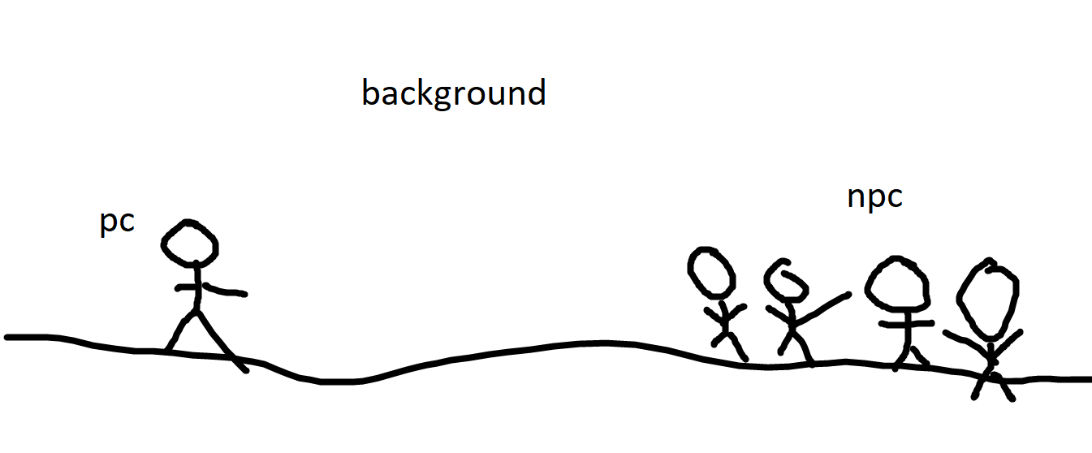

How do you plan to make your game engaging?

To make it fun to play with many colors to make it more atrative