TATA TECHNOLOGIES LTD.
TECH PULSE FY-26 | AI/ML CAPSTONE PROJECT
PROJECT SYNOPSIS
Institute: Pimpri Chinchwad College of Engineering (PCCOE), Pune
Programme / Batch: Final Year IT | Batch 2023–27
Student Name: Vedant Sarode | PRN: 123B1F129
Case Study ID: CS1
Project Title: AUTOSAR HLD Document Analysis Assistant

1. Case Study ID and Project Title / Topic
Case Study ID: CS1
Project Title: AUTOSAR HLD Document Analysis Assistant

2. Objectives
- Develop a prototype that accepts automotive High-Level Design (HLD) PDF documents and extracts their text for analysis.
- Split extracted content into page-aware chunks and generate semantic embeddings for retrieval.
- Retrieve relevant evidence for a user question and return an answer grounded in retrieved passages with document and page citations.
- Handle unsupported or out-of-scope questions conservatively and reduce unsupported claims through evidence-based answering and deterministic fallback behavior.
- Evaluate the prototype using reproducible tests for retrieval, source-page matching, unsupported questions, empty inputs, and prompt-injection attempts.

3. Scope

In Scope – To Be Implemented
- PDF ingestion and extraction for text-based HLD documents, with clear handling of unreadable or malformed files.
- Page-aware chunking, local sentence-transformer embeddings, and similarity-based retrieval using FAISS.
- A Streamlit user interface for document ingestion, question answering, retrieved-evidence inspection, and evaluation.
- Source citations containing the source document name and page number.
- A synthetic demonstration knowledge base covering BMS, Brake-by-Wire, and ADAS fusion architecture examples.
- Automated unit tests and a repeatable evaluation suite.

Out of Scope – Will Not Be Implemented
- Certification, homologation, or production safety approval of an automotive design.
- Replacement of an automotive safety engineer or other qualified human reviewer.
- Claims that synthetic demonstration HLDs are real OEM documents or validated production specifications.
- Guaranteed OCR support for all scanned PDFs or guaranteed extraction from every PDF layout.
- Automatic modification of ECU software, AUTOSAR configuration, or vehicle-control systems.

4. Proposed Approach
- Ingest: accept PDF files and extract text while retaining page-level source metadata.
- Chunk: divide extracted text into manageable, page-aware segments to support retrieval and citations.
- Embed and index: create semantic vectors using the locally run all-MiniLM-L6-v2 embedding model and store vectors in a FAISS index.
- Retrieve: encode the user question and rank candidate passages by semantic similarity.
- Answer: present retrieved architectural findings and their citations; use deterministic fallback behavior when a generative provider is not configured or evidence is insufficient.
- Evaluate: run automated tests and a 12-scenario evaluation suite over synthetic test documents.

5. Proposed Technology Stack
Layer | Technology / Role
Language | Python
User interface | Streamlit
PDF text extraction | pypdf
Embeddings | Sentence Transformers: all-MiniLM-L6-v2 (local CPU execution)
Vector retrieval | FAISS
Numerical / supporting libraries | NumPy and scikit-learn
Testing | Python unittest and project evaluation runner

6. Expected Outcomes
- A locally runnable prototype for querying text-based synthetic AUTOSAR HLD PDFs.
- Evidence passages displayed with source document and page citations.
- A repeatable evaluation report with machine-readable JSON and CSV outputs.
- A documented project structure, setup instructions, known limitations, and demonstration workflow.
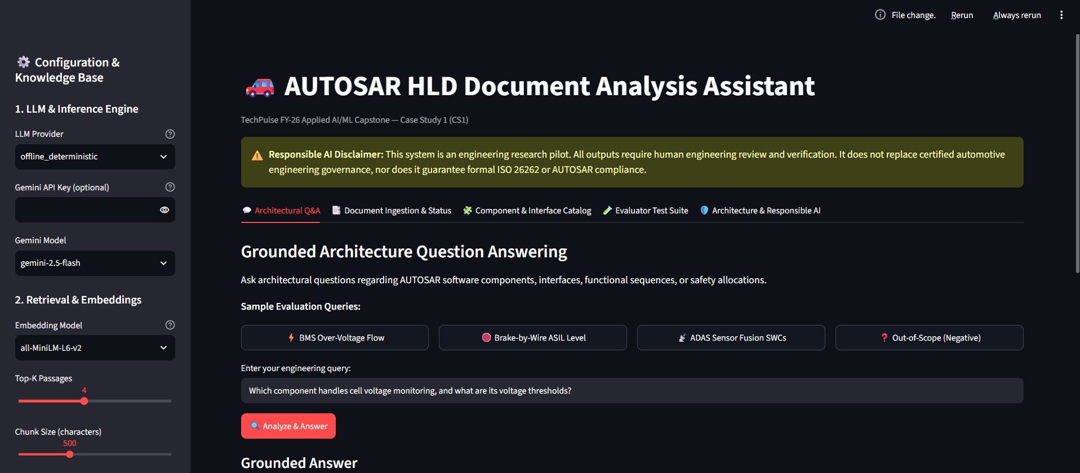

7. Data and Responsible Use
The demonstration knowledge base uses synthetic HLD PDFs created for this capstone. These documents are not approved OEM specifications and must not be used to make real vehicle safety decisions. Answers should be reviewed by a qualified human, especially where safety-related architecture is discussed. Results from the synthetic evaluation should not be interpreted as proof of production readiness.

8. Evaluation Plan
The current recorded run reports 12/12 unit tests passing and 12/12 evaluation scenarios passing. Scenarios cover direct retrieval, multi-passage coordination, component/interface identification, functional flow, safety allocation, page citation correctness, unsupported questions, prompt injection, and empty-input handling. These results apply to the current synthetic test suite only.

9. Student Declaration

[X] I will not change the approved case-study scope, major methodology, or implementation approach without prior faculty approval.

[X] I confirm that the work submitted under this synopsis represents my own understanding and contribution, and I will be responsible for explaining every significant part of the selected case study and its implementation.

10. Approval / Sign-off
Student Signature and name: Vedant Sarode
Date: 14/10/2026

