TATA TECHNOLOGIES LTD.
TECH PULSE FY-26 | AI/ML CAPSTONE PROJECT
TECHNICAL REPORT
Institute: Pimpri Chinchwad College of Engineering (PCCOE), Pune
Programme / Batch: Final Year IT | Batch 2023–27
Student Name: Vedant Sarode | PRN: 123B1F129
Case Study ID: CS1
Project Title: AUTOSAR HLD Document Analysis Assistant

1. Problem Statement and Intended Users
Automotive High-Level Design documents can contain many software components, ports, interfaces, dependencies, functional flows, and safety-related statements. Manually locating a relevant statement across multiple pages can be time-consuming. This project prototypes a document-grounded assistant that retrieves relevant passages from HLD PDFs and presents findings with source-document and page citations.
Intended users: students, developers, and engineering reviewers who need to explore technical HLD documents. The prototype is an information-retrieval aid, not a production engineering authority or a safety certification tool.

2. Input Data / Knowledge Base
Item | Description
Sources | Synthetic demonstration HLD PDFs created for the capstone: Powertrain/BMS, Brake-by-Wire, and ADAS Fusion. Additional scanned/damaged files are used for boundary testing.
Size and format | Three primary synthetic PDF documents, each reported as 3 pages; PDF is the ingestion format.
Preprocessing / EDA | PDF text extraction, page-level metadata retention, text normalization as implemented by the ingestion pipeline, and checks for empty/unreadable inputs.
Chunking strategy | Page-aware chunking to preserve source-page attribution and reduce cross-page citation errors.
Data limitation | Synthetic data only; not OEM production documentation and not representative of every automotive HLD format.

3. Solution Architecture
Component | Choice / role
Pre-trained generative model | No paid external generation API is required for the default deterministic fallback path. Any optional provider must be configured explicitly.
Embedding model | all-MiniLM-L6-v2 via Sentence Transformers, run locally on CPU.
Vector store | FAISS similarity index built from chunk embeddings.
RAG pipeline | PDF extraction → page-aware chunks → embeddings/index → query retrieval → evidence-grounded response with citations.
Service layer and UI | Python modules with a Streamlit web interface.
Tools / deterministic rules | Source metadata and page citations; handling for empty, unsupported, and adversarial queries as covered by the evaluation suite.

4. Implementation Details
- Configuration and environment loading are separated into project modules.
- PDF ingestion extracts text and retains source metadata, including document name and page number.
- Chunking creates smaller retrieval units while preserving page boundaries.
- The embedding module generates semantic vectors; FAISS indexes those vectors for nearest-neighbor search.
- The retriever selects relevant passages for a question. The interface exposes the resulting grounded findings and source citations.
- The application includes separate areas for question answering, ingestion, architecture entities, evaluation, and responsible-AI governance, as described in the project completion notes.

5. User Workflow
- Launch the application with the project virtual environment.
- Upload a supported HLD PDF or use the synthetic demonstration documents.
- Wait for ingestion, chunking, embedding, and index construction to finish.
- Ask a question about a component, interface, functional dependency, or design detail.
- Inspect the answer and the retrieved evidence passages, then validate the cited page in the source PDF.
- If evidence is missing, treat the response as incomplete and do not infer safety-critical values.

6. Evaluation Methodology
The project includes a Python unittest suite and a separate evaluation runner. The evaluation runner ingests the three synthetic HLD documents, creates 25 chunks in the recorded run, builds a FAISS index, and executes 12 test scenarios. The scenarios check factual retrieval, multi-passage coordination, component/interface identification, functional flow, safety allocation, citations, unsupported-query behavior, prompt-injection handling, and empty input.

7. Results
Metric | Recorded result | Interpretation
Unit tests | 12/12 passed | All tests in the executed unittest suite passed.
Evaluation scenarios | 12/12 passed (100%) | All current synthetic evaluation scenarios passed.
Positive source-page checks | 9/9 passed, per generated evaluation summary | Applies to the included test cases only.
Unsupported / negative tests | 2/2 passed | Included unsupported/empty or out-of-scope cases were handled as expected.
Prompt-injection test | 1/1 passed | One included adversarial scenario passed; this is not a comprehensive security audit.
Latency | Per-scenario values shown around 9–13 ms in the reported run | These are retrieval/evaluation measurements, not necessarily full UI or model-generation latency.
Verification evidence: the user-provided terminal output on 15 October 2026 showed `Ran 12 tests ... OK` and `EVALUATION COMPLETE: 12/12 PASSED (100.0%)`. The run also emitted an EOF-marker message and scikit-learn runtime warnings, but the unit test process still finished successfully. The evaluation runner saved evaluation_results.json, evaluation_results.csv, and EVALUATION_REPORT.md.

8. Limitations and Risks
- Synthetic documents may not reflect the structure, terminology, or ambiguity of real OEM HLDs.
- A successful retrieval test does not guarantee that every answer is complete or correct.
- PDF extraction can fail on scanned pages, complex layouts, tables, or malformed files; OCR is not guaranteed unless explicitly implemented and verified.
- The deterministic fallback may return extracted architectural findings rather than a fluent synthesized answer.
- A small prompt-injection test set cannot establish robust security against all adversarial inputs.
- No result from this prototype should be used alone for safety-critical automotive design, calibration, validation, or compliance decisions.

9. Responsible AI and Human Review
The assistant should present source citations so a reviewer can check claims against the original page. It should avoid filling gaps with guessed values and should indicate when evidence is insufficient. Synthetic inputs are clearly identified as demonstration data. Human review is required before using any extracted finding in engineering work.

10. Reproducibility and Execution
Environment: Windows project workspace with an isolated Python virtual environment at C:\TechPulseCapstone\.venv. The recorded run used Python 3.14.5. Dependencies are listed in the project's requirements.txt; use the project's environment rather than installing packages globally.
& "C:\TechPulseCapstone\.venv\Scripts\python.exe" -m streamlit run app.py
& "C:\TechPulseCapstone\.venv\Scripts\python.exe" -m unittest discover -s tests -p "test_*.py"
& "C:\TechPulseCapstone\.venv\Scripts\python.exe" tests/run_evaluation.py
The application is expected to open locally at http://localhost:8501 when Streamlit starts successfully.

11. Conclusion and Future Work
The capstone prototype demonstrates a local semantic retrieval workflow for synthetic AUTOSAR HLD PDFs, with page-aware evidence and citations. The recorded unit and evaluation runs passed all included tests. Future work may include testing against approved real-world documents, stronger evaluation sets, robust OCR for scanned files, richer table extraction, calibrated confidence/abstention thresholds, and security testing with a wider range of adversarial prompts.

References / Project Artifacts
- Project source modules and Streamlit application in the Code folder.
- Synthetic HLD PDF knowledge base and input data catalog.
- Evaluation_Results/EVALUATION_REPORT.md, evaluation_results.json, and evaluation_results.csv.
- Model_Prompts_Config/prompts.md, model_configuration.json, and environment_spec.md.
- TechPulse FY-26 synopsis and technical report templates supplied for this capstone.

Screenshots
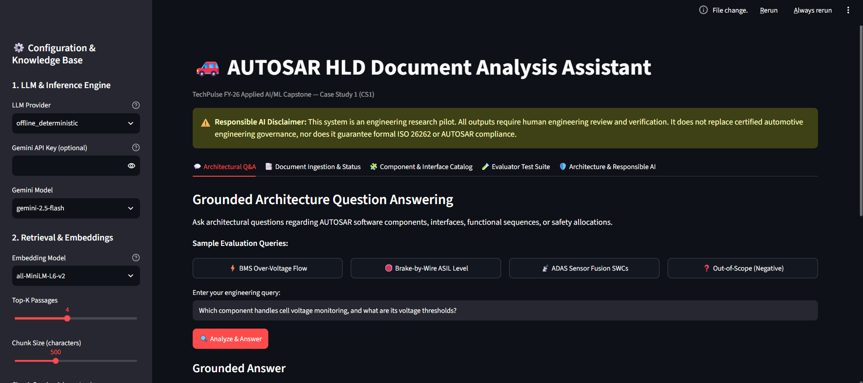
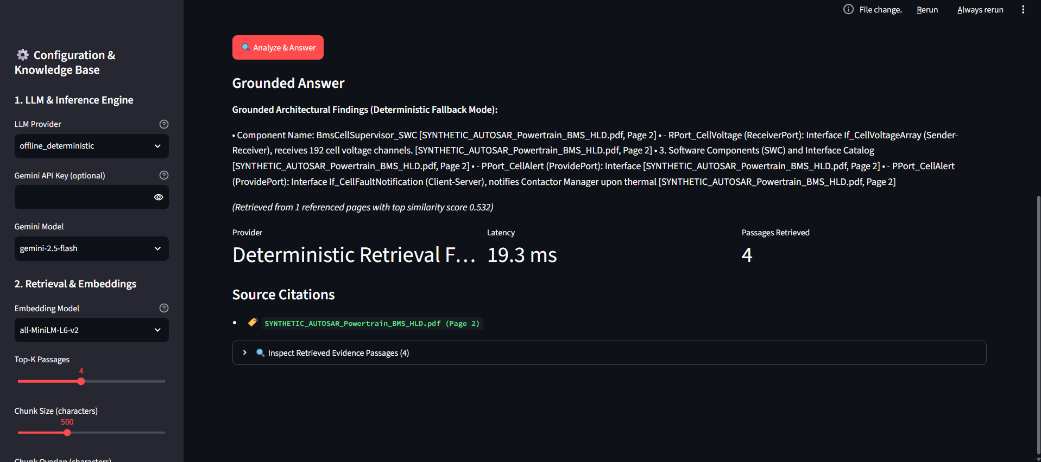
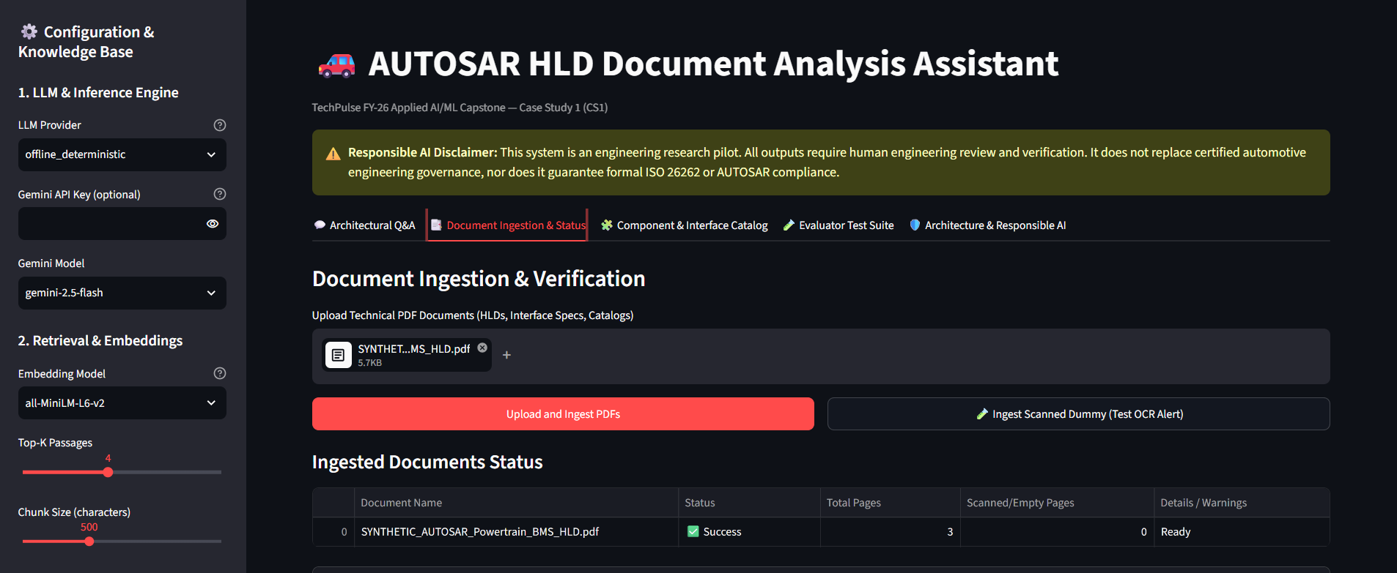
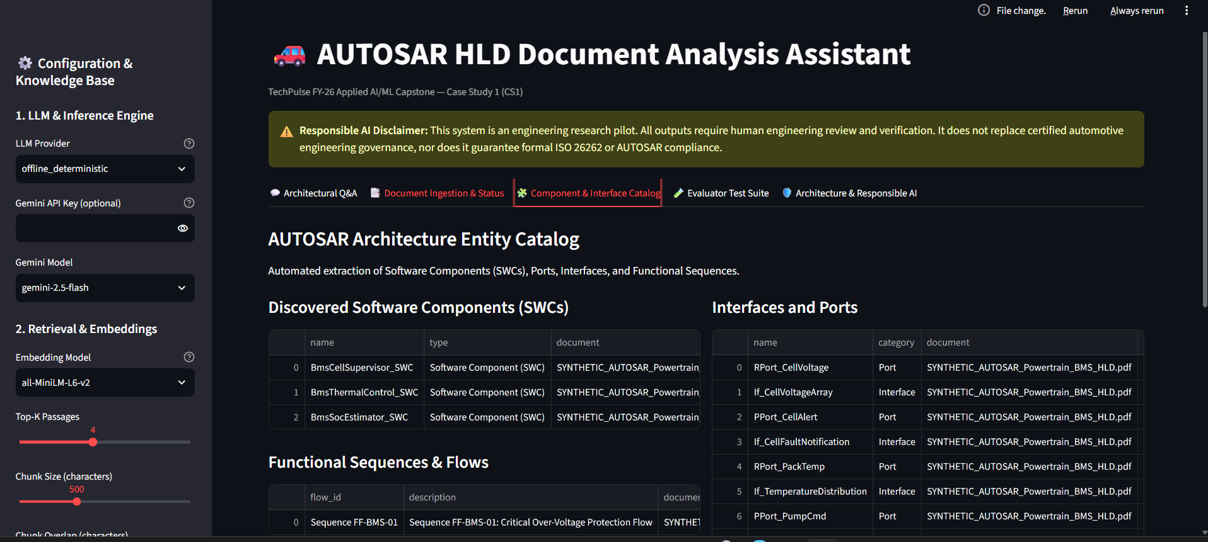
Student Declaration
I confirm that this report represents my own understanding and contribution, that the work follows the approved case-study scope, and that I can explain every significant part of the implementation.
Signature: Vedant Sarode Date: 14/10/2026

