Website

Improvements -
- Photos
- Location
- Volunteer data
- Geo-tagging
- Survival data
- Font size and alignment, font style

Mistakes -
- Partnership data missing
- Donate tab
- Our Work (Useable links)
- change name of csr to our goal
- (Alphabetical order)
- Urban Forest Tab (species / data / survival)
- Youtube channel missing
No photos in :
- education
- rural development
- water projects
- Empowering women
- Solar energy
- Green Gujarat
- Sanitation
- Nari Gruh



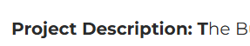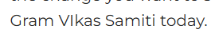

Only at bottom of the site.

Direct link / direction.
c:\Users\HP\.gemini\antigravity\scratch\grgvs-redesign\index.html

Theme - Font, colour grade
Photos – each goal
Info -
About us
Our work (csr)
Our goals (10 tabs)
Volunteers’ data
Contact details
Donate Tab / Details
Partnership data / logos
Addresses / Location of sites
Plant Data / Species / Survival rate
Social media links
Contact us icon

