**Structures and its Declaration**

**ITP Group Assignment II**

**Electronics and Communication Engineering**

**Indian Institute of Information Technology, Allahabad**

*Abstract* ***-̶* Declare the C structures for the given scenario: (I) College contains the following fields: College code (2characters), College Name, year of establishment, number of courses. (ii) Each course is associated with course name (String), duration, number of students. (A College can offer 1 to 50 such courses)**

**I.INTRODUCTION**

We have to declare two separate Structures for College Details and Course Details

Elements or Members of

1] First structure: College code, college name, established year and number of courses in college.

2] Second structure: Course name, course duration and number of students in course.

**II.ALGORITHM DESIGN**

**As Stated in problem statement We have to declare the structure for two main parts**

**A. College details**

**B. Course details**

**So, first we will declare separate structures for above parts**

**[A]. Declaring Structures -̶ “College’’**

**In “Struct college’’, We will declare the elements of structure “college’’**

**Elements are college code (college_code),college name (college_name),established year (college_est year) and finally number of courses in college (number_Courses) which are called members of structures**.

struct college{

char college_code [3];

char college_name [100];

char college_estyear [5];

Int number_courses;

};

[B]. **Declaring structures –“course_details”:**

In “Struct Course _Details’’, we will declare the elements of structure “Course_ details’’.

Elements are course name (Course _name),duration (Course_duration), number of students (number_of_students) which are called members of structures.

struct course_details{

char course_name[100];

float course_duration;

Int number_of_student;

};

After declaring both the structures, we will declare the individual structure specific variable S.

In the first part , declaring variable “Entry 1’’ for structure “College” and after that taking user input for college details.

struct college entry1; (Declaration of variable)

.

.

gets(entry1.college_code); (Taking user input)

Now after declaring first variable and taking user input, we will store number of courses into another variable “temp’’ and declare variable which would of type array which is “storing_data[temp]’’ for structure “course_details’’.

Then we will use “for’’ loop to take course details as an input from user which literates “temp’’ times which is no. of courses.

int temp;

temp=entry1.number_courses;

struct course_details storing_data[temp];

for(int i=0;i<temp;i++){

.

.

getchar();

gets(storing_data[i].course_name);

.

**Finally,** we will print college details and using another “for ‘’ loop we will print the course details.

**III. TIME COMPLEXITY AND SPACE COMPLEXITY:**

We carefully analyzed our algorithm and came up with the following:

(i) The time complexity is O(N)

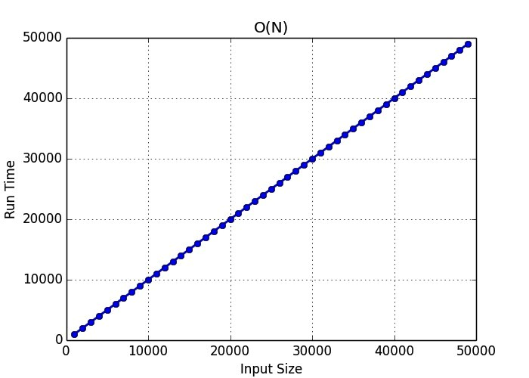

(ii) The Space complexity is O(N)

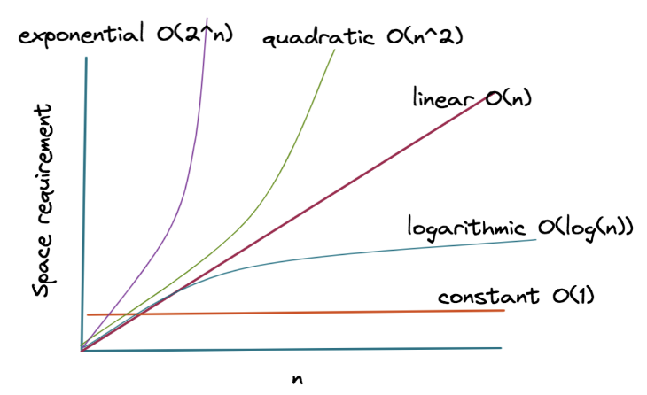

**Here, in the Graph the pink line is depicting current code scenario w.r.t space and input n**

**IV. CONCLUSION**

**The above design algorithm is of declaring Structures and taking user inputs which works perfectly.**

**V. REFERENCES:**

**Here are some references which we used to solve the problem:**

[**https://www.geeksforgeeks.org/structures-in-cpp/?ref=lbp**](https://www.geeksforgeeks.org/structures-in-cpp/?ref=lbp)

[**https://www.geeksforgeeks.org/array-of-structures-vs-array-within-a-structure-in-c-and-cpp/**](https://www.geeksforgeeks.org/array-of-structures-vs-array-within-a-structure-in-c-and-cpp/)

[**https://stackoverflow.com/questions/30619085/error-in-getting-input-in-structure-using-gets**](https://stackoverflow.com/questions/30619085/error-in-getting-input-in-structure-using-gets)

**VI. CODE:**

#include <stdio.h>

struct college {

char college_code [3];

char college_name [100];

char college_estyear [5];

int number_courses;};

struct course_details{

char course_name[100];

float course_duration;

int number_of_student;

};

int main(){

struct college entry1;

printf("Enter college code:\n");

gets(entry1.college_code);

printf("\n");

printf("Enter college name:\n");

gets(entry1.college_name);

printf("\n");

printf("Enter establishement year of college:\n");

gets(entry1.college_estyear);

printf("\n");

printf("Enter number of courses:\n");

scanf("%d",&entry1.number_courses);

printf("\n");

/****************part 2 input*****************/

int temp=entry1.number_courses;

struct course_details storing_data[temp];

for(int i=0;i<temp;i++)

{

printf("Enter course %d name:\n",i+1);

getchar();

gets(storing_data[i].course_name);

printf("\n");

printf("Enter course %d duration in years:\n",i+1);

scanf("%f",&storing_data[i].course_duration);

printf("\n");

printf("Enter number of students in course %d:\n",i+1);

scanf("%d",&storing_data[i].number_of_student);

printf("\n");

}

/****************output section***************/

printf("\t \t \t \t \t \t \t***COLLEGE DETAILS*** \n");

printf("\n");

printf("College code :");

printf("%s \n",entry1.college_code);

printf("\n");

printf("College name :");

printf("%s \n",entry1.college_name);

printf("\n");

printf("Year of establishement :");

printf("%s\n",entry1.college_estyear);

printf("\n");

printf("Number of courses in college :");

printf("%d\n",entry1.number_courses);

printf("\n");

printf("\t \t \t \t \t \t \t***COURSE DETAILS*** \n");

printf("\n");

for(int j=0;j<temp;j++)

{

printf("%d] ",j+1);

printf("\nCourse name :");

printf("%s",storing_data[j].course_name);

printf("\nCourse duration :");

printf("%0.1f",storing_data[j].course_duration);

printf("\nNumber of students :");

printf("%d",storing_data[j].number_of_student);

printf("\n \n ");

}

return 0;

}

**Submitted by:**

**IEC2021079 ( VEDANT BORKAR)**

**IEC2021080 (Nallabothula Pooja)**

**IEC2021081 (ASHUTOSH SHAH)**

**IEC2021082 (NEHA MEENA)**