A
PROJECT REPORT
ON
CuraVision AI - AI Powered Medical Image Classification System

BY
Vedant Dilip Khedkar 1272240644
Sakshi Pandey 1272240631
IN PARTIAL FULFILLMENT OF
B.C.A(Science)

MITWPU, PUNE
2025-2026
Certificate

This is to certify that Mr Vedant Dilip Khedkar, a student of B.C.A (Science), has successfully completed a Software Development Project as part of the course Project-Based Learning (Course Code: _______). This project was undertaken in partial fulfilment of the requirements for the Bachelor of Computer Applications (BCA)Science program under the MIT world Peace University, for the academic year 2025–2026.

Mr. Tanmay Bhosale Dr. Pradeep Tiwari
Faculty Program Head,BCA(Science)

Date: 25/04/2026

Certificate

This is to certify that Mrs Sakshi Pandey, a student of B.C.A (Science), has successfully completed a Software Development Project as part of the course Project-Based Learning (Course Code: _______). This project was undertaken in partial fulfilment of the requirements for the Bachelor of Computer Applications (BCA)Science program under the MIT world Peace University, for the academic year 2025–2026.

Mr. Tanmay Bhosale Dr. Pradeep Tiwari
Faculty Program Head,BCA(Science)

Date: 25/04/2026

ACKNOWLEDGEMENT

DECLARATION

Project Report Index
CHAPTER 1: INTRODUCTION
1.1 Company Profile (only applicable for Live Project)
CuraVision AI is an academic healthcare-technology mini project that provides AI-assisted chest X-ray triage support through a web application. The solution integrates secure doctor workflow, machine-learning inference, persistent report storage, and patient report lookup.

1.2 Existing System and Need for System
Many educational medical-AI demos directly classify uploaded files without verifying whether the image is a valid chest X-ray. This can generate unreliable outputs and weakens trust in AI-assisted triage.
CuraVision AI addresses this by using a two-stage pipeline: suitability validation first, pneumonia classification second. This improves practical reliability and creates a better clinician-facing workflow.

1.3 Scope of Work
The scope includes doctor registration and OTP verification, secure login, case upload with patient details, chest X-ray validation, prediction with confidence score, AI-generated summary, and persistent case/report retrieval.
The project scope is educational and decision-support oriented; it does not provide final clinical diagnosis.

1.4 Operating Environment - Hardware and Software
Hardware: Minimum 8 GB RAM (16 GB recommended), modern multicore CPU, optional CUDA-enabled GPU for training experiments.
Software: Python 3.11, Flask, Flask-SQLAlchemy, Flask-Bcrypt, TensorFlow/Keras, Transformers CLIP, Pillow/OpenCV, SQLite, Git, and VS Code.

CHAPTER 2: PROPOSED SYSTEM
2.1 Proposed System
The proposed system is a web-based Clinical Decision Support System for chest X-ray triage. It performs model inference only after image suitability validation and presents transparent confidence-based outputs.
The architecture includes authentication layer, upload and validation layer, AI inference layer, and persistence/reporting layer.

2.2 Objectives of System
1. Implement reliable two-stage inference (validation + classification).
2. Reduce out-of-domain misuse by rejecting non-chest inputs.
3. Provide confidence and explanatory summary for each prediction.
4. Maintain secure doctor workflow with OTP verification.
5. Store and retrieve complete case history for academic evaluation.

CHAPTER 3: ANALYSIS & DESIGN
3.1 Entity Relationship Diagram
The database layer consists primarily of doctors and patients entities. Doctor records support authentication and verification lifecycle, while patient records store case metadata, prediction outputs, confidence values, and report timeline.

3.2 Data Flow Diagrams
Main flow: Doctor Login -> Upload Patient Data and X-ray -> Suitability Validation -> Classification -> Result + Confidence -> Save to Database -> Report Retrieval.
Secondary flow: Patient ID -> Report Lookup -> Report Detail View.

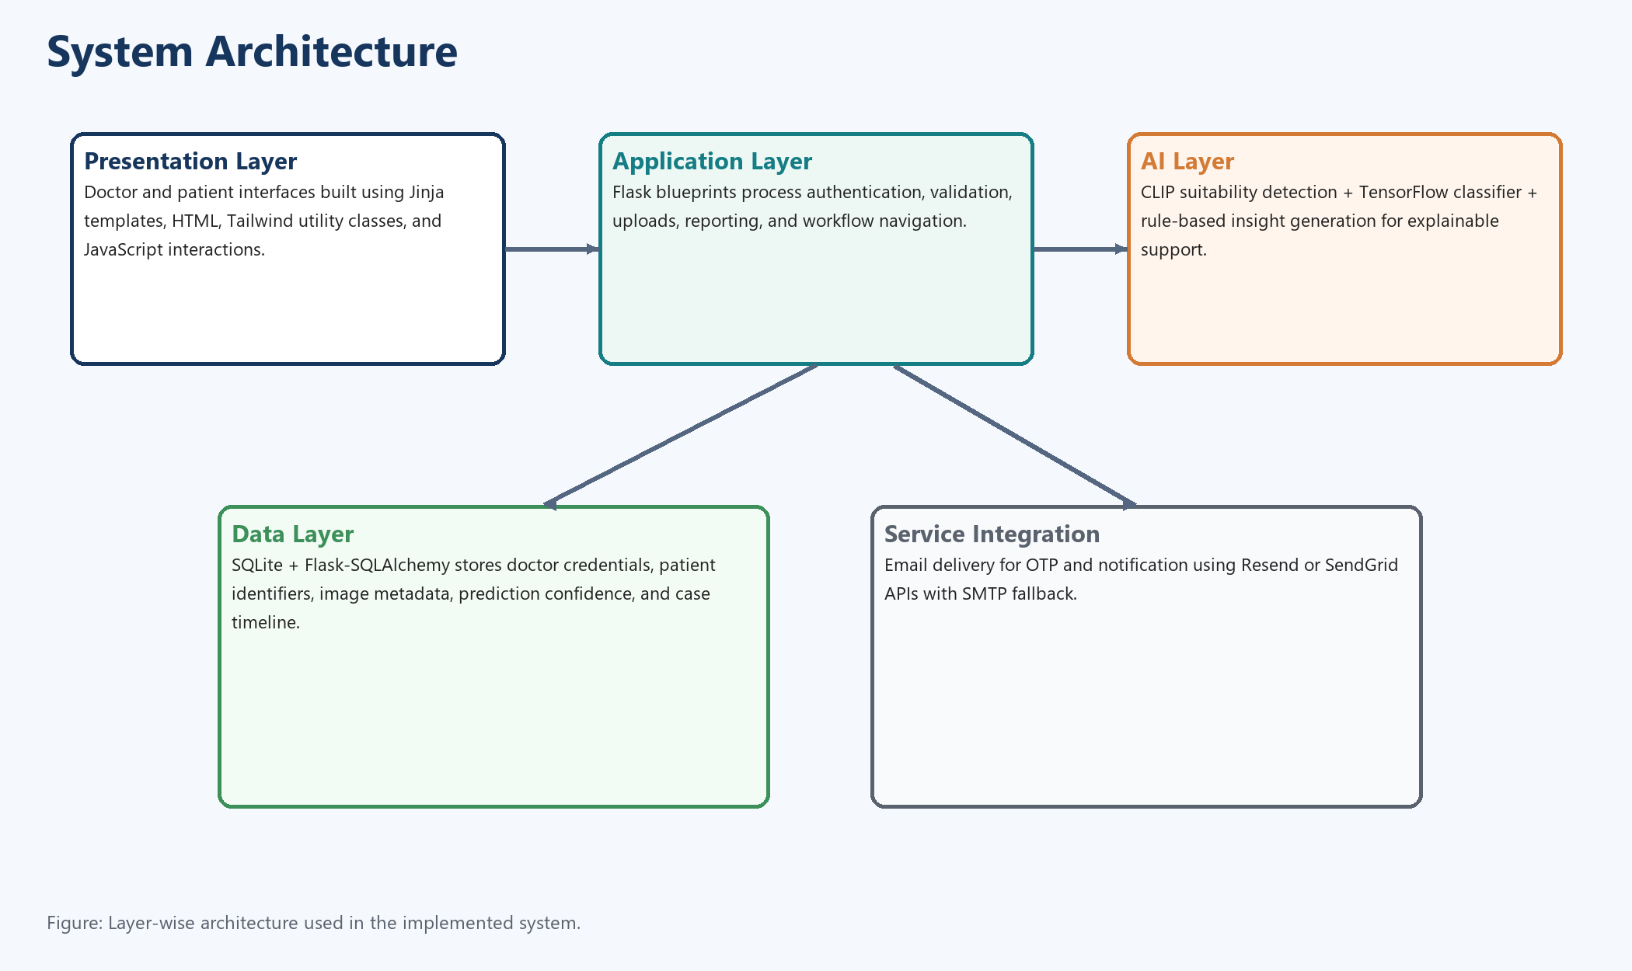
Figure: System Architecture
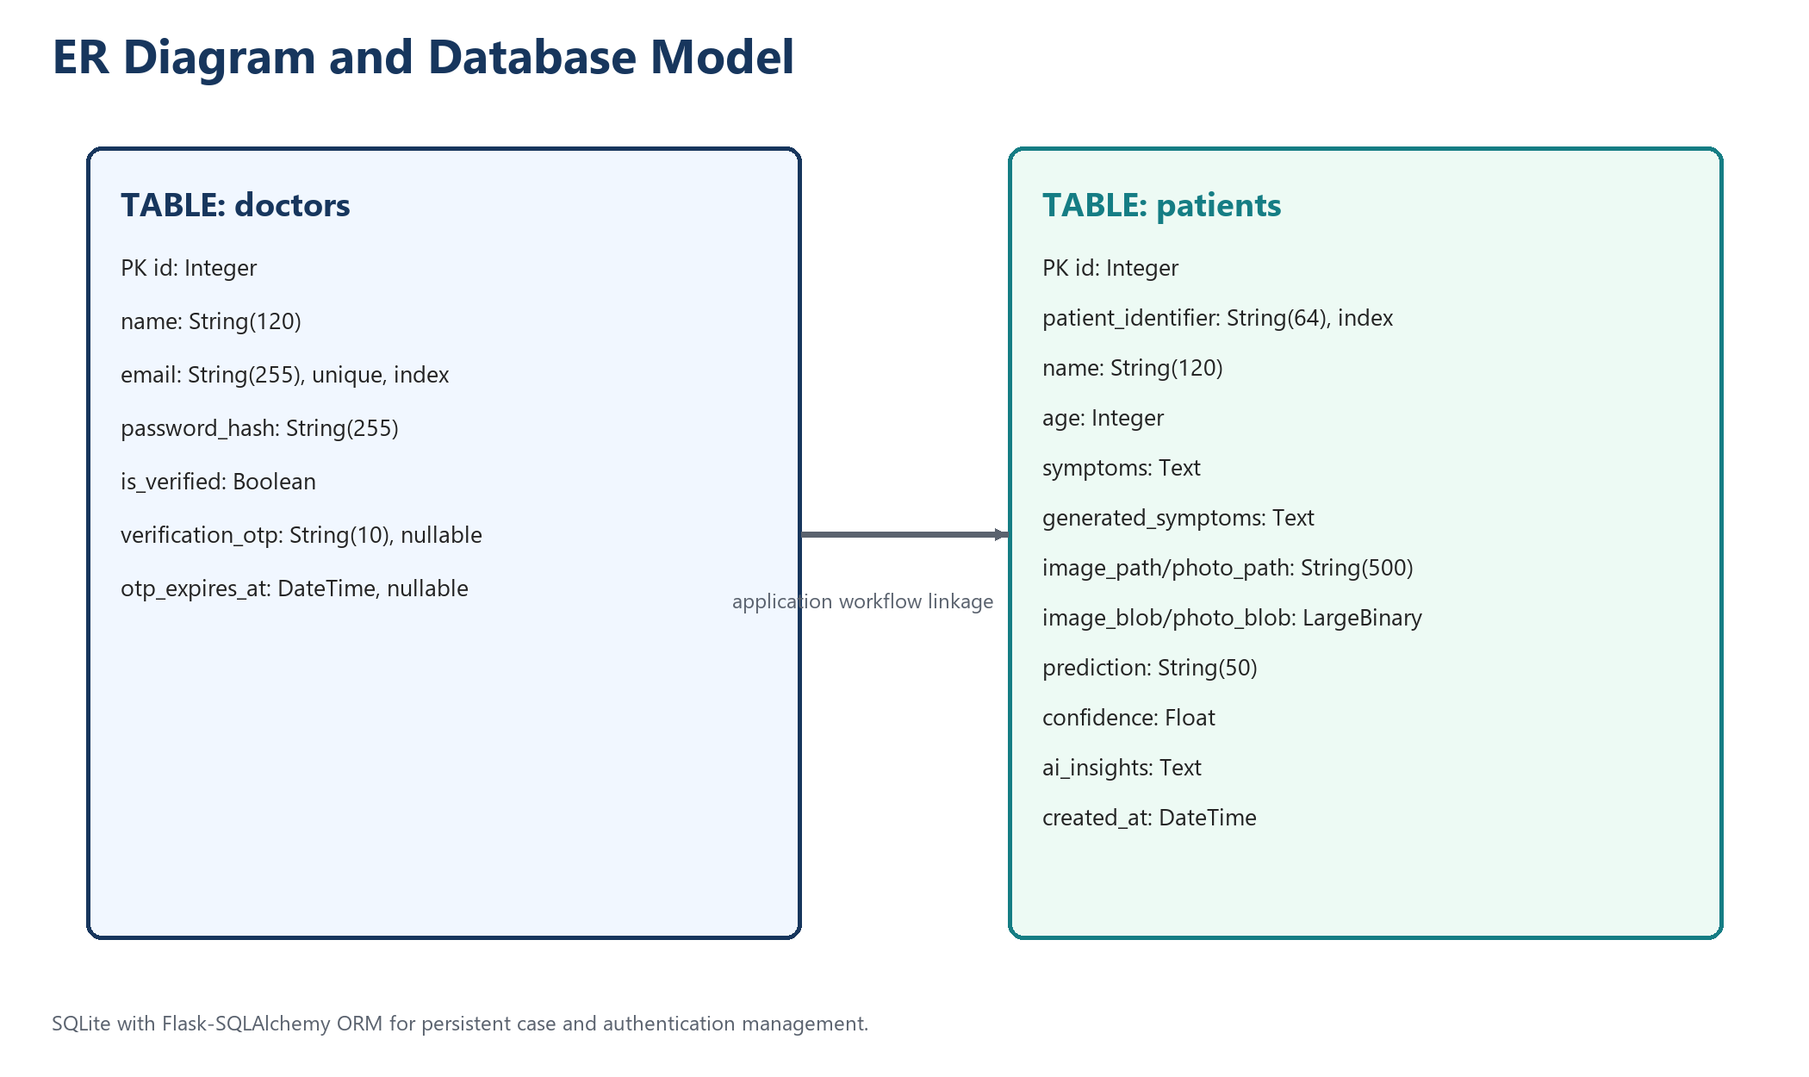
Figure: ER Diagram
CHAPTER 4: Input Screens and Reports
4.1 : INPUT FORMS WITH DATA
(Insert your website input screenshots below)

A) Login / Registration Input Screen

B) Upload Form Input Screen

4.2 OUTPUT REPORTS WITH DATA
(Insert your website output screenshots below)

A) Prediction Result Output Screen

B) Case Detail / Patient Report Output Screen

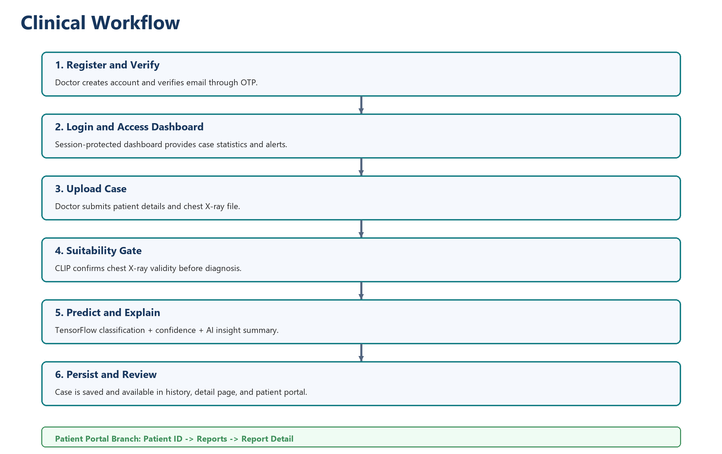
Figure: Project Flow Diagram
CHAPTER 5: Drawbacks and Limitations
The current system is limited to binary classification (NORMAL vs PNEUMONIA).
Prediction quality depends on dataset representativeness and uploaded image quality.
The deployment is academic and local; it is not a certified clinical system.
Outputs require expert validation and should not be treated as final diagnosis.

CHAPTER 6: Proposed Enhancements
Extend to multi-class thoracic disease prediction.
Add explainability visualization such as Grad-CAM.
Introduce role-based access control and cloud deployment pipeline.
Improve calibration and threshold tuning using validation cohorts.
Integrate periodic retraining workflow with clinician feedback.

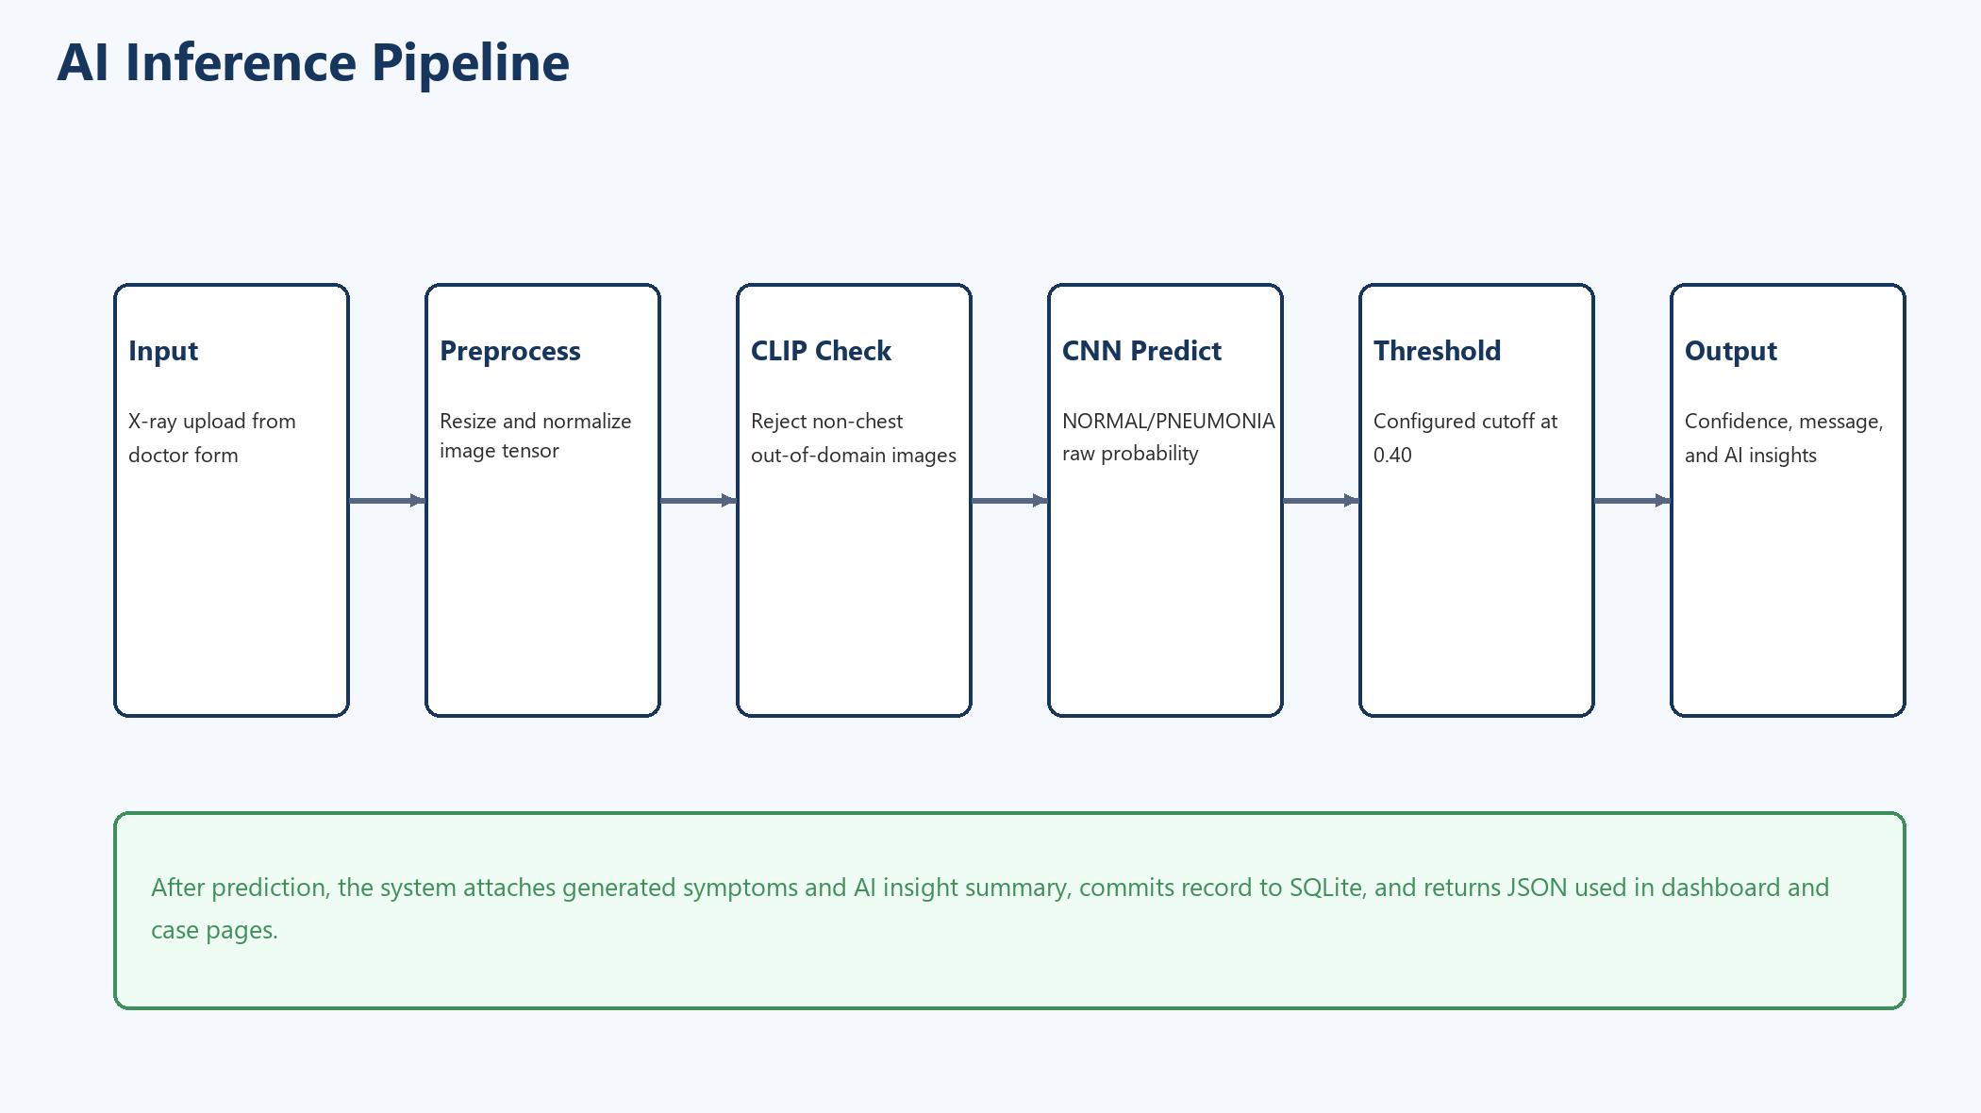
Figure: AI Inference Pipeline
CHAPTER 7: Bibliography
1. Kaggle Chest X-ray Pneumonia Dataset: https://www.kaggle.com/paultimothymooney/chest-xray-pneumonia
2. TensorFlow Documentation: https://www.tensorflow.org/
3. Keras Documentation: https://keras.io/
4. Flask Documentation: https://flask.palletsprojects.com/
5. Flask-SQLAlchemy Documentation: https://flask-sqlalchemy.palletsprojects.com/
6. Transformers Documentation: https://huggingface.co/docs/transformers/
7. MobileNetV2 Paper: https://arxiv.org/abs/1801.04381
8. SQLite Documentation: https://www.sqlite.org/docs.html
9. Project Repository: https://github.com/vedant420-s/mini-project

CHAPTER 1: INTRODUCTION
1.1 Company Profile (only applicable for Live Project)
1.2 Existing System and Need for System
1.3 Scope of Work
1.4 Operating Environment – Hardware and Software

CHAPTER 2: PROPOSED SYSTEM
2.1 Proposed System
2.2 Objectives of System

CHAPTER 3: ANALYSIS & DESIGN
3.1 Entity Relationship Diagram
3.2 Data Flow Diagrams

CHAPTER 4: Input Screens and Reports
4.1 : INPUT FORMS WITH DATA
4.2 OUTPUT REPORTS WITH DATA

CHAPTER 5: Drawbacks and Limitations

CHAPTER 6: Proposed Enhancements

CHAPTER 7: Bibliography

