**SQL Assignment-1**

**Simple SQL Query with a single table with where clause**

Create Table Query:

CREATE TABLE Products (

ProductID int NOT NULL PRIMARY KEY,

ProductName varchar(40) NOT NULL,

SupplierID int,

CategoryID int,

QuantityPerUnit varchar(20),

UnitPrice real,

UnitsInStock int,

UnitsOnOrder int,

ReorderLevel int,

Discontinued bit NOT NULL,

);

1. Write a query to get a Product list (id, name, unit price) where current products cost less than $20.

QUERY:

SELECT ProductID, ProductName, UnitPrice FROM Products WHERE UnitPrice < 20;

OUTPUT:

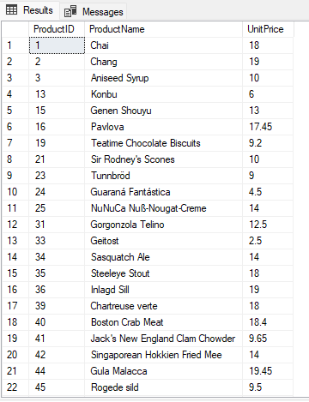

2. Write a query to get Product list (id, name, unit price) where products cost between

$15 and $25

QUERY:

SELECT ProductID, ProductName, UnitPrice FROM Products WHERE UnitPrice > 15 AND UnitPrice < 25;

OUTPUT:

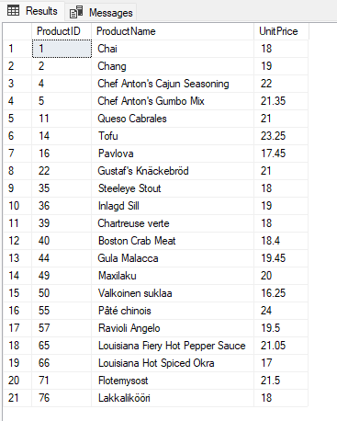

3. Write a query to get Product list (name, unit price) of above average price.

QUERY:

SELECT ProductName, UnitPrice FROM Products where UnitPrice > (SELECT AVG(UnitPrice) FROM Products);

OUTPUT:

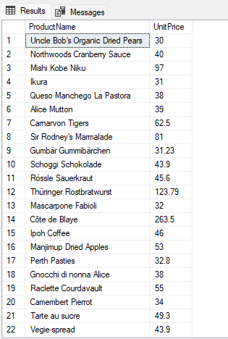

4. Write a query to get Product list (name, unit price) of ten most expensive products

QUERY:

SELECT TOP 10 ProductName, UnitPrice FROM Products ORDER BY UnitPrice DESC;

OUTPUT:

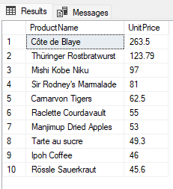

5. Write a query to count current and discontinued products

QUERY:

SELECT COUNT(ProductId) FROM Products GROUP BY Discontinued;

OUTPUT:

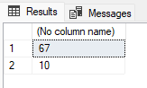

6. Write a query to get Product list (name, units on order , units in stock) of stock is less than the quantity on order

QUERY:

SELECT ProductName, UnitsOnOrder, UnitsInStock FROM Products WHERE UnitsInStock < UnitsOnOrder;

OUTPUT:

