Topscorers:
A

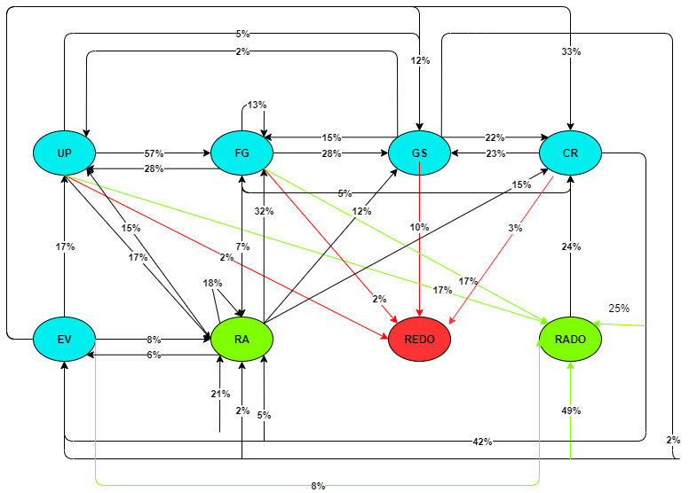

Insights:
1. The state transition for toppers can show us that they are in RADO state much more than in REDO i.e, they are accessing resources for solving problems before saving. Which means that they less often get negative feedback after saving.
2. The transition from GS to REDO (10%) is higher than UP and FG(2%) which implies that students find GS section more difficult and thus depend on feedback to get correct answers.

B:
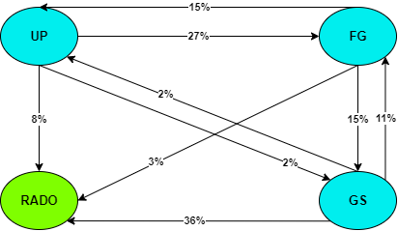

Low Scorers:
A;
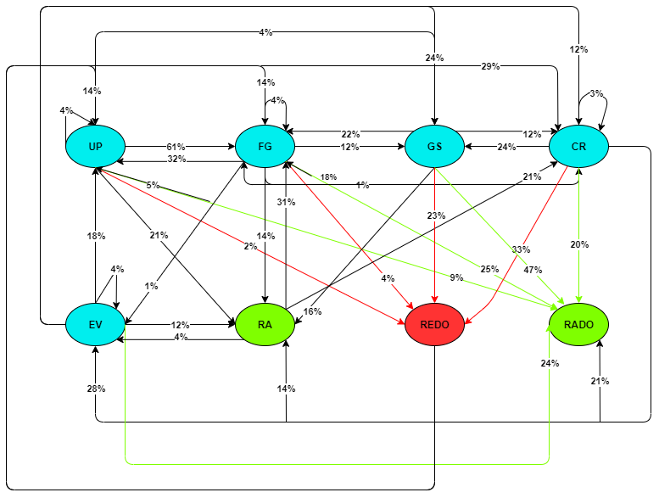

Insights:
1. The lowscorers are comfortable in UP and FG but face problem in GS AND CR section.
2. Transition to RA is higher in comparision while returning form GS to FG is also higher.
3. Students are spending more time accessing Resources (RADO 47%)

B:
