RESULTS AND DISCUSSION
5.1 Implementation
1. Data pre processing:
Processing scores into a uniform csv

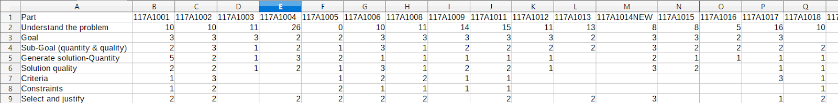

Mapping of log entry to activity:
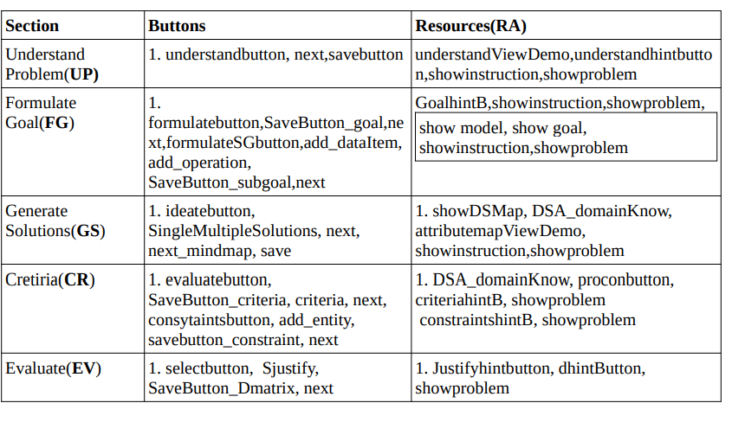

2. Pass Sequence through HMM and Creating HMM:
The size of dataset is very low thus the likelihood probability of some particular sequence was very low. Thus, we need more training data for obtaining a particular sequence which can be followed by all students to get high marks.

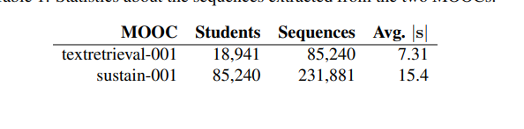

Some students had incomplete sequences for reasons such as:

- Logging in with different usernames and having both scored
- Solving only half the problem and still getting high scored
We resolved some of the problems by manually solving each but were able to resolve others by changing data cleaning conditions.

Example of manually resolving Problems:
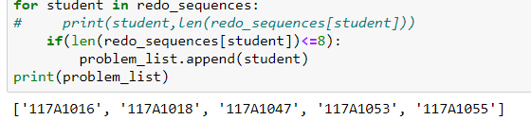

5.2 Discussion
After resolving all the ambiguities, we passed the student activity sequences to the Hidden Markov Model and obtained the following state transition graphs:
State Transition Graph for High Scoring Students

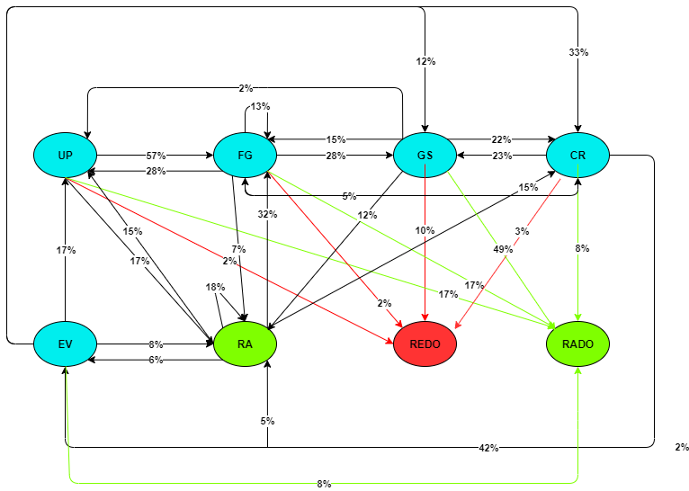
Insights:
- The state transition for toppers can show us that they are in RADO state much more than in REDO i.e, they are accessing resources for solving problems before saving. Which means that they seldom get negative feedback after saving. This can be an important point for the educator as they can infer that the high scorers almost always get correct answer in first attempt and do not depend on feedback from Fathom for finding the correct answer.
- The transition from GS to REDO (10%) is higher than UP and FG to REDO(2% each) which implies that students find GS section more difficult and thus depend on feedback to get correct answers. Possibly, the students are able to understand the problem and formulate goals and sub-goals required to solve the problem easily as compared to come up with solutions for the problem. This tells the educator that the high scoring students are good at understanding the question and formulating the ways to solve it. The educator need only guide the students in generating solutions.
- Lastly, the students seem to redo their tasks more often in the identify criteria and constraints section (17%). The students seem to depend on the feedback from Fathom more in this state than any other. However, the transition to RADO and RA is very low (8% and 5% respectively) which indicates that the resources might not be sufficient to help the students solve this section. The educator needs to focus more on the time and space constraints of various data structures to improve the high scoring students’ performance in this section.
Below, is the state transition diagram for the hidden states. These 4 states stood out the most as most of the student logs contain actions from within these four states. Most of the students were able to solve the three sections without redoing much and so these indicate the strong sections for the students. The students activities have also been influenced by these states most heavily as most of the student activities have been categorized under these states.
Hidden State Transition for High Scoring Students
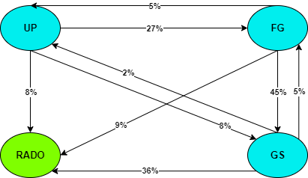

State Transition Graph for Low Scoring Students
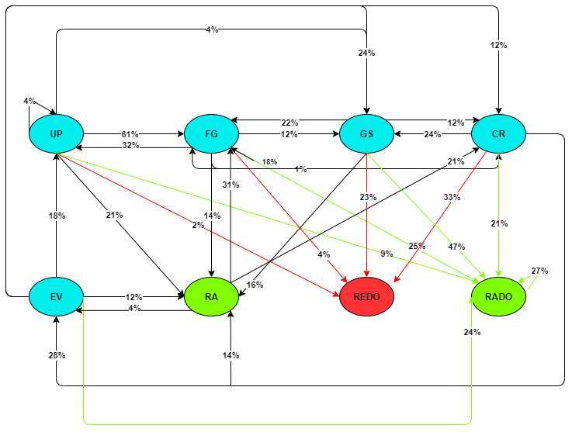
Insights:
- The low scoring students are comfortable in understanding the problem and formulating goals and sub goals but they face difficulty in generating solutions and identifying criteria and constraints as the transition to REDO state is comparatively higher from GS and CR state respectively. In contrast, the high scoring students fare better in generating solutions and identifying criteria and constraints as they have a lower transition to the REDO state signifying that they get correct solutions without depending on feedback much.
- The transition from CR to EV state is 24% for low scoring students as compared to 42% for the high scoring students. The problem can only be completed once the students reach the EV state and thus we can infer that most low scoring students have been able to complete till the GS section but could not complete the CR section either because they weren’t able to solve it in time or perhaps quit the test after generating solutions.
- It can also be observed that the low scoring students tend to access resources more often than high scoring students. The transition from GS to RADO state is noticeably high as compared to all other transitions implying that the students depend heavily on resources for generating solutions. The resources provided in the GS Section include notes on Data Structures and Algorithms and so the educators can focus on strengthening the student’s knowledge on data structures.
- Lastly, one conspicuous difference between the high scorers and the low scorers is that the low scoring students have a tendency to transition back and forth between states more so than the high scoring students. Perhaps they lack concentration, or perhaps they simply explore through the problem sections more than the high scoring students. The educator can reflect on this insight and come up with ways of helping students out by taking surveys revolving around this insight.
Below, is the state transition diagram for the hidden states of low scoring students. We can observe that the low scoring students transition many times to the RADO state which signifies that they depend on the resources a lot as was inferred from the state transition diagram. However, we can further observe that tendency to stay in RADO state is significantly high which means that the students used resources multiple times in the same section. We can also infer that the
Hidden State Transition for High Scoring Students
