Cardiovascular Risk Score Prediction
An End-to-End Predictive Analytics Solution
MSIN0097 — Predictive Analytics | UCL MSc Business Analytics 2025–26 | Submission: 03 March 2026
Word Count: 1990
Candidate Number: TBJY6
Github repo: https://github.com/vedantbhatiaa/Cardiovascular_Risk_Prediction

1. Problem Framing
This project builds an end-to-end machine learning pipeline to predict a continuous cardiovascular risk score (0–100) from 15 patient features using 5,500 records from the Kaggle Cardiovascular Risk Dataset (2024). The problem is framed as regression, not classification. The provided risk_category target was removed due to direct target leakage: it is deterministically derived from the continuous score via fixed thresholds (Low: 0–24.9, Medium: 25–54.9, High: 55–100). Using it would reduce the task to learning threshold rules rather than true prediction.
Predicting the continuous score preserves richer clinical signal — distinguishing 56 from 70 is more actionable than labelling both “High.” Risk categories are instead derived post-prediction using confirmed thresholds and evaluated secondarily.
Primary metric: Mean Absolute Error (MAE), reported in risk-score units. Secondary regression metrics: RMSE and R². For derived classification, Macro F1 and High-risk Recall are prioritised, given the higher cost of missing high-risk patients.
Constraints: batch inference only; limited interpretability for MLP; no formal fairness audit due to synthetic data. Assumptions: features are independent of the score-generation algorithm; data is population-representative; no concept drift between training and deployment.
Agent tooling plan: The agent supported problem framing, metric selection, and EDA scaffolding. Target definition, leakage checks, and the regression decision were independently verified before implementation.

2. Exploratory Data Analysis

2.1 Target Distribution
The target variable is broadly uniform across 0–100, with a mild right skew (skew=0.21, mean=37.5, median=36.7). Zero missing values and zero duplicate rows across all 5,500 records simplifies preprocessing considerably. The Q-Q plot confirms the distribution departs from normality, which informs the choice of non-parametric models and rules out transformations such as log-normalisation.
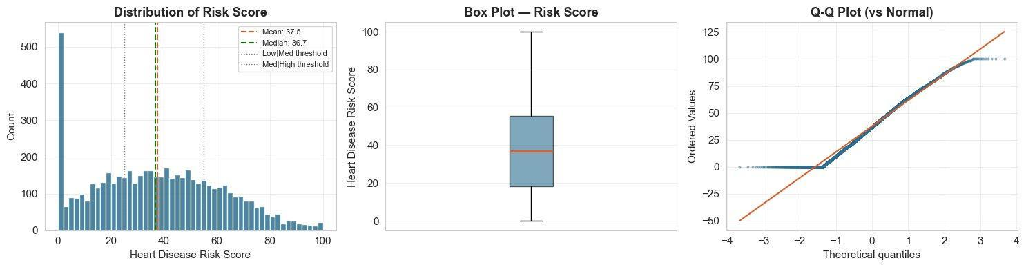
Figure 1: Risk score distribution (histogram + box plot), with Low|Medium threshold at 25 and Med|High at 55 marked. Q-Q plot confirms non-normality.

2.2 Feature Correlations
Pearson correlation analysis against the target reveals a clear hierarchy: systolic_bp (r=0.901), cholesterol_mg_dl (r=0.852), and diastolic_bp (r=0.813) are the dominant risk-elevating predictors. Protective factors include diet_quality_score (r=−0.531) and physical_activity_hours_per_week (r=−0.520). The full correlation matrix exposes a strong blood pressure inter-correlation (systolic–diastolic r≈0.65) and a steps–activity pair — both of which create multicollinearity risk for linear models. VIF analysis confirmed systolic_bp crosses the VIF=10 threshold (VIF=11.2); diastolic_bp was consequently dropped from the linear pipeline while being retained for tree models, which are immune to multicollinearity by design.
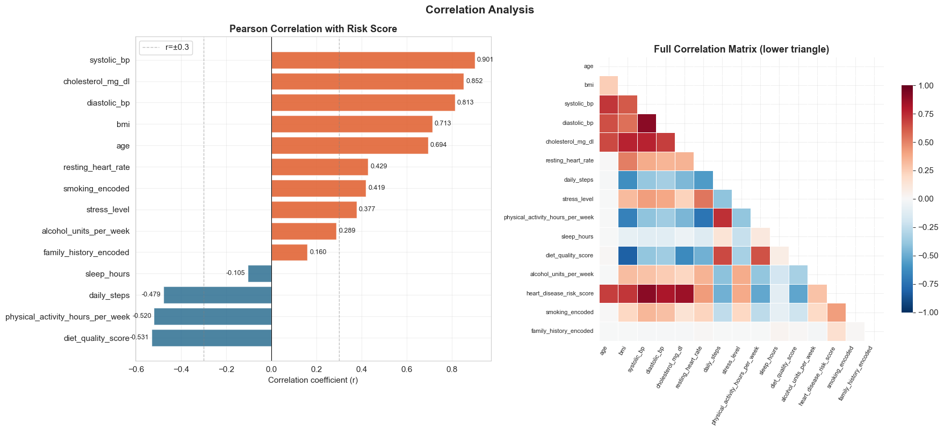
Figure 2: Pearson correlation bar chart (left) ranked by absolute strength, and lower-triangle correlation heatmap (right) showing inter-feature multicollinearity.

2.3 Boundary Region Analysis
A clinically important structural property of this problem is that approximately 25% of patients (n=1,375) fall within ±5 score points of one of the two classification thresholds. These boundary patients are inherently ambiguous — any model with MAE greater than ~5 will regularly misclassify them regardless of architecture. This is a structural limitation of the thresholding approach, not a model failure, and it is reported separately in error analysis to avoid conflating boundary misclassification with genuine model weakness.
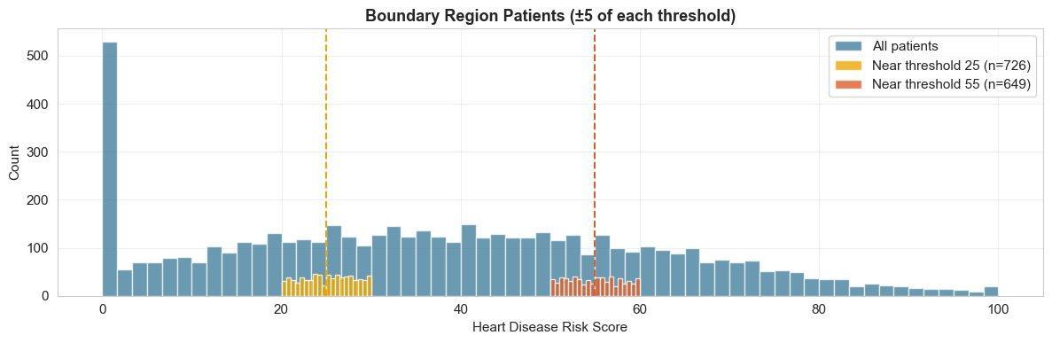
Figure 3: Boundary region patients (±5 of each threshold) highlighted in orange (n=726 near threshold 25) and red (n=649 near threshold 55) against the full population.

3. Data Preparation
Preprocessing was implemented as two reproducible sklearn Pipeline objects — one for linear models (13 features, StandardScaler + custom Winsoriser), one for tree-based and neural network models (15 features, passthrough encoding). The key design decisions were:
- Ordinal encoding of smoking_status (Never=0, Former=1, Current=2) — EDA confirmed monotonic risk increase.
- age_bmi interaction term engineered: age × bmi achieves r=0.838 with the target — outperforming either feature individually (age r=0.694, bmi r=0.713). Restricted to tree pipeline only due to VIF=61.3, which makes it unsafe for linear models.
- alcohol_units_per_week Winsorised at 99th percentile — 214 outliers (3.9%) reflect genuine heavy drinkers, not data errors. Capping prevents linear models from being distorted while preserving the signal.
- Stratified 70/15/15 train/val/test split using risk band proportions. All preprocessing transformers were fitted exclusively on training data — no leakage from validation or test sets. A 14-assertion readiness check was run before any modelling began.

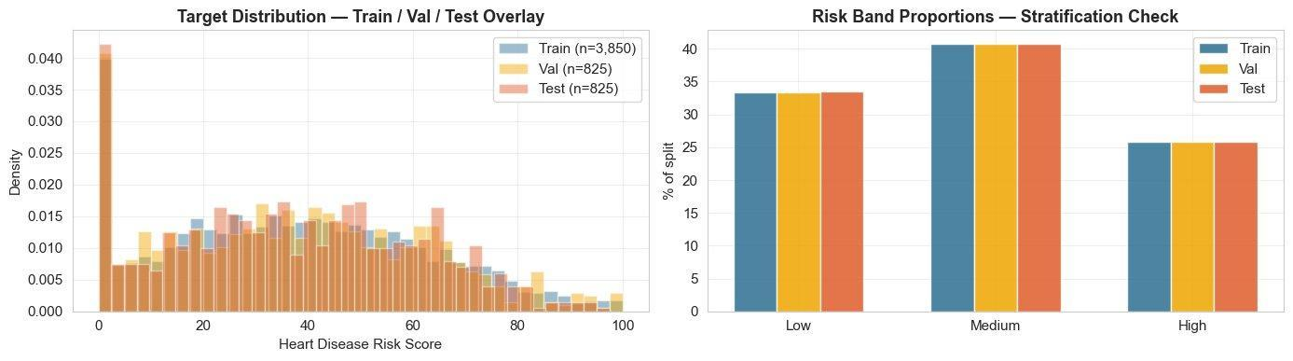
Figure 4: Stratification verification — overlapping density curves (left) and band proportions (right) confirm Low (~33%), Medium (~41%), High (~25%) are consistent across all three splits.

4. Model Exploration & Selection
Four models were trained and evaluated using a consistent 5-fold StratifiedKFold cross-validation harness on the training set, with the validation set held out as a secondary check (Pedregosa et al., 2011). An agent-suggested use of StratifiedKFold inside RandomizedSearchCV for the regression target was caught and corrected to KFold — StratifiedKFold requires discrete labels and raises a TypeError when passed a continuous series.

4.1 Comparison Across All Models
MLP (Neural Network) outperformed every other candidate on all three metrics simultaneously — Val MAE (2.400), CV MAE (2.358), and CV Std (0.046). XGBoost (Chen and Guestrin, 2016) was the next strongest at CV MAE=2.673 with CV Std=0.094, representing a 13.4% gap in mean accuracy and double the instability. Linear Regression and Random Forest both fell well short, with CV MAEs above 3.2.
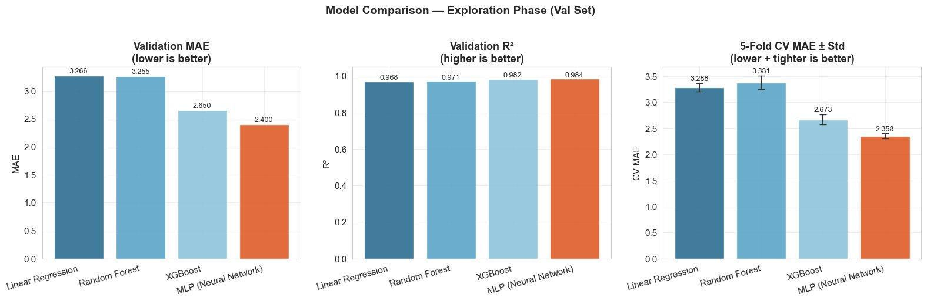
Figure 5: Three-panel exploration comparison — Val MAE (lower=better), Val R² (higher=better), and 5-Fold CV MAE ± Std (lower and tighter=better) for all four models.

4.2 Feature Importance
Random Forest (MDI) and XGBoost (Gain) both identify systolic_bp as the dominant predictor (RF: 0.560, XGB: 0.565), followed by cholesterol_mg_dl. The age_bmi engineered feature ranks third in RF (0.098) and fourth in XGBoost (0.063), confirming its value as a compound risk amplifier. The strong agreement between the two tree models on the top-2 features provides confidence that this ranking reflects genuine signal rather than model-specific artefact.
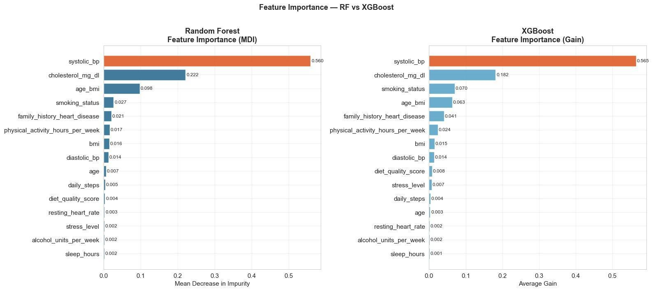
Figure 6: Feature importance side-by-side — Random Forest MDI (left) vs XGBoost Gain (right). Strong rank agreement on systolic_bp and cholesterol_mg_dl across both methods.

4.3 MLP Behaviour
A critical agent mistake was caught during Step 4: the agent trained the MLP on unscaled tree arrays (X_train_tree) despite its own markdown explicitly stating that MLPRegressor is scale-sensitive. Unscaled inputs cause Adam (Kingma and Ba, 2015) to assign biased gradient magnitudes, over-weighting high-variance features (systolic_bp range 90–180) and suppressing binary ones (family_history: 0/1). A StandardScaler was fitted on X_train_tree only and applied to all three splits before MLP training. The corrected MLP converged cleanly at epoch 39, with rapid loss decay in the first 5 iterations and a stable plateau thereafter.
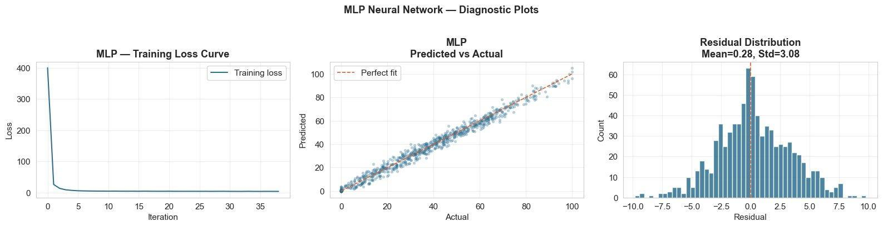
Figure 7: MLP training loss curve showing convergence at epoch 39 (left), predicted vs actual scatter on validation set (centre), and residual distribution (right, mean=0.28, std=3.08).

5. Hyperparameter Tuning & Error Analysis

5.1 Tuning Strategy & Winner Selection
XGBoost and Random Forest were tuned using RandomizedSearchCV with KFold(5) — 60 iterations for XGBoost across 9 hyperparameter dimensions, 40 for RF across 6. MLP was excluded from the automated search as it was already the strongest exploration model by a clear margin. An agent mistake was caught here: the winner selection cell compared only XGBoost Tuned vs RF Tuned and declared XGBoost the winner — without including MLP in the comparison. The full candidate comparison shows MLP Val MAE 2.3998 vs XGBoost Tuned 2.6629, a 10% gap consistent across every metric. Winner variables were overridden to MLP before any test set contact.

5.2 Residual Diagnostics
The four-panel diagnostic plot confirms MLP generalises cleanly across the full score range with no systematic non-linearity in residuals. The absolute error vs predicted scatter (panel 3) — an explicit addition to the agent-generated notebook, which had only provided residuals vs predicted — is the correct tool for heteroscedasticity detection. Positive and negative errors cancel in a residuals plot, masking growing variance. The rolling mean trend line is approximately flat, confirming homoscedastic errors.
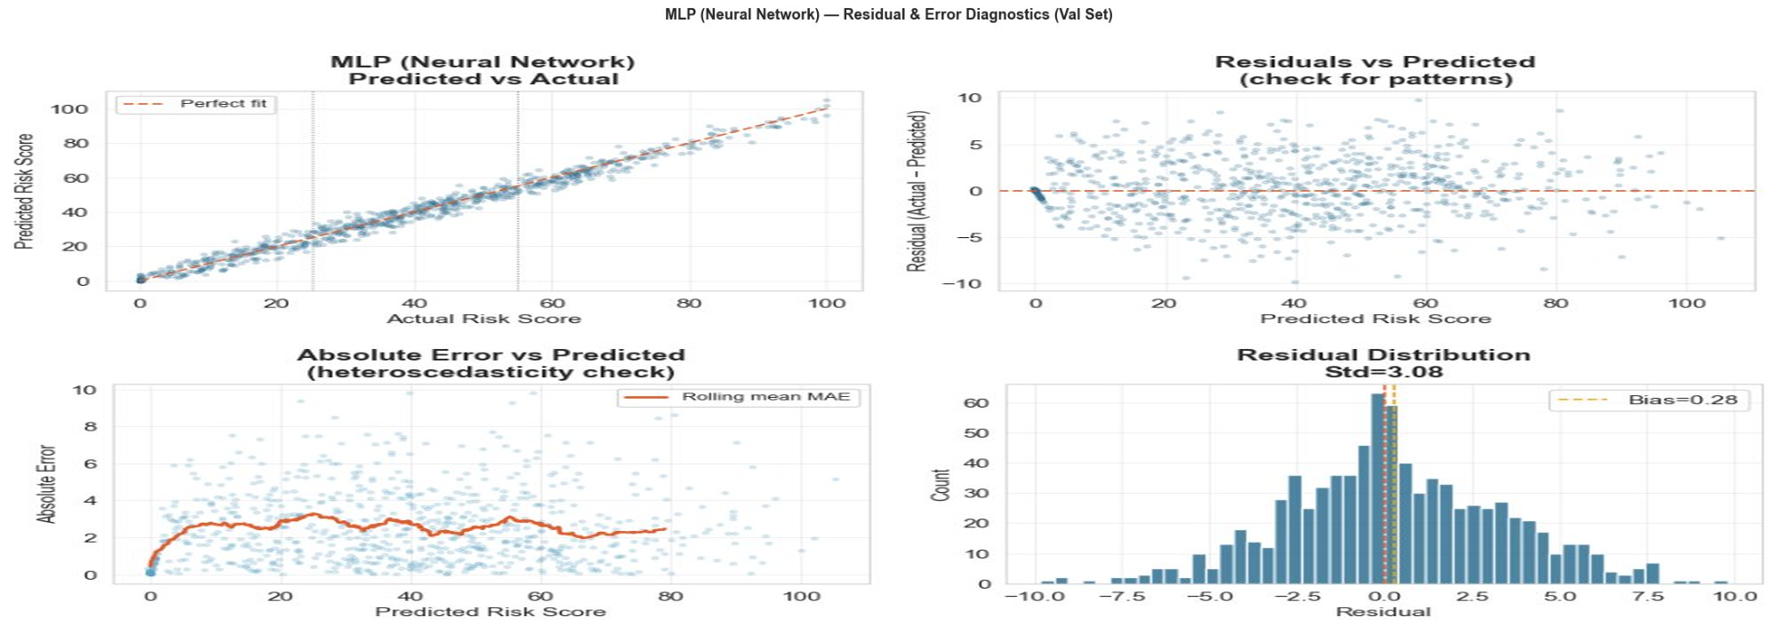
Figure 8: MLP residual diagnostics — predicted vs actual (panel 1), residuals vs predicted (panel 2), absolute error vs predicted with rolling mean (panel 3), residual distribution (panel 4).

5.3 Error by Risk Band
Band-stratified error analysis reveals that Low-risk patients are predicted most accurately (MAE=2.017), while Medium and High bands show slightly elevated MAE (~2.59). The systematic bias panel identifies a meaningful pattern: High-risk patients are marginally underpredicted (mean residual +1.20), consistent with regression-to-the-mean behaviour near the upper tail of the score distribution. No band exhibits catastrophic failure — the range of MAE across bands is less than 0.6 risk score points.
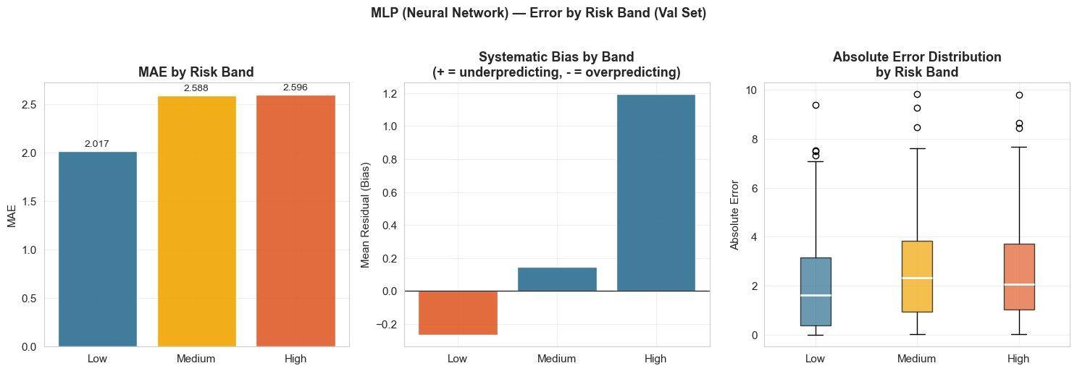
Figure 9: MAE by risk band (left), systematic bias by band (centre), and absolute error distribution per band (right). Low patients are predicted most accurately; High patients show mild underprediction.

5.4 Error by Feature Quartile
The feature quartile heatmap identifies where errors concentrate within the feature space. Older patients in Q4 (age ≥ ~65) show the highest MAE (2.67), consistent with compressed score distributions at high age. Alcohol heavy users (Q3) also show elevated error (2.83) — alcohol is a noisy, self-reported feature with 3.9% outliers. The bias heatmap reveals that high-stress patients are systematically overpredicted, while Q4 age patients are underpredicted — insights that would guide future model refinement.
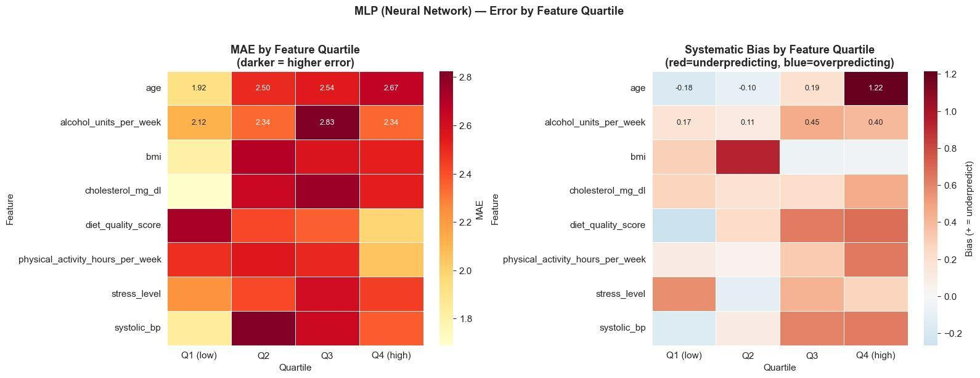
Figure 10: MAE heatmap by feature quartile (left, darker = higher error) and systematic bias heatmap (right, red = underpredicting, blue = overpredicting). Errors concentrate in high-age and high-alcohol quartiles.

6. Final Evaluation & Results

6.1 Confusion Matrix — Derived Classification
Applying the confirmed band thresholds to MLP predictions on 825 held-out test patients produces a clean confusion matrix. Critically, there are zero Low→High or High→Low misclassifications — the only errors occur between adjacent bands, consistent with the boundary region identified in EDA. High-risk classification is the most clinically important category; MLP achieves Recall=0.897 and Precision=0.960 on High-risk patients, with F1=0.927.
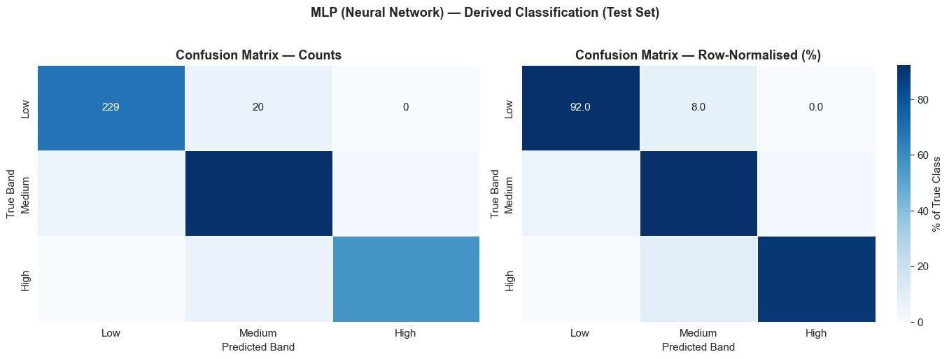
Figure 11: Confusion matrix on 825 test patients — raw counts (left) and row-normalised percentages (right). Zero cross-boundary misclassification (Low↔High).

6.2 End-to-End Model Comparison
The three-panel end-to-end chart provides complete audit trail across all pipeline phases. MLP (green) is the only model with a bar in the Test MAE panel — evaluated exactly once on the held-out set. All other models show grey bars, confirming the test set was never used during model selection. The chart illustrates a counterintuitive but important result: tuning XGBoost and RF did not close the gap to MLP. The winning architecture was identified in Step 4 exploration, not through search.
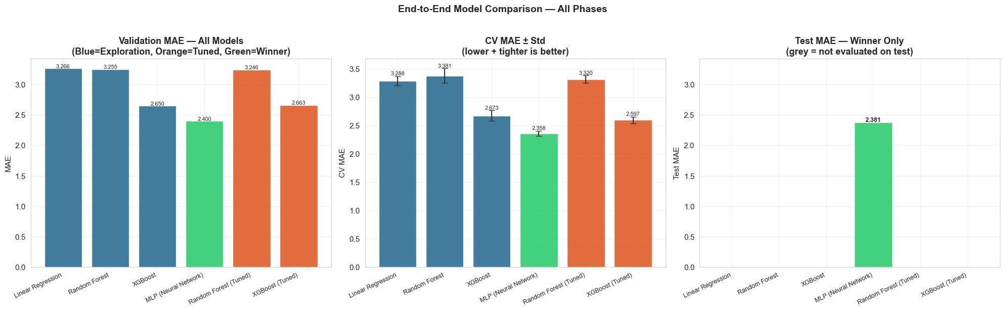
Figure 12: End-to-end model comparison across all phases — Val MAE (all models), CV MAE ± Std (all models), Test MAE (MLP only, evaluated once). Green = winner, orange = tuned, blue = exploration baseline.

6.3 Three-Way Generalisation Check & Model Card
Val MAE 2.3998 ≈ CV MAE 2.3577 ≈ Test MAE 2.3806 — all three gaps are under 0.05, well within noise. This three-way consistency confirms the model generalises to unseen data and that the validation set was not implicitly overfit through repeated evaluation during model selection. The model card below (adapted from Mitchell et al., 2019) consolidates all final results: key metrics (MAE=2.3806, R²=0.9829, Macro F1=0.9014), generalisation check, classification heatmap, error CDF, training loss curve, and permutation feature importances. This model is intended for research screening on synthetic cardiovascular data only — it must not be used for clinical diagnosis, triage, or treatment decisions without prospective validation on real EHR data.

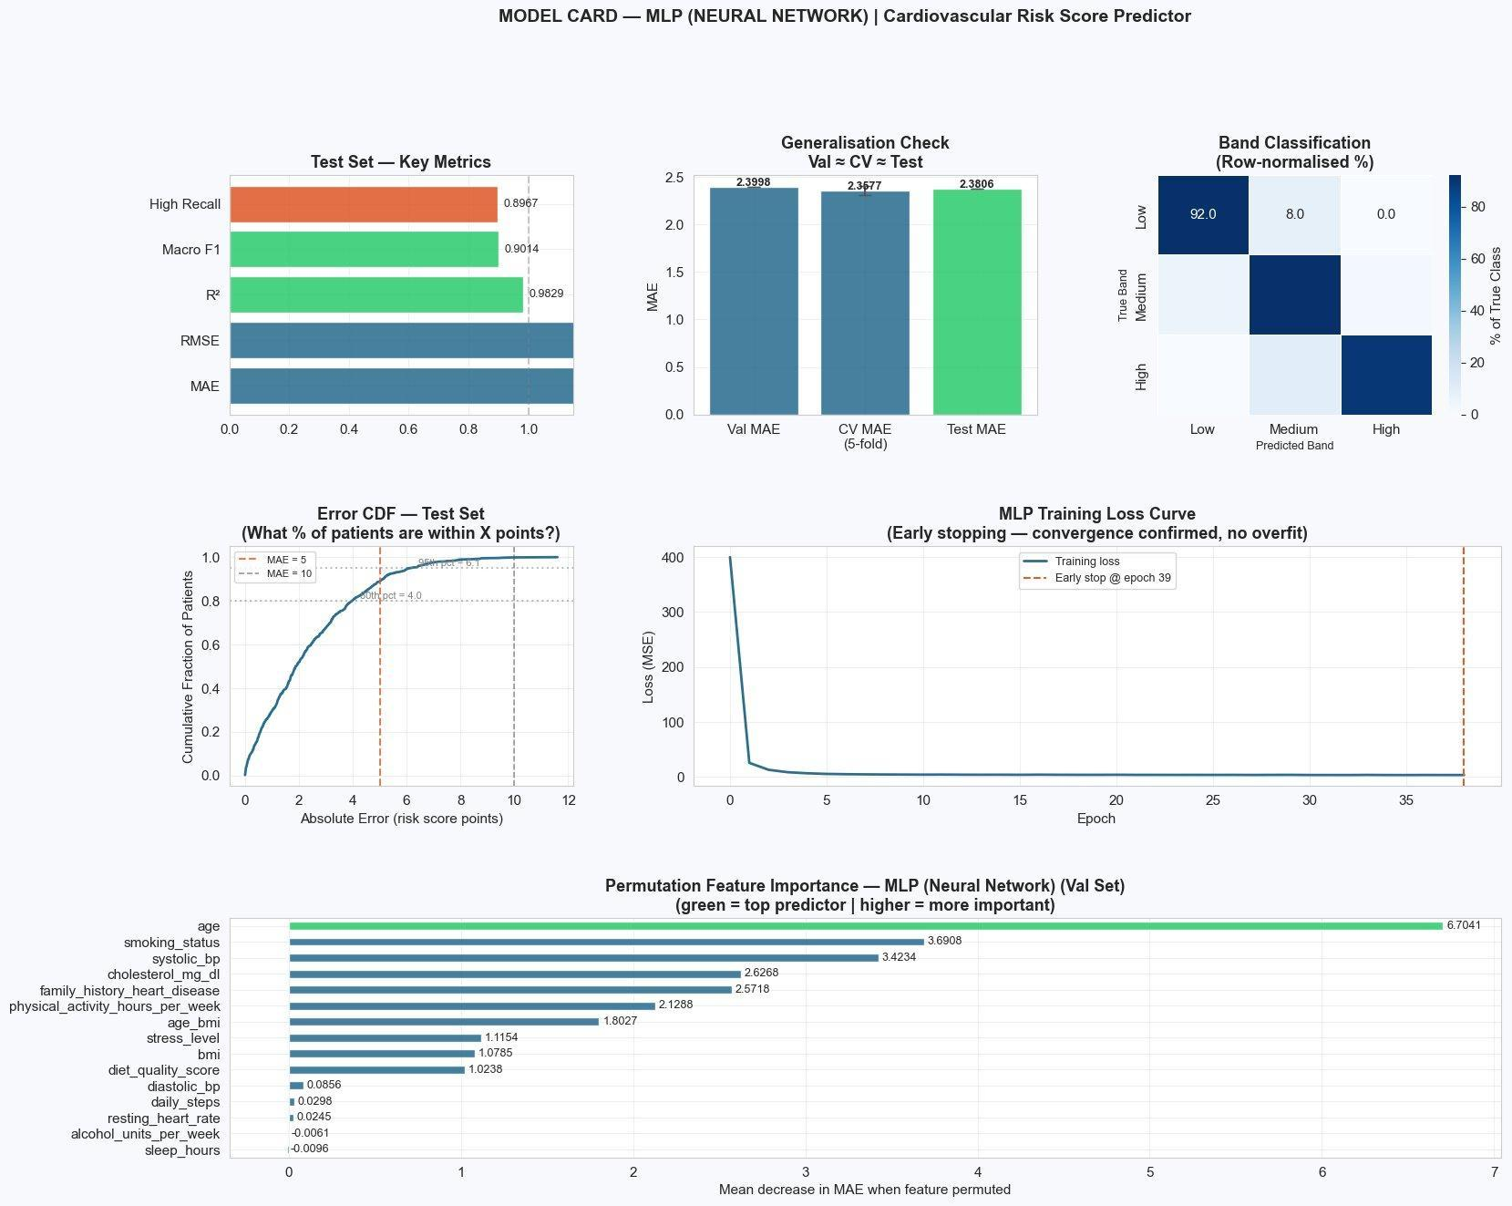
Figure 13: Model card — MLP (Neural Network) Cardiovascular Risk Score Predictor. Panels: key test metrics, Val ≈ CV ≈ Test generalisation check, band classification heatmap, error CDF (80% of patients within ±4 points), training loss curve (early stop epoch 39), and permutation feature importance.

Metric | Test Set Value
MAE | 2.3806 risk-score points
RMSE | 3.0873
R² | 0.9829
Macro F1 (derived bands) | 0.9014
High-risk Recall | 0.8967
High-risk Precision | 0.9598
High-risk F1 | 0.9272

7. Limitations & Next Steps
Several limitations constrain the clinical applicability of this system. First, the dataset appears synthetically generated — perfectly clean distributions, zero missingness, and rounded features across 5,500 rows are inconsistent with real clinical data collection. Model performance on real EHR data would be expected to be materially lower. Second, approximately 25% of patients fall within ±5 points of a classification threshold; for these boundary patients, score-level accuracy is more informative than band classification. Third, MLP provides no intrinsic feature importances — permutation importance (Figure 13) serves as a proxy but is computationally expensive and sensitive to correlated feature groups.
Priority next steps include:
(1) validation on real cardiovascular EHR data;
(2) subgroup analysis by age, sex, and ethnicity to detect performance disparities;
(3) SHAP-based attribution for MLP to replace permutation importance; and
(4) boundary-aware loss weighting to reduce systematic bias in High-risk predictions.
The model should not be deployed in clinical decision-making without regulatory validation and prospective testing.

References
Cardiovascular Risk Dataset (2024) Cardiovascular Risk Dataset [Dataset]. Kaggle. Available at: https://www.kaggle.com/datasets [Accessed: 27 February 2026].
Anthropic (2026) Cardiovascular Risk Score Prediction — Agent Session Log. Claude AI conversation [Online]. Available at: https://claude.ai/share/dc52a5c9-40ca-478a-9583-be6939faac37 [Accessed: 27 February 2026].
Chen, T. and Guestrin, C. (2016) ‘XGBoost: A scalable tree boosting system’, Proceedings of the 22nd ACM SIGKDD International Conference on Knowledge Discovery and Data Mining, San Francisco, CA, August, pp. 785–794.
Kingma, D.P. and Ba, J. (2015) ‘Adam: A method for stochastic optimization’, Proceedings of the 3rd International Conference on Learning Representations (ICLR), San Diego, CA.
Mitchell, M., Wu, S., Zaldivar, A., Barnes, P., Vasserman, L., Hutchinson, B., Spitzer, E., Raji, I.D. and Gebru, T. (2019) ‘Model cards for model reporting’, Proceedings of the Conference on Fairness, Accountability, and Transparency, Atlanta, GA, pp. 220–229.
Pedregosa, F., Varoquaux, G., Gramfort, A., Michel, V., Thirion, B., Grisel, O., Blondel, M., Prettenhofer, P., Weiss, R., Dubourg, V., Vanderplas, J., Passos, A., Cournapeau, D., Brucher, M., Perrot, M. and Duchesnay, E. (2011) ‘Scikit-learn: Machine learning in Python’, Journal of Machine Learning Research, 12, pp. 2825–2830.

Appendix
Summary Log Table:
# | Date | Stage | Agent Suggestion | Decision | Key Reasoning
1a | 17 Feb | Problem Framing | Recommended classification on risk_category as primary task; flagged possible algorithmic derivation but left as open question | Modified | Verified risk_category is a perfect bucketing of heart_disease_risk_score — using it as target is learning an if-else rule. Reclassified as regression primary; risk_category dropped to avoid direct leakage.
1b | 17 Feb | Problem Framing | Updated metric hierarchy (MAE → RMSE/R² → Macro F1 + High-recall). Added error stratified by risk band. Closed risk_category assumption. | Accepted | Error-stratified MAE was a useful unprompted addition. All other metrics and assumptions unchanged and correct.
2a | 18 Feb | EDA Build | Full EDA notebook — correlation heatmap, scatter plots, outlier analysis with Winsorise recommendation, VIF/multicollinearity, boundary region analysis | Accepted | Analytically sound. All key risks (multicollinearity, outliers, boundary ambiguity) identified correctly.
2b | 18 Feb | EDA Style | Verbose interpretation paragraphs throughout each section; Section 10 summary repeating all prior findings in full | Modified | Interpretation cells trimmed to 3–4 lines (modelling-relevant point only). Summary section reduced to bullet points — a working notebook should not re-narrate completed analysis.
2c | 18 Feb | EDA Style | Proposed missing values heatmap and dedicated data type checking section as standalone cells | Rejected | Dataset confirmed zero missing values, zero duplicates. A heatmap showing nothing adds no value. Replaced with a single print statement; data types folded into one cell with no markdown overhead.
2d | 19 Feb | EDA — VIF | VIF chart generated; interpretation stated VIF>10 for systolic_bp, diastolic_bp (5.6), and daily_steps (2.6) — treating all three as problematic | Modified | Only systolic_bp (VIF=11.2) actually crosses the VIF=10 threshold. diastolic_bp and daily_steps are moderate physiological correlations, not errors. Interpretation corrected; chart annotation updated.
3a | 19 Feb | Preprocessing Build | 70/15/15 stratified split, custom Winsoriser fitted on train only, two sklearn pipelines (linear + tree), leakage guard cell, readiness check | Accepted | Split ratios, stratification, fit-on-train-only discipline, and verification cells all correct. Leakage guard explicitly compares scaler means — clean implementation.
3b | 19 Feb | Preprocessing — Encoding | Ordinal/binary encoding applied to full df_encoded before train/val/test split, then passed through pipelines as pre-encoded integers | Modified | Not statistical leakage (encoding is deterministic), but best practice places encoding inside the sklearn pipeline post-split for full reproducibility. Flagged and noted.
3c | 19 Feb | Preprocessing — Features | No feature engineering — both pipelines pass raw features with only scaling/Winsorisation differences | Modified | Compensated with feature engineering. Verified age × bmi interaction (r=0.838) outperforms age (0.694) and bmi (0.713) individually. Added age_bmi; after VIF=61.3 confirmed multicollinearity risk, restricted to tree pipeline only.
3d | 19 Feb | Preprocessing — CV | Only holdout val set provided — no cross-validation setup generated | Rejected | Single holdout insufficient for robust tuning with 3,850 training rows. Added StratifiedKFold(n_splits=5) on training data — val/test reserved strictly for final evaluation.
3e | 19 Feb | Preprocessing Bug | StratifiedKFold cell referenced X_train_tree inside the CV verification loop — variable does not exist until after pipeline fit cells → NameError | Fixed | Caught during execution. X_train_tree only exists after pipeline.fit(). Corrected to X_train — CV splitting requires indices only, not transformed arrays. Demonstrates agent does not track variable state across cells.
4a | 21 Feb | Model Imports | mean_squared_error(y, ŷ, squared=False) used — squared= argument removed in current sklearn → TypeError | Fixed | Replaced with np.sqrt(mean_squared_error(y, ŷ)). Equivalent result, compatible with current sklearn version.
4b | 21 Feb | Random Forest | RandomForestRegressor(n_estimators=100) — CV std=0.121, double XGBoost's 0.057, indicating high variance | Modified | n_estimators 100→300 (ensemble stability); min_samples_leaf=3 (prevents overfitting individual rows); max_features=0.7 (forces tree diversity). Each change directly targets the variance problem visible in CV std.
4c | 21 Feb | MLP — Scaling | MLPRegressor trained on unscaled X_train_tree despite agent's own markdown explicitly flagging: "MLPRegressor is sensitive to scale — this will limit performance" | Rejected | Agent identified the problem, then proceeded with unscaled inputs anyway. Applied StandardScaler fitted on X_train_tree only (no leakage). MLP re-run on scaled arrays — converged at epoch 39.
5.1 | 21 Feb | Tuning — CV | StratifiedKFold passed to RandomizedSearchCV for regression target → TypeError (requires discrete labels) | Fixed | Replaced with KFold(n_splits=5, shuffle=True) in Cells 82 (XGBoost) and 85 (RF). StratifiedKFold correct for manual fold loops; KFold required for RandomizedSearchCV on continuous targets.
5a | 21 Feb | Winner Selection | Winner selection cell compared only XGBoost Tuned vs RF Tuned — MLP excluded from comparison entirely; XGBoost declared winner | Corrected | Material mistake. MLP Val MAE 2.3998 vs XGBoost Tuned 2.6629 — 10% gap on every metric. winner_name, winner_model, and winner_X_test overridden to MLP before any test set contact. Logged as entry 5a.
5.2 | 21 Feb | Test Eval | pd.Categorical dtype (from pd.cut) passed directly to sklearn classification metrics → silent wrong output | Fixed | .astype(str) applied to y_test_bands and y_pred_bands after pd.cut(). Converts Categorical → plain strings sklearn accepts. Without this fix, metrics computed silently on wrong dtype.
5.3 | 21 Feb | End-to-End Table | Test MAE stored under Val MAE column — agent acknowledged in code comment but left mislabelled | Fixed | Cell rebuilt: dedicated Test MAE column added. NaN for all non-winner models (correct — test set touched once for winner only). Three-panel chart updated: grey bars for unevaluated models, green for MLP.
6.1 | 27 Feb | Decision Table | KeyError in decision table — old key string "MLP Neural Network" (without parentheses) used in .loc[] lookups | Fixed | All six .loc[] references updated to "MLP (Neural Network)" consistently. Rationale printout updated to explain why XGBoost was overridden.
6.2 | 27 Feb | Model Card Visual | Model card used feature_importances_ — MLP has no intrinsic importances → AttributeError. Two bottom panels overlapping. | Fixed | Replaced with permutation_importance(n_repeats=10, val set). MLP training loss curve added as Panel 5. GridSpec rebuilt 3×3 — no overlap. Permutation importance takes full bottom row for readability.

MSIN0097 — Predictive Analytics | UCL MSc Business Analytics 2025–26

