**SOFTWARE ENGINEERING LAB**

**PRACTICAL-5**

**NAME: VEDANT BHUTADA NAME: YASH PATNI**

**ROLL NO: 69 ROLL NO: 71**

**BATCH: A4**

**CASE STUDY: MOVIE TICKET BOOKING SYSTEM**

**Aim:** To create a Sequence Diagram to represent the dynamic view (behavior) of the system.

Class comments

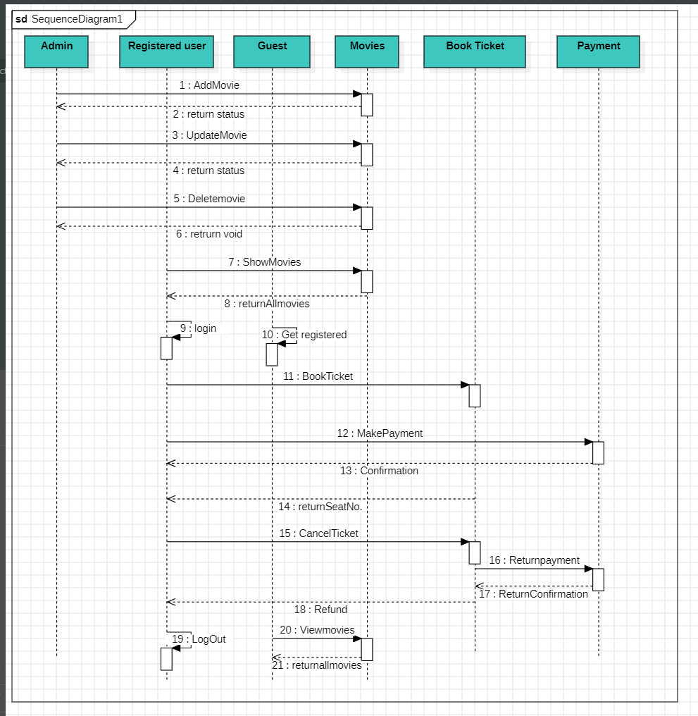

**Entities Involved:**

* Admin (A): Responsible for managing movie information (adding, updating, and deleting movies).
* Registered User ®: Users who have an account and can directly book tickets.
* Guest (G): Users who need to register before booking tickets.
* Movies (M): Represents the movie database.
* Book Ticket (B): Handles ticket booking.
* Payment (P): Manages payment processing.

**Sequence of Actions:**

* Admin Actions:
* AddMovie (1): The admin adds a new movie to the system.
* UpdateMovie (2): Admin updates movie details.
* DeleteMovie (4): Admin removes a movie from the system.
* User and Guest Actions:
* ShowMovies (7): Both registered users and guests can view available movies.
* Login (9): Guests register to become registered users.
* GetRegistered (10): Registered users proceed directly.
* BookTicket (11): Users book tickets for selected movies.
* MakePayment (12): Payment process for booked tickets.
* Confirmation (13): Users receive a booking confirmation.
* Logout (14): Users log out after completing the process.
* CancelTicket (15): Option to cancel booked tickets.
* ReturnPayment (16): Initiate return payment process.
* ReturnConfirmation (17): Confirmation of return process.
* Refund (18): Refund process for canceled tickets.
* ViewMovies (19, 20): Users can view all available movies.

**Conclusion:**

The sequence diagram emphasizes interactions between entities during the movie ticket booking process.The system ensures a smooth flow from movie selection to payment and confirmation.