**SOFTWARE ENGINEERING LAB**

**PRACTICAL-6**

**NAME: VEDANT BHUTADA NAME: YASH PATNI**

**ROLL NO: 69 ROLL NO: 71**

**BATCH: A4**

**CASE STUDY: MOVIE TICKET BOOKING SYSTEM**

**Aim:** To construct a Statechart Diagram representing a behavioral view of the system.

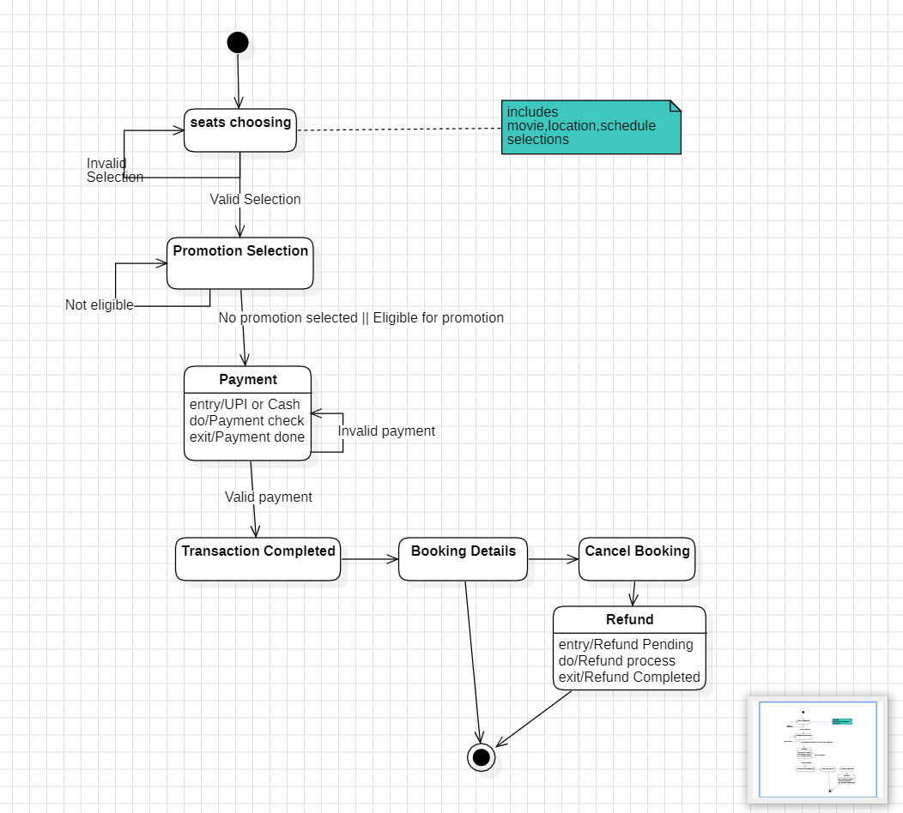

The **statechart diagram** for a **movie ticket booking system** outlines the various states and transitions involved in the process:

* **Initial State:**

The process begins with the user selecting a seat for booking a movie ticket.

* **Seat Choosing:**

This state includes selections such as the **movie**, **location**, and **schedule**.

If the selection is **invalid**, it loops back to the seat choosing state.

If the selection is **valid**, it proceeds to the next step.

* **Promotion Selection:**

Users can be either **eligible for promotions** or **not**.

If eligible, it moves forward; otherwise, it still proceeds to the next stage.

* **Payment:**

Users can make payments via **UPI** or **Cash**.

The system checks the validity of the payment.

If valid, the transaction is completed.

If invalid, it loops back for another payment attempt.

* **Transaction Completed:**

Indicates successful completion of the booking process.

* **Booking Details and Cancel Booking:**

Users can access booking details or cancel their booking.

Cancellation leads to a **refund process**.

* **Refund Process:**

Involves stages like **refund pending** and **refund completed**.

**Conclusion:** The statechart diagram provides a systematic approach to booking movie tickets, ensuring user-friendly interactions at each step. It covers everything from seat selection to payment and potential refunds in case of cancellations.