**SOFTWARE ENGINEERING LAB**

**PRACTICAL-8**

**NAME: VEDANT BHUTADA NAME: YASH PATNI**

**ROLL NO: 69 ROLL NO: 71**

**BATCH: A4**

**CASE STUDY: MOVIE TICKET BOOKING SYSTEM**

**Aim:** To construct a Data Flow Diagram to depict the functional/informational view of the system.

**LEVEL 0 DFD**

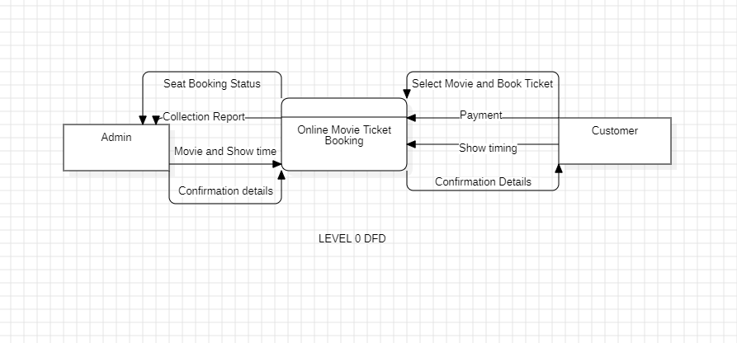

**LEVEL 1 DFD**

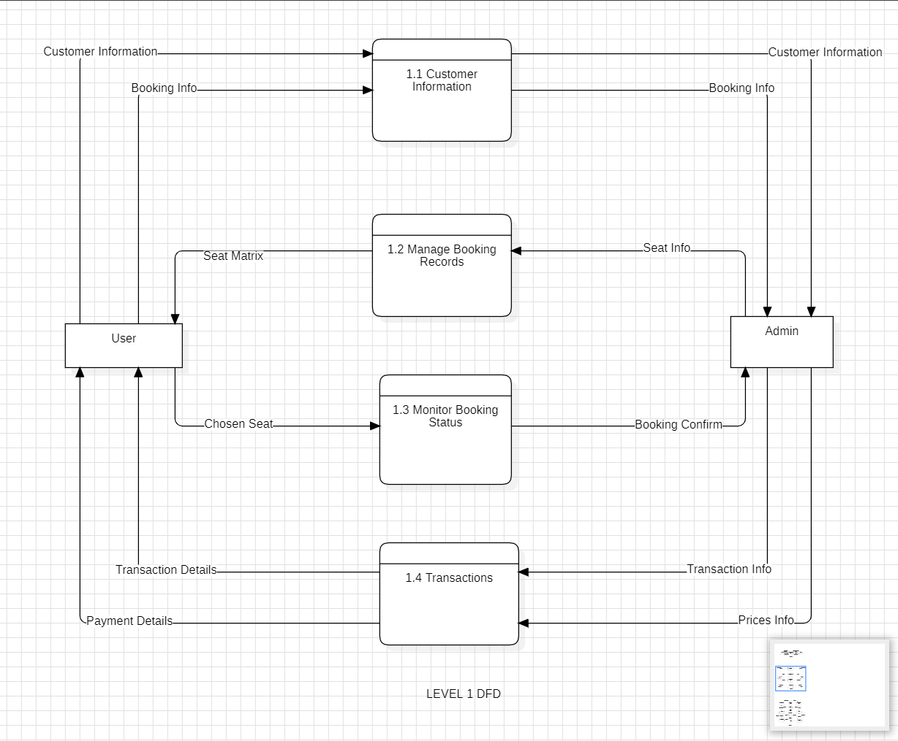

**LEVEL 2 DFD**

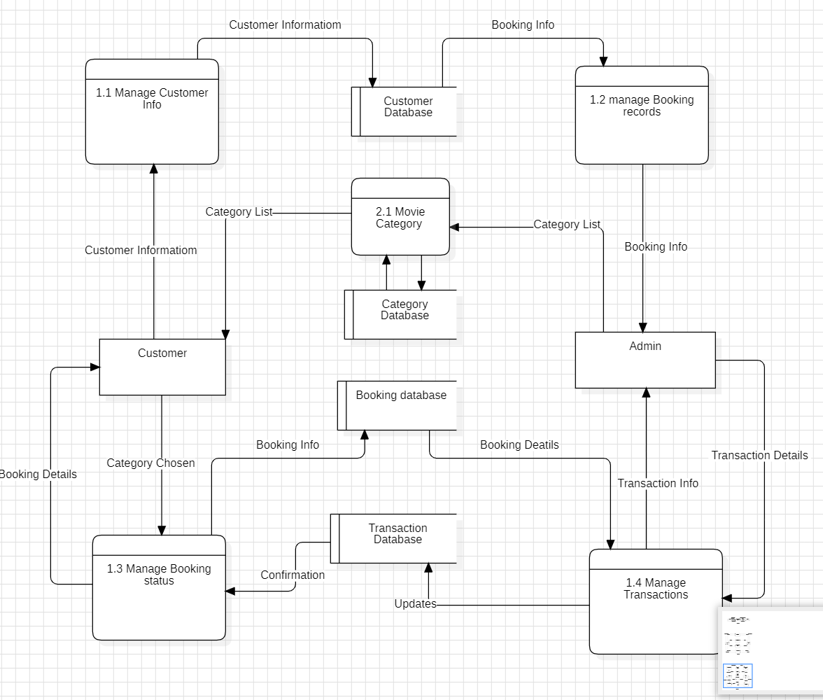

The diagram of **Level 0 DFD** provides a high-level overview of how information flows within the system. Here are the key components:

**Entities**:

**Admin**: Represents the system administrator or staff responsible for managing the movie ticket booking process.

**Customer**: Refers to the end-users who want to book movie tickets online.

**Central Process**:

The central process is labeled as **“Online Movie Ticket Booking.”**

It orchestrates the entire ticket booking flow.

**Inputs and Outputs**:

**From Admin to Online Movie Ticket Booking**:

**Seat Booking Status**: The Admin provides information about seat availability.

**Collection Report**: The Admin inputs data related to ticket collections.

**Movie and Show Time**: Details about movie schedules and show timings.

**Output to Admin**: The process generates **“Confirmation Details”** for the Admin.

**From Customer to Online Movie Ticket Booking**:

**Select Movie and Book Ticket**: The Customer chooses a movie and books a ticket.

**Payment**: The Customer makes a payment for the booked ticket.

**Outputs to Customer**:

**Show Timing**: The system provides information about the show timing.

**Confirmation Details**: The Customer receives confirmation details after successful booking.

The diagram of **Level 1 DFD** provides a more detailed view of how data flows within the system. Here are the key components:

**Entities and Processes**:

**User**: Represents the end-users who want to book movie tickets online.

**Admin**: Refers to the system administrator or staff responsible for managing the movie ticket booking process.

**Processes**:

**Customer Information**: This process receives input from the User, including details like customer information and booking preferences.

**Manage Booking Records**: Responsible for handling booking-related data. It receives data from both the User and the Admin.

**Monitor Booking Status**: Monitors the status of bookings.

**Transactions**: Manages payment-related information.

**Data Flow**:

**From User to Customer Information Process**:

**Customer Information**: The User provides details such as name, contact information, and preferences.

**Booking Info**: Information related to the desired movie, showtime, and seat selection.

**From Admin to Manage Booking Records Process**:

**Seat Matrix**: The Admin provides data about available seats.

**Within Manage Booking Records Process**:

**Chosen Seat**: The process combines User’s booking info with seat availability.

**Booking Confirm**: Confirms the booking.

**Transaction Info**: Manages transaction-related details.

**Prices Info**: Handles pricing information.

**From User to Transactions Process**:

**Payment Details**: The User provides payment information.

**Outputs**:**Transaction Info** is sent to both the Admin and the Monitor Booking Status process.

The diagram of **Level 2 DFD** provides a detailed view of how data flows within the system. Here are the key components:

**Entities and Processes**:

**Manage Customer Info**: Responsible for handling customer-related information.

**Admin**: Represents the system administrator or staff overseeing the booking process.

**Manage Booking Status**: Monitors the status of bookings.

**Processes**:

**Customer**: Receives input from the User, including details like customer information and booking preferences.

**Category List**: Manages movie categories (e.g., action, drama, comedy).

**Booking Info**: Combines User’s booking preferences with available seat information.

**Manage Transactions**: Handles payment-related details.

**Outputs**:

**Transaction Info**: Sent to both the Admin and the Monitor Booking Status process.

**Data Flow**:

**From User to Customer Process**:

**Customer Information**: The User provides details such as name, contact information, and preferences.

**Booking Info**: Information related to the desired movie, showtime, and seat selection.

**From Admin to Manage Booking Records Process**:

**Seat Matrix**: The Admin provides data about available seats.

**Within Manage Booking Records Process**:

**Chosen Seat**: Combines User’s booking info with seat availability.

**Booking Confirm**: Confirms the booking.

**Transaction Info**: Manages transaction-related details.

**Prices Info**: Handles pricing information.

**From User to Transactions Process**:

**Payment Details**: The User provides payment information.

**Database Connections**:

**Customer Database**: Stores customer-related data.

**Category Database**: Manages movie category information.

**Transaction Database**: Stores transaction details.

**Conclusion:**

* Level 0 DFD:

High-level overview.

Admin and Customer interactions.

Central process: Online Movie Ticket Booking.

* Level 1 DFD:

Detailed breakdown.

User, Admin, and processes.

Focus on booking flow.

* Level 2 DFD:

Deeper understanding.

Manage customer info, transactions, and databases.