**SOFTWARE ENGINEERING LAB**

**PRACTICAL-1**

**NAME: VEDANT BHUTADA**

**ROLL NO:69**

**BATCH: A4**

**CASE STUDY: MOVIE TICKET BOOKING SYSTEM**

**Aim: To design a class diagram to represent the structural view of the system.**

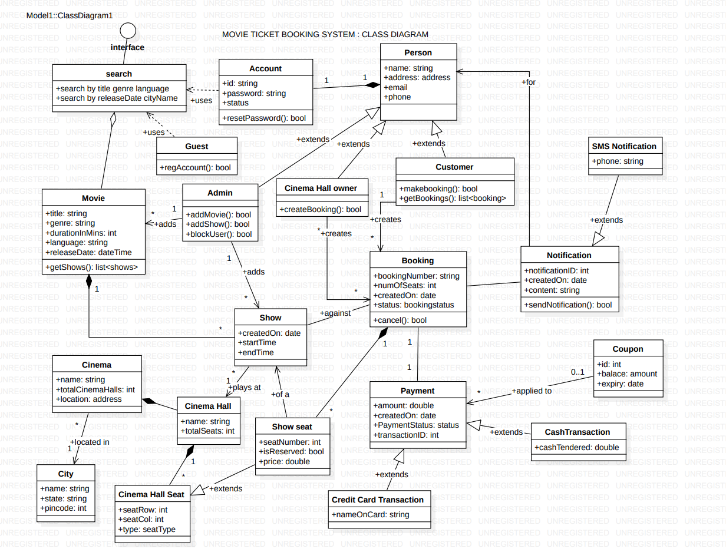

**Description:**

Here are Some of the main classes of the Movie Ticket Booking System:

* **Account:** Admin will be able to add/remove movies and shows, as well as block/unblock accounts. Customers can search for movies and make bookings for shows. CinemaHall Owner can book tickets for movie shows.
* **Guest:** Guests can search and view movies descriptions. To make a booking for a show they have to become a registered member.
* **Cinema:** The main part of the organization for which this software has been designed. It has attributes like ‘name’ to distinguish it from other cinemas.
* **CinemaHall:** Each cinema will have multiple halls containing multiple seats.
* **City:** Each city can have multiple cinemas.
* **Movie:** The main entity of the system. Movies have attributes like title, description, language, genre, release date, city name, etc.
* **Show:** Each movie can have many shows; each show will be played in a cinema hall.
* **CinemaHallSeat:** Each cinema hall will have many seats.
* **ShowSeat:** Each ShowSeat will correspond to a movie Show and a CinemaHallSeat. Customers will make a booking against a ShowSeat.
* **Booking:** A booking is against a movie show and has attributes like a unique booking number, number of seats, and status.
* **Payment:** Responsible for collecting payments from customers.
* **Notification:** Will take care of sending notifications to customers.