**SOFTWARE ENGINEERING LAB**

**PRACTICAL-1**

**NAME: VEDANT BHUTADA NAME: YASH PATNI**

**ROLL NO. 69 ROLL NO:71**

**BATCH: A4**

**Aim:** To study Unified Modeling Language (UML) perspectives and notations in StarUML.

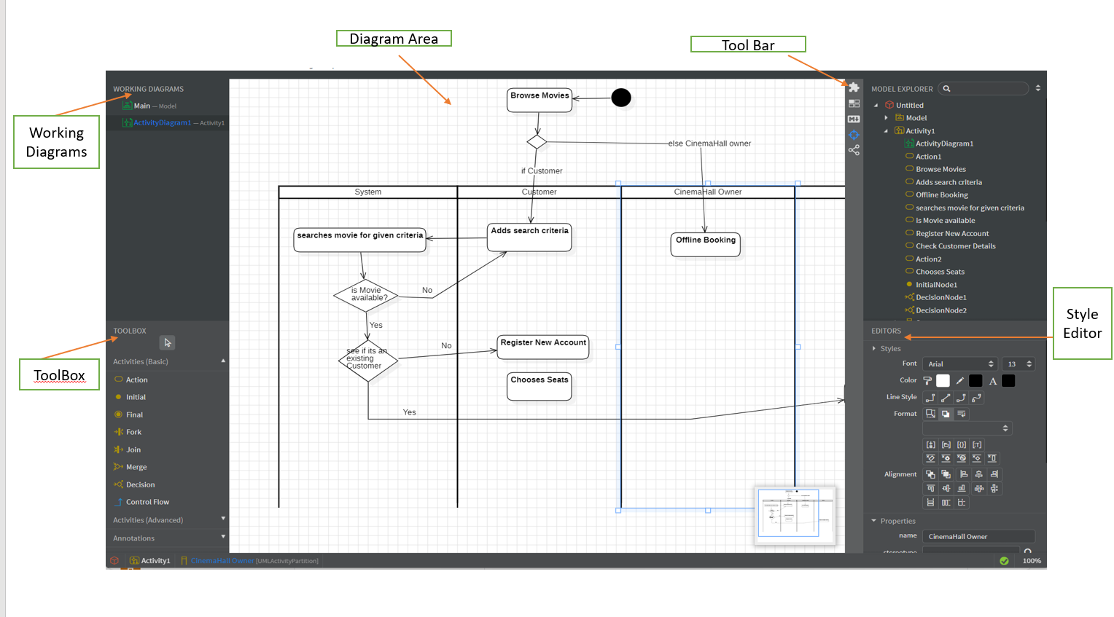

**DESCRIPTION:**

**Toolbox:** The Toolbox in StarUML contains all the tools and elements that we can use to create UML diagrams. It typically includes tools for creating different types of UML elements such as classes, interfaces, actors, use cases, etc. We can select the appropriate tool from the Toolbox and then click on the diagram area to add that element to our diagram.

**Working Diagrams:** Working diagrams refer to the actual UML diagrams that we create within StarUML. These diagrams can be of various types such as class diagrams, use case diagrams, sequence diagrams, etc. We can create, edit, and manipulate these diagrams to model different aspects of our system.

**Diagram Area:** The Diagram Area is the central area of the StarUML interface where we create and edit our UML diagrams. This is where we drag and drop elements from the Toolbox, connect them with relationships, and arrange them to represent the structure or behavior of our system.

**Toolbar:** The Toolbar contains various tools and commands that we can use to perform actions on our diagrams. This includes tools for creating new diagrams, saving and exporting diagrams, zooming in and out, aligning elements, and more. The Toolbar provides quick access to commonly used functions to streamline our modeling process.

**Style Editor:** The Style Editor allows us to customize the appearance of elements in our diagrams. We can modify properties such as colors, fonts, line styles, and sizes to create diagrams that adhere to our preferred visual style or organizational standards. The Style Editor helps us maintain consistency and clarity in our diagrams by applying consistent formatting across different elements.

**Conclusion:** Understanding how each of these components works together will help us effectively create and manage our UML diagrams in StarUML.