CD NOZZLE ANALYSIS

CONTENTS

ABOUT
CD Nozzle stands for a Convergent Divergent Nozzle also known as De Laval Nozzle after the inventor Carl de Laval who had originally designed it for the use in steam power plants. The main function of the cd nozzle is to generate supersonic flow conditions for scientific or engineering purposes. In the modern world the CD nozzle has applications ranging from rocket exhaust nozzles, turbo jet engines to supersonic wind tunnels. Computational Fluid Dynamics (CFD) is a vital branch of fluid mechanics which simultaneously aids the analytical and experimental process of studying and predicting a real-life physical problem. There are many softwares available which perform CFD analysis. SU2 is an open-source software which will be used in the present study.
The aim of this report is to check the reliability of the software in simulation of a CD nozzle for various convective schemes. The problem is divided into two cases, one is with perfect expansion and the other is with a normal shock in the nozzle. Both the cases are inviscid. The initial stagnation conditions and geometry is taken from the Back & Massier research paper.

BACK & MASSIER

GEOMETRY
The model for the CD nozzle is referred from the Back & Massier paper.
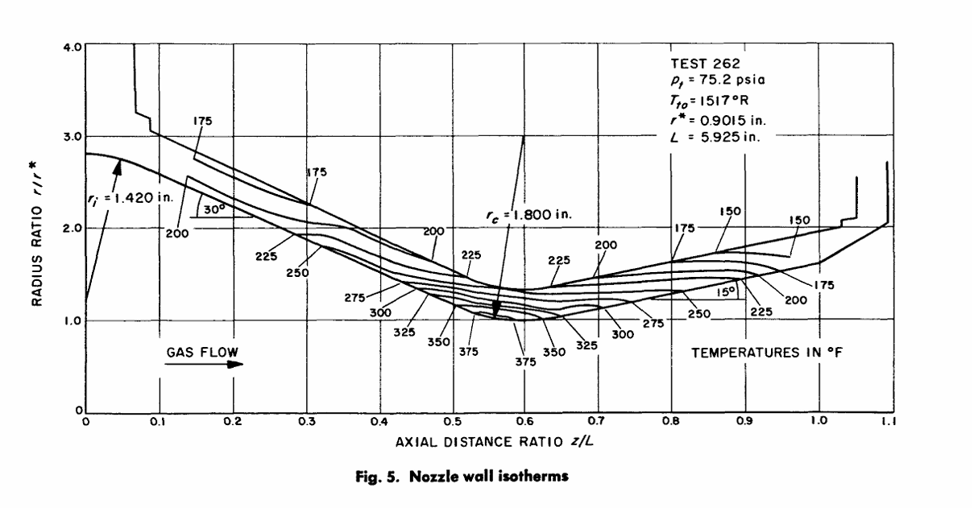
Fig 1: Nozzle drawing from the Back & Massier paper

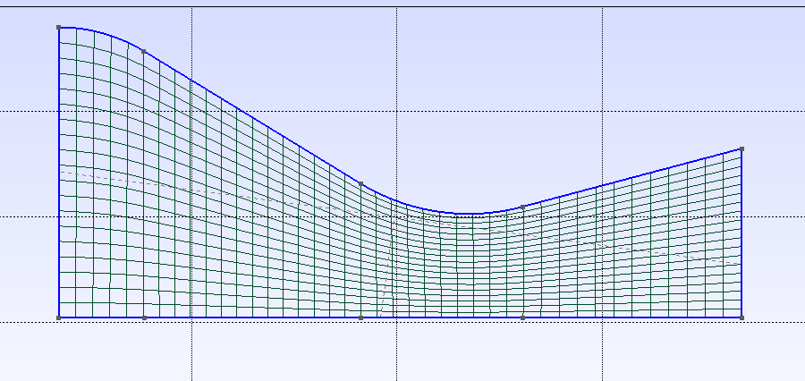
Fig 2: Mesh of the domain

The mesh was created using the Gmsh software which is opensource. The number of nodes are 840 and number of elements are 779. For grid refinement study which is performed afterwards the above mesh is the coarse mesh.

CASE 1

Boundary Conditions

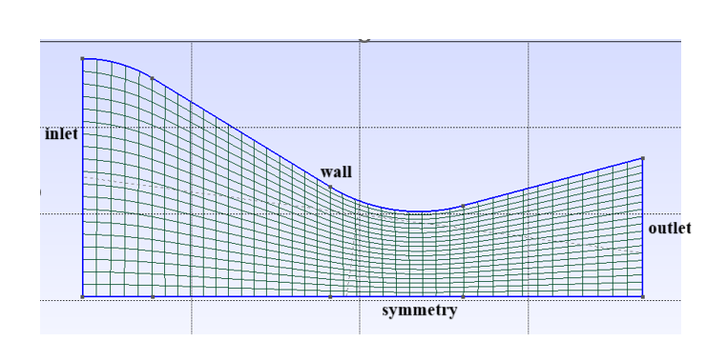
Fig 2: Boundary Conditions of the Nozzle

The conditions at the inlet are given as P₀ = 1,038,350.4 Pa, T₀ = 824.44 K. The direction of the mass flow inlet is parallel to the axis along the symmetry line. The condition at the outlet is P_{b} = 59,147.39 Pa. In SU2, boundary conditions are specified by using the option “MARKER”. The boundary conditions applied to the model are shown in the table below.

Table 1: Boundary Conditions
Sr. No. | Named Selection | Boundary Condition
1. | inlet | MARKER_RIEMANN
2. | outlet | MARKER_RIEMANN
3. | wall | MARKER_EULER
4. | symmetry | MARKER_SYM

Solver Setup
The solver used is Euler since the flow is inviscid with standard air as the fluid model. For spatial gradients, the numerical method used is Green Gauss and Lax Friedrich convective scheme is used. In the slope limiter option, Venkatkrishnan model is applied. The CFL number is set to 0.5, which is adaptive in nature.

Results
The normalised static pressure values along the wall of the nozzle are extracted and plotted with the analytical quasi-1D curve and the experimental data of Back et al. The numerical solution agrees well with both the results.

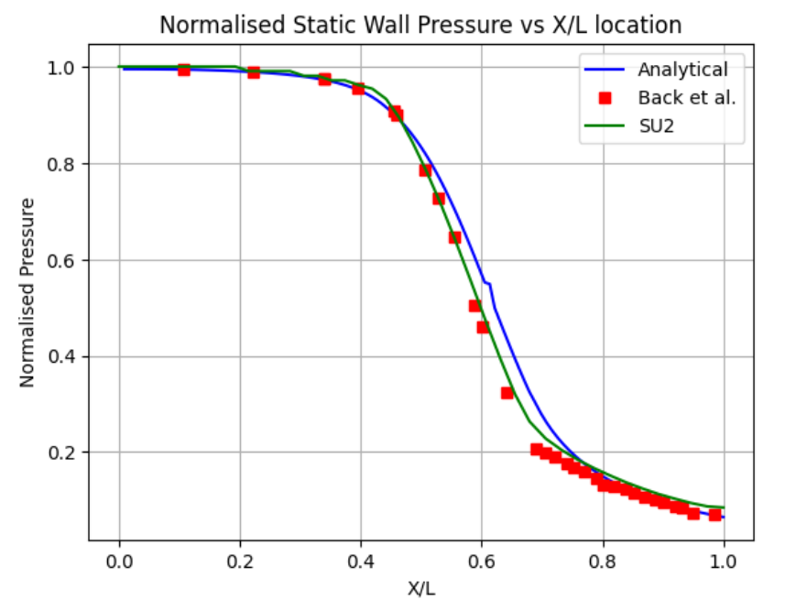
Fig 3: Comparison of normalised static wall pressure values

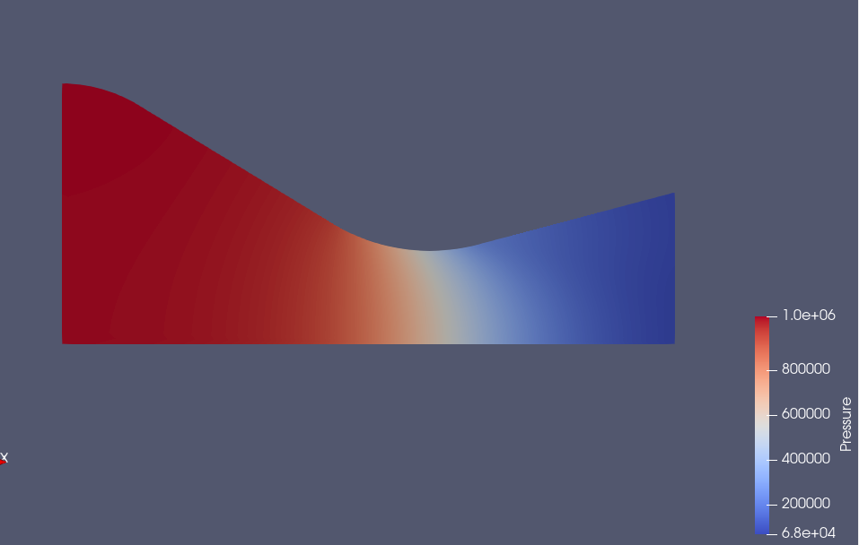
Fig 4: Contour of pressure

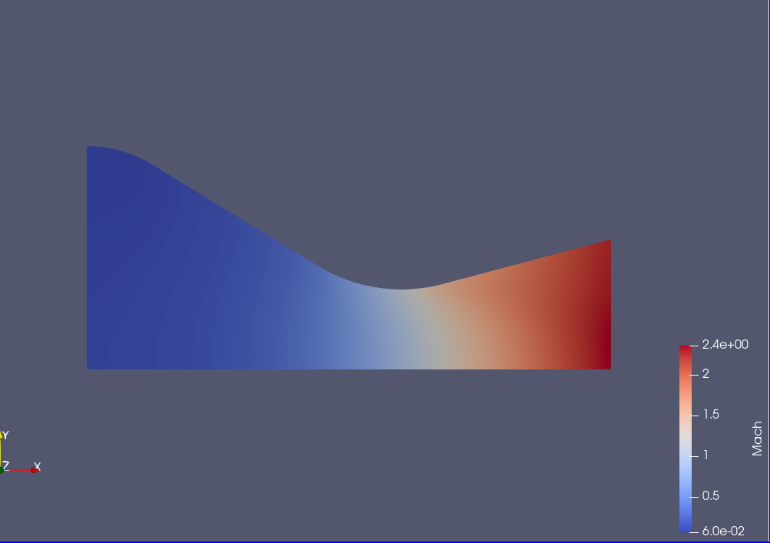
Fig 5: Contour of Mach Number
Grid independence study is performed to find the optimum mesh size for further studies. For post-processing data is extracted from a line at y = 0.02 m. This position is chosen because it behaves as the averaged position to compare with the analytical 1D results.

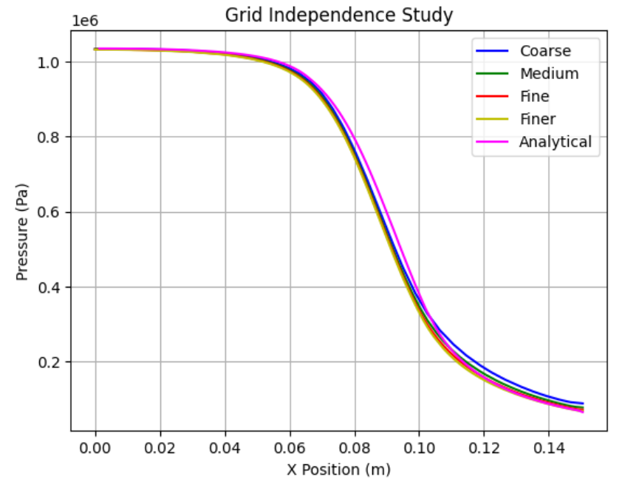
Fig 6: Grid Independence Study

Fig 7: Variation of the Exit Pressure with number of cells

Fig 8: Time taken for simulating domain of different mesh sizes

Fig 9: Log-Log plot of error vs no. of cells

Where e = (P_{exit} – P_{exit analytical})/ P_{exit analytical}
P_{exit}: Computational exit pressure
P_{exit analytical}: Analytical exit pressure
The value of the analytical exit pressure is 65330 Pa and the analytical mach number is 2.447041. Observing the results of the grid independence study, it was decided to perform further studies using the fine grid. The number of elements in the fine grid are 4,444. Using the fine grid, the compatibility of various numerical schemes and slope limiters are checked. For now the slope limiter applied is Venkatkrishnan which is held constant for the study of numerical schemes, it is also compared to results in which the slope limiter is disabled.

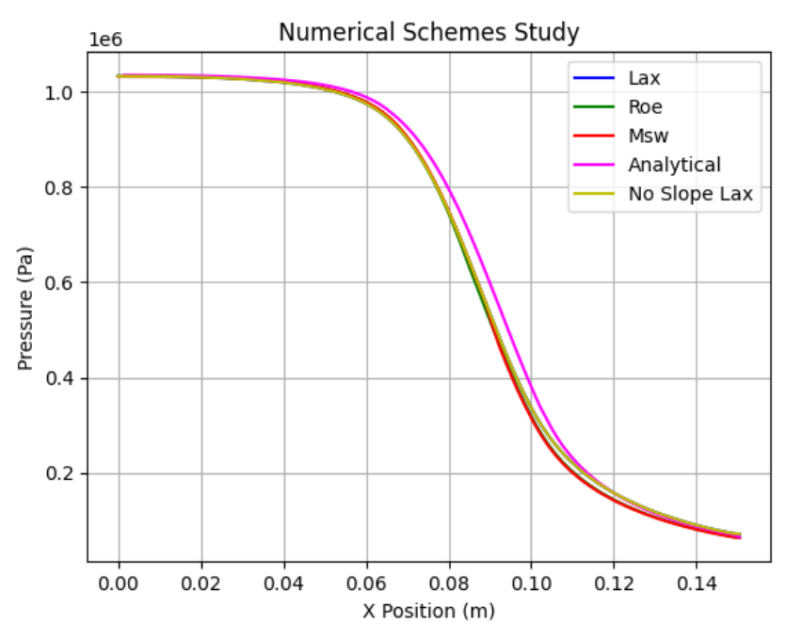
Fig 10: Pressure vs Position

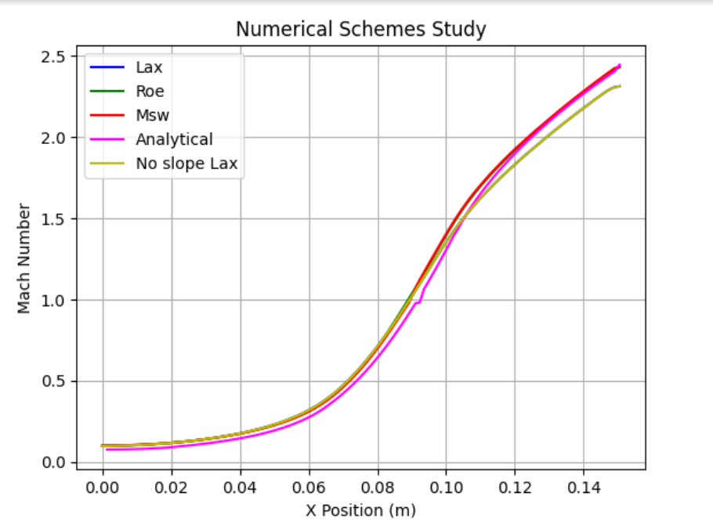
Fig 11: Mach number vs position

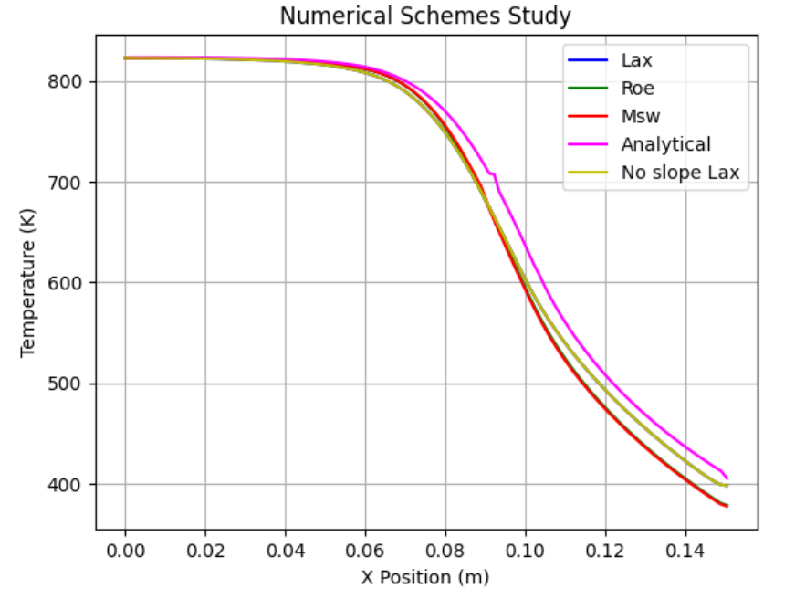
Fig 12: Temperature vs position
Table 2: Results of various convective schemes
Sr. No. | Convective Scheme | Spatial Gradient Scheme | Exit Mach No. | Exit Pressure
1. | Lax Friedrich | Green Gauss | 2.3137 | 71639
2. | Roe | Green Gauss | 2.4302 | 64204
4. | MSW | Green Gauss | 2.4362 | 63640
5 | MSW | Weighted Least Squared | 2.4362 | 63640
6. | Lax Friedrich | Weighted Least Squared | 2.3137 | 71639
7 | Roe | Weighted Least Squared | 2.4302 | 64204
8. | Lax Friedrich | Green Gauss | 2.3137 | 71639

The plot of the Lax Friedrich scheme and the Lax Friedrich with the slope limiter disabled scheme are both coincident lines. Although the exit pressure and exit mach number of the Lax Friedrich scheme have a larger difference from the analytical values when compared to other schemes, the overall plot matched well in the pressure and temperature curve. Various other numerical schemes have not been added to the table like Ausm, etc because the results highly deviated from the theoretical expectations.
Hence, the Lax Friedrich scheme is chosen to perform further studies to check the effects of different slope limiters.

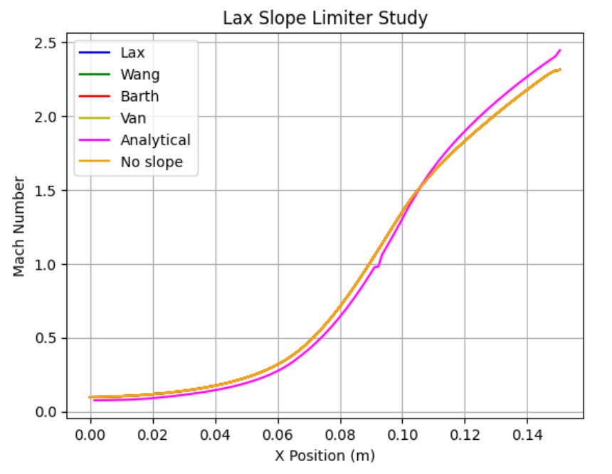
Fig 13: Mach number vs x position

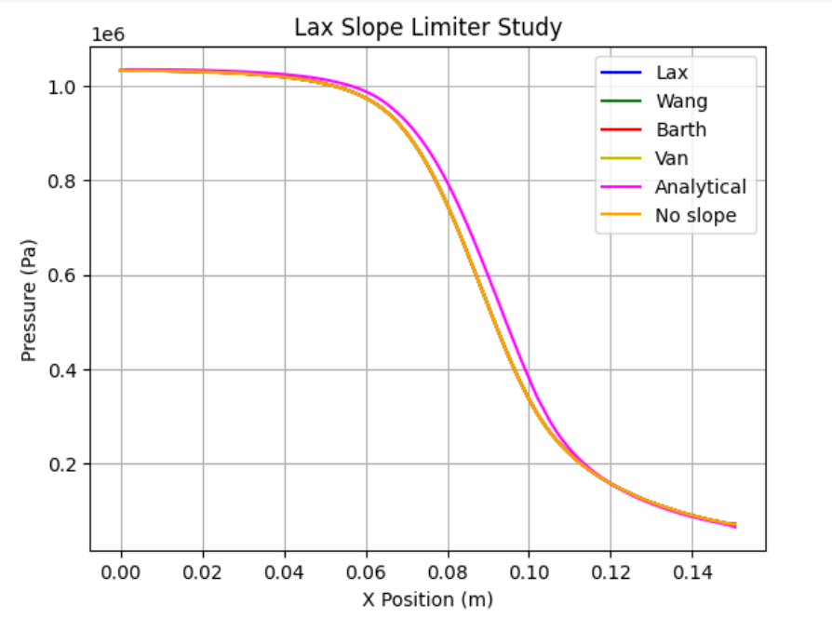
Fig 14: Pressure vs x position

Table 3: Results of various slope limiters
Sr. No. | Convective Scheme | Slope Limiter | Mach No. | Pressure
1. | Lax | Venkatkrishnan-Wang | 2.3137 | 71639
2. | Lax | Barth-Jesperen | 2.3137 | 71639
3. | Lax | Van_Albada_Edge | 2.3137 | 71639

Varying the slope limiters didn’t produce any change in the results, so Venkatkrishnan is chosen as the slope limiter.

The values of exit Mach number (M_{ec}) and back pressure (P_{bc}) computationally obtained are as follows:
M_{ec} = 2.3137; P_{bc} = 71639 Pa
The values of exit Mach number (M_{e}) and pressure (P_{b}) obtained analytically using isentropic gas table are as follows:
M_{e} = 2.447041; P_{b} = 65330 Pa
The percentage error in the exit Mach number is: e_{m} = ((M_{e} - M_{ec})/ M_{e})*100
Hence, e_{m} = 5.45%
Similarly, percentage error in the back pressure is: e_{p} = ((P_{b} – P_{bc})/ P_{b})*100
Hence, e_{p} = 9.66%

Conclusion
As shown above the error in the exit Mach number is 5.45% and back pressure is 9.66%. Both the errors are below 10% which are good. Hence, we can say that the solver predicted the solution with considerable accuracy.

CASE 2

Boundary Conditions
The conditions at the inlet are given as P₀ = 308885.1 Pa, T₀ = 835 K. The direction of the mass flow inlet is parallel to the axis along the symmetry line. The condition at the outlet is P_{b} = 92665.53 Pa. In SU2, boundary conditions are specified by using the option “MARKER”. The boundary conditions applied to the model are shown in the table below.

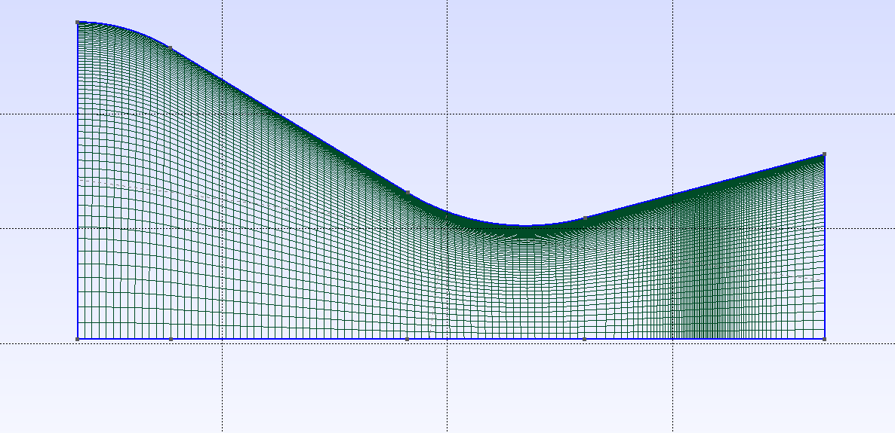
Fig 15: Mesh of the domain
Table 3: Boundary Conditions for Case 2
Sr. No. | Named Selection | Boundary Condition
1. | INLET | MARKER_INLET
2. | OUTLET | MARKER_OUTLET
3. | WALL | MARKER_EULER
4. | SYMMETRY | MARKER_SYM

The cell height near the wall of the early mesh was reduced to accommodate the viscous boundary layer and the region near the shock is refined more to capture the shock more effectively. The total number of cells in this are 8909.

Solver Setup
The solver used is Euler since the flow is inviscid with standard air as the fluid model. For spatial gradients, the numerical method used is Green Gauss and Roe convective scheme is used. In the slope limiter option, Venkatkrishnan model is applied. The CFL number is set to 0.5, which is adaptive in nature. Turbulence model used is SST Menter and the viscosity is taken as constant.

Results
The results plotted for case 2 are given below.

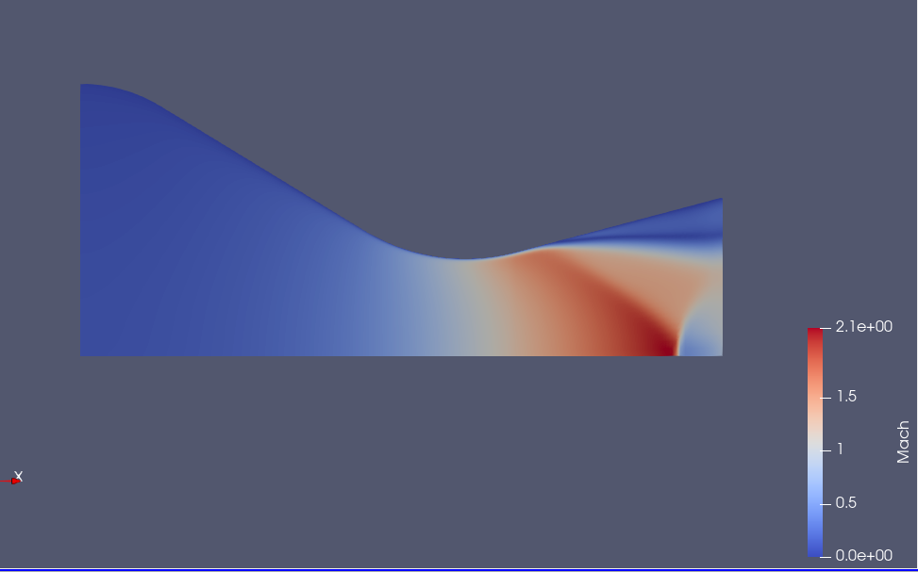
Fig 16: Contour of Mach Number

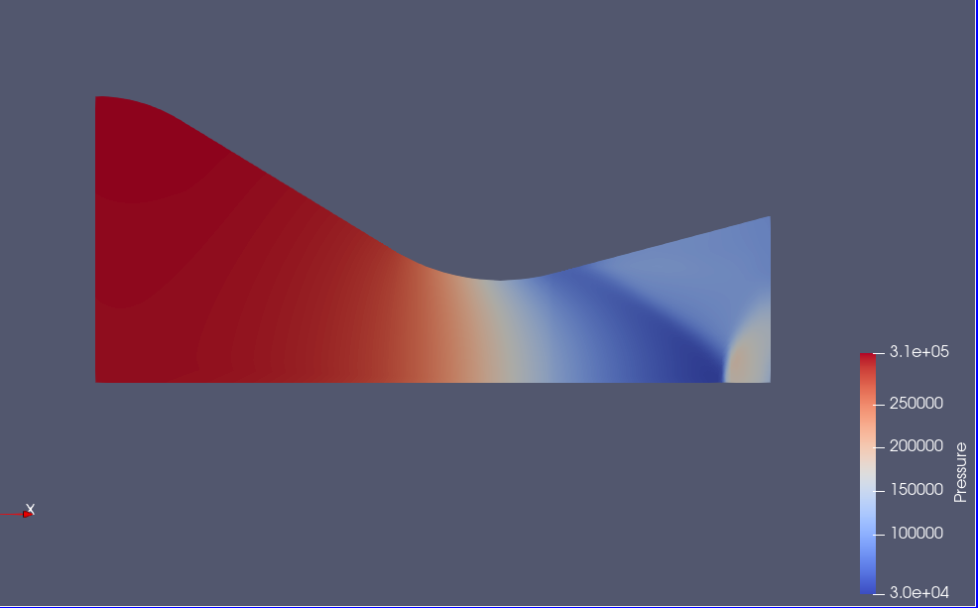
Fig 17: Contour of Pressure
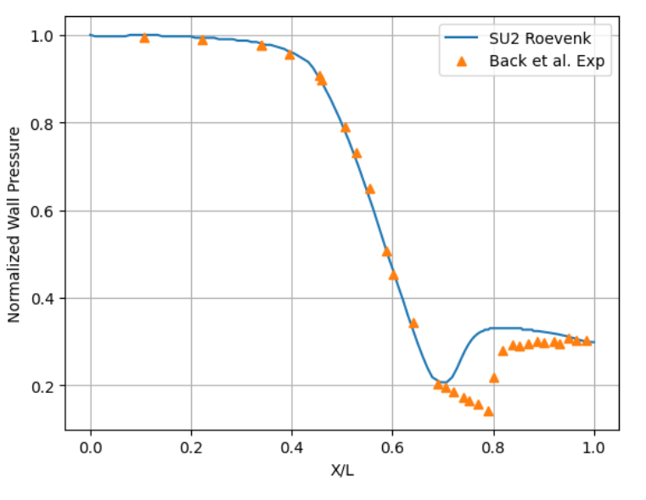
Fig 17: Normalised Wall Static Pressure vs x/L position

The experimental wall exit pressure P_{ee} is 92665.53 Pa and the computed value is P_{ec} = 92175 Pa.
Hence, the percentage error in P_{e} is: e_{p} = ((P_{ee} - P_{ec})/ P_{ee})*100
Therefore, e_{p} = 0.52 %
The experimental value of the area ratio at which the shock is present is a₁ = 1.688 and the computed value is a_{1c} = 1.265.
Hence, the percentage error in a₁ is: e_{a} = ((a₁ - a_{1c})/ a₁)*100
Therefore, e_{a} = 25.05 %

Conclusion
The error in wall exit pressure is 0.52 % and the error in the area ratio regarding the location of the normal shock is 25.05 %. Both the errors are within 25% but there is still scope for improvement.

SAJBEN

GEOMETRY

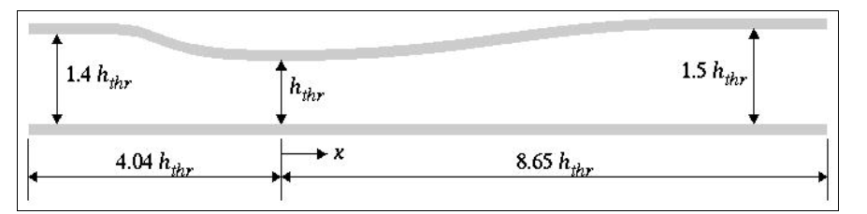
Fig 18: Geometry

Where h_{thr} is 1.7322 inches.

MESH AND BOUNDARY CONDITIONS

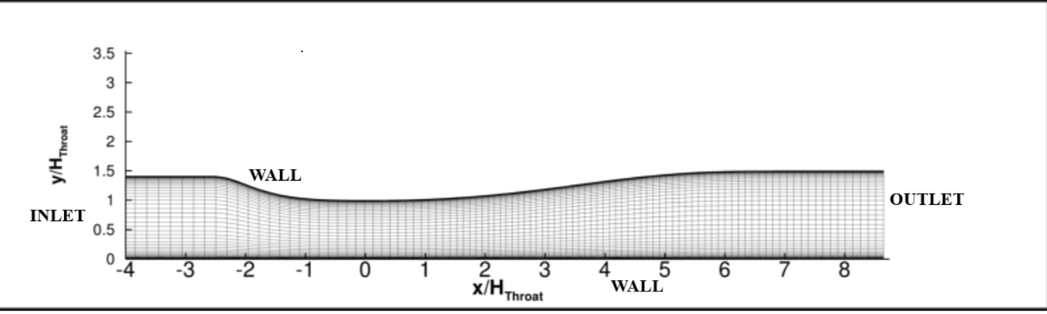
Fig 19: Mesh and Patch regions

Table 1: Boundary Conditions
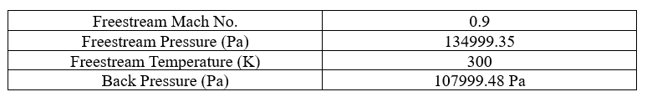

SOLUTION AND RESULTS
The Spalart Allmaras (SA) model performed better than the Shear Stress Transport (SST) model. Hence, this was chosen as the appropriate turbulence model for further studies. Various numerical schemes were considered, among them JST scheme agreed the best. As for the slope limiter scheme, it has been previously (Back & Massier Case Study) shown that the choice of the scheme doesn’t affect the flow solution. Thus, the default scheme that is Venkatkrishnan is continued for further studies.

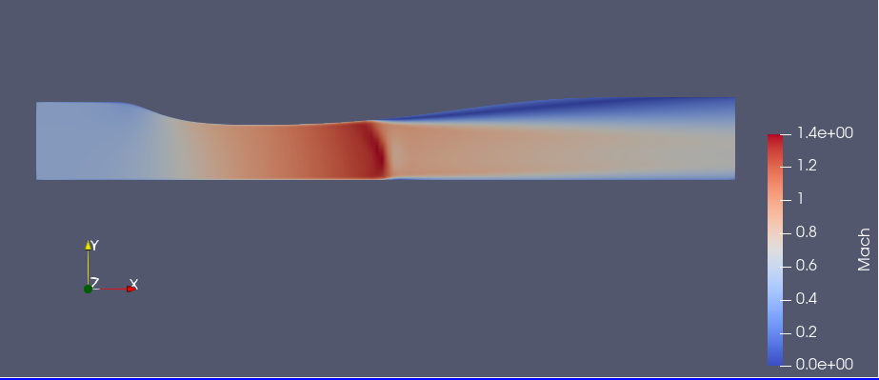
Fig 20: Mach number Contour

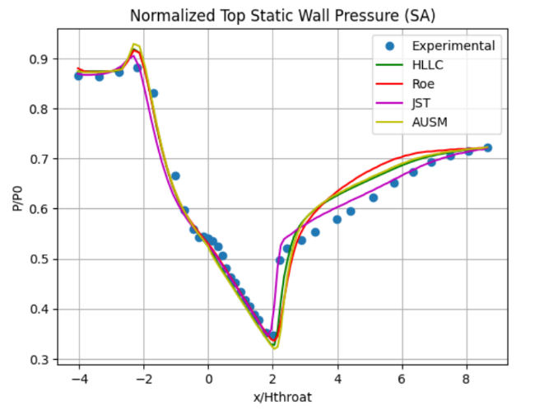
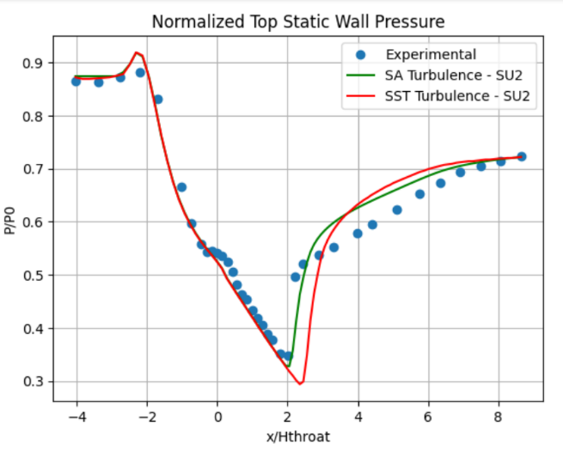

- (b)
Figure 21: Depicts the variation of top wall pressure along the length of the nozzle

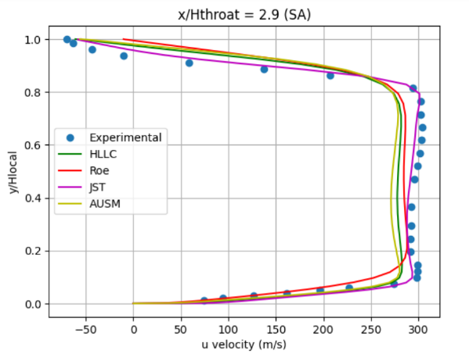
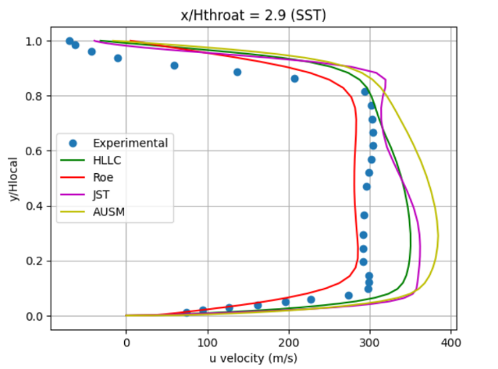

(a) (b)
Figure 22: Velocity profile of various schemes

- With an R² of 0.9495, the SA model exceeds SST by 13.67% and lowers RMSE by 44.63%, achieving a value of 0.0088.
- The JST numerical scheme shows the best performance with an R² of 0.9759 and RMSE of 0.021.

CHEN

