CD NOZZLE

INVISCID PERFECT EXPANSION
Software Used: SU2
Stagnation Pressure = 518485.7 Pa
Stagnation Temperature = 843.33 K
Back Pressure = 5133.52 Pa

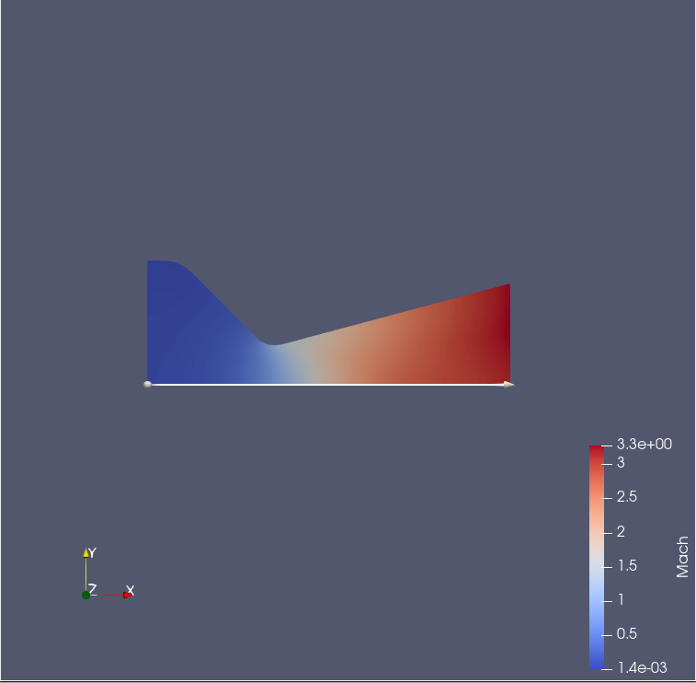
Fig 1: Mach No. contour

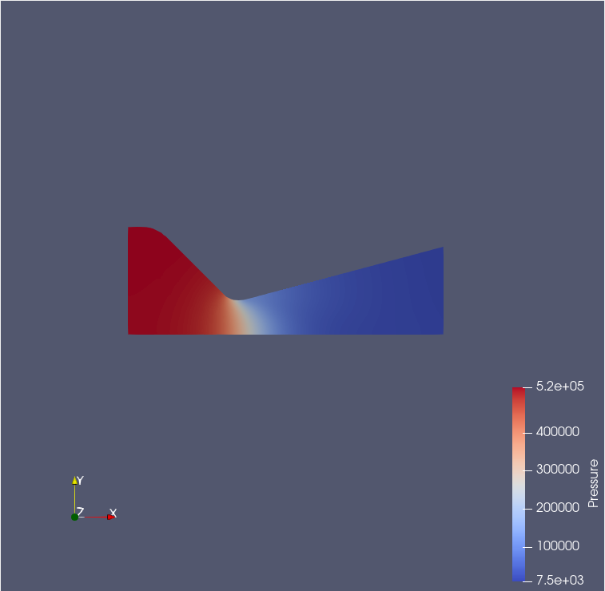
Fig 2: Pressure Contour

PLOTS
Charts are plotted along the symmetry line of the CD Nozzle.

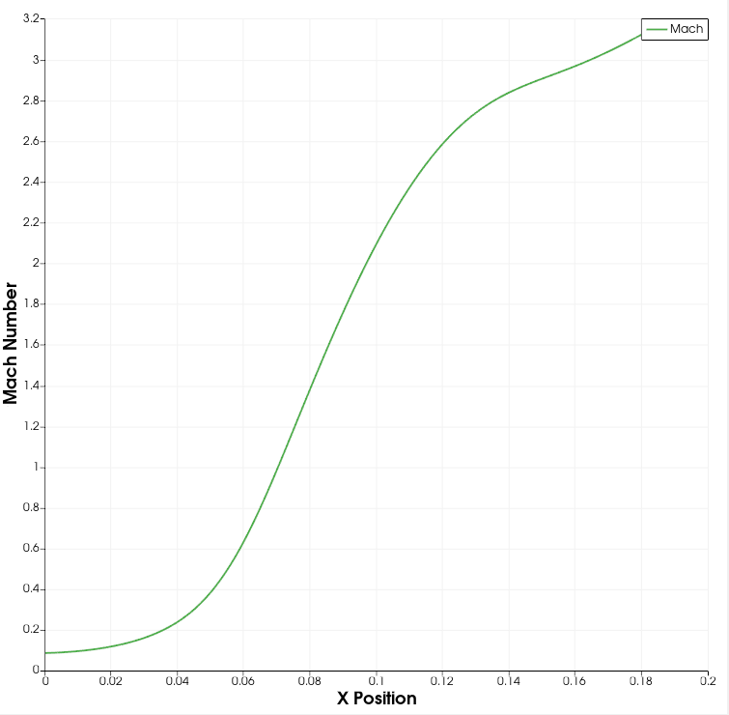
Fig 3: Mach No. vs X position plot

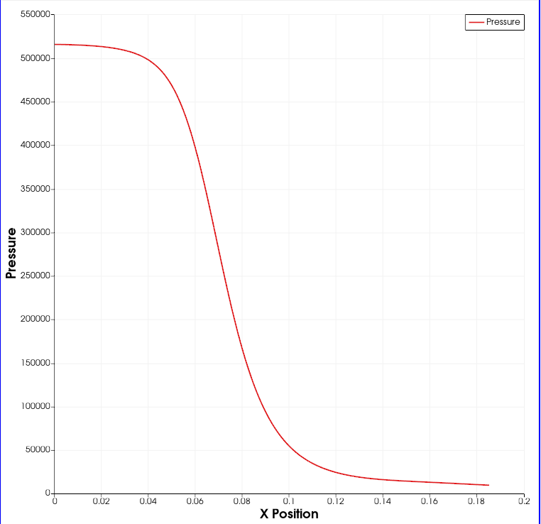
Fig 4: Pressure vs X position plot

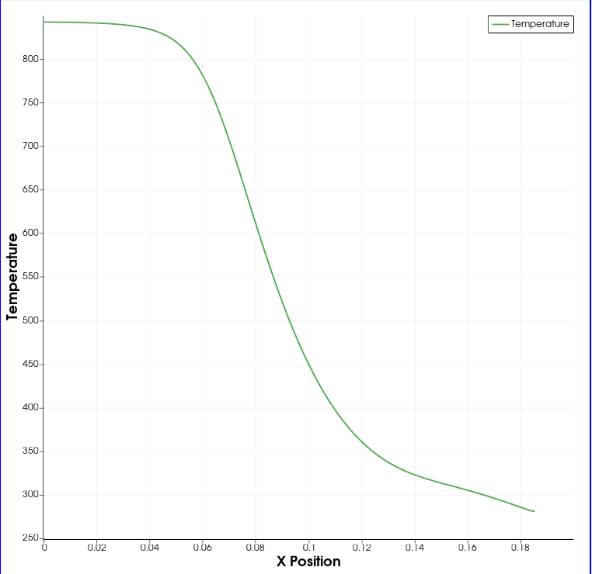
Fig 5: Temperature vs X position plot

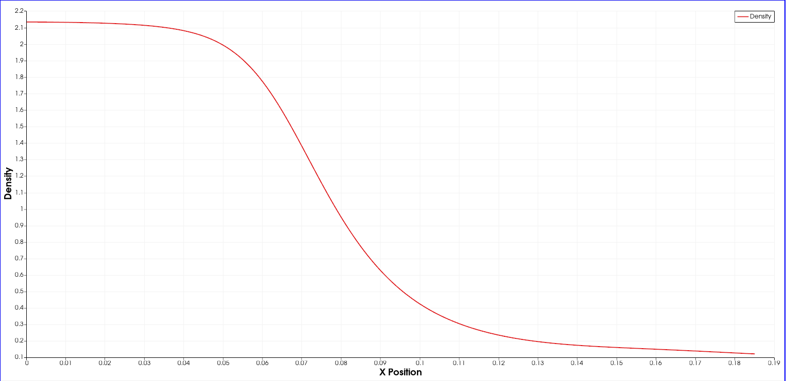
Fig 6: Density vs X position plot

