
Indian Institute of Technology Bombay

Report On

A Computational Analysis of Converging Nozzle Using SU2 Solver

By

Vedant K. Chaudhari

Guide: Prof. Dr. Chandra T. & Prof. Dr. Kowsik Bodi

Abstract

Computational Fluid Dynamics (CFD) has become an essential tool for analyzing compressible flows in aerospace and propulsion applications. In the present work, numerical simulations of compressible flow through converging duct configurations of varying lengths and boundary conditions were performed using the open-source CFD software SU2 (Stanford University Unstructured). SU2 provides a robust framework for solving the compressible Reynolds-Averaged Navier-Stokes (RANS) equations and enables detailed investigation of flow acceleration, pressure variation, temperature distribution, and Mach number development within internal flow passages.
The study considers multiple converging duct geometries and operating conditions to examine the influence of geometric parameters and wall boundary conditions on flow behavior. Both slip-wall and no-slip wall configurations were analyzed to assess the effects of viscous phenomena and boundary layer development. Numerical results were post-processed to evaluate key flow properties, including Mach number, pressure ratio, and temperature ratio distributions along the duct length. The CFD predictions were further examined in the context of classical compressible flow theory to understand the extent of agreement and the influence of multidimensional and viscous effects.
The work demonstrates the capability of SU2 as an efficient and reliable tool for the simulation of compressible internal flows and provides insights into the aerodynamic characteristics of converging duct systems under different flow conditions.

Introduction
Converging ducts are widely used in aerospace and propulsion applications where controlled acceleration of compressible flow is required. The flow behavior within such ducts is influenced by geometric parameters, operating conditions, and wall boundary effects, making them an important subject for numerical investigation.
Advances in Computational Fluid Dynamics (CFD) have enabled detailed analysis of compressible internal flows with reduced dependence on experimental testing. Among the available CFD tools, SU2 (Stanford University Unstructured) has emerged as a powerful open-source platform capable of solving compressible flow problems using finite-volume methods and advanced numerical schemes. Its flexibility and accessibility make it suitable for both academic research and engineering applications.
The present work focuses on the numerical simulation of compressible flow through converging duct configurations using SU2. Different duct geometries and boundary condition combinations were investigated to study their influence on flow acceleration and the variation of key flow parameters. The simulations provide a basis for understanding the behavior of compressible flow within converging passages and for assessing the capability of SU2 in predicting such flow phenomena.
The results obtained from the CFD simulations are analyzed through distributions of Mach number, pressure ratio, and temperature ratio along the duct length. The numerical predictions are also examined with reference to established compressible flow relations to evaluate their physical consistency.

Geometry and Computational Domain

Geometry Description
The computational model consists of a two-dimensional converging duct designed to accelerate subsonic compressible flow. Owing to the geometric symmetry about the duct centerline, only the upper half of the physical domain was considered in the numerical simulations. This approach reduces computational cost while preserving the essential flow physics.
The duct has a total length of 1 m with an inlet height of 0.36 m and an outlet height of 0.18 m, resulting in a geometric area ratio of 2:1. The upper boundary is defined by a smooth converging profile to ensure gradual flow acceleration and

minimize abrupt geometric discontinuities. The lower boundary is treated as a symmetry plane representing the duct centerline.

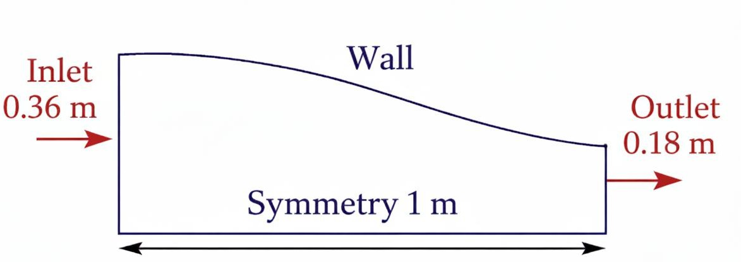
Figure 1 illustrates the computational geometry and boundary condition locations used in the simulations.

3.2 Computational Domain and Mesh Generation
The computational domain was discretized using a structured quadrilateral mesh generated in Gmsh. A structured grid was selected to improve numerical accuracy and provide better alignment of grid lines with the primary flow direction. Grid clustering naturally occurs in the converging region, allowing the mesh to adequately capture the strong gradients in velocity, pressure, and Mach number expected near the outlet section.
The final mesh consists of approximately 7,250 quadrilateral elements. Particular attention was given to maintaining smooth grid transitions and minimizing cell distortion throughout the domain. The structured topology also facilitates stable convergence of the compressible flow solver and reduces numerical diffusion.
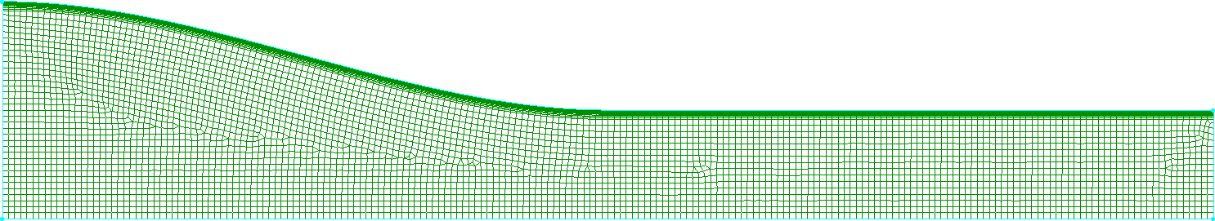

Figure 2 presents the computational mesh employed for the simulations.

3.3 Computational Setup and Boundary Conditions

The numerical simulations were performed using the open-source CFD solver SU2. The compressible Reynolds-Averaged Navier-Stokes (RANS) equations were solved assuming air as an ideal gas with a specific heat ratio of 1.4 and a gas constant of 287 J/kg·K. The SST turbulence model was employed for all simulations. Spatial gradients were computed using the Green-Gauss method, while the JST scheme was used for flow discretization. Time integration was performed using an implicit Euler method.
A total pressure of 200 kPa and a total temperature of 354 K were prescribed at the inlet. The outlet was defined using a static pressure boundary condition. Different outlet pressures were employed to obtain the desired exit Mach numbers. For the case corresponding to an exit Mach number of approximately 0.4, the outlet static pressure was set to 179120 Pa, whereas an outlet pressure of 156800 Pa was used for the case corresponding to an exit Mach number of approximately 0.6. Additional outlet pressure conditions were considered for higher Mach number cases.
Both slip-wall and no-slip wall boundary conditions were investigated to study the influence of viscous effects on the flow development. In all simulations, the lower boundary was treated as a symmetry plane. The simulations were iterated until convergence was achieved, and the resulting flow fields were post-processed to obtain distributions of Mach number, pressure ratio, and temperature ratio along the duct length.

Numerical Methodology

The flow simulations were carried out using SU2, an open-source finite-volume CFD solver. The governing compressible Reynolds-Averaged Navier-Stokes (RANS) equations were solved for steady-state flow conditions. Air was modeled as an ideal gas throughout the analysis.
A structured quadrilateral mesh consisting of approximately 7,250 elements was employed for all cases. The computational domain was discretized using the finite-volume method, with flow variables stored at cell centers. Spatial gradients were evaluated using the Green-Gauss approach. Convective fluxes were computed using the Jameson-Schmidt-Turkel (JST) scheme, while temporal discretization was performed using an implicit Euler method.
The simulations were initialized using total pressure and total temperature conditions at the inlet. Convergence was monitored through the residual histories

of density, momentum, and energy equations. Simulations were continued until the residuals decreased by several orders of magnitude and the monitored flow variables reached stable values.
To investigate the influence of viscous effects, both slip-wall and no-slip wall boundary conditions were considered. The resulting flow fields were analyzed through Mach number, pressure ratio, and temperature ratio distributions along the duct length. The numerical results were subsequently compared with predictions from one-dimensional isentropic flow theory.

Results and Discussion

  - Extended 1 m Duct (Target Mach ≈ 0.95)

Mach Number Distribution
The Mach number increased continuously through the converging section due to the reduction in flow area. The slip-wall solution showed good agreement with the theoretical isentropic prediction and reached a maximum value close to unity near the throat region. The no-slip case exhibited lower acceleration due to viscous effects and boundary layer development. Downstream of the throat, the centreline Mach number continued to increase gradually in the constant-area section.
Figure 3: Mach Number Comparison
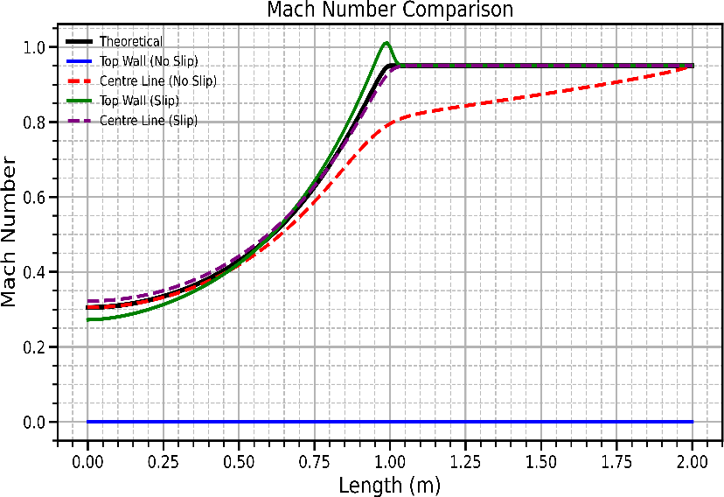

Pressure Ratio Distribution
The pressure ratio decreased along the converging section as pressure energy was converted into kinetic energy. The slip-wall case closely followed the theoretical trend, while the no-slip case showed deviations due to viscous losses. A more gradual pressure reduction was observed for the no-slip configuration.

Figure 4: Pressure Ratio Comparison
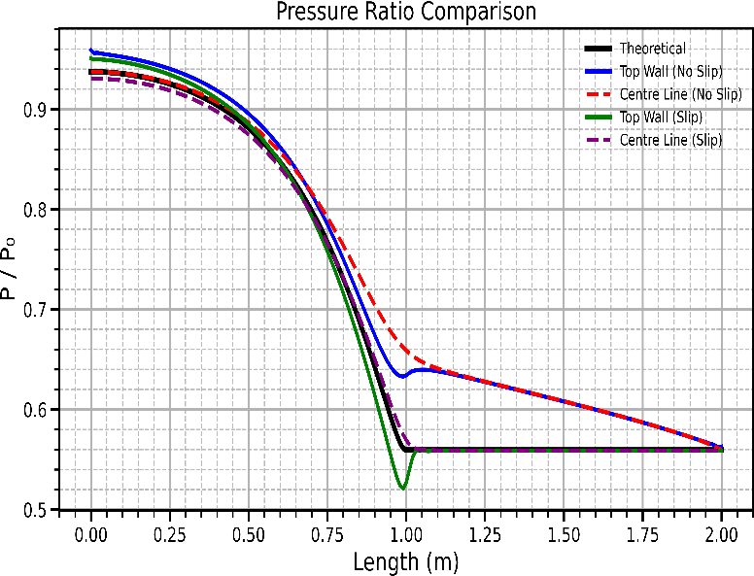

Temperature Ratio Distribution
The temperature ratio decreased with increasing Mach number. The slip-wall case showed behaviour close to the theoretical isentropic solution, whereas the no-slip case maintained relatively higher temperatures due to viscous dissipation within the flow.
Figure 5: Temperature Ratio Comparison
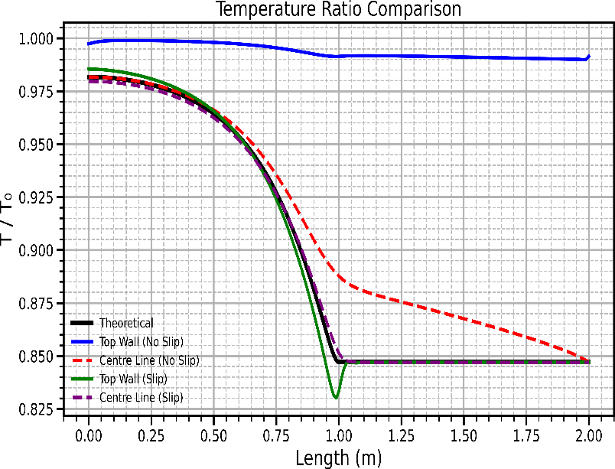

Density and Velocity Variation
The density decreased continuously as the flow accelerated through the converging duct. Correspondingly, the velocity increased along the flow direction and attained its maximum value near the throat region. The slip-wall case demonstrated stronger acceleration compared to the no-slip configuration.

Figure 6: Density Variation Along Duct LengthInsert Figure 7
Figure 7: Velocity Comparison
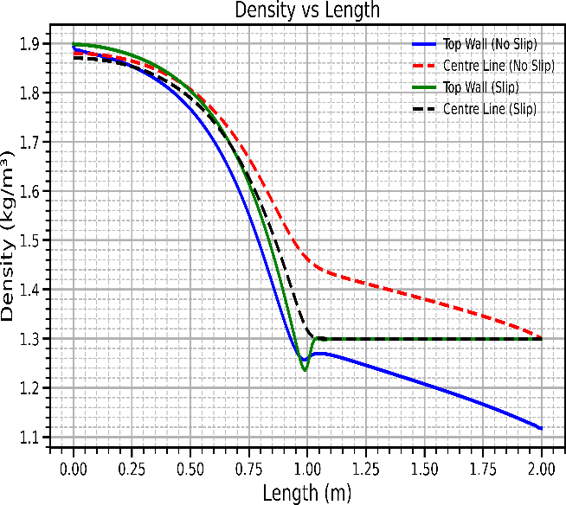
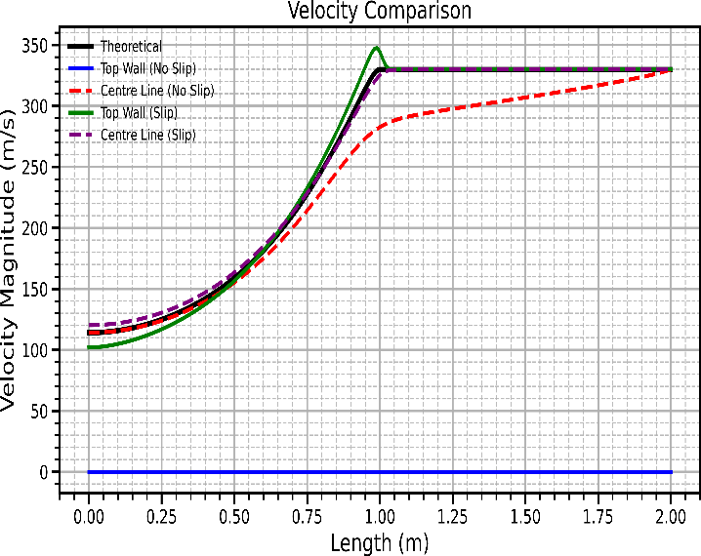

Mach Contours
Mach contours provide a qualitative visualization of the acceleration process within the duct. The slip-wall case exhibited a nearly uniform acceleration and closely followed isentropic behaviour. In contrast, the no-slip case showed the influence of wall effects and non-uniform velocity distribution due to boundary layer development.
Figure 8: Mach Contour – Slip Wall Case
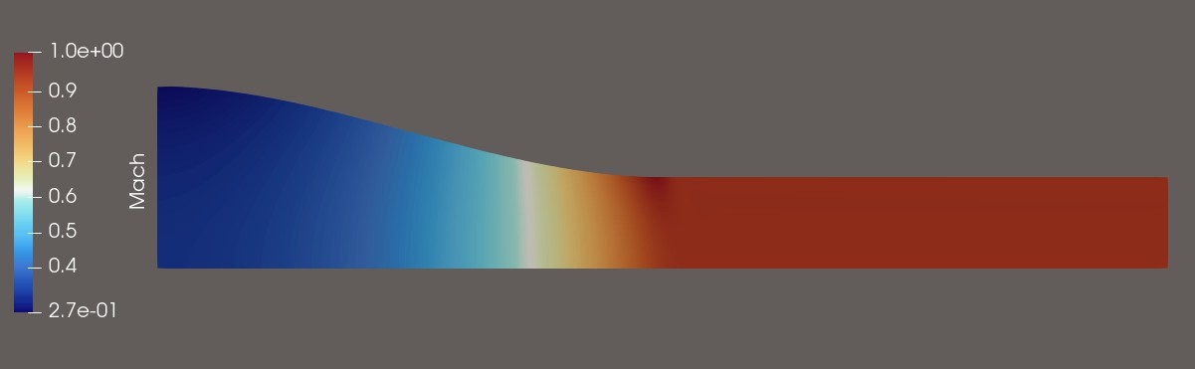

Figure 9: Mach Contour – No-Slip Wall Case
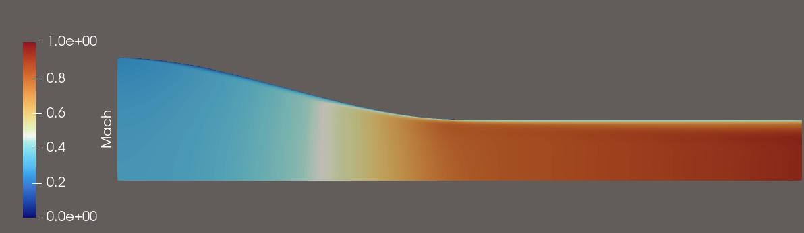

Cross-Sectional Profiles (No-Slip Case)

Pressure Ratio Profiles
The pressure ratio profiles indicate a reduction in pressure from the centreline towards the wall region. As the duct length increased, the pressure distribution became more uniform across the cross-section.
Figure 10: Pressure Ratio Profiles
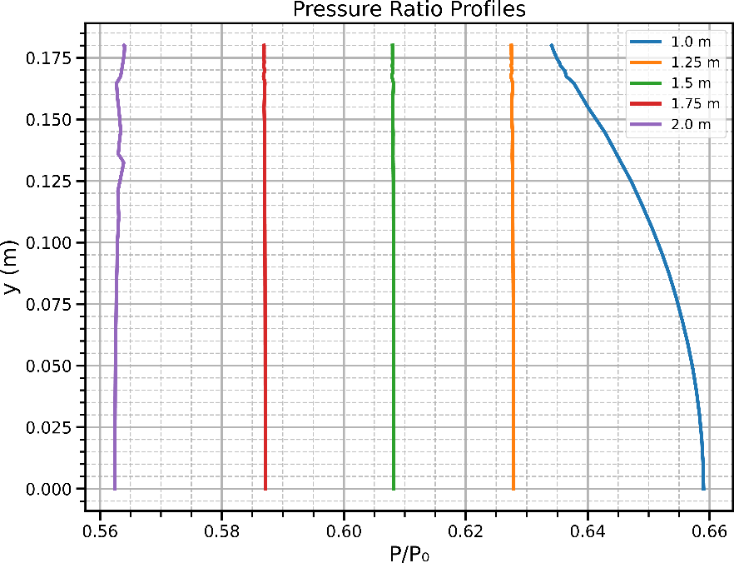

Velocity Profiles
The velocity profiles show the effect of the no-slip wall condition. Velocity decreases near the wall due to boundary layer formation, while the core flow maintains higher velocity values. The boundary layer thickness increases with duct

length.
Figure 11: Velocity Profiles
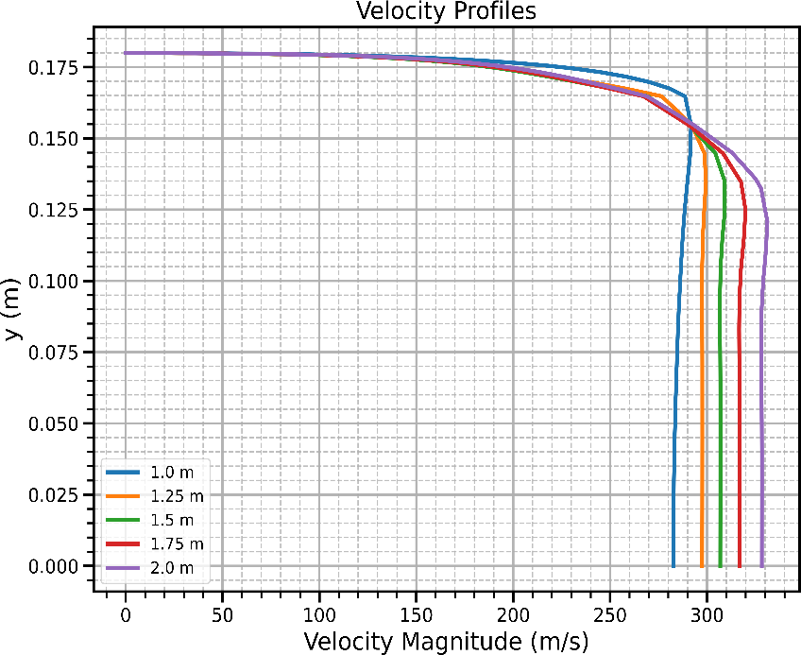

Mach Number Profiles
The Mach number distribution follows a trend similar to the velocity profiles. Higher Mach numbers are observed in the core region, whereas lower values occur near the wall because of viscous effects.
Figure 12: Mach Number Profiles
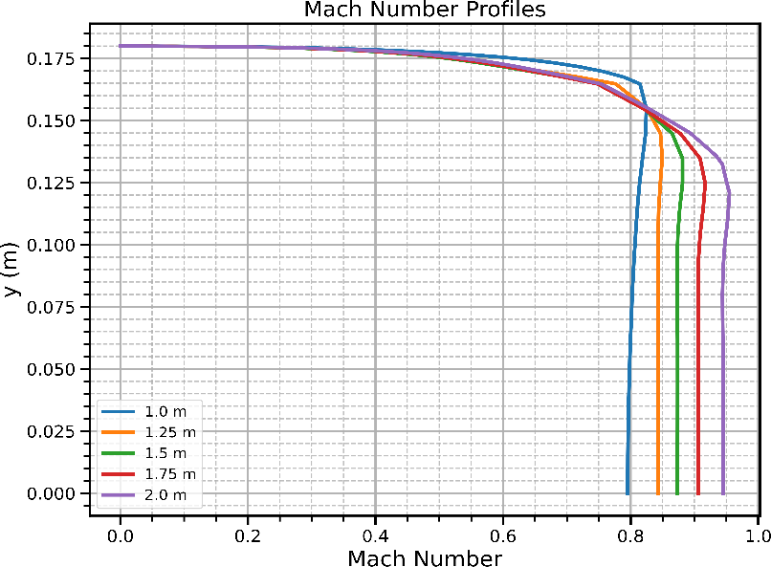

Temperature Profiles
The temperature profiles indicate higher temperatures near the wall and lower temperatures in the accelerated core region. This behaviour is consistent with the velocity and Mach number distributions.

Figure 13: Temperature Ratio Profiles
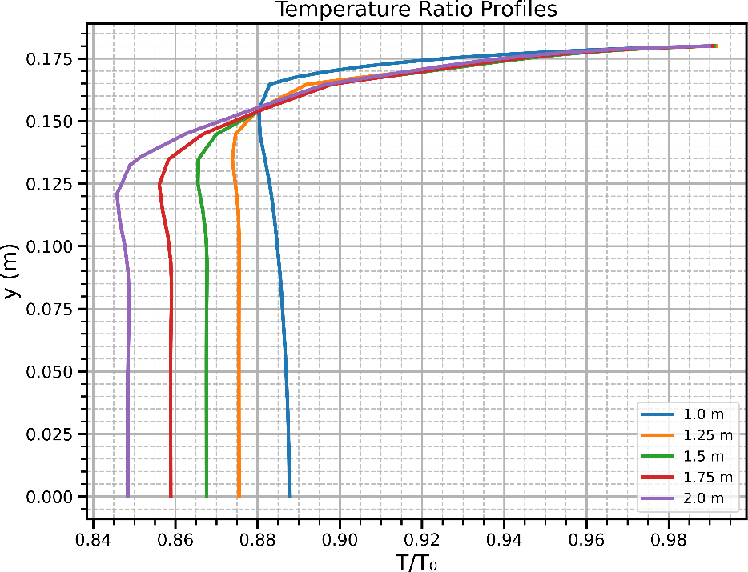

Density Profiles
The density ratio decreases in regions where acceleration is stronger. The profiles demonstrate the redistribution of flow properties across the duct height as the boundary layer develops.
Figure 14: Density Ratio Profiles

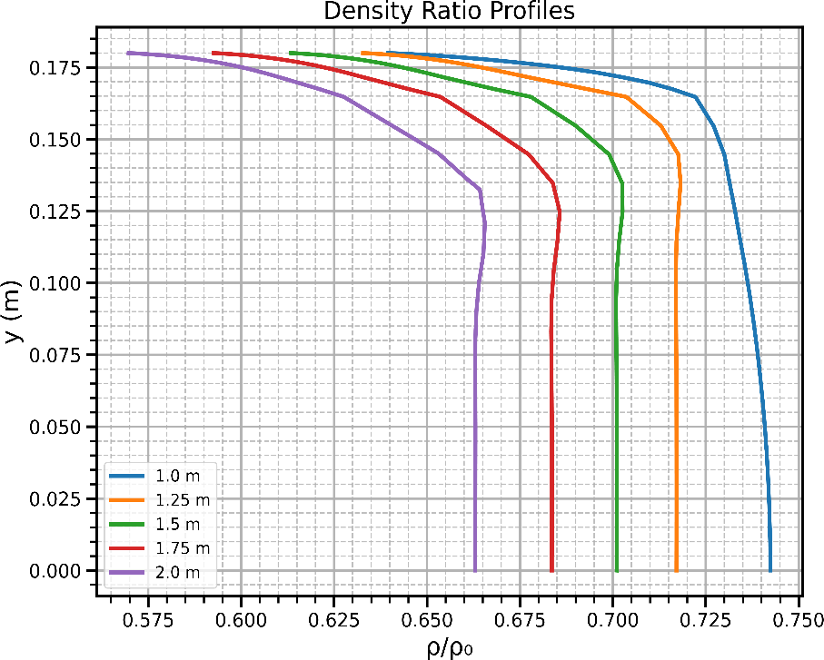

  - Extended 1 m Duct (Mach ≈ 0.4) Figure Placement

Figure 10: Mach Number Comparison (M ≈ 0.4)
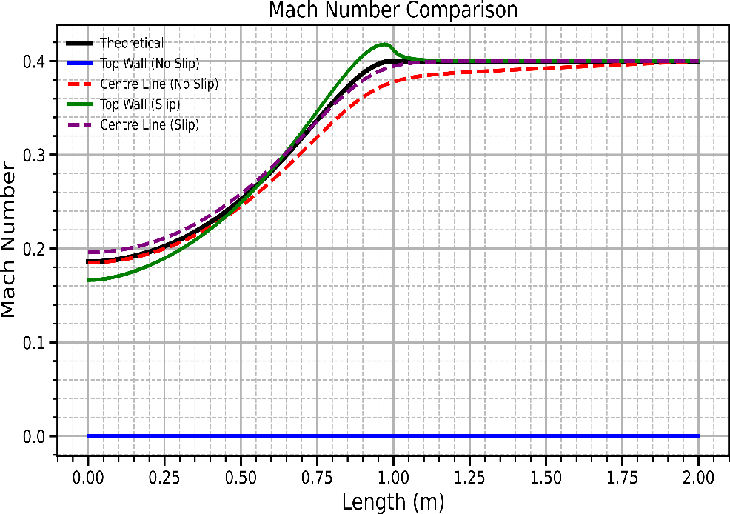
Figure 11: Pressure Ratio Comparison (M ≈ 0.4)

Figure 12: Temperature Ratio Comparison (M ≈ 0.4)
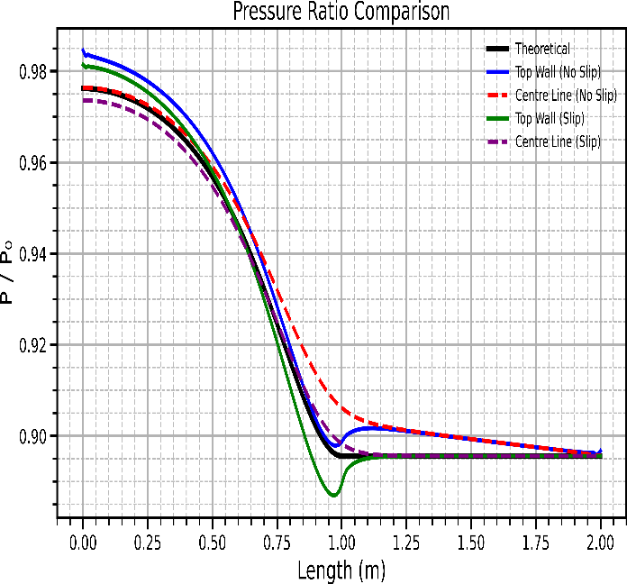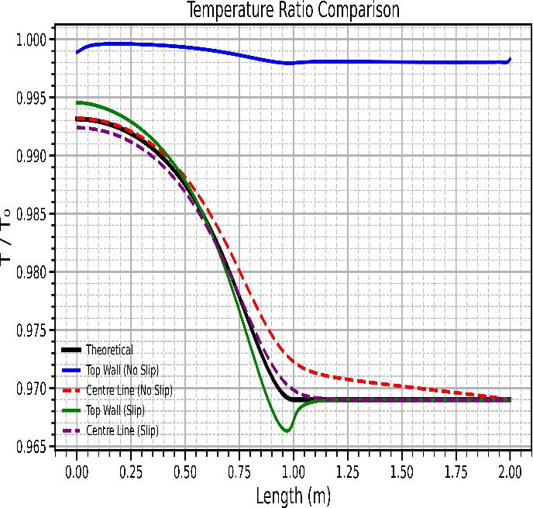
Figure 13: Density Ratio Comparison (M ≈ 0.4)
Figure 14: Velocity Comparison (M ≈ 0.4)
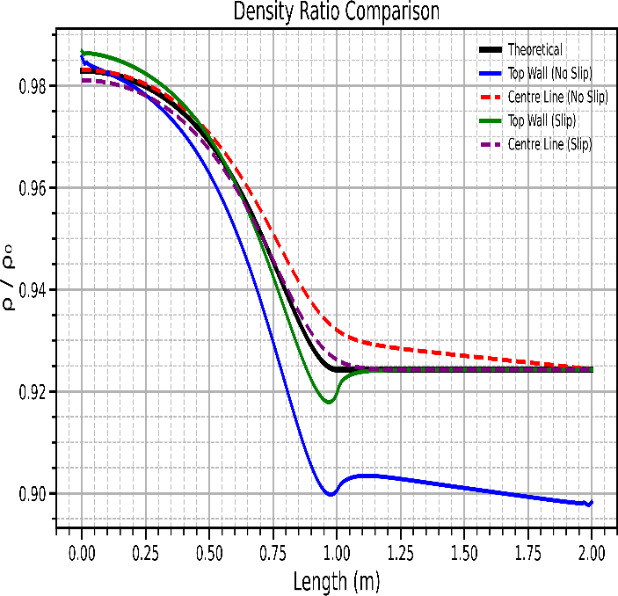
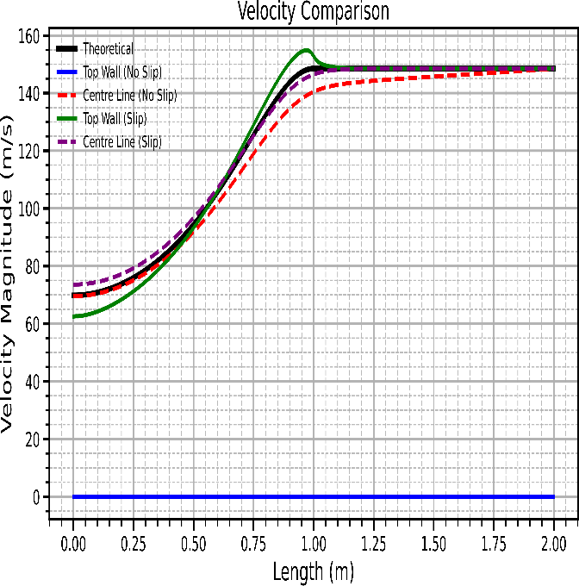
  - Extended 1 m Duct (Mach ≈ 0.6) Figure Placement

Figure 15: Mach Number Comparison (M ≈ 0.6)

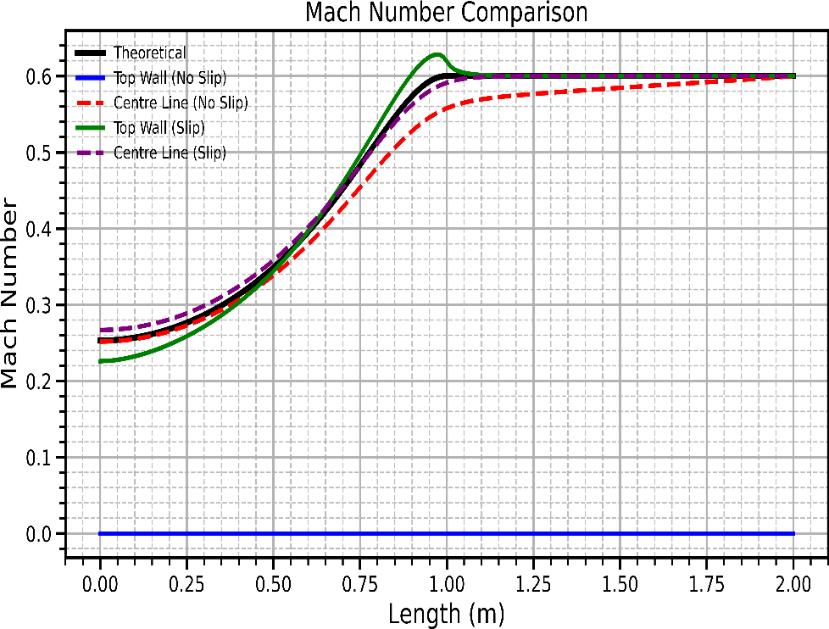

Figure 16: Pressure Ratio Comparison (M ≈ 0.6)
Figure 17: Temperature Ratio Comparison (M ≈ 0.6)
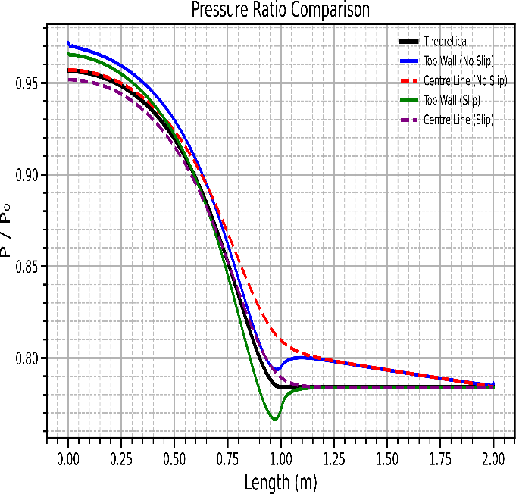
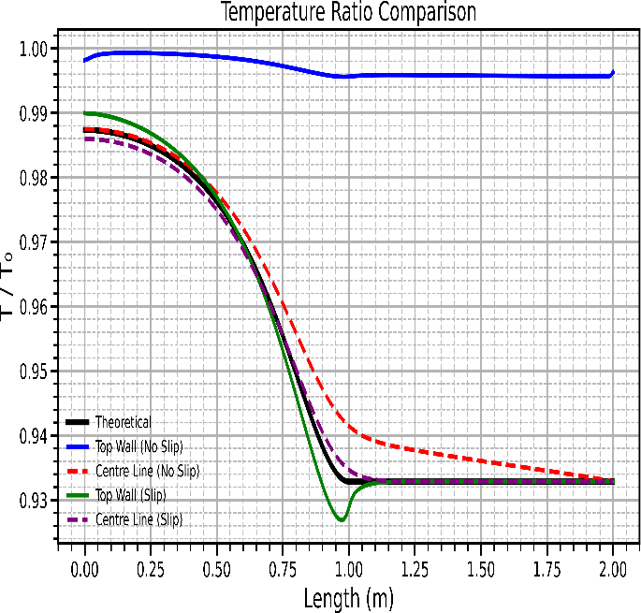

Figure 18: Density Ratio Comparison (M ≈ 0.6)
Figure 19: Velocity Comparison (M ≈ 0.6)
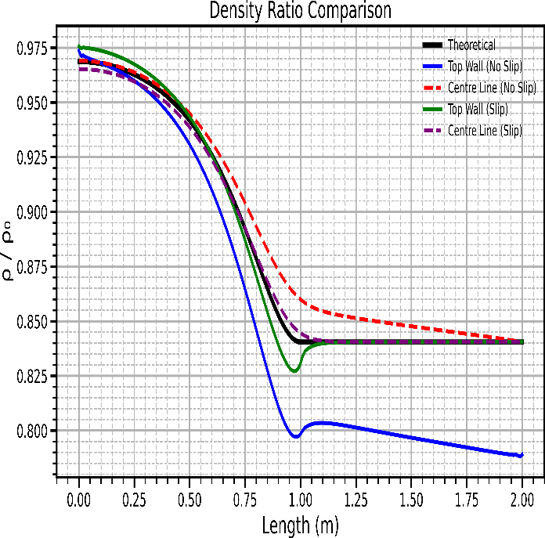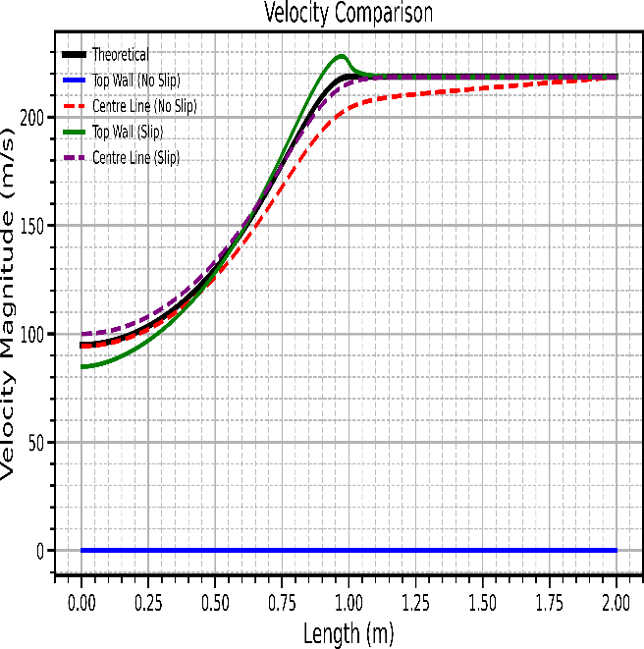

Flow Field Visualization

Figure 20: Mach Number Contour (1 m Converging Duct)
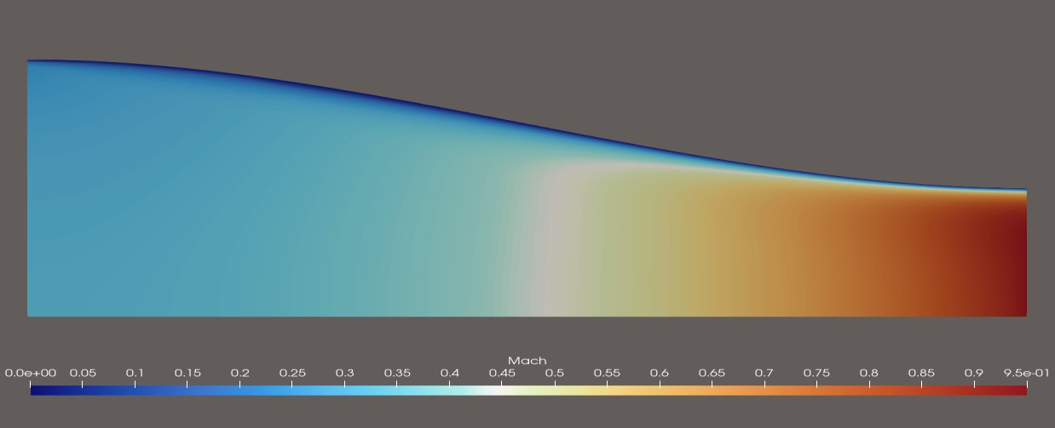
Figure 21: Mach Number Contour (0.5 m Converging Duct) 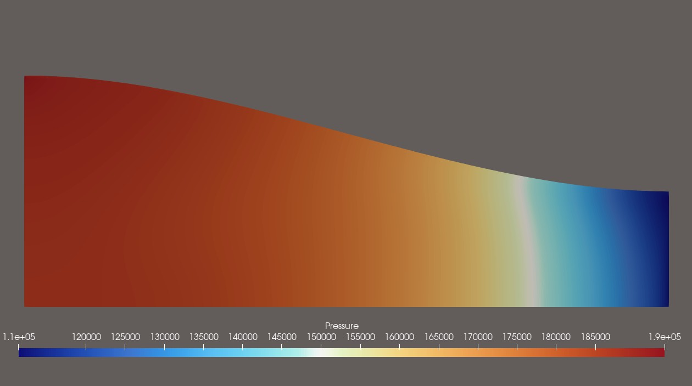

Figure 22: Mach Number Contour (0.25 m Converging Duct)
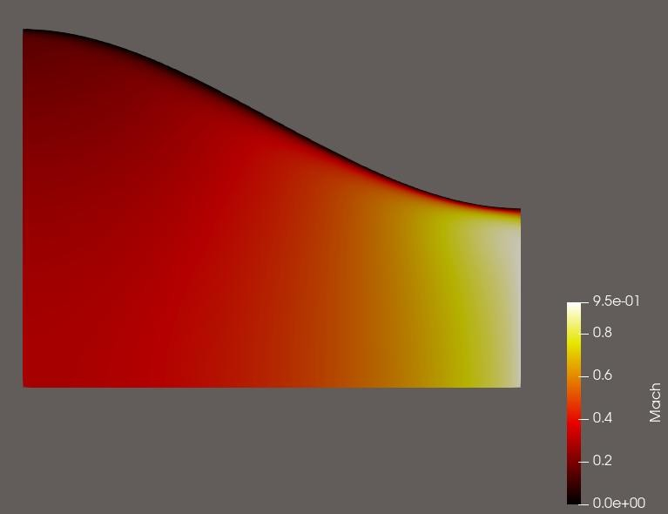
Figure 23: Static Pressure Contour (1 m Duct)

Figure 24: Static Pressure Contour (0.5 m Converging Duct)
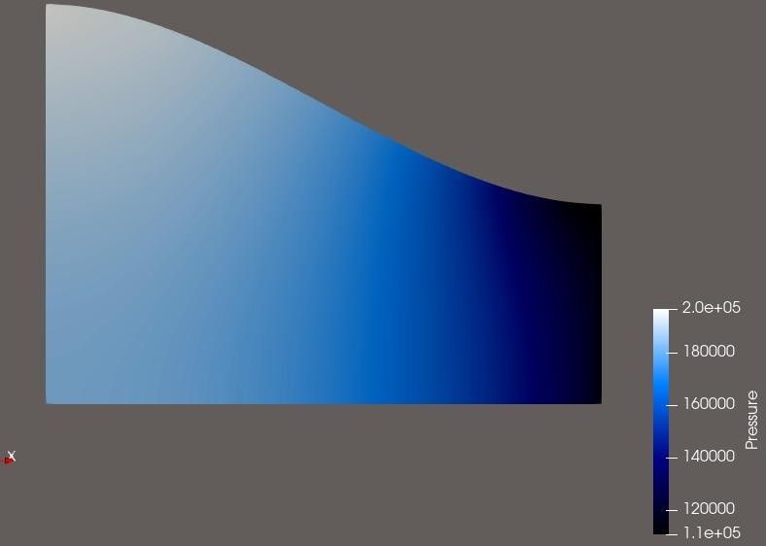
Figure 25: Static Pressure Contour (0.25 m Converging Duct)
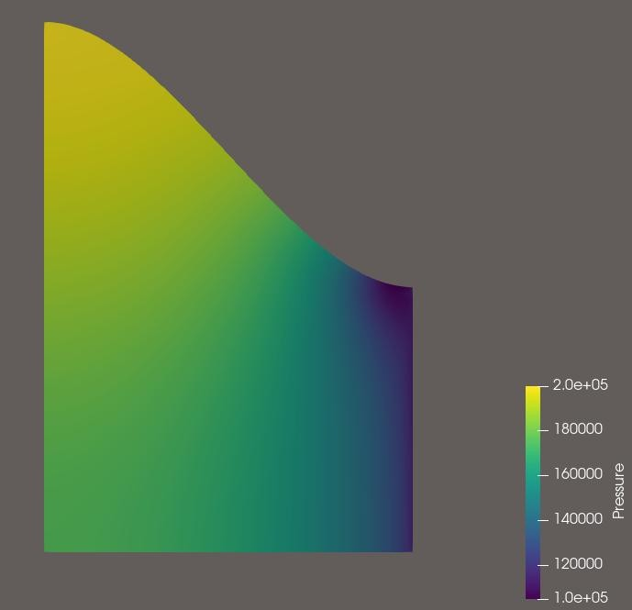
Figure 26: Static Temperature Contour (1 m Converging Duct) 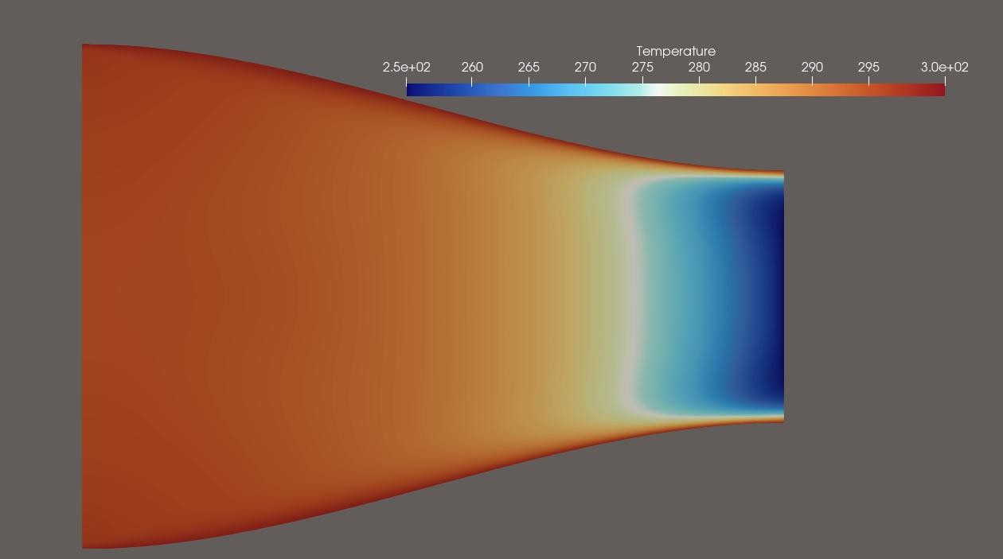

Figure 27: Density Contour (1 m Converging Duct)
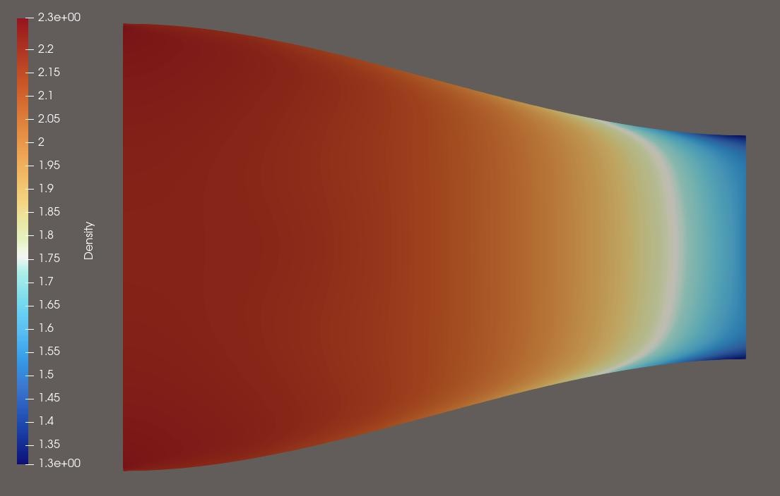

Figure 28: Velocity Magnitude Contour (1 m Converging Duct)

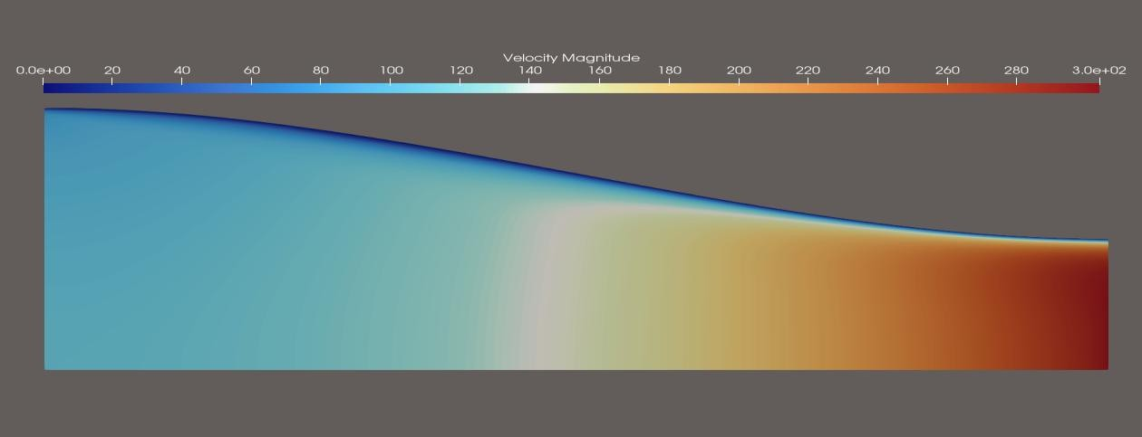

Conclusion

The present study investigated compressible flow through converging duct configurations using the SU2 CFD solver. Simulations were performed for different outlet pressure conditions and duct geometries to examine the variation of flow properties under both slip-wall and no-slip wall boundary conditions.
The numerical results demonstrated the expected acceleration of subsonic flow within the converging section, accompanied by corresponding decreases in static pressure, temperature, and density. Comparison with one-dimensional isentropic relations showed good agreement for slip-wall cases, while deviations were observed for no-slip wall conditions due to viscous effects and boundary layer development.
The influence of outlet pressure on the flow acceleration was successfully captured, enabling the investigation of cases corresponding to different exit Mach numbers. The extended duct simulations also provided insight into the downstream evolution of flow properties beyond the converging section.
Contour visualizations and profile analyses revealed the effects of duct geometry and wall boundary conditions on the flow field. The results confirm that SU2 is capable of accurately predicting compressible internal flows and can be effectively used for the analysis of converging duct configurations.
Overall, the study provided a numerical assessment of compressible flow behavior in converging ducts and highlighted the importance of geometry, outlet conditions, and wall effects in determining the resulting flow characteristics.

- Three-Dimensional Simulation

Three-Dimensional Geometry and Computational Domain

The same simulation setup used in 2d case was for 3d case.

In 3d case 0.36 M extrusion was given.

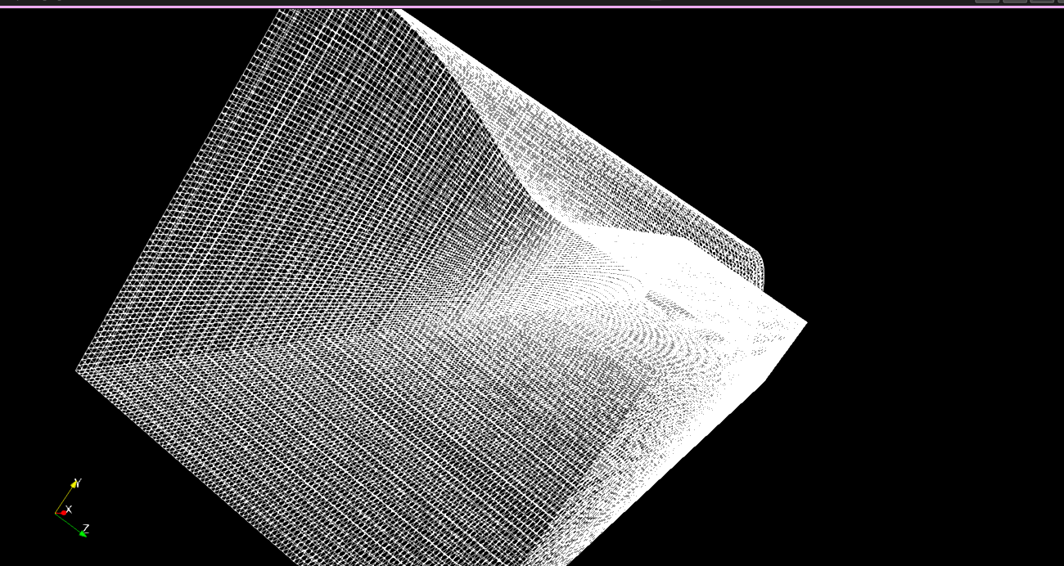
Elements :683100
Structured mesh
Statistics

Results

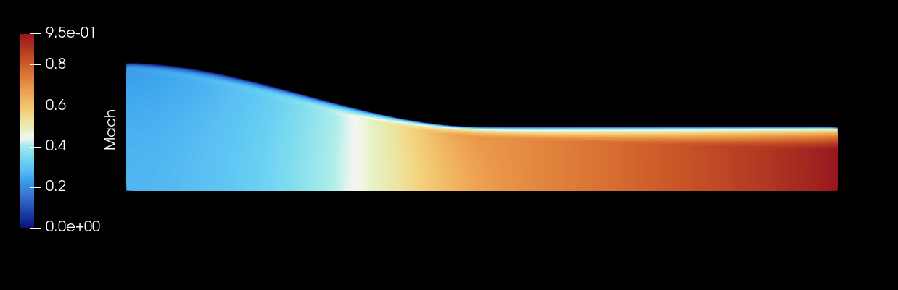

Contours of slice at 0.18 m Thickness
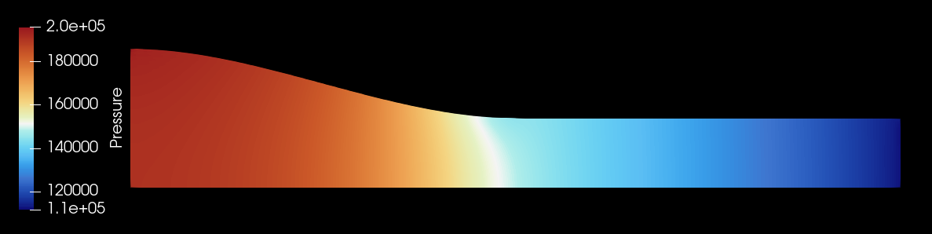
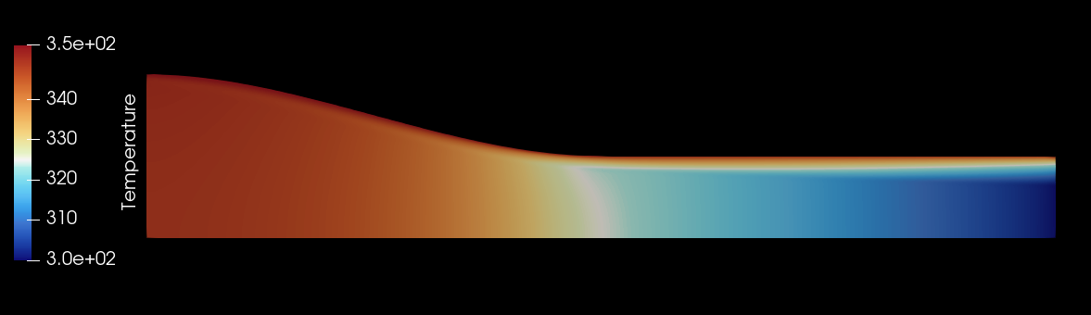
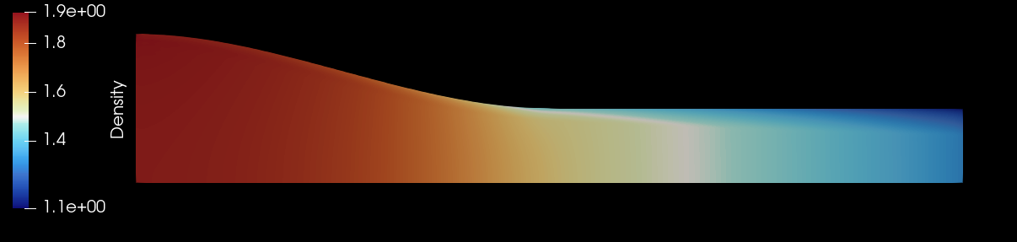

Cross sections
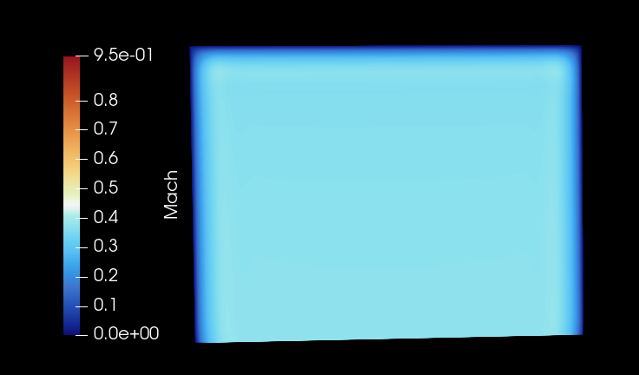
At 0.5m
At 0.5m

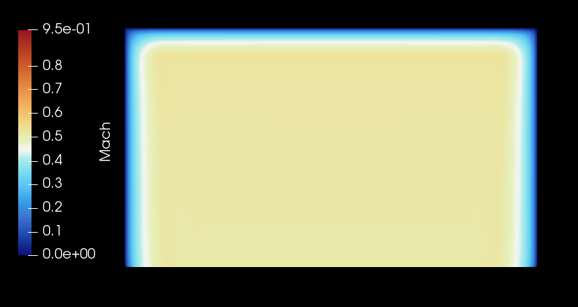
At 0.75m
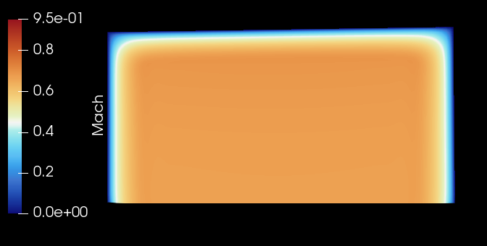
At 1m
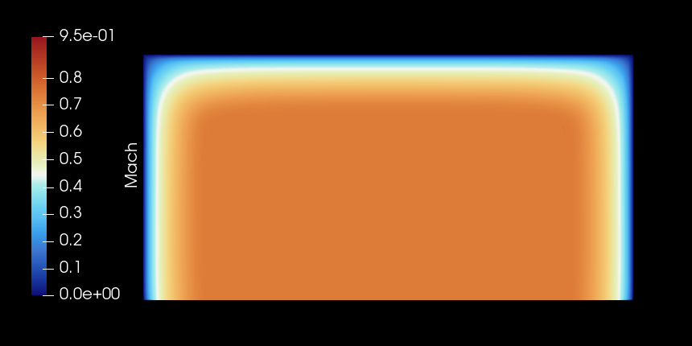
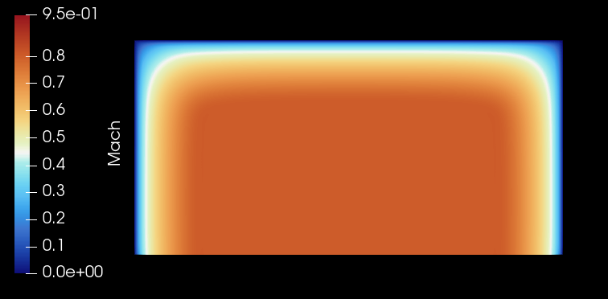
At 1.25m

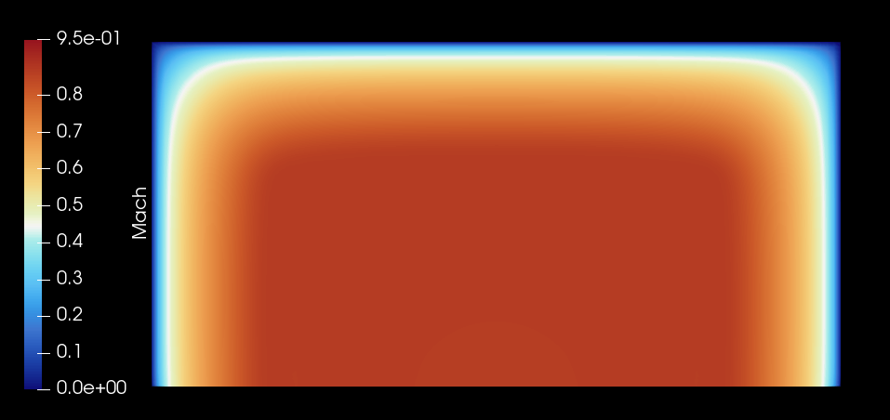
At 1.75m
At 1.50m
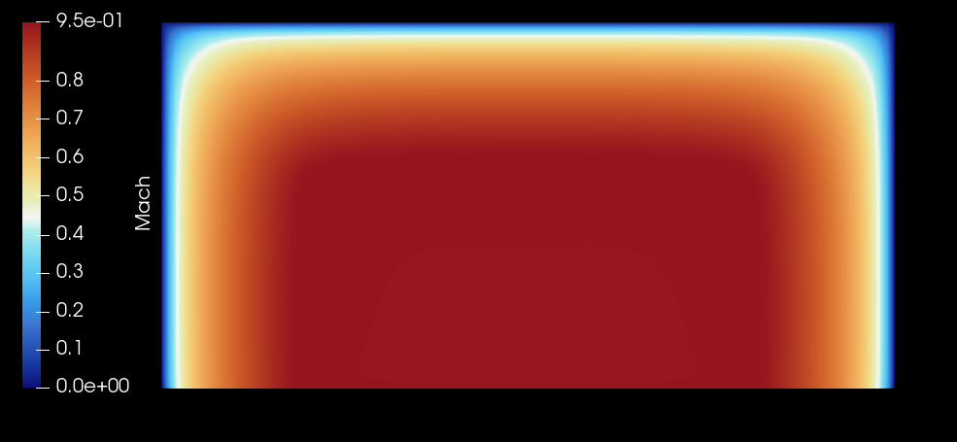
At 2m



