**PIZZA SALES PROJECT (SQL, POWERBI)**

**PROBLEM STATEMENT:**

Analyze key indicators (KPI) for pizza sales data to gain the insights for business performance and calculate the following metric:

**A. KPI**

1. Total Revenue
2. Total Orders
3. Average Order Value
4. Total Pizzas Sold
5. Average Pizza Per Order

**B. ORDER TREND**

1. Daily Trend for Total Orders
2. Hourly Trend for Total Orders
3. Monthly Trend for Total Orders

**C. OTHER METRIC**

1. Sales Percentage by Pizza Category
2. Sales Percentage by Pizza Size
3. Total Pizza Sold by Category
4. Top Pizza by Sales
5. Bottom Pizza by Sales
6. Top Pizza by Quantity
7. Bottom Pizza by Quantity

**A.KPI**

**1. Total Revenue:**

select sum(total_price) as total_revenue from pizza_sales;



**2. No of orders**

select count(distinct order_id) as total_orders from pizza_sales;



**3. Average order value**

select sum(total_price)/count(distinct order_id) as avg_order_value from pizza_sales;



**4. Total pizzas sold**

select sum(quantity) as total_pizzas_sold from pizza_sales;



**5. Average pizza per order**

select cast(cast(sum(quantity)as decimal(10,2)) / cast(count(distinct order_id)as decimal(10,2)) as decimal(10,2)) as avg_pizza_per_order from pizza_sales;



**B. ORDER TREND**

**1. Daily trend for Total orders**

select datename(dw,order_date) as order_day, count(distinct order_id) as total_order from pizza_sales group by datename(dw,order_date);

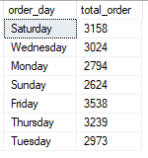

**2. Hourly trend for total order**

SELECT datepart(hour, order_time) as order_hour, count(distinct order_id) as total_order from pizza_sales group by datepart(hour, order_time) order by datepart(hour, order_time);

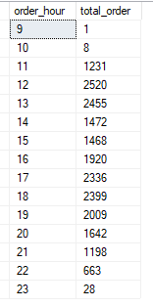

**3. Monthly trend**

select datename(month,order_date) as order_month, count(distinct order_id) as total_order from pizza_sales group by datename(month, order_date);

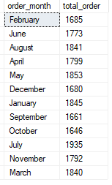

**C.OTHER METRIC**

**1. Sales % by Pizza category**

select pizza_category,sum(total_price) as total_sales, sum(total_price)*100/ (select sum(total_price) from pizza_sales) as pct_sales from pizza_sales group by pizza_category;

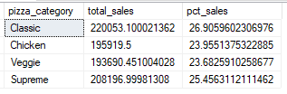

**2. Sales % by Pizza size**

select pizza_size,sum(total_price) as total_sales, sum(total_price)*100/ (select sum(total_price) from pizza_sales) as pct_sales from pizza_sales group by pizza_size order by pct_sales;

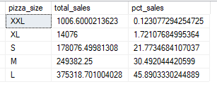

**3. Total Pizza sold by Category**

select pizza_category,sum(quantity) as total_quantity_sold from pizza_sales group by pizza_category order by total_quantity_sold desc;

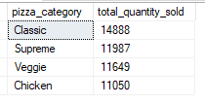

**4. Top 5 pizza by Sales**

select top 5 pizza_name, sum(total_price) as total_sales from pizza_sales group by pizza_name order by total_sales desc;

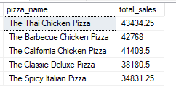

**5. Bottom 5 pizza by sales**

select top 5 pizza_name, sum(total_price) as total_sales from pizza_sales group by pizza_name order by total_sales asc;

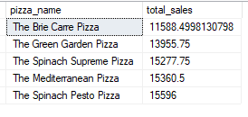

**6.Top 5 pizza by sales quantity**

select top 5 pizza_name, sum(quantity) as total_quantity from pizza_sales group by pizza_name order by total_quantity desc;

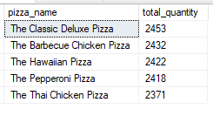

**7.Bottom 5 pizza by sales quantity**

select top 5 pizza_name, sum(quantity) as total_quantity from pizza_sales group by pizza_name order by total_quantity asc;

