**Database Schema (database name - classicmodels)**

This MySQL database consists of the following tables:

* customers - Stores customer’s data
* products – Stores a list of scale model cars
* productlines – Stores a list of product line categories
* orders – Stores sales orders placed by customers
* orderdetails – Stores sales order line items for each sales order
* payments – Stores payments made by customers based on their accounts
* employees – Stores all employee information as well as the organization structure
* offices – Stores sales office data

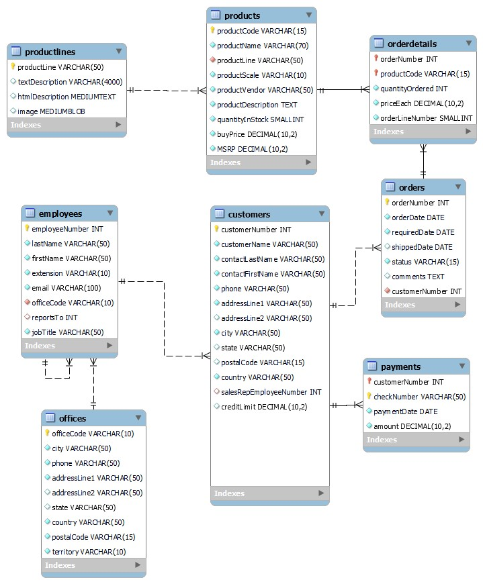

|  |  |  |  |  |
| --- | --- | --- | --- | --- |
| Table Name | Columns | Data Type & Size | Null | Keys |
| customers | customerNumber | int | NO | PRI |
|  | customerName | varchar(50) | NO |  |
|  | contactLastName | varchar(50) | NO |  |
|  | contactFirstName | varchar(50) | NO |  |
|  | phone | varchar(50) | NO |  |
|  | addressLine1 | varchar(50) | NO |  |
|  | addressLine2 | varchar(50) | YES |  |
|  | city | varchar(50) | NO |  |
|  | state | varchar(50) | YES |  |
|  | postalCode | varchar(15) | YES |  |
|  | country | varchar(50) | NO |  |
|  | salesRepEmployeeNumber | int | YES | MUL |
|  | creditLimit | decimal(10,2) | YES |  |

|  |  |  |  |  |
| --- | --- | --- | --- | --- |
| products | productCode | varchar(15) | NO | PRI |
|  | productName | varchar(70) | NO |  |
|  | productLine | varchar(50) | NO | MUL |
|  | productScale | varchar(10) | NO |  |
|  | productVendor | varchar(50) | NO |  |
|  | productDescription | text | NO |  |
|  | quatityInStock | smallint | NO |  |
|  | buyPrice | decimal(10,2) | NO |  |
|  | MRSP | decimal(10,2) | NO |  |

|  |  |  |  |  |
| --- | --- | --- | --- | --- |
| productLines | productLine | varchar(50) | NO | PRI |
|  | textDesciption | varchar(4000) | YES |  |
|  | htmlDescription | mediumtext | YES |  |
|  | image | mediumblob | YES |  |

|  |  |  |  |  |
| --- | --- | --- | --- | --- |
| orders | orderNumber | int | NO | PRI |
|  | orderDate | date | NO |  |
|  | requiredDate | date | NO |  |
|  | shippedDate | date | YES |  |
|  | status | varchar(15) | NO |  |
|  | comments | text | YES |  |
|  | customerNumber | int | NO | MUL |

|  |  |  |  |  |
| --- | --- | --- | --- | --- |
| orderDetails | orderNumber | int | NO | PRI |
|  | productCode | varchar(15) | NO | PRI |
|  | quantityOrdered | int | NO |  |
|  | priceEach | decimal(10,2) | NO |  |
|  | orderLineNumber | smallInt | NO |  |

|  |  |  |  |  |
| --- | --- | --- | --- | --- |
| payments | customerNumber | int | NO | PRI |
|  | checkNumber | varchar(50) | NO | PRI |
|  | paymentDate | date | NO |  |
|  | amount | decimal(10,2) | NO |  |

|  |  |  |  |  |
| --- | --- | --- | --- | --- |
| employees | employeeNumber | int | NO | PRI |
|  | lastName | varchar(50) | NO |  |
|  | firstName | varchar(50) | NO |  |
|  | extension | varchar(10) | NO |  |
|  | email | varchar(100) | NO |  |
|  | officeCode | varchar(10) | NO | MUL |
|  | reportsTo | int | YES | MUL |
|  | jobTitle | varchar(50) | NO |  |

|  |  |  |  |  |
| --- | --- | --- | --- | --- |
| offices | officeCode | varchar(10) | NO | PRI |
|  | city | varchar(50) | NO |  |
|  | phone | varchar(50) | NO |  |
|  | addressLine1 | varchar(50) | NO |  |
|  | addressLine2 | varchar(50) | YES |  |
|  | state | varchar(50) | YES |  |
|  | country | varchar(50) | NO |  |
|  | postalCode | varchar(15) | NO |  |
|  | territory | varchar(10) | NO |  |