State Of the Future Index (SOFI) Method

By

Theodore J. Gordon
with updates by Elizabeth Florescu

I. History of the Method

II. Description of the Method

III. How to Do It

IV. Conducting a SOFI Analysis

V. Strengths and Weaknesses of the Method

VI. Frontiers of the Method

VII. Combining with other Methods

Appendices
Appendix A. Example of the Method

Appendix B. SOFI Software Development

Bibliography

Acknowledgments

Theodore J. Gordon has developed the State Of the Future Index (SOFI) and continuously improved it over some 20 years.

Valuable comments and suggestions on the first version of this method were received from Jerome Glenn, The Millennium; Joseph Coates, Joseph Coates Consulting Futurists, Washington, D.C., USA; Osmo Kuusi, Consultant for the Committee for the Future, Parliament of Finland; Peter Bishop, Founder, Program for the Study of the Future, University of Houston, USA; and José Cordeiro, Chair of the Millennium Project Node in Venezuela.

The team for the SOFI Software Development (presented in Appendix B) was formed of: Peter Yim (project director), Jonathan Cheyer (technical lead and architect), Douglas C. Engelbart (system architecture advisor), Adam Cheyer, John Bear, Kurt Conrad, Lisa Colvin, Eric Garlick, Darren Haas, Hal Hildebrand, Mary Keitelman, David Leibs, and Bo Newman.

SOFI project support over the years has been provided by Elizabeth Florescu, John Young, and Kawthar Nakayima.

I. HISTORY OF THE METHOD

Is the future getting better or worse? How could the complexity of potential futures be simplified and put into perspective in a form that is easily accessible and understandable? How can policymakers be informed about long-term global trends across various key sectors — such as social, economic, environmental, technological, and others — for enabling data-driven decisions that proactively address future challenges? In this sense, nothing can be more expressive than composite indexes and graphs.

Indexes have been constructed in a variety of areas to aggregate many factors into a single number that depicts the general state of affairs. Some indexes such as the OECD Better Life Index, and the UNDP Human Development Index measure average progress based on some key dimensions at country levels. Dow Jones Industrial Average, S&P 500, Russell 2000 and many others quantify the aggregate state of certain stocks. Such indexes have very stringent quality controls applied to the data and computational processes, and generally, show the current or very short-term state of affaires.

Polls are being conducted to obtain public perceptions about the future outlook (e.g., “Do you think things are likely to get better or worse?”), but such surveys are subject to recent news and media pressures, people answering may not know the long-term trends, discount or not know about recent improvements or threats, and the answers are strongly biased by the respondents' personal believes.

By 1999, the Millennium Project has already identified the 15 Global Challenges as a framework for thinking about the future, assessing their evolution of qualitative, as well as quantitative point of view. But what about the combined effects of the challenges? How does their interaction impact the future as a whole, and which are the impacts of various factors of change on the whole system? The quest to answer these questions led to the construction of a State of the Future Index (SOFI), as a graphical representation of the potential outlook of the future based on the combination of several indicators relevant to the 15 global challenges.

Many issues must be considered when constructing such an index, since it's difficult to reduce the future to a simple line. Therefore, for developing the SOFI, the Millennium Project conducted a thorough study. Consultations suggested that a SOFI would need historical data for a period at least double of that forecasted (e.g., for a 10 years forecast, data for at least 20 years directly prior to the forecasted period.) In 1999–2000, the Global Lookout Panel of the Millennium Project suggested and selected the indicators to be considered for a SOFI. The indicators were selected through a series of international questionnaires and refined through a review of index studies (Glenn and Gordon 2008), and evaluated in terms of their usefulness and availability of reliable data.

In 2001, after a list of indicators for SOFI has been established, a Global Lookout Panel collected judgments about what would be the best (norm) and worst (dystopic) status for each indicator in 2011. They also rated the relative importance of each indicator for the system as a whole.

Figure 1 presents the first SOFI. It was computed in 2001 with outlook to 2011, and included 19 indicators.

Figure 1. State of the Future Index 2011
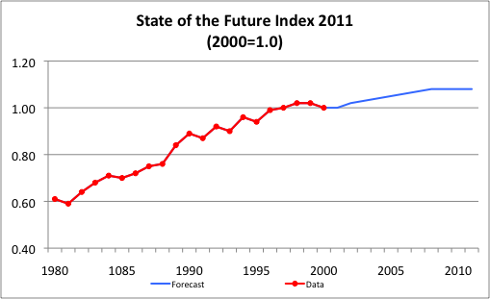

Over the years, the SOFI computation has evolved and the factors considered have been reassessed periodically. The reassessments include:
- Updates on the indicators included in the SOFI, their weights, and expectations about the best and worst values they might attain by the end of the forecasted period.
- Review of data sources.
- Reassessment of each indicator's trajectory.
- Further development of the forecasting approaches used in extrapolating the variables (use of Trend Impact Analysis).
- Collection of judgments about future developments that could be important to the course of the indicators included in the SOFI.
- Application of the SOFI approach to individual countries.
- Integration of the technique with the International Futures (IFs) global model.

Judgments on SOFI indicators are usually collected using a Real-Time Delphi questionnaire. An example of such a question is shown in Figure 17, in section "V. Strengths and Weaknesses of the Method".

Since 2001, each SOFI study's results have been reported in the Millennium Project’s State of the Future reports and the latest SOFI version has been posted online, on The Millennium Project's website, under "Projects/Programs".

Automating the SOFI computation has been attempted, but it's not an easy process. From the selection of the indicators to be included in the SOFI, to choosing the equations for the trajectories of the variables, all the steps imply collective, non-biased judgments based on considerable expertise from divers sectors and types of organizations. Most importantly — as the main problem with all modeling — data ontology has not been solved yet. Appendix B shows the concept for developing a SOFI software system, attempt that was not finalized by lack of funding. However, considering the fast advancements in cybernetics, collaborative systems, and artificial intelligence, there is a high potential for automating this sort of application.

There were several efforts for improving the visualization and even a partial automation of SOFI computation. The latest example can be seen at [..to be added the project led by Andreas Bueckle, from Luddy School of Informatics, Computing and Engineering, Indiana University Bloomington. ........] linked from the SOFI webpage.

If confidence were developed in such an index, it could be useful for setting priorities: strategies could be evaluated and compared based on their potential impact on the system as a whole.

One of the reviewers of the original version of this chapter said:
If properly communicated, the SOFI (could) become a reference and play a role in shaping the future. In this ultimate step, the SOFI surpasses its function of passive measurement to become an award for good and bad achievements, thereby contributing to changing significantly the behavior of the key actors.

II. DESCRIPTION OF THE METHOD

Note: throughout this SOFI chapter, the terms "indicator" and "variable" are used interchangeably, depending on the context: "indicators" refer to the components of the SOFI (as elements of the system and sources of data), while "variables" represent the role of the respective indicators in the SOFI computation/equation.

SOFI is a graphical representation of the potential future outlook based on historical data and mathematically assessed likely trajectories for a selection of indicators representative for the system. It helps identifying positive and negative changes to the component factors, the interplay among them, informs about the outlook of the future, and creates a framework for assessing potential options.

Figure 2 illustrates the global SOFI for 2035. Its analysis is discussed further in this chapter.

Figure 2. State of the Future Index 2035
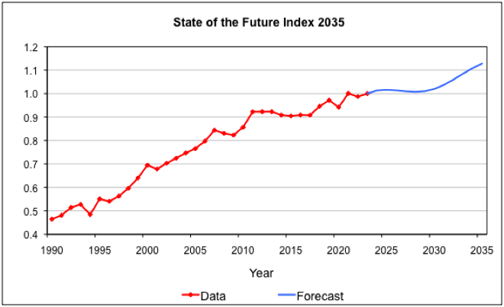

SOFI is similar to other indexes since it combines many indicators into a single measure, but it differs in several important respects. While most indexes are concerned with the past, present, and eventually, short-term future, SOFI is designed to give an impression about a longer-term future. The majorities of indexes are cross-sectional and are designed to compare countries to countries or various groups of countries at some point in time (usually the most recent possible). The SOFI is longitudinal and is designed to track and project change over time, focusing on the future state of the indicators.

SOFI is also unique as it was designed based on suggestions from the Millennium Project’s Global Lookout Panel — hence, involving a large number of experts from around the world, from several disciplines and types of organizations, without a set agenda or specific interests.

In the SOFI, the indicators are individually forecasted and combined into a single measure. Therefore, in addition to the comprehensive system graph, the SOFI process also produces individual graphs with the potential trajectories for each indicator, showing the historical data, assumptions, and judgments. These graphs — see Figure 3 for an illustration — provide valuable bases for more detailed analysis. For each indicator, the data source is also specified.

Figure 3. Example of Forecast for an Individual Indicator
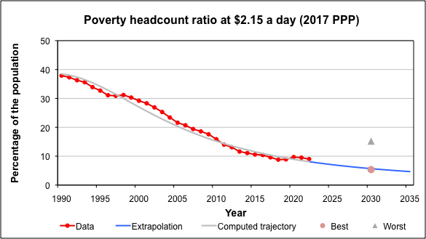
Data source: WB, Poverty headcount ratio at $2.15 a day (2017 PPP) (% of population),
and trajectory computed with CurveExpert Professional

The list of indicators to be included in the SOFI, the variables' weights and the historical data, as well as the individual equations for each indicator's forecast are reviewed periodically, thus adapted to the latest developments.

If the outlook of the future seems to be changing, then the SOFI would make it clear how, and an analysis would make it possible to identify the factors responsible. Data manipulation function of various policies could show the potential ripple effect of those actions on the system. Such sensitivity analysis can help identify areas or policies that could have a positive or negative impact on the system as a whole.

Since the SOFI is designed to be an aggregated measure, it can mask differences among nations and regions; the global SOFI could look very positive and yet, for some domains or nations, the situation could be worsening. Therefore, it is important to recognize that disaggregated SOFI analyses are essential to identify those areas or nations. Also, for more detailed analysis, specific data and weights can be used to see how things seem to be changing.

SOFI can — and has been — computed for the global future outlook, as well as for that of countries, regions, or even sectors of activity.

Obviously, national SOFIs use national data.

Two major types of national SOFIs can be considered:
- National Comparison SOFI — national SOFIs designed to be compared to SOFIs of other countries. This type of SOFI uses a standard set of variables and assumptions that will be identical in all aspects of the computation. It can be used to compare countries at any point in time (e.g., cross-sectional comparison). The variables included in this type of SOFI will cover a broad span and have meaning and importance to essentially all countries that are being compared. Attention has to be paid that the meaning of progress/regress for all indicators be the same for all countries that are being compared. For example, fertility rate improvement would mean reduction to a country as Niger, where it was 6.75 in 2022, while for South Korea, which had a fertility rate of 0.78 the same year, improvement would mean increase; hence, it could be confusing to consider this indicator for SOFI comparison.

- National Focus SOFI — designed to assess and track a country’s progress over time, using a set of variables that may be unique to that country, as well as certain other assumptions that reflect a country’s goals, concerns, and expectations. Countries will not be able to perform one-to-one comparisons of National Focus SOFIs because they will be built using different country-specific elements, but they will afford a country the means of tracking its performance over time (longitudinal tracking). For example, while no country is entirely free of freshwater concerns, the indicator for freshwater availability would have a different priority for countries concerned about persistent drought (e.g. Yemen), than for countries with no such distress (e.g. Switzerland).

Individual countries that computed their national SOFIs with The Millennium Project's assistance include: Azerbaijan, Czech Republic, Hungary, Pakistan, Poland, Slovak Republic, South Africa, South Korea, Turkey, and most of the Latin American states, wile some other countries computed it on their own.

III. HOW TO DO IT

Building a State of the Future Index (SOFI) consists of several steps, each of them involving some assumptions. Therefore, a minimum knowledge of economics, statistics/mathematics, and foresight would be beneficial.

1. Choosing the indicators to be included in a State of the Future Index. This is the most important step, since on the choice of indicators depends the relevance of SOFI. It involves a very clear understanding of the domain and extent for which SOFI is computed. Is it for global, national, or regional level? Is it for general future or for a certain sector/domain? What aspects should be included? What does a promising future mean for that area and in the respective timeframe? What can be considered an improvement? How would we know it if it happened? What would influence it?

The most important criteria for selecting the indicators are:
- clarity; the indicators have to be clearly defined and change has to be an indicator of progress or regress — e.g. reduction of number of wars is an indication of a more peaceful world, hence, progress; while increase in defense expenditure can't be an indication nor for a more peaceful, nor for a more belligerent world.
- data availability; the indicators have to have data available from reliable sources for a period at least double of that for which we forecast — e.g., for a 10 years forecast, at least 20 years of historical data immediately prior to the forecasted period.
- actionable; when possible, it is preferable to use indicators that can be influenced by human decisions — policies, strategies, etc. — e.g. access to clean drinkable water is measurable and can be improved by human action, while quantity of accessible freshwater is difficult both to measure and to influence.
- avoid double accounting; this has to be considered for avoiding that some areas be over-represented. For example, life expectancy is an important indicator, but at its turn, it is the result of other factors that are also included — e.g. number of physicians to 1,000 people, education, etc. This requires careful thought and examination of the definitions of similar or overlapping variables, and relies on judgments of the analysts to choose variables that best capture the essence of the problem being addressed.

Note: Excellent explanation on these and other issues involved in constructing indexes can be found in OECD's Handbook on Constructing Composite Indicators: Methodology and User Guide (OECD, 2008).

While the main question for any SOFI is the same, "does the future seem to be getting better or worse?", the indicators and the process of selecting them would be quite different pending on the scope and spectrum of the SOFI. For the global SOFI, international panels and a large range of views are important. However, in a corporate setting, a committee might select the indicators; for a specific sector, the best experts in the domain can make the selection. No matter what the technique, in the aggregate, the selected indicators have to represent the key elements of the question that the index is designed to address.

For selecting the indicators and related judgments, the Real-Time Delphi type questionnaires proved to be useful. An example of such a question is shown in Figure 17, in section "V. Strengths and Weaknesses of the Method".

2. Forecasting the variables. Since SOFI is dealing with the future, the indicators used for its computation have to be forecasted. The simplest way is to use a curve-fitting technique: historical data is fed into a software, such as CurveExpert Professional, to get the estimated values for the forecasted period. At this step, the most important is the choice of the equation, since not necessarily the best-fit curve for the set of historical data is the one that would make sense for the respective indicator. Hence, some expertise in econometrics and statistics is useful for choosing the most relevant potential trajectory (and equation) for the variables.

Figure 4 presents an example of forecasting a variable. Each graph presents:
- the historical data — the red dotted line;
- the best-fit curve — the gray continuous line — this is the trajectory generated with CurveExpert Professional;
- the forecasted data based on the trajectory — the blue segment;
- the "Best" and "Worst" data points — the average of the estimates provided by the panel (in this case, by the international panel through a Real-Time Delphi study conducted in 2020 for 2030.)

Figure 4. Example of Variable Forecast
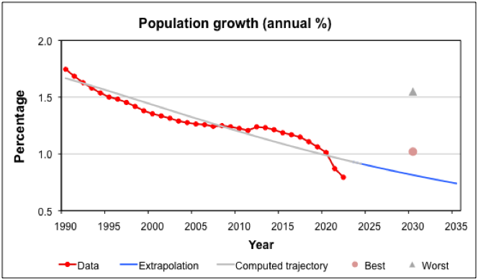
Data source: WB, Population growth (annual %), and trajectory computed with CurveExpert Professional

For rigorousness, it is important that the source of data is listed for each indicator. The equation of the trajectory should also be made available upon request.

At the beginning of SOFI's development, the Global Lookout Panel was asked to provide judgments about what would be the best (norm) and worst (dystopic) status for each nominated indicator at the end of the forecasted period (e.g., 10 years). In the graph of Figure 4, it is interesting to note that these values are way off the trajectory. Since this phenomenon happened for several indicators, and such assessments imply a high level of subjectivity, the use of best/worst values in the computation of SOFI has been abandoned over time. However, since these are, in fact, scenario-like assumptions about how the future may evolve, recent Real-Time Delphi questionnaires still asked for them and they are featured on the graphs for the individual variables (see the graphs in the example of the use of the method presented in Appendix A.) Analyzing why the assessment of a panel of [assumed] informed people would differ so much of the data computed with the software could constitute itself the subject of an interesting study.

3. Normalization; combining the different variables. Since the data of the different indicators included in SOFI is expressed in different units, it is necessary to make all the values commensurate — normalize them — to be expressed in terms that are comparable. Normalization permits the compilation of data of completely different origins and meanings into a single index.

Normalization consists in expressing the values of the variables as a percentage of the range between the worst (MIN) and best (MAX) values of the variable.

The formula for normalization is:
X = (actual value of the variable– MIN)/(MAX – MIN)
As a result, all the variables will range between 0 and 1.

Following is an example:
Suppose that there are two variables: V1 and V2. V1 is similar to literacy rate — so, an increasing value is viewed as desirable. V2 is similar to unemployment and a thus, a diminishing value is viewed as good. For both, there are 20 years of historical data, and a computed 10-year projection, as shown in the following table (in the table, some years are omitted for clarity/simplicity):

Year | V1 - literacy  (increasing is good) | V2 - unemployment  (diminishing is good)
20 years ago | 30 | 8
10 years ago | 35 | 10
Present year | 40 | 5
10 years forecast | 42 | 7
Max -- best value | 42 | 5
Min -- worst value | 30 | 10

Hence, the non-dimensionalized values are:

Year | V1 - literacy  (non-dimensionalized) | V2 - unemployment  (non-dimensionalized)
20 years ago | 0.00 | 0.40
10 years ago | 0.42 | 0.00
Present year | 0.83 | 1.00
10 years hence | 1.00 | 0.60

These are the values for V1 and V2 that would be used in further computation of the index.

4. Weighting the variables. The SOFI elements are not all of equal importance to the future; thus the SOFI uses the concept of nonlinear weighting in order to balance the significance of the measures that are included. In the SOFI equation, all the variables are factored by their respective weight. Typically, these weights are the result of a collective exercise that involves many experts from various fields. Usually, they are collected through a Real-Time Delphi type process.

The criteria for assigning the weight are of the type: the number of people affected, the significance of the effect, the time over which the effect would be felt, and whether the effect is reversible.

Most indexes usually assume that weights are constant (and usually sum to unity) and are independent of the value of the variable they modulate. Instead, an interesting approach to the weighting of the variables explored in the SOFI assumed that the weights assigned to some indicators should change as the values of the indicators rise and fall. When an indicator reaches a level of saturation (maximum value), it may not be as important as it used to be. For example, when the level of food intake is below 1500 calories per person, the variable is very important, but when it is above 3000, the sense of urgency associated with hunger no longer gives this variable much weight. To accommodate this nonlinearity, an S-shaped function was developed that allowed the weight of a variable to change with the value of the variable. However, this technique proved complex and was not used in more recent applications, but it is an important aspect that might be considered in certain instances.

In any case, weighting also leads to other problems: different people may see one or the other measure as being more or less important (e.g., freshwater availability is of utmost importance to Yemen, but less so to Finland), or even of different polarity —that is, some may see an increase in a variable as good while others see it as bad (e.g., the example of fertility rate mentioned previously, for which improvement means decrease for Niger, but increase for South Korea).

5. Computing and Generating the SOFI. With all the data gathered so far, the SOFI can be computed and the graph generated. The formula for computing SOFI is:

SOFI = (V₁×W₁ + V₂×W₂+... V_{n}×W_{n})/(V_{1ref}×W₁+V_{2ref} ×W₂+... V_{nref} ×W_{n})
where:
V_{n} = non-dimensionalized value of variable “n” in the respective years
V_{nref} = non-dimensionalized value of variable “n” in the reference year
W_{n} = weight of variable “n”

For computing the SOFI, we created an excel file with several tabs:
- Indicators, which includes all the indicators with their sources, historical data, normalized values, and their graphs with the trajectories and the respective equations (see Figure 5);
- SOFI, which includes the weights and normalized values of the variables, computation of the SOFI values, and the SOFI graph;
- Sensitivity analysis tab(s), for the computations of SOFI function of various analysis aspects.

Figure 5. Excerpt of the Excel sheet with the variables.
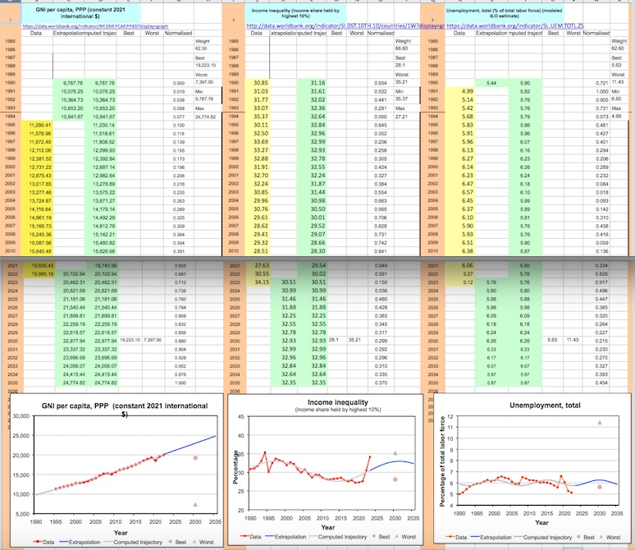
The screenshot with excerpt of the excel spreadsheet features the indicators' names at the top, the sources of data immediately under their names, and the way the data is organized –– historical data on yellow background, the extrapolations on green background, while on white are the normalized values. At the bottom are the graphs for each variable with the respective trajectories, and under the graphs are the respective equations (not featured in the screenshot.)

The indicators included in SOFI 2035 are listed in "Appendix A, Example of the Method."

With all the data at hand, SOFI could be computed and the graph generated. Figure 6 shows the SOFI 2035.

Figure 6. State of the Future Index 2035 baseline

6. SOFI analysis. The whole purpose of producing a SOFI is to simplify and put into perspective in an easily accessible way the complexity of a system, while also creating the possibility to identify the factors of change. It can help understand the reasons of the curve's slopes in the past and detect various potential future trajectories. Such a quantitative analysis would support narratives, but could also help generate various scenarios and assess the combined impact of different policies. Considering the evolution of computer-based modeling and visualization, these alternatives can be turned into short videos.

The next section presents various analysis examples. Obviously, these are not exhaustive, since the analysis possibilities offered by SOFI are limitless.

IV. CONDUCTING A SOFI ANALYSIS

SOFI analysis is very versatile and can be conducted on several levels, from different points of view, and for many purposes. It can help identify the factors of change in the past as well as those influencing the future, assess how various policies or actions could impact the future, and eventually make comparisons among countries or regions and their prospects. Following are some examples of SOFI analysis.

Direct analysis. One of the most important features of SOFI is its possibility to illustrate by a simple line the evolution of a past period and the potential future outlook. The dips and growth segments can be analyzed to identify the factors of change and understand their impact on the system as a whole.

Considering the graph mentioned above, Figure 6. SOFI 2035 (repeated below): there are some noticeable dips that corroborate what we already know — the consequences of the economic slowdown of 1995 and of the Great Recession that lasted from late 2007 to mid-2009, and those of the Covid-19 pandemic of 2019-2020.

Figure 6. State of the Future Index 2035 baseline

As for the future outlook, this graph has a particularity that was never so strongly noticed in the previous SOFIs: the down-curve for the 2027–2031 period. Identifying the potential causes implies analyzing the trajectory of all the individual indicators — see the graphs in figures A3-A31 in Appendix A. We found that the valley can be the result of the interplay of several indicators that have an unfavorable trajectory for that period: freedom rights, refugee population, unemployment, and income inequality. For decisionmakers, this could be an important starting point to assess which of these areas are actionable and how could policies and strategies improve the respective situations for a better future outlook.

Policy sensitivity analysis. SOFI's potential in helping setting policy and action priorities by performing a sensitivity analysis might be one of its most useful functions. This implies manipulating the forecasted data — the trajectory — of certain indicators in specific directions function of certain policies. While the combination of indicators and number of attempts are limitless, attention has to be paid that the indicators for which the data is manipulated be policy-sensitive and actionable— that reasonable policies and actions can be set so that the data moves in the respective direction. The outcome will show the impact on the system as a whole and hence, the most reasonable or desirable combination(s) can be used for designing further strategies. At this point, using SOFI-generated data, several scenarios could help fine-tuning and promoting certain policies or priorities.

Figure 7 is an example of a simple sensitivity testing on how certain policies could impact the future outlook of SOFI 2035. The three variables showcased are all related to the energy sector:
- If CO₂ emissions were to decrease from 2022 to 2035 at the same pace as they increased during the same number of years in the period just before, than the global forecast would look considerable better.
- Both increasing "Energy efficiency" and higher rate of "Energy from renewable" have a positive impact on the SOFI; removing each of those indicators from the set, would weaken the global forecast.

Figure 7. State of the Future Index 2035 with sensitivity analysis
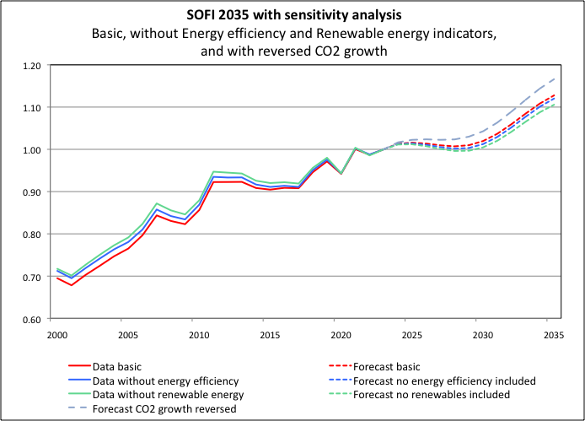

This not only offers evidence for what is intuitively known already—that a more aggressive policy in the domain of energy would considerably improve the future outlook—but also shows the potential quantitative impact of each variable on the forecast. Such sensitivity analysis can be conducted using any variable or group of variables, thus identifying the likely impact of various policies on the system as a whole.

SOFI comparison. Generally, a one-to-one comparison among SOFIs prepared in different years, or for different countries or domains would be misleading for several reasons, such as:
- mismatch of the set of indicators — SOFI computed in different years or for different countries could include different indicators;
- historical data changes — even if the indicators are the same, the data is often updated by the organizations collecting it, sometimes impacting the equations/trajectories of the variables;
- weight of the indicators changes — the importance of the indicators for the system could change over time or differ among countries, regions, or domains.

Nevertheless, for various purposes, such comparisons can be performed. Following are two examples — one for the global SOFI and one for national SOFIs.

Comparison of global SOFIs. Since the 2030 SOFI (using pre-Covid-19 data) and the 2035 SOFI (including Covid-19 impact) have been computed with the same variables and most of the historical data overlapped, a comparison has been attempted, as shown in Figure 8, featuring the two SOFIs up to the year 2030.

Figure 8. Comparison between SOFI 2030 using pre-Covid-19 data, and SOFI 2035 computed using data that reflects the impact of the Covid-19 pandemic
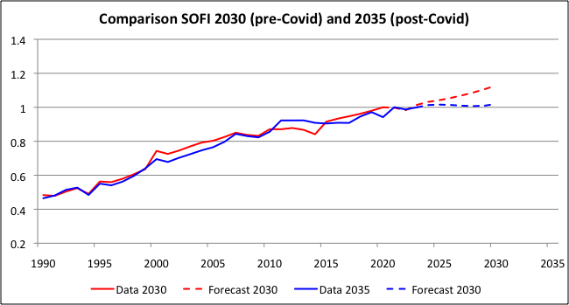

While the set of indicators is the same, it should be noted that some historical data has been reassessed by the respective organizations, thus explaining the mismatch of the "Data" segments — continuous red and blue lines. The negative impact of the Covid-19 pandemic on the outlook of the future is very noticeable — the pre-Covid red dotted forecast line is considerably higher than the post-Covid blue dotted line.

A further analysis can identify the indicators that were the most affected by the pandemic and thus had a stronger influence on the lower curve line for the post-Covid forecast. Not surprisingly, the indicators most impacted by the Covid-19 pandemic include GNI per capita, Population growth, and Life expectancy, as shown by the dip for the years 2020-2022 in the graphs of Figures 9, 10, and 11 respectively. (As previously explained, the “best” and “worst” values in the graphs are averages from the RTD panel’s forecasts.)

Figure 9. GNI per capita, purchase power parity
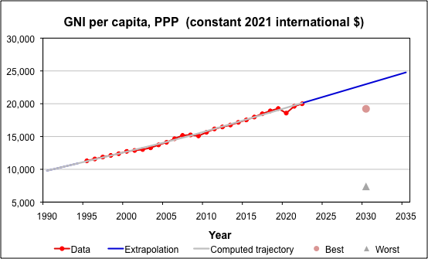
Data source: WB, GNI per capita, PPP (constant 2021 international $), and
trajectory computed with CurveExpert Professional

Figure 10. Population growth, annual percentage
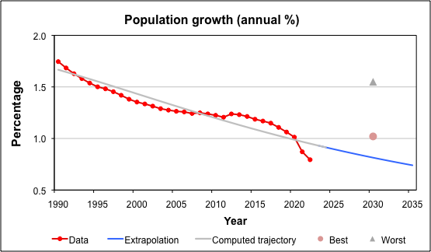
Data source: WB, Population growth (annual %), and
trajectory computed with CurveExpert Professional

Figure 11. Life expectancy at birth
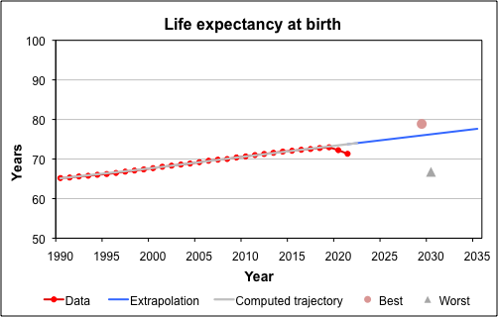
Data source: WB, Life expectancy at birth, total (years), and
trajectory computed with CurveExpert Professional

National Comparison SOFIs. These are national SOFIs designed to be comparable. They use standard set of variables and sources, same weights for the indicators, and identical computation technique. The variables included in this type of SOFI have to be meaningful and have the same positive/negative implication to essentially all countries that are being compared. Such a comparison could help identify strategies that help certain countries' better development than others, for eventual emulation.

An example of national comparison SOFIs is that produced by the Visegrad Group (V4) countries—Czech Republic, Hungary, Poland, and Slovakia—that computed their national SOFIs and then placed them on the same graph, as shown in Figure 12.

Figure 12. SOFI 2024 Comparison among V4 countries
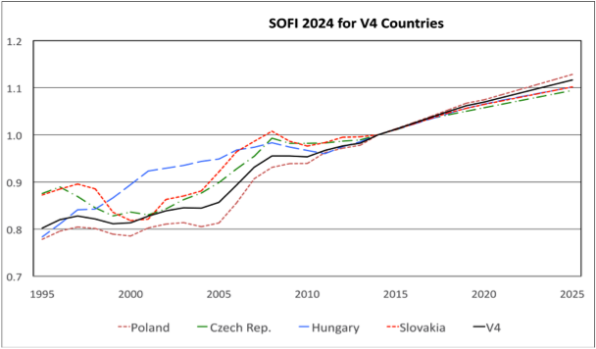

A more in-depth analysis allowed them to identify which were the areas that helped some of the countries develop better in the past and correspondingly, which could have a positive impact on their respective future.

Individual indicators' assessment. Since for the SOFI it is necessary to compute the trajectory and generate the graph for each indicator, an in-depth analysis can be performed for assessing the individual indicators. These can by themselves represent study subjects for further policy and priority settings. Some examples of such indicator forecasts have been shown in several figures above and all the 29 graphs are presented in Appendix A, "Example of the Method".

While the “best” and “worst” estimates by experts are not used for the SOFI computation anymore, it is still interesting to feature them as a reference and point for further discussion. Some questions might arise: why in some cases the estimates by experts are so off of the trajectories computed with the software? What could alter the trajectory of certain indicators? Which indicators are impacting each other, or even annul each-other?

It is also interesting to do follow-ups at some years to check the validity of the equations with updated real data to adjust the equation of the trajectory. Such an example is presented in the next section, discussing the indicator "Number of countries rated "free"" computed for SOFI 2027 and for SOFI 2035 (Figures 18 and 19 respectively.)

It is also this analysis that helps identify indicators that should be dropped for lack of relevance. For example, "Individuals using the Internet" shown in Figure 13, used to be highly relevant 20 years ago, but it is less so today and will be completely irrelevant when all the world population will have access to the Internet.

Figure 13. Individuals using the Internet
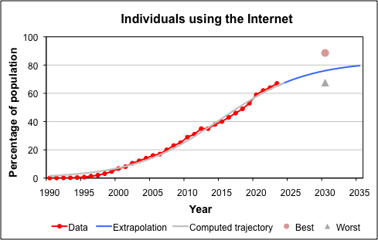
Data source: WB, Individuals using the Internet (% of population) and
trajectory computed with CurveExpert Professional

Report card on the future. One of the advantages of computing the SOFI is the identification of the areas where there is progress, regress, or there is no clear change — thereby helping set priorities. Figures 14 and 15 show where humanity is making progress and where more political attention and efforts are needed, by looking at 4 decades.

Figure 14. Areas where humanity is winning
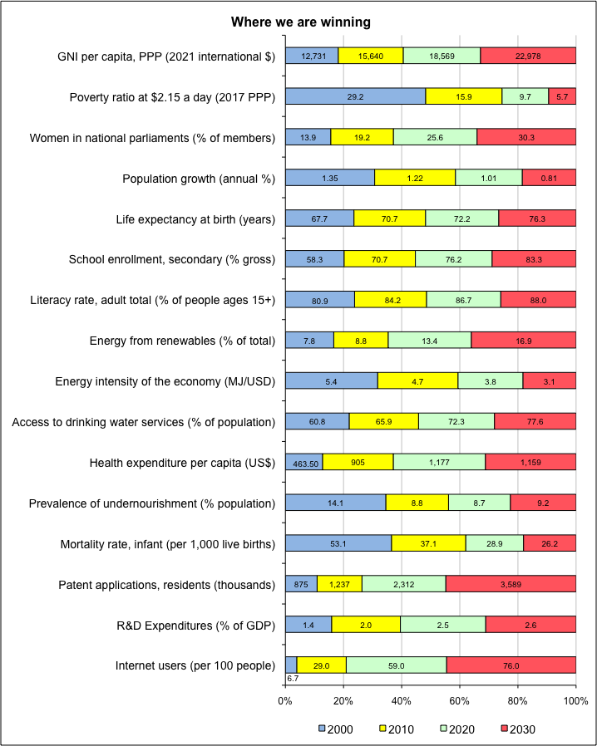

Figure 15. Areas where humanity is losing or there is no progress
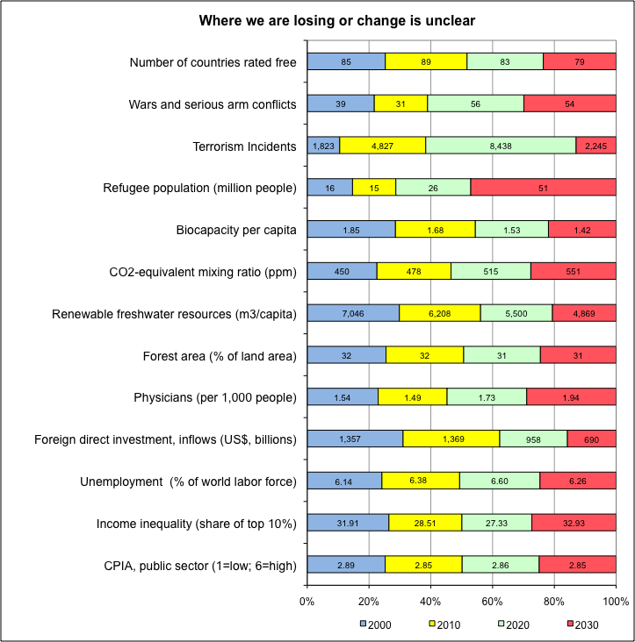

The world seems to be making progress in more areas than it is regressing or stagnating in, but since the areas of stagnation or regress are crucially important for human and planetary survival, addressing them should be a top priority.

National Focus SOFIs. These SOFIs would provide more in-depth analysis relative to the respective country, but might sacrifice the ability to make one-to-one comparisons among countries and between a country’s SOFI and a global SOFI. For this analysis, countries could use a non-standard set of variables that might include those that have special importance to the country (for example, measurements of the policy achievements), unique goals expressed through the selection of “best” and “worst” values, variable weights, and data manipulated to test various policies/strategies/actions.

It is also possible to use Trend Impact Analysis (TIA) — described in section "VII. Combining with other Methods" — for assessing the impact of specific events of national importance. Practically, these are potential future developments that could affect the future of a country. They are being assigned a certain probability and their impact on the variables is different — e.g., an increased energy tax might have a much different effect on energy use than on life expectancy. While the use of TIA introduces a new level of subjectivity, it also expands the level of granularity of the analysis.

Figure 16 shows the national SOFI computed for Azerbaijan, with TIA. It identified which are the most important areas that could positively impact the future of Azerbaijan, so that policies can be set accordingly. And the government adopted the best strategies to make those happen.

Figure 16. Azerbaijan State of the Future Index 2025, using TIA
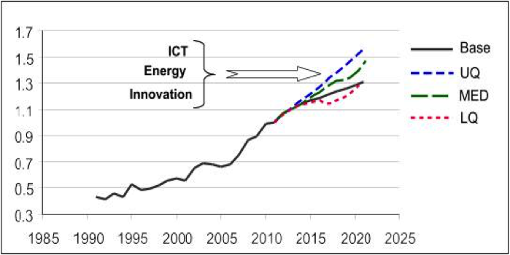

National Focus SOFIs can be used to track the state of the future of a country over time, test potential policies through sensitivity analysis, evaluate the success of various policies, assess the proximity to goals, and stimulate discussions about productive policies and factors that can affect their success. Furthermore, when many countries in a region have produced National Focus SOFIs, the effects of policies or developments in one country can be assessed on others in the region.

V. Strengths and Weaknesses of the Method

Interestingly enough, SOFI's strengths are also the grounds for its weaknesses. Hence, they will be presented in tandem.

Simplicity and Imprecision. The most important strength of SOFI is the simplified and accessible illustration of the past and of future prospects of a complex system. However, the apparent precision of the graph shouldn't be confused for accuracy; nor the past, nor the future can be reduced to a simple line or a string of numbers. Even if it looks mathematically precise, the future outlook illustrated by SOFI should not be mistaken for a forecast. SOFI serves more for generating questions and testing alternatives, than for getting precise answers.

Over-simplification also leads to loss of details and masks differences among countries and sectors. Positive developments in some countries or sectors could annihilate regresses in others. SOFI also masks the interaction among variables, and the eventual double accounting. Hence, it is important to always analyze each indicator individually and do as many sensitivity analyses as possible or needed to get a better understanding of the SOFI as a whole and its components and their respective roles.

Furthermore, computing a SOFI involves a lot of subjectivity and other caveats that will be discussed in this section. Hence, SOFI should be considered only what it has been designed for: a tool for a quantitative analysis of a complex system, for identifying the interplay of a selection of factors of change, and for testing various strategies and supporting narratives.

Flexibility and Subjectivity. Building a SOFI is very flexible, which is one of its strengths. The variables and the factoring elements are all the choice of those producing it, or of a panel contributing to it. That's good, but it also means that SOFI involves a lot of subjectivity. From the choice of the indicators to be included and their data sources, to the collection of opinions on the weight, "best" and "worst" values of the variables, and the selection of the equations for the variables' trajectories, all imply personal choices of a group of individuals.

As in any modeling situation, no matter how objective the panel tries to be, there are some basic aspects that will influence the choices for the SOFI elements:
- Whose future? — is it to address the best future for all, or that of a certain group?
- Who leads? — is the panel independent or under certain constraints?
- Whose system of values? — different people have different systems of values.
- Political dependency? — is it independent of political or ideological interests?
- What to include? — what are the factors to be considered? (e.g., the example of the importance of access to freshwater in Switzerland versus Yemen.)
- What does progress mean? does it mean the same thing to all members? (e.g., fertility rate in Niger versus South Korea.)
- What assumptions? — correctness of certain believes (e.g., that democracy will only expand around the world, while in reality it regressed over the past few years.)
- Which data? — choice of the sources of data; which are "reliable" sources, when it is proven that sometimes the official data has been fabricated?

Some of these aspects will be discussed further in this section.

An illustration of subjectivity is the use of the Real-Time Delphi questionnaire to collect judgments about the variables. Figure 17 is an example of the Real-Time Delphi study run in 2019 for collecting opinions for the SOFI 2030. Each question featured the graph of the respective indicator with the historical data and its potential trajectory, and asked for the weight that it should have in the SOFI (the slider), and the best and worst values in the year 2030 (the two field under the slider), as well as for comments on the respective indicator. The "best" and "worst" data points marked on the graph were from a previous study and were only given as guidance.

Figure 17. Example of a Real-Time Delphi question to collect judgments on SOFI variables (featured is Freedom Rights — Number of countries rated "free" by Freedom House)
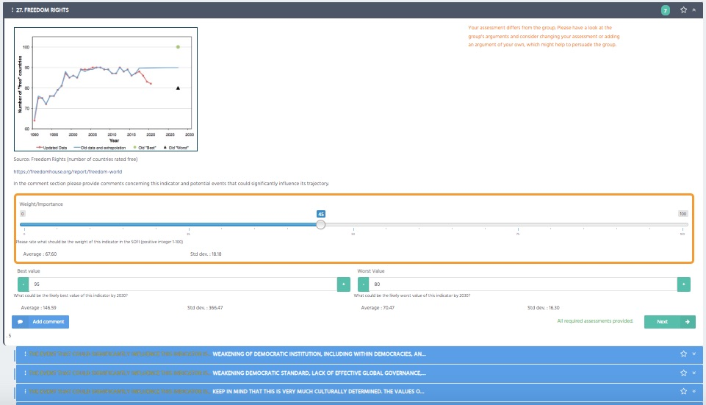
The Real-Time Delphi platform was provided by 4CF-The Futures Literacy Company

The Millennium Project runs such Real-Time Delphis periodically for re-assessing the global SOFI variables and their related values.

Assumptions and Reality. Practically, this also falls in the flexibility and subjectivity category, but with another nuance. When choosing an indicator's trajectory, the SOFI team makes certain assumptions. Checking back on previous SOFIs, it turns out that in some cases, in reality, the assumptions didn't prove right. One example is the evolution of democracy — Number of countries rated "free" by Freedom House. The SOFI in Figure 18, computed in 2017 (with outlook to 2027) assumed the trajectory of courtiers rated "free" ascending until an eventual certain saturation. However, a few years later, when the data has been updated for SOFI 2030, that assumption proved to be wrong, since the number of countries rated "free" actually decreased. For SOFI 2035, using updated data, the trajectory looks completely different, as shown in Figure 19. Obviously, such assumptions influence the whole SOFI.

Figure 18. Variable "Number of countries rated "free"" computed for SOFI 2027
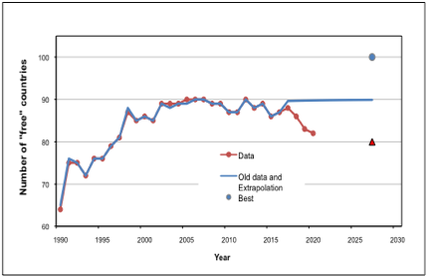

Figure 19. Variable "Number of countries rated "free"" computed for SOFI 2035
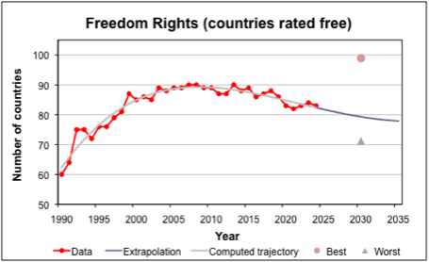
Data source: Both graphs use data from Freedom House and
trajectory computed with CurveExpert Professional

Another caveat in this category is: what is the real outlook? Although SOFI 2035 shows a positive future, we see that at least one critical variable, "freedom/democracy" shows a decreasing trend. Hence, will the future really look better in a world with potentially less freedom?

Trend and Surprise Events. SOFI is based on hard data from reliable sources. It cannot foresee surprise events (except if they are intentionally introduced by data manipulation.) However, such events can completely change the future outlook. One example is given in Figure 20, which compares pre-Covid 19 SOFI and post-Covid 19. As discussed in the previous section, the impact of COVID-19 on the future outlook is obvious.

Figure 20. Comparison between pre-Covid 19 SOFI and post-Covid 19 SOFI
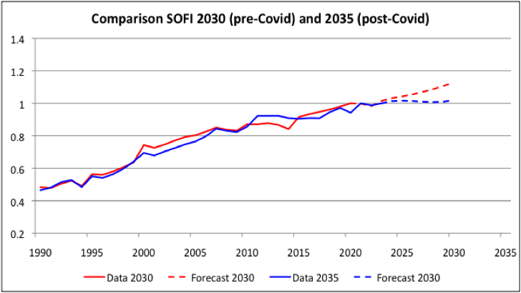

This graph reveals another SOFI weakness that should be mentioned: that comparison among SOFIs from different years is not encouraged. The reasons were already discussed in the previous section. The comparison shown in Figure 20 was done as an experiment and example to identify the degree to which surprise events can impact SOFI.

Use of AI and Sense-making. Use of artificial intelligence might help address many of the SOFI weaknesses such as selecting the indicators and getting the data, assess the interaction among the future events, computing the SOFI, and making comprehensive sensitivity analysis. One important issue to be address remains the sense-making step when choosing the trajectory of the variables. While AI can suggest equations faster and better, the decisions still have to be supervised by humans with experience in the domain — at least for the foreseeable future.

VI. Frontiers of the Method

The main frontiers of the method were practically covered in the previous section, as weaknesses. The most important frontiers to be highlighted would be: how realistic SOFI truly is? SOFI only uses a set of indicators. How representative are they? How well-chosen are the trajectories of each variable? How good are all the subjective assumptions? But most of all: How do different indicators impact each other? What's the interaction among the future events?

Another aspect would be the somewhat restrictive choice of indicators. For example, several indicators were identified that apparently could be important to a SOFI but were not included because it is not clear what progress or regress (increase or decrease of their value) means — e.g., number of UN peacekeepers, military expenditure, global surface temperature anomalies; urban population; number of nuclear warheads; and many more. Some work needs to be done to determine how such variables can be accounted for.

It would be preferable to compute SOFI on a regular bases and each time, all inputs — indicators, data, assumptions, and trajectories — be re-evaluated. Historical data are changed frequently by the respective organization as new information is introduced (e.g., country data updates, international agencies' compilations) or when the definitions change. Thus, it is important to not only add a new data point each year but to continually revisit all the older data and re-run the trajectories with the new data.

Comprehensive narratives explaining the key outcomes, reasons why the future appears to be better or worse, and which are the main factors of change should accompany the SOFI charts. Otherwise, just the SOFI graph could be superficial and even misleading.

A new kind of “dashboard” software that integrates databases and graphics should be considered. It would show changes in the variables much like the dashboard of a car shows changes in speed, temperature, fuel, etc. to help the driver make decisions. An effort in this sense has been made with SOFI 2035, by improving the visualization and impact of choice of indicators. to be added the project led by Andreas Bueckle, from Luddy School of Informatics, Computing and Engineering, Indiana University Bloomington. ........] linked from the SOFI webpage at:

An attempt should be made to derive the weights statistically by correlating public opinion about the future, or some objective measures, with the set of indicators designated for the SOFI.

The next section will discuss how a combination with some other futures research methods could help improve the SOFI process.

VII. Combining with other Methods

Combining SOFI with other futures research methods could considerably improve both the graph of the outlook, as well as the analysis. Following are presented some methods that were already used by The Millennium Project, but the possibilities are much larger.

Real-Time Delphi (RTD). For the global SOFI, the RTD is already used regularly for collecting judgments regarding the indicators. Usually, the questionnaire includes a list of indicators, for each showing the latest graph and asking:
- what should be the weight of the respective indicator in the SOFI;
- what would be the "best" and "worst" values of the indicator at the end of the forecasted period;
- comments about the respective indicators;
- suggestions for other indicators and justification for the suggestions.

An example of such a question has been given above, in Figure 17. Example of a Real-Time Delphi question to collect judgments on SOFI variables (featured is Freedom Rights — Number of countries rated "free" by Freedom House).

Note: When conducted for the first time, the RTD asks for a list of indicators and justification for their inclusion in SOFI. Then that list is rated and the top and most relevant indicators are chosen for further consideration in SOFI. This list of indicators is than fed into another RTD that asks the above questions for each indicator.

Reassessment RTDs are good to be conducted periodically. For the global SOFI, they are run at approximately 5 years.

Trend Impact Analysis (TIA). Some attempts have been made using TIA to present a somewhat more realistic view of the future. However, this technique also involves great over-simplification and introduces more subjectivity, such as the choice of the events, and their probability. It also omits any interaction among the future events — the occurrence of one may well affect the probability of other events. Nevertheless, the TIA remains an interesting exercise for the SOFI because it raises the question of what future developments might change past trends. Hence, the use of TIA or some similar method(s) that accepts perceptions about future perturbing events should be considered.

The general question for collecting inputs for the TIA is: What future developments might occur that could affect the future and what would be each development's probability?

It should be taken into consideration that each development impacts to a different extent on different variables. As mentioned in a previous example: an increased energy tax might have a much different effect on energy use than on life expectancy.

The Millennium Project used TIA in its 2002 and 2003 work with the SOFI. Following is a short description about the process, as an example. The developments used in TIA were suggested or were based on responses from previous Millennium Project Global Lookout Panels, and they are only an illustration of what is certainly a much longer list.

Those used in the TIA for the 2003 SOFI included:
- Mono-culture agriculture proves susceptible to attack by adapted organisms.
- Biotech in agriculture: improved food availability as well as enhanced animal health, insect- and disease-resistant plants, etc.
- Water: many political water issues resolved (e.g. 50% of current disputes.)
- Inexpensive very long-term contraceptives: wide availability and low cost.
- Sustainability: environmental consciousness is pervasive, affects decision making everywhere.
- Convergence of information/communication technologies (including Internet) leads to improved education, employment, environment, health, and production.
- Middle East war escalates, Iraq war and its consequences interminable, or Chinese-Taiwan wars, accounting for more than 50,000 casualties over 4 years.
- Large families gain favor in most developed countries, raising overall annual population additions 5%.
- International corporations help build national infrastructures and services to promote the development of poor countries.
- Genetic design: essentially full control of genetics and biochemical processes of all living organisms.
- Global economic depression resulting in drop of GDP per capita by 15%.
- Desalination: cost-effective desalination eventually increasing safe water access by 20%.
- Further industrialization of China, India.
- Great increase in economic participation of women in most poor countries (e.g. through micro-entrepreneurship), increasing GDP/cap by 2% worldwide.

TIA produces a range of outcomes rather than just a single value. It begins with an extrapolation of a time series. This is taken to be a "baseline forecast," which would be the future of the variable if there were no future trend-changing developments of the sort listed above. Then a list of such developments is constructed, using the analysts' imagination, literature search, Delphi surveys, or any other technique(s). These developments might include a unique technology, societal changes, political actions, or any other change that may affect the future course of the variable. Each development on the list is expressed in terms of its expected probability of occurrence over the future time interval of concern, and, if it were to occur, its impact on the variable under study.

Given such a list, TIA "plays out" all possible combinations of the events and their effect on the variable (a Monte Carlo process was used in this case, iteratively selecting and deciding on the occurrence or non-occurrence of the events), adjusting the baseline forecast in the process. In this simulation, a single run consists of deciding, at each point in the forecasted time range, whether or not each event “occurs” and then adjusting the baseline forecast accordingly. Ideally, more than 1,000 runs of this sort are made, playing out the various combinations of events and their impacts. The result of each simulation is essentially a mini-scenario. These simulations are combined statistically to find the median and quartiles, and the TIA results are generally presented as a "fan" of outcomes, spread according to their probability.

In the global SOFI, a set of future developments important at the global level were developed by the expert panel and probabilities for these developments were assigned by staff on the basis of prior work and apparent plausibility.

Now the question was: how do these developments affect the variables? For a SOFI that includes 26 indicators, this would mean a matrix for each development, containing 10 rows representing 10 future years, and 26 columns representing the variables. Most cells have zero entries - that is, the developments do not affect the variables - but a significant number would have other entries.

Following is an example of such a matrix actually used to show a development’s effect on four variables:

1 | A nuclear accident such as Three Mile Island (which causes many nuclear nations to de-nuclearize).
 |  | Impact | 5 | 3 | 0 | 0
 |  | Time | 10 | 2
Year | Probability % |  | 1. CO2 | 2. R Energy | 3. Food | 4. Forest
2008 | 1.00 |  | 0.50 | 1.50 | 0.00 | 0.00
2009 | 2.00 |  | 1.00 | 3.00 | 0.00 | 0.00
2010 | 3.00 |  | 1.50 | 3.00 | 0.00 | 0.00
2011 | 4.00 |  | 2.00 | 3.00 | 0.00 | 0.00
2012 | 5.00 |  | 2.50 | 3.00 | 0.00 | 0.00
2013 | 6.00 |  | 3.00 | 3.00 | 0.00 | 0.00
2014 | 7.00 |  | 3.50 | 3.00 | 0.00 | 0.00
2015 | 8.00 |  | 4.00 | 3.00 | 0.00 | 0.00
2016 | 9.00 |  | 4.50 | 3.00 | 0.00 | 0.00
2017 | 10.00 |  | 5.00 | 3.00 | 0.00 | 0.00

The gray cells show where judgments are to be entered. The 10 at the bottom of the probability column shows that the probability of this development will rise to 10% in 2017. This is the likelihood value derived from the global SOFI study.

The two gray bands across the top are where judgments about impacts of the development on the variables in the country under study are to be entered. Two estimates are required for each impact: first is the level of the impact (that is, the amount that the extrapolation of the variable will shift –in percentage terms) if the development occurs, and second is an estimate of the time required to reach this impact.

Hence, the above table indicates the judgments:
If “A nuclear accident such as Three Mile Island” were to occur, this would:
- increase expectations about the level of CO₂ emissions by 5% in 10 years
- it would increase the amount of renewable energy by 3% within 2 years
- there is no effect on food availability or forestation.

Having the TIA inputs, the actual TIA solution is computed using a Monte Carlo procedure. The “play” involves first choosing a random number between zero and 100 for each development. If the probability of a development in a given year exceeds the random number, it is said to occur. The impacts of all of the occurring events are added algebraically to determine the total impact on the extrapolated curve in a given year. The resulting curve is saved and the process is repeated 100 times or more. Each of these 100 runs can be considered a mini-scenario, with different sequences of events occurring and their aggregate impacts determining the shape of the future curve. The results of a TIA for each variable are generally presented as shown in Figure 21, where “base” represents the original extrapolation and “UQ, MED, and LQ”, the upper quartile, median, and lower quartile of the TIA runs respectively.

Figure 21: TIA Example
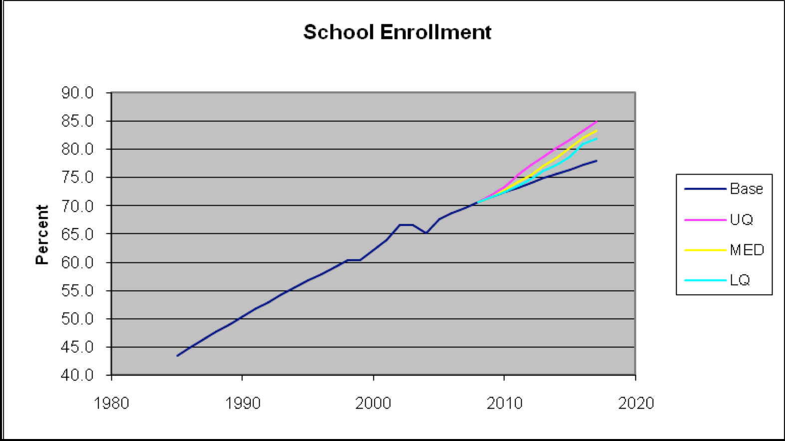

Then the standard SOFI process outlined in section "III. How to Do It" is repeated once using the upper quartile, once the median, and once the lower quartile. The excel sheet has been adapted so that once the TIA is run on the previous sheet, the SOFI sheet computes and displays the completed SOFI. Figure 22 displays the typical graph of the results for all of the runs, in summary.

Figure 22. SOFI including TIA Results
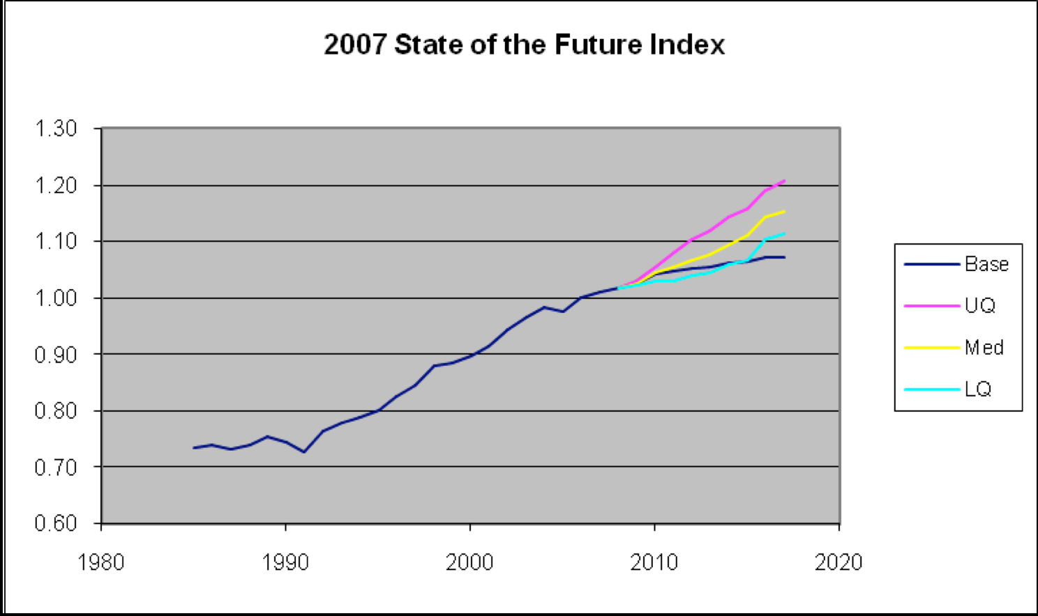

Cross-Impact Analysis (CIA). Another method for improving the forecasts of the variables would be to include a CIA. In the examples of this paper, the variables were considered to be independent, but in the real world, when one variable changes, others may be affected. A full consideration of the SOFI would include such complexities.

With an excel spreadsheet, doing a CIA for some 30 indicators (and even more so for an additional tens of developments if TIA is used) would be difficult. However, an automated SOFI or use of AI could make the process relatively easy and certainly more efficient and almost instantaneous.

Scenarios. It has been mentioned several times already that manipulating the data for sensitivity analysis can be used for testing various policies or strategies, which could represent different scenarios. Hence, SOFI can be used to support scenario building. However, the other way around is also valid: feeding the assumptions into a SOFI could test various scenarios, or, using data from various scenarios could enrich SOFI. With the advent of new technologies, these could be used to generate short videos of potential future worlds supported by data with a potential likelihood or probability.

International Futures (IFs). A notable experiment was conducted in 2007, in which the IFs econometric model was used to produce global and national SOFIs to determine whether it might be practical to develop a periodic reporting service that produced SOFIs for all countries with the purpose of tracking over time (International Futures, 2009).

The IFs model of the University of Denver is an extensive, quantitative, multi-equation model that links economic, demographic, and social measures of essentially all countries in the world. It is built of both systems dynamic relationships (flows and stocks) and econometric relationships.

Its creators call the methodology “Structure-Based and Agent-Class Driven Modeling.” It includes historical data and projections for hundreds variables of 182 countries, and generally is used to project the long-term future (up to year 2100). For the purpose of its exercise, The Millennium Project use was limited to projections to about 2020 and for only 20 SOFI variables.

To test the parallelism between the methods, the 20 IFs variables were inserted into The Millennium Project template and a global SOFI was computed using the maximum, minimum, and weights used by the IFs model to produce a new SOFI. The results are shown in Figure 23. In this proof of concept work, the model was equipped with the ability to compute forecasted State of the Future Indexes (SOFI) for all of the countries represented in the model.

Figure 23. Comparison of IFs and Millennium Project SOFI Methods
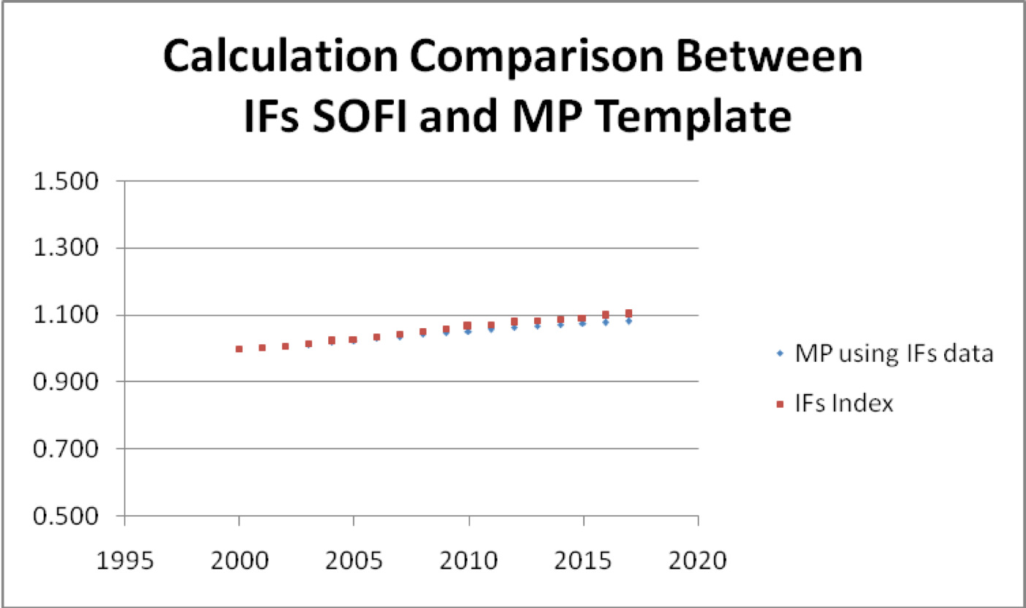

The model’s equation for computing SOFI matched that used by the Millennium Project. The results are within 2% difference; the reason for the error is not clear but is probably in the rounding of data. Conclusion: the algorithms used in the IFs model and in the Millennium Project Excel spreadsheet produce essentially the same result when supplied with the same data.

If the capability to compute the SOFI is added to the publicly available on-line model and the databases are updated periodically, then individuals everywhere would be able to compute the SOFIs for their countries and regions. This opens the opportunity to produce an annual or biennial publication that tracks and ranks the State of the Future Index for the countries in the model, just like the UNDP tracks and publishes the Human Development Index.

Appendices

Appendix A. Example of the Method

As an example for the SOFI computation will be used the latest, SOFI 2035, published in the State of the Future 20.0 report.

The steps followed are those described in the section "III. How to Do It".

The initial step is to prepare the excel spreadsheet with two tabs: one for the individual variables, and the second tab for the computation of SOFI. An example for the sheet for the variables is presented in Figures A1, tabbed "Graphs".

Figure A1. Excerpt of the Excel spreadsheet for recording the individual variables
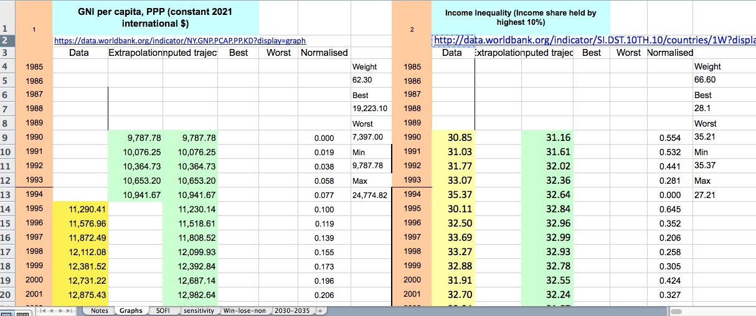

For each variable there should be considered the following entries:
- the name of the variable
- the source of data
- the years (on brown background)
- historical data (on yellow backgraound)
- interpolated and extrapolated data (on green background)
- normalized value (on white background)
- weight, "best", and "worse" values, as well as Min and Max values (last column for each variable)

1. Choosing the indicators. The indicators included in the computation of the 2035 SOFI are listed in Box 1, along with their data sources. The indicators were selected over the years through several RTD questionnaires and by The Millennium Project staff.
Box 1.
Variables included in the computation of 2035 SOFI
1 GNI per capita, PPP (constant 2021 international $) https://data.worldbank.org/indicator/NY.GNP.PCAP.PP.KD?display=graph
2 Income Inequality (Income share held by highest 10%) http://data.worldbank.org/indicator/SI.DST.10TH.10/countries/1W?display=graph
3 Unemployment, total (% of total labor force) (modeled ILO estimate) https://data.worldbank.org/indicator/SL.UEM.TOTL.ZS
4 Poverty headcount ratio at $2.15 a day (2017 PPP) (% of population) https://data.worldbank.org/indicator/SI.POV.DDAY
5 CPIA transparency, accountability, and corruption in the public sector rating http://data.worldbank.org/indicator/IQ.CPA.TRAN.XQ?display=graph
6 Foreign direct investment: Inward flows and stock, annual (current US$, bill.) https://unctadstat.unctad.org/datacentre/dataviewer/US.FdiFlowsStock
7 Research and development expenditure (% of GDP) http://data.worldbank.org/indicator/GB.XPD.RSDV.GD.ZS?display=graph
8 Population growth (annual %) http://data.worldbank.org/indicator/SP.POP.GROW/countries/1W?display=graph
9 Life expectancy at birth (years) http://data.worldbank.org/indicator/SP.DYN.LE00.IN?display=graph
10 Mortality rate, infant (per 1,000 live births) http://data.worldbank.org/indicator/SP.DYN.IMRT.IN/countries?display=graph
11 Prevalence of undernourishment (% of population) http://data.worldbank.org/indicator/SN.ITK.DEFC.ZS?display=graph
12 Current health expenditure per capita (current US$) https://data.worldbank.org/indicator/SH.XPD.CHEX.PC.CD?display=graph
13 Physicians (per 1,000 people) http://data.worldbank.org/indicator/SH.MED.PHYS.ZS?display=graph
14 People using safely managed drinking water services (% of population) http://data.worldbank.org/indicator/SH.H2O.SAFE.ZS
15 Renewable internal freshwater resources per capita (cubic meters) http://data.worldbank.org/indicator/ER.H2O.INTR.PC?display=graph
16 Biocapacity (gha per person) https://data.footprintnetwork.org/#/countryTrends
17 Forest area (% of land area) https://data.worldbank.org/indicator/AG.LND.FRST.ZS?display=graph
18 CO₂-equivalent mixing ratio (ppm) https://gml.noaa.gov/aggi/aggi.html
19 Energy intensity of the economy (MJ/USD) https://www.iea.org/data-and-statistics/data-tools/energy-end-uses-and-efficiency-indicators-data-explorer
20 Share of primary energy from renewable sources (% of total) https://ourworldindata.org/grapher/renewable-share-energy?tab=chart&country=~OWID_WRL\
21 Literacy rate, adult total (% of people ages 15 and above) https://data.worldbank.org/indicator/SE.ADT.LITR.ZS?display=graph
22 School enrollment, secondary (% gross) http://data.worldbank.org/indicator/SE.SEC.ENRR?display=graph
23 Patent applications, residents https://data.worldbank.org/indicator/IP.PAT.RESD
24 Number of conflicts (state-based violence) https://ucdp.uu.se/#/
25 Terrorism Incidents https://www.start.umd.edu/gtd/search/BrowseBy.aspx?category=date
26 Refugee population by country or territory of asylum (million people) https://data.worldbank.org/indicator/SM.POP.REFG?view=chart
27 Freedom Rights (number of countries rated free) https://freedomhouse.org/report/freedom-world
28 Proportion of seats held by women in national parliaments (% of members) https://data.worldbank.org/indicator/SG.GEN.PARL.ZS?display=graph
29 Individuals using the Internet (% of population) https://data.worldbank.org/indicator/IT.NET.USER.ZS, https://www.itu.int/en/ITU-D/Statistics/Pages/stat/default.asp

2. Forecasting the variables. The indicators used in the SOFI 2035 were forecasted with the curve-fitting software CurveExpert Professional. The historical data is fed into the software, which generates many potential equations that fit the data. This is a very important step, since not necessarily the best-fit curve for the set of historical data is the one that would make sense for the respective indicator. Hence, some expertise in econometrics and statistics is useful for choosing the most relevant equation for the variables.

Figure A2 presents how the graphs are featured in the spreadsheet. Below each graph is also given the equation used for the trajectory (in this screenshot, truncated.)

Figure A2. Excerpt of the Excel spreadsheet featuring the graphs for the individual variables
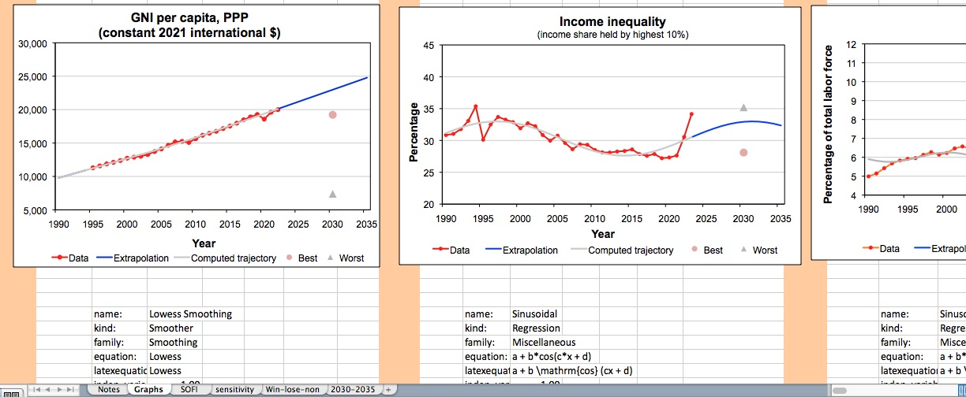

Figures A3 to A31 present the graphs for all the variables used in SOFI. The red dotted line represents the historical data; the gray continuous line represents the best-fit curve — the trajectory generated with CurveExpert Professional — and the blue part of it is the forecast based on that trajectory. The "Best" and "Worst" data points are the average of the estimates for 2030 provided by an international panel through a Real-Time Delphi study conducted in 2020.

It is interesting to note that in some cases the "best" and "worst" estimates by the panel of experts are considerable off the estimated trajectory. These indicators could make the subject of an extra analysis — why do the experts' estimates differ so much of the computed trajectory?

Another observation would be that in some cases, the data seems so randomly distributed, that it was really difficult to choose the best-fit curve. In some cases — such as for Terrorist incidents — the trajectory seems really off, but it seemed the best fit of all.

It is also important to note that the big impact of the Covid-19 pandemic on several indicators impacted their trajectory and therefore, the SOFI as a whole.

Graphs of the individual indicators included in the 2035 SOFI

Figure A3
Data source: WB, GNI per capita, PPP (constant 2021 international $), https://data.worldbank.org/indicator/NY.GNP.PCAP.PP.KD, and trajectory computed with CurveExpert Professional

Figure A4
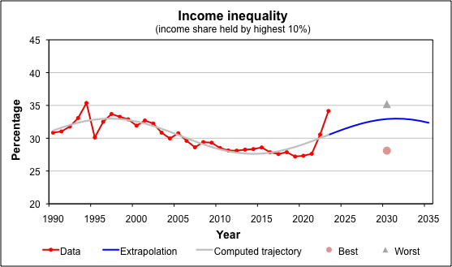
Data source: WB, Income share held by highest 10%, https://data.worldbank.org/indicator/SI.DST.10TH.10, and trajectory computed with CurveExpert Professional

Figure A5
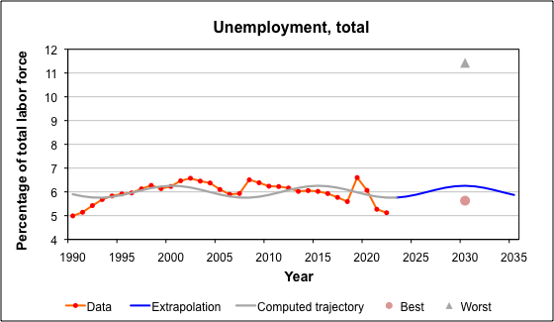
Data source: WB, Unemployment, total (% of total labor force) (modeled ILO estimate), https://data.worldbank.org/indicator/SL.UEM.TOTL.ZS, and trajectory computed with CurveExpert Professional

Figure A6
Data source: WB, Poverty headcount ratio at $2.15 a day (2017 PPP) (% of population), https://data.worldbank.org/indicator/SI.POV.DDAY, and trajectory computed with CurveExpert Professional

Figure A7
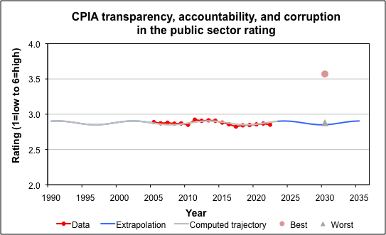
Data source: WB, CPIA transparency, accountability, and corruption in the public sector rating (1=low to 6=high), https://data.worldbank.org/indicator/IQ.CPA.TRAN.XQ, and trajectory computed with CurveExpert Professional

Figure A8
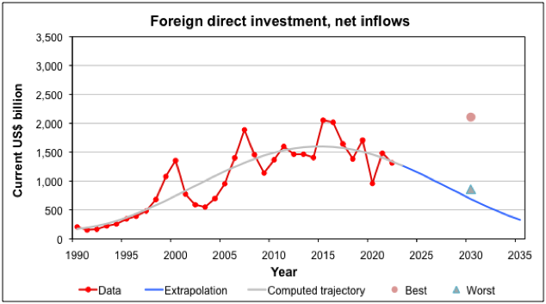
Data source: UNCTAD, Foreign direct investment: Inward and outward flows and stock, annual, US$ at current prices in millions, https://unctadstat.unctad.org/datacentre/dataviewer/US.FdiFlowsStock, and trajectory computed with CurveExpert Professional

Figure A9
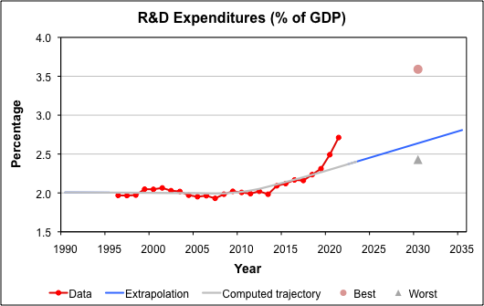
Data source: WB, Research and development expenditure (% of GDP), https://data.worldbank.org/indicator/GB.XPD.RSDV.GD.ZS, and trajectory computed with CurveExpert Professional

Figure A10
Data source: WB, Population growth (annual %), https://data.worldbank.org/indicator/SP.POP.GROW, and trajectory computed with CurveExpert Professional

Figure A11
Data source: WB, Life expectancy at birth, total (years), https://data.worldbank.org/indicator/SP.DYN.LE00.IN, and trajectory computed with CurveExpert Professional

Figure A12
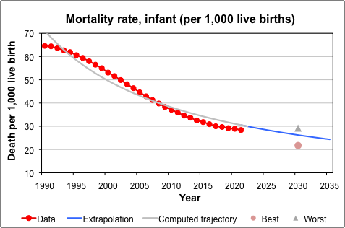
Data source: WB, Mortality rate, infant (per 1,000 live births), https://data.worldbank.org/indicator/SP.DYN.IMRT.IN, and trajectory computed with CurveExpert Professional

Figure A13
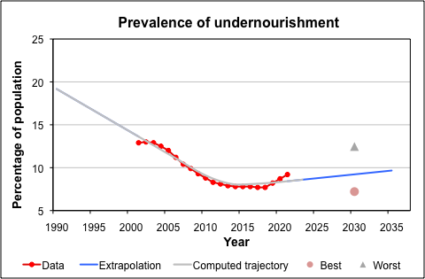
Data source: WB, Prevalence of undernourishment (% of population), https://data.worldbank.org/indicator/SN.ITK.DEFC.ZS, and trajectory computed with CurveExpert Professional

Figure A14
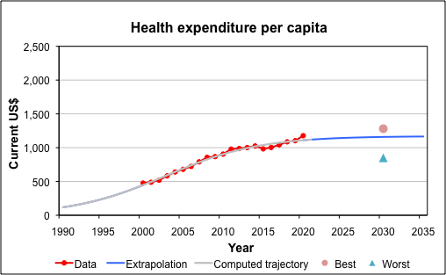
Data source: WB, Current health expenditure per capita (current US$), https://data.worldbank.org/indicator/SH.XPD.CHEX.PC.CD, and trajectory computed with CurveExpert Professional

Figure A15
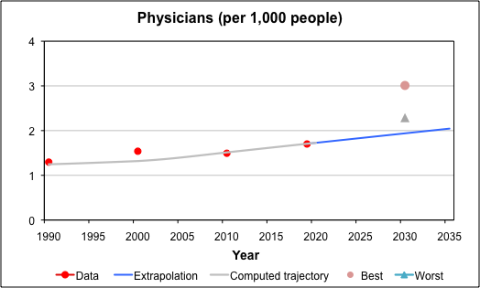
Data source: WB, Physicians (per 1,000 people), https://data.worldbank.org/indicator/SH.MED.PHYS.ZS, and trajectory computed with CurveExpert Professional

Figure A16
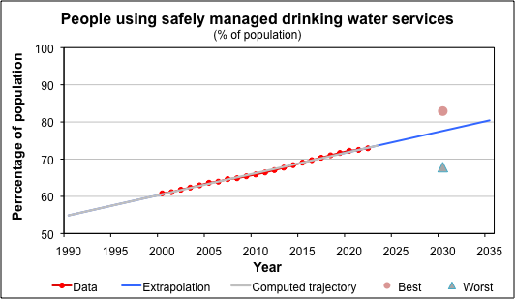
Data source: WB, People using safely managed drinking water services (% of population), https://data.worldbank.org/indicator/SH.H2O.SMDW.ZS, and trajectory computed with CurveExpert Professional

Figure A17
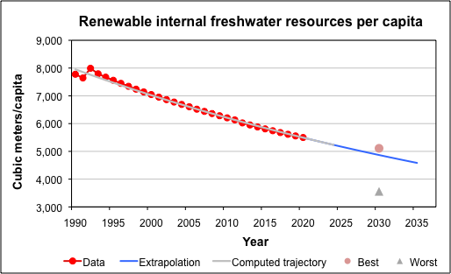
Data source: WB, Renewable internal freshwater resources per capita (cubic meters), https://data.worldbank.org/indicator/ER.H2O.INTR.PC, and trajectory computed with CurveExpert Professional

Figure A18
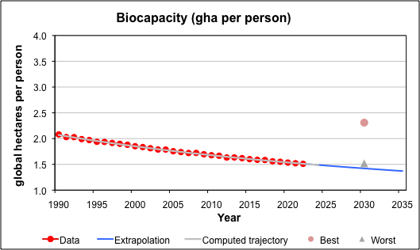
Data source: Global Footprint Network, Biocapacity Accounts 2023 Public Data Package, https://data.footprintnetwork.org, and trajectory computed with CurveExpert Professional

Figure A19
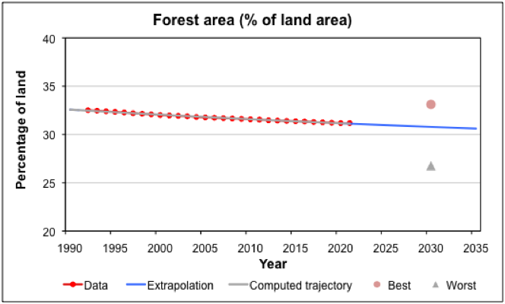
Data source: WB, Forest area (% of land area), https://data.worldbank.org/indicator/AG.LND.FRST.ZS?, and trajectory computed with CurveExpert Professional

Figure A20
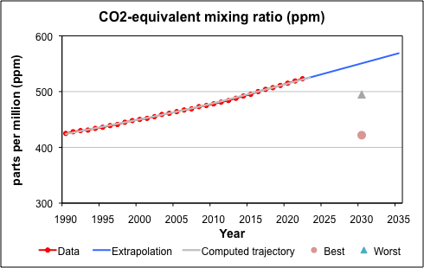
Data source: NOAA Global Monitoring Laboratory, CO2-equivalent mixing ratio, https://gml.noaa.gov/aggi/aggi.html, and trajectory computed with CurveExpert Professional

Figure A21
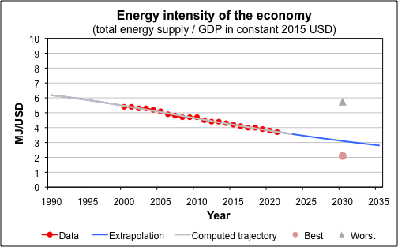
Data source: IEA, Energy intensity of the economy, https://www.iea.org/data-and-statistics/data-tools/energy-efficiency-indicators-data-explorer, and trajectory computed with CurveExpert Professional

Figure A22
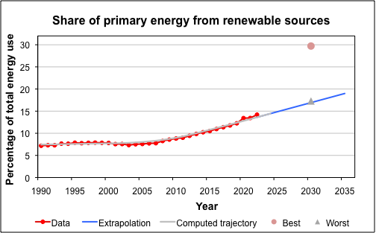
Data source: Our World in Data, Share of primary energy consumption from renewable sources, https://ourworldindata.org/grapher/renewable-share-energy?tab=chart&country=OWID_WRL%5C~OWID_WRL, and trajectory computed with CurveExpert Professional

Figure A23
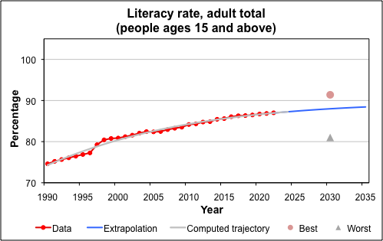
Data source: WB, Literacy rate, adult total (% of people ages 15 and above), https://data.worldbank.org/indicator/SE.ADT.LITR.ZS?, and trajectory computed with CurveExpert Professional

Figure A24
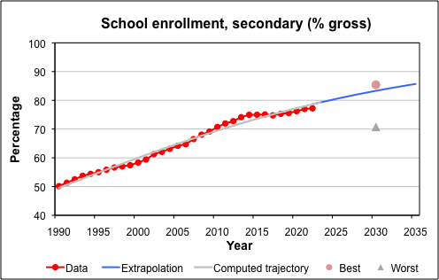
Data source: WB, School enrollment, secondary (% gross), https://data.worldbank.org/indicator/SE.SEC.ENRR, and trajectory computed with CurveExpert Professional

Figure A25
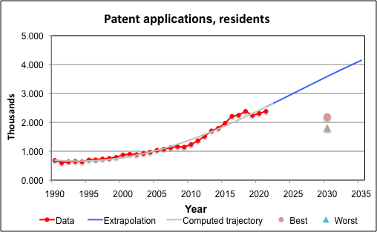
Data source: WB, Patent applications, residents, https://data.worldbank.org/indicator/IP.PAT.RESD, and trajectory computed with CurveExpert Professional

Figure A26
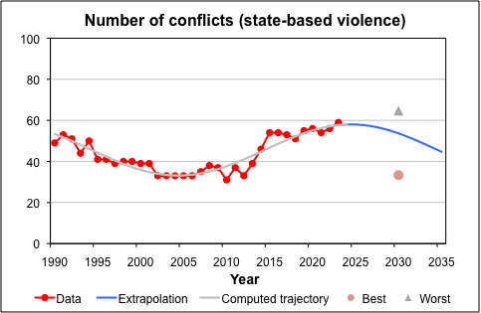
Data source: Uppsala Conflict Data Program, https://ucdp.uu.se/#/, and trajectory computed with CurveExpert Professional

Figure A27
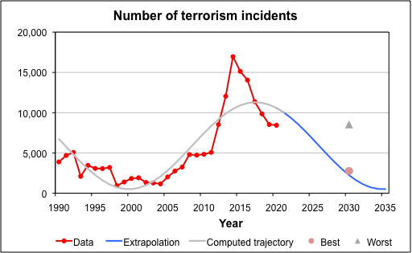
Data source: Study of Terrorism and Responses to Terrorism (START), Global Terrorism Database, https://www.start.umd.edu/gtd/, and trajectory computed with CurveExpert Professional

Figure A28
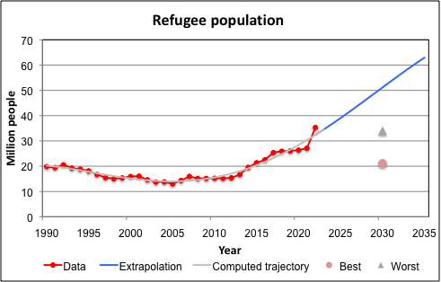
Data source: WB, Refugee population by country or territory of asylum (millions), https://data.worldbank.org/indicator/SM.POP.REFG, and trajectory computed with CurveExpert Professional

Figure A29
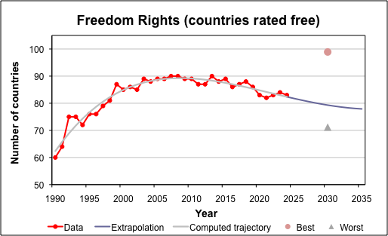
Data source: Freedom House, Freedom in the World, https://freedomhouse.org/report/freedom-world, and trajectory computed with CurveExpert Professional

Figure A30
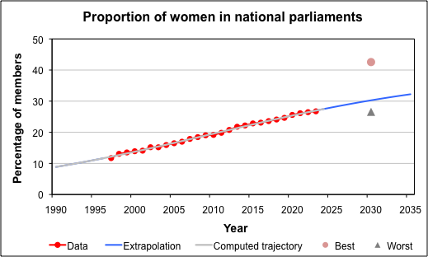
Data source: WB, Proportion of seats held by women in national parliaments (%), https://data.worldbank.org/indicator/SG.GEN.PARL.ZS, and trajectory computed with CurveExpert Professional

Figure A31
Data source: WB, Individuals using the Internet (% of population) https://data.worldbank.org/indicator/IT.NET.USER.ZS, and trajectory computed with CurveExpert Professional

3. Normalization; combining the different variables. The values of the different indicators were normalized, to be comparable and usable for compilation in the SOFI equation.

The formula for normalization is:
X = (actual value of the variable– MIN)/(MAX – MIN)
As a result, all the variables range between 0 and 1.

The following table shows the normalized values for two variables:

7 | Research and development expenditure (% of GDP) |  |  |  |  | 8 | Population growth (annual %)
 | http://data.worldbank.org/indicator/GB.XPD.RSDV.GD.ZS?display=graph |  |  |  |  |  | http://data.worldbank.org/indicator/SP.POP.GROW/countries/1W?display=graph
 | Data | Extrapolation | Computed trajectory | Normalized |  |  | Data | Extrapolation | Computed trajectory | Normalized
1985 |  |  |  |  | Weight | 1985 | 1.7504 |  |  |  | Weight
1986 |  |  |  |  | 65 | 1986 | 1.7717 |  |  |  | 65.1
1987 |  |  |  |  | Best | 1987 | 1.7885 |  |  |  | Best
1988 |  |  |  |  | 3.59 | 1988 | 1.7734 |  |  |  | 1.02
1989 |  |  |  |  | Worst | 1989 | 1.7443 |  |  |  | Worst
1990 |  | 2.0069 | 2.0069 | 0.087 | 2.43 | 1990 | 1.7455 |  | 1.6664 | 0.000 | 1.55
1991 |  | 2.0064 | 2.0064 | 0.087 | Min | 1991 | 1.6840 |  | 1.6446 | 0.061 | Min
1992 |  | 2.0058 | 2.0058 | 0.086 | 1.9303 | 1992 | 1.6280 |  | 1.6223 | 0.117 | 1.7455
1993 |  | 2.0053 | 2.0053 | 0.085 | Max | 1993 | 1.5806 |  | 1.5996 | 0.164 | Max
1994 |  | 2.0048 | 2.0048 | 0.085 | 2.8082 | 1994 | 1.5373 |  | 1.5765 | 0.207 | 0.7403
1995 |  | 2.0043 | 2.0043 | 0.084 |  | 1995 | 1.5011 |  | 1.5531 | 0.243
1996 | 1.9683 |  | 2.0038 | 0.043 |  | 1996 | 1.4815 |  | 1.5295 | 0.263
1997 | 1.9664 |  | 2.0033 | 0.041 |  | 1997 | 1.4536 |  | 1.5056 | 0.290
1998 | 1.9723 |  | 2.0025 | 0.048 |  | 1998 | 1.4191 |  | 1.4816 | 0.325
1999 | 2.0478 |  | 2.0014 | 0.134 |  | 1999 | 1.3807 |  | 1.4575 | 0.363
2000 | 2.0466 |  | 2.0003 | 0.132 |  | 2000 | 1.3532 |  | 1.4333 | 0.390
2001 | 2.0642 |  | 1.9993 | 0.153 |  | 2001 | 1.3350 |  | 1.4091 | 0.408
2002 | 2.0289 |  | 1.9986 | 0.112 |  | 2002 | 1.3137 |  | 1.3850 | 0.430
2003 | 2.0187 |  | 1.9983 | 0.101 |  | 2003 | 1.2892 |  | 1.3609 | 0.454
2004 | 1.9706 |  | 1.9980 | 0.046 |  | 2004 | 1.2749 |  | 1.3370 | 0.468
2005 | 1.9517 |  | 1.9960 | 0.024 |  | 2005 | 1.2637 |  | 1.3131 | 0.479
2006 | 1.9640 |  | 1.9934 | 0.038 |  | 2006 | 1.2576 |  | 1.2895 | 0.485
2007 | 1.9303 |  | 1.9921 | 0.000 |  | 2007 | 1.2427 |  | 1.2661 | 0.500
2008 | 1.9834 |  | 1.9945 | 0.060 |  | 2008 | 1.2486 |  | 1.2428 | 0.494
2009 | 2.0210 |  | 2.0017 | 0.103 |  | 2009 | 1.2383 |  | 1.2199 | 0.505
2010 | 2.0067 |  | 2.0138 | 0.087 |  | 2010 | 1.2246 |  | 1.1972 | 0.518
2011 | 1.9903 |  | 2.0306 | 0.068 |  | 2011 | 1.2060 |  | 1.1747 | 0.537
2012 | 2.0213 |  | 2.0518 | 0.104 |  | 2012 | 1.2382 |  | 1.1526 | 0.505
2013 | 1.9831 |  | 2.0807 | 0.060 |  | 2013 | 1.2311 |  | 1.1308 | 0.512
2014 | 2.0921 |  | 2.1103 | 0.184 |  | 2014 | 1.2136 |  | 1.1093 | 0.529
2015 | 2.1204 |  | 2.1403 | 0.216 |  | 2015 | 1.1864 |  | 1.0882 | 0.556
2016 | 2.1670 |  | 2.1709 | 0.270 |  | 2016 | 1.1692 |  | 1.0674 | 0.573
2017 | 2.1596 |  | 2.2019 | 0.261 |  | 2017 | 1.1485 |  | 1.0470 | 0.594
2018 | 2.2352 |  | 2.2336 | 0.347 |  | 2018 | 1.1078 |  | 1.0269 | 0.634
2019 | 2.3116 |  | 2.2660 | 0.434 |  | 2019 | 1.0627 |  | 1.0071 | 0.679
2020 | 2.4917 |  | 2.2991 | 0.639 |  | 2020 | 1.0131 |  | 0.9878 | 0.729
2021 | 2.7119 |  | 2.3331 | 0.890 |  | 2021 | 0.8708 |  | 0.9688 | 0.870
2022 |  | 2.3670 | 2.3670 | 0.497 |  | 2022 | 0.7941 |  | 0.9501 | 0.947
2023 |  | 2.4010 | 2.4010 | 0.536 |  | 2023 |  | 0.9319 | 0.9319 | 0.809
2024 |  | 2.4349 | 2.4349 | 0.575 |  | 2024 |  | 0.9140 | 0.9140 | 0.827
2025 |  | 2.4688 | 2.4688 | 0.613 |  | 2025 |  | 0.8964 | 0.8964 | 0.845
2026 |  | 2.5028 | 2.5028 | 0.652 |  | 2026 |  | 0.8793 | 0.8793 | 0.862
2027 |  | 2.5367 | 2.5367 | 0.691 |  | 2027 |  | 0.8624 | 0.8624 | 0.879
2028 |  | 2.5707 | 2.5707 | 0.729 |  | 2028 |  | 0.8460 | 0.8460 | 0.895
2029 |  | 2.6046 | 2.6046 | 0.768 |  | 2029 |  | 0.8299 | 0.8299 | 0.911
2030 |  | 2.6385 | 2.6385 | 0.807 |  | 2030 |  | 0.8141 | 0.8141 | 0.927
2031 |  | 2.6725 | 2.6725 | 0.845 |  | 2031 |  | 0.7987 | 0.7987 | 0.942
2032 |  | 2.7064 | 2.7064 | 0.884 |  | 2032 |  | 0.7836 | 0.7836 | 0.957
2033 |  | 2.7404 | 2.7404 | 0.923 |  | 2033 |  | 0.7689 | 0.7689 | 0.972
2034 |  | 2.7743 | 2.7743 | 0.961 |  | 2034 |  | 0.7544 | 0.7544 | 0.986
2035 |  | 2.8082 | 2.8082 | 1.000 |  | 2035 |  | 0.7403 | 0.7403 | 1.000

4. Weighting the variables. In the SOFI equation, all the variables are factored by their respective weight. The Millennium Project collects the weights through a RTD questionnaire. For the 2035 SOFI, were used the weights collected through a RTD run in 2019 (initially collected for the 2030 SOFI.)

Interestingly enough, most of the weights were between 55 and 75.

5. Computing and Generating the SOFI.

The values from the Excel spreadsheet tabbed "Graphs" were copied to the "SOFI" spreadsheet, which contains the indicators weights (on yellow background, under each indicator) and the normalized values, as shown in Figure A32.

Figure A32. Excerpt of the Excel spreadsheet for computing SOFI
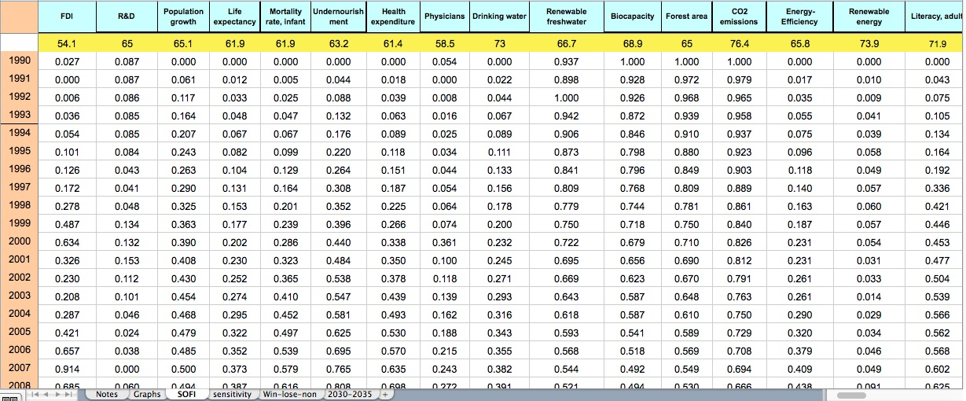

With all the data gathered so far and organized in the spreadsheet, the SOFI can be computed and the graph generated.

The formula for computing SOFI is:

SOFI = (V₁×W₁ + V₂×W₂+... V_{n}×W_{n})/(V_{1ref}×W₁+V_{2ref} ×W₂+... V_{nref} ×W_{n})
where:
V_{n} = non-dimensionalized value of variable “n” in the respective years
V_{nref} = non-dimensionalized value of variable “n” in the reference year
W_{n} = weight of variable “n”

Figure A33 presents an excerpt from the Excel spreadsheet that contains the SOFI computation and the graph.

Figure A33. Excerpt from the Excel spreadsheet with the SOFI computation and the graph
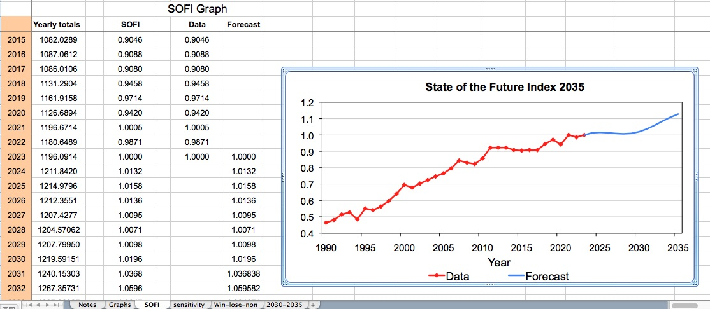

At this stage it is important to analyze the graph for any eventual anomalies and identify where they might come from and fix the eventual computation or data transfer errors, if any.

6. SOFI analysis. A rather detailed analysis has been already presented in the section "IV. Conducting a SOFI Analysis" and will not be repeated here. However, it might be useful to underline that the analysis of SOFI 2035 included a thorough assessment to identify the indicators responsible for the curving shape of the outlook segment of the graph. A review of all the indicators revealed that those seemingly most responsible for the down-curve of the 2027–2031 period are: freedom rights, refugee population, unemployment, and income inequality, which all have an unfavorable development for that time. Such information can be useful to policymakers for paying attention to, and eventually assess strategies that could avoid or improve the respective situations for a better future outlook.

At this point, the data can be assessed and manipulated to generate some alternative scenarios pending on changes to the evolution of some of the indicators. Figure A34 shows an excerpt of the Excel sheet used to perform sensitivity analysis. Practically, some indicators with actionable policies are selected. In this case, they were all from the energy sector. Then a specific action is decided — e.g., reducing CO₂ emissions by 2035 at the same pace as they increased during the same number of years in the period just before; or how would SOFI look if energy efficiency or production from renewable sources would be excluded. The outcomes are illustrated in the graph and the analysis has been already discussed in section "IV. Conducting a SOFI Analysis" above.

Figure A34. Excerpt of the Excel sheet used to perform sensitivity analysis
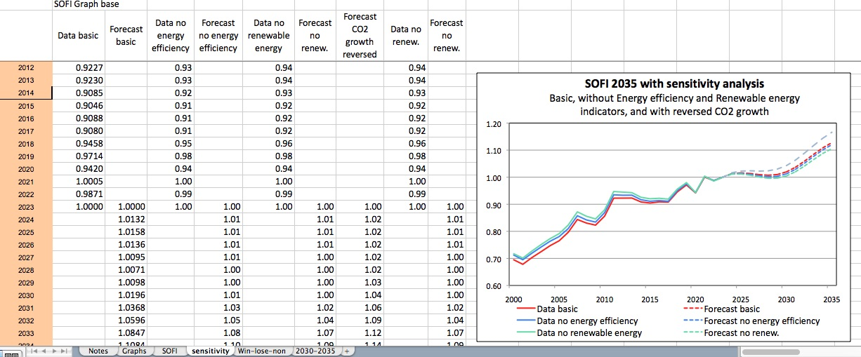

The other important analysis is for the "report card" on the future that is illustrated by Figures 14 and 15 in section "IV. Conducting a SOFI Analysis". Those graphs show where humanity is making progress and where it regresses or change is not clear. They are specifically helpful for setting political priorities.

Appendix B. SOFI Software Development

Initially, this section was a stand-alone chapter. However, since the software never got to be developed as a method itself, it was considered appropriate to include it here, as a commendable effort and example of automation of the SOFI process. This is a slightly edited version of the original paper. Some descriptions of the SOFI were already mentioned in the previous sections, but they are repeated here for completeness. This SOFI System project could be useful as a starting point for other eventual attempts of SOFI automation.

SOFI Software System

by

Peter P. Yim, Jonathan M. Cheyer, and Theodore J. Gordon

I. The Project
II. What is the SOFI System Application
III. How to Use the SOFI System
IV. Strengths and Weaknesses
V. Use with other Futures Research Methods
VI. Speculations about Future Development of the Software
VII. An Update
Appendix B1: Access to the Software and the Project Information
References

Acknowledgement

Theodore J. Gordon (chair), Peter P. Yim, Jerome C. Glenn, and John J. Gottsman formed the SOFI Advisory Committee that guided the formation and Phase-I work in 2002 and 2003.

Douglas C. Engelbart, Adam Cheyer, David Leibs and Hal Hildebrand who contributed as members of the SOFI system architecture advisory panel to the original planning and Phase-I work.

Phase-I SOFI system development team members: Adam Cheyer, Darren Haas, Eric Garlick, John Bear, Jonathan Cheyer (technical lead and architect), Kurt Conrad, Lisa Colvin, Mary Keitelman, Bo Newman, and Peter Yim (project director).

Continued work (mainly in the second half of 2007) as described in the “update” (Section VII of this chapter), since the first publication about it in Futures Research Methodology V2.0 in 2003, on the SOFI System architecture, design and proposals has been contributed by Adam Cheyer, Denise Bedford, Duane Nickull, Jack Park, Jerome Glenn, Jonathan Cheyer, Kenneth Baclawski, Patrick Cassidy, Theodore Gordon, and Peter Yim.

I. The Project

The SOFI methodology developed by Ted Gordon in 2001 used Lotus 1-2-3 and its macros. That proved to be very cumbersome, time consuming and not at all conducive to widespread adaptation and use of the SOFI.

Because of those limitations, a much more flexible version was imagined, which could be accessed and used in other domains, such as countries, industries, or corporations. Furthermore, if a more advanced system were to be available, it could serve as a common repository for the arrays of data and judgments that make up a SOFI. With proper safeguards, it could become a vehicle for combining proprietary with public data to draw insights not otherwise attainable. In July 2002, The Millennium Project Planning Committee decided to look into improving the software and developing a full-scale implementation of the SOFI methodology. A SOFI Advisory Committee established the MP-SOFI-SD Project (Millennium Project - State of the Future Index - Software Tool/System Development Project; hereafter, "MP-SOFI-SD" or, simply, the "Project") as a sub-project under The Millennium Project.

Phased Implementation

Three initial phases of the implementation were identified:
- Phase 0: Strategizing, planning, staging, and requirements gathering.
- Phase 1: Initial software tool implementation and the launch of a community of practice around SOFI.
- Subsequent Phases: Continuous development and improvement of the SOFI system, content, and knowledge through the collaboration of open communities that are augmented by the Internet and other technologies.

The Project was officially launched and the first architecture design workshop was held in Silicon Valley, in November, 2002.

Core Concepts and Values

Of particular significance to this full-scale implementation of SOFI are the following concepts and processes, which, together, form the core values of the approach:

- The SOFI Methodology combines historical data and future forecasts, quantitative as well as qualitative techniques, mathematical derivations, as well as human judgments, to systematically paint a picture of the state of the future. The SOFI time series data and their graphical representation provide highly condensed information and visual impact, but also of great value to other users and analysts would be the details (historic data, assumptions, choices, judgments, debates, studies, inter-relationships, cross-impacts, etc.) that contributed to the resultant SOFI. For this reason, it was important in this project that all of the information that contributes to a SOFI be properly captured, stored and made available through some knowledge access system. Current and future work in information, knowledge, artificial intelligence, and collaborative systems does hold the promise of a continuously improving ability for this sort of application.

- A paradigm called "Bootstrapping," originated from visionary/inventor Doug Engelbart, which envisions the kind of new, co-evolutionary environment that can be created to help cope with simultaneous complex social, technical, and economic changes at the rate, scale and urgency that humanity is now faced with, is being adopted here.

Of particular relevance to the work here are the few (excerpted) ideas cited in Engelbart's Bootstrap mission statement [1]:
- Promote development of Collective IQ among, within and by networked improvement communities
- Cultivate a knowledge environment which includes a shared dynamic knowledge repository
- Foster development of an open platform information system infrastructure, based on an Open Hyperdocument Systems (OHS) framework

- Serving a wide variety of applications. While The Millennium Project developed and used the SOFI concept to produce a global forecast of the state of the future, other possible applications illustrate the potential of the approach. Countries, regions, cities or communities could develop SOFIs based on factors that they themselves consider to be important in defining their state of being and expectations. If many countries were to develop their own measures, their improvement or degradation could be compared, one to another, on a rational basis. Corporations could produce, track, and make decisions on the basis of a corporate state of the future; and competitive analysis could be enhanced in this way. Indexes of various sorts could be constructed and forecasted for various purposes such as an index of moral behavior in an organization or an index of technological prowess in a nation. The intriguing aspect is that this wide variety of applications can use a common computational framework, a common means of communication among all of the contributors to an index, and, to some important degree, even common data pertaining to time series and the external events that can deflect the future course of those variables. This project was designed to provide such a facility.

- Collaboration among participants and stakeholders in the form of virtual communities. A diverse, distributed, international community with the infrastructure and track record of collaboration in future studies would provide an ideal startup environment in which to grow the system. This turns out to be the type of thing leaders and participants of the Millennium Project have been doing all along. The node-based structure of the Millennium Project organization, possibly with the addition of some early adopter organizations, could, together, be organically formed into communities of practice and provide that kind of ecology needed. Further augmentation by state-of-the-art technology, provided that it is non-intrusive, and that proper training is conducted, will promise to improve the result even more. The participatory involvement of stakeholders formed into communities, with the use or development of SOFIs as a focal point, and augmented by a shared electronic workspace that helps alleviate some of the limitations posed by geography and time, begins to give us a glimpse into the co-evolutionary bootstrapping environment that Engelbart alludes to.

- The notion of "Openness" -- as in open systems, open standards, free and open source software, open content, open collaboration, open knowledge and open mind. The process solicits and builds upon open participation, open contribution and open sharing of resultant work. This mode of operation promises more robust software, better efficiency, greater participation, and a myriad of systematic advantages [2] over closed/proprietary systems and other modes of development/ production of the system. In this vein, it has been adopted that the software developed for this project shall be made available under the General Public License (GPL) software licensing arrangement [3].

The Project is attempting to adhere to the above concepts and processes and to gain the advantages they promise. With the belief that (i) futures research can lead to normative futures, and (ii) that augmented collaboration can help harness the collective intelligence needed to help cope with the complexities of building a generalizable SOFI computation and use scheme. This is where we begin – where, hopefully, we will develop an initial infrastructure and a process that results in a participatory SOFI, and through the participation, better infrastructure and processes, better research, better SOFIs and better futures.

II. What is the SOFI System Application

The full-scale implementation of SOFI involves taking the existing personal research and analysis SOFI tool and making it into a robust, Internet-based, open, collaborative SOFI user and developer environment.

At the time of this writing, the first phase of the Project was underway. During this phase, the team (i) has established an initial architecture, (ii) was developing a functional code base, and (iii) planned to develop and deploy a community of practice with early adopters. This approach was intended to spur continued development and improvement/expansion of the market, the use cases, the model, and the methodology, as well as the software and the system, once the first phase would have been completed. Following is a description of this phase of development, where the system was developed as a software application (“SOFI application” or “the application”.) The application was hosted on a series of servers that run on the Linux operating system and provided for an open, standards-compliant, scalable, fault-tolerant and secure system.

The Phase-1 SOFI Application

The SOFI application is a scalable, Web-based application that allows users to view, create, and modify data from the State of the Future Index. Users can also perform a “run”, or calculation of the index, based on a set of data. The calculations and data can be seen in multiple ways (as text, numbers, graphs, etc.). Users can choose to collaborate with others, or work independently, or they may work in small groups for a while and then when ready, “publish” the results for the world to see.

The data of the application currently include historical data of variables, future values of the variables based on a particular type of curve fitting, weights of the variables, hypothetical events that impact the variables, and the amount of the impact on those variables. It is expected that additional types of data will be added in future versions of the software.

The calculations performed on the data are handled by the SOFI computation engine. Currently, two types of calculation algorithms are processed by the engine: (i) the original SOFI algorithm that aggregates the forecasts of the variables, and (ii) the Trend Impact Analysis (TIA) that accounts for the impacts of future events in the variable forecasts. It is expected that additional types of algorithms will be available in future versions of the software.

The system comprises "server" software components that run on an Internet server, and a "client" software program which runs on users' personal computers. The application has support for multiple types of clients. Currently, a client written in Visual Basic provides the dynamic, graphical view of the data and calculations, and a built-in Web browser provides a dynamic, text-based view of data and calculations. The browser can also display any type of static information, such as documentation, pre-defined graphs, and other information. Future versions of the software are expected to include multiple types of clients, with individual clients focusing on providing more sophisticated views on specific areas or uses.

The following sections will discuss the goals of the SOFI application, the architecture that implements those goals, and the components of the application. The components include the computation engine, Web front-end, Visual Basic client, database, and the collaborative platform.

Goals

The predecessor to the SOFI application, the SOFI spreadsheet, focused exclusively on the calculations. While well-designed, it had some limitations inherent in the spreadsheet model. However, it also had some advantages that are well worth mentioning. The spreadsheet model excels in providing a clear, concise view of the data. The tabular format is easy for people to read, and is quite familiar to the average business computer user. Programs such as Lotus 1-2-3 and Microsoft Excel have done much to further the spreadsheet model and make it available to almost any MS Windows user. More recent programs such as OpenOffice provide a Free Software alternative to commercial products that works on multiple platforms such as Windows, Linux, Solaris, and Mac OS X.

Spreadsheet programs are simple to install and do not require complex administration skills. No programming skills are needed to use it, although some mathematical background and understanding of formulas is very helpful. However, spreadsheets are primarily written for a single user, working on a local computer (usually a PC). The “architecture” of the spreadsheet is usually described as a single tier, meaning that the presentation, the logic, and the persistence are all tied together in the spreadsheet. This provides advantages in simplicity, but it is not very flexible.

Spreadsheet formulas are handled on a per-cell basis, and the presentation of the cell is specified together with the formula. In order to apply a formula to multiple cells, the formula is usually copied to each cell, instead of referenced a single time. Both mistakes in copying formulas and mistakes as to which cells the formulas are referencing can be very difficult to locate (although easy to fix when found). Spreadsheets don't make clear distinctions between original inputs and temporary, intermediate results that are used as inputs later in an algorithm, since everything is represented by a cell. (Whereas programming languages can sometimes do a better job at providing a clearer abstraction with the introduction of various programming artifacts, such as local variables and data encapsulation.)

The SOFI application was written in response to some of these limitations. Creating a SOFI can be a complicated thing to do and take quite a bit of time. Data must be obtained, and sometimes massaged, to get it into the proper format. Weights must be determined. Events must be chosen, and their implications considered. All of this suggests that work could be done in a collaborative way, with peer review and discussion of the finer points an important aspect of the process.

The application should be able to be more than just a replacement application for the SOFI spreadsheet. It should support a SOFI community, one in which participants may be in more than one country, speaking more than one language. It should be able to provide support for the collaborative process itself, helping users work together. It should be able to support multiple ways of viewing data. It should be able to store its data separately from the application in a standardized way so that the data can be read even without using the application. The code itself should be open, available for users to inspect and improve.

Architecture

The architecture of an application is what holds all the pieces together, and drives it towards the goals of the application. Figure B1 is the architecture of the system being implemented.

Figure B1: SOFI System Architecture

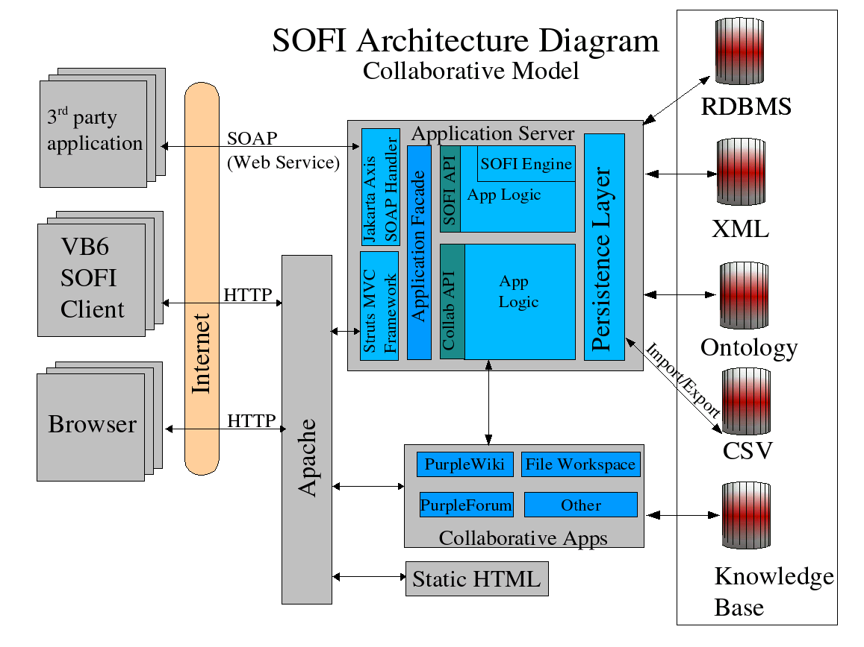

The language chosen for the current implementation of the SOFI application is Java. While no language is perfect, Java is a good fit for the implementation language for the SOFI application for a number of reasons. It is considered to be a modern language and has support for things such as object orientation, garbage collection, exception handling, and security. It has also been around long enough to be fairly mature at this point, with stable, well-published APIs and language constructs. There is widespread support both from industry and Free Software/Open Source organizations. It has strong type-checking and is a compiled language, which assists greatly in reducing bugs. Automatic variable boundary checking by the Java Virtual Machine and removal of direct address manipulation from the language render impossible the most common security problem found in C language programs: the buffer overflow error. Java runs on many platforms, including Windows, Linux, Solaris, and many others.

Java is especially good in Web-based applications in which it is running on a server. For this reason, the Java 2 Enterprise Edition (J2EE) technology was chosen. There is a large number of existing API’s and frameworks written that ease the development effort for applications. J2EE allows for competing implementations of well-known interfaces, which gives developers the ability to choose the best implementation for their needs without losing interoperability and the option of changing their choice later on. The Java Community Process allows companies, organizations, and individuals to participate in the process of deciding the future direction of Java and of the various standards and specifications.

A 3-tier architecture was chosen, following a well-known J2EE pattern. The tiers are broken up into presentation, logic, and persistence. This allows for the possibility of having different clients, each which can be plugged into the core infrastructure on its own. Because of the many ways in which data can be represented, a new client may be written that delivers the user interaction in a novel way. Likewise, there may be multiple schemes for the persistence, such as storing the data in a relational database or an XML file, for example.

The model and logic is exposed through a public, language-neutral, platform-neutral API known as a Web Service. The definition of the Web service is described using the Web Service Description Language (WSDL). The protocol used to communicate with the Web service is the Simple Object Access Protocol (SOAP), which is essentially XML over HTTP. Both WSDL and SOAP are open standards, defined by the World Wide Web Consortium (W3C). It has strong support from industry such as Microsoft and Sun, as well as open source organizations such as Apache. The current implementation used is Apache Axis, which is a SOAP processor that runs as a servlet in the Apache Tomcat application server. By providing the core pieces of the SOFI application as a Web service, other third-party applications could leverage the functionality of the SOFI software without it being seen by third-party application users as a separate application.

Computation Engine

The computation engine is at the heart of the application, as far as generation of the SOFI time-series is concerned. It is responsible for computing SOFI values from the given input data. The current engine can handle both the original SOFI calculations as well as TIA SOFI calculations. The engine defines and implements a public API. This allows for the possibility of replacing the existing implementation with a completely different engine implementation that performs the same tasks.

Although the engine normally runs in a J2EE application server within the SOFI application, it is intended to be able to run as a standalone Java process as well. This would allow other Java programmers to re-use the SOFI engine even if they didn't want to use any other portion of the SOFI application, such as the user interface or persistence.

Web Front-End

Most of the current SOFI application is seen through the Web front-end [B]. It interacts with the rest of the application, including the engine and persistence layer, to provide the user experience. Since the user interface for the text is done through HTML, a simple Web browser is all that is needed in order to participate in much of the collaborative work through the SOFI application. This allows the widest possible user base, since the requirements on the client software is just a Web browser on any operating system, and some kind of TCP/IP network connection to the server. Normally, the server would be located somewhere on the Internet. However, it is also possible for a company or organization to run their own server, for example on an intranet, or even to run both the Web front-end and the server on a single computer (although the installation and configuration is more complex than installing a spreadsheet program). The HTML is generated through a standard J2EE technology called Java Server Pages (JSP). The JSP pages are processed by a J2EE-compliant servlet and JSP application server. By default, the SOFI application uses Apache Tomcat, an open source implementation by the Apache Software Foundation, as its servlet container/application server.

Standard JSPs provide a good separation of presentation detail (HTML) from Java code.
However, an even cleaner approach to handling presentation is to separate the presentation processing from the presentation view. This involves a well-known pattern named Model-View-Controller (MVC).

The current SOFI application makes use of Apache Jakarta Struts, which is one of the open source frameworks that uses the MVC pattern, and is built on top of JSP. Beyond providing a cleaner abstraction, it also provides good support for internationalization (i18n standard compliant) and localization (l10n standard compliant). Furthermore, it offers some simple assistance to the JSP programmer in handling HTML form validation and error control.

Visual Basic Client

The user views the text and the graphical information seen in the SOFI application through its Visual Basic (“VB”) client. This VB client software contains a built-in Web browser that is used to navigate through the various features of the application. It also allows the user to see graphical representations of the data along with their values, such as those for each of the variables, or for the computed SOFI.

Database

All of the data in the application is stored in a relational database. By default, the SOFI application will use the open source database MySQL. However, since the application uses SQL calls (through the standard JDBC API) and does not use stored procedures or other database-specific logic, it is possible to use any JDBC-compliant database.

The data can also be exported in various formats, such as a comma- or pipe-delimited format that is common for spreadsheets.

An expected feature of a future version of the SOFI application will include the ability to export the data in XML format.

Ontology

Ontology is the standardization of meanings. An ontology defines the terms used to describe and represent an area of knowledge [4]. Ontologies are used by people, databases, and applications that need to share domain information. Ontologies include computer-usable definitions of basic concepts in the domain and the relationships among them. They encode knowledge in a domain and also knowledge that spans domains. In this way, they enable semantic interoperability and hence allow knowledge to become more reusable.
In developing the ontology for SOFI, descriptions for the following kinds of concepts will need to be captured:
- Classes (general things) in the many domains of interest
- The relationships that can exist among things
- The properties (or attributes) those things may have

The reason why ontology is designed in as part of the SOFI system architecture is that ontologies figure prominently in the emerging Semantic Web as a way of representing the semantics of documents and enabling the semantics to be used by Web applications and intelligent agents. Ontologies can prove very useful for the SOFI community(ies) as a way of structuring and defining the meaning of the data and metadata terms that will be collected and standardized. The ontology, and the ontological engineering approach adopted, and to be implemented in future phases, provides the basis for the system’s knowledge architecture. This will enable the SOFI system to support tomorrow's “intelligent” application, giving its users better access to the information and knowledge that is continuously being captured into the system as it is being used.

Collaboration Platform

Since the SOFI application aims to support collaborative work by the SOFI community, it is important to provide tools to enable or facilitate collaboration. The phase-1 application was supposed to leverage the features found in some of the best Web-based, open source tools as integrated in the CIM3.NET Collaborative Work Environment suite. The platform was to include both tools and processes for asynchronous and synchronous collaboration support. It featured:
- an archived e-mail/discussion forum
- a community wiki (which is a website that is both writable as well as browsable)
- a document repository/file-sharing workspace
- a Web portal. This portal is accessible from the SOFI application Web front-end, as well as from any Web browser
- support for full-text search and fine-grain (paragraph-level) access to shared content

Synchronous collaboration support includes:
- voice conferencing
- screen/application sharing
- instant messaging
- real-time chat session

The primary mechanism in which the collaborative applications communicate with one another is over the Internet (through TCP/IP). The most popular user applications are retained as the interface to the user, thus lowering the learning curve for new users. As an example, user discussions are made through electronic mail with whatever e-mail system a user may already be using. The e-mail messages exchanged are then processed, transparently, by the system -- archived, parsed, turned into Web pages, indexed (to facilitate listing and search), … -- so that any user in the community may retrieve or cite an earlier message (or parts of it) with his/her Web browser.

Some of the primary software used currently includes forum list management (Mailman) and archiving (mharc), search (namazu), and a community-writable Web site with paragraph-level accessibility (UseModWiki / PurpleWiki). Fine-grain accessibility (Purple / PurpleSlurple) is achieved through the use of various tools that implement the Engelbart/Bootstrap/OHS notion of “purple numbers”[5].

It is worth mentioning that the emerging WebDAV standard is adopted here. Briefly, WebDAV stands for "Web-based Distributed Authoring and Versioning". It is a set of extensions to the HTTP protocol which allows users to collaboratively edit and manage files on remote Web servers. With that, users can be sharing electronic files with drag-and-drop ease from almost any personal computer (whether it runs on Windows, Linux, Unix, or a Macintosh system.) Optional mechanisms are in place to prevent users from overwriting each other’s work. The promise of true versioning in the future development of WebDAV will enable even greater system flexibility and capabilities.

With this collaborative platform, distributed SOFI developer and user communities will be able to carry on discussions, interact, learn, share, provide mutual support, explore, innovate and thrive as communities.

III. How to use the SOFI system?

The Millennium Project has intended for this to be a simple-to-run, integrated, program with a well-designed graphical user interface for calculating SOFI. The value proposition for such a tool is best expressed in Chapter 2 of the 2001 State of the Future:
“The SOFI is a statistical combination of key global indicators and forecasts that depict whether the future promises to be better or worse. If the promise of the future seems to be changing, then the SOFI is intended to show the directions and intensity of change and to identify the factors responsible. If confidence were developed in such an index, it could be used in policy analysis at the global, national and local levels. Furthermore, nations could be ranked by their SOFI to determine if the future outlook in their regions was better or worse than the global outlook and the reasons for any differences.”

Who are the users?

The target audience for this tool are those people interested in the SOFI, and, in particular, those who want to develop and compute their own SOFIs. The latter could include:
- Global, regional and corporate policymakers
- Professionals, scholars, academics
- Economists, political scientists, social scientists, etc.
- The Millennium Project and its Nodes

Users will need to work with computers (or have staff support that does) and will need to have access to the Internet, to take full advantage of the system functionalities.

We can also identify different classes of users. Each class of user will look at and work with the system differently. These classes of users may include:
- General public
- Researchers, journalists, trend watchers
- Policy makers
- SOFI developers, modelers, futures researchers
- Data owners (those who own and maintain databases whose data is used to construct the SOFIs)
- System developers (those who will contribute to the software)
- System Administrators (those who administer the SOFI system)

What can we do on the system?

Users will be able to do some (as this is only a partial list) of the following: (Note that some functions will require the user to be set up with proper access rights and authentication.)

Viewing/reading up

Any user accessing the system will be able to view all SOFI’s (current as well as archived historic versions) that have been published for public viewing. The Millennium Project’s published Global SOFI is in this category. There are also SOFIs (particularly works-in-progress) that may be restricted (through password authentication requirements) to be viewable only by certain communities, or even by the authors alone.

In addition, the document repository will host, among other contributions of the SOFI communities, all documentation relating to the creation and the analysis of the public SOFIs (for example, the SOFI chapters in the MP State of the Future Reports or this Futures Research Methodology V3.0 will be accessible there.) Therefore, users will be able to read up about the SOFIs and how they are constructed as well.

Comparisons

When multiple versions of a SOFI (e.g., MP has published the Global SOFI for 2001, 2002 and 2003) are available, a user will be able to call up more than one SOFI time series, and compare them (charted with each represented as a different color plot). Similarly, if someone had already done and published the country SOFIs for, say, the US, the EU, and China, one will be able to pull them up, overlay them on top of one another, and compare them with each other and with the Global SOFI of that particular year.

Drill-downs and searches on related information

This system is implemented along the lines of Engelbart’s Open Hyperdocument System (“OHS”). One can think of all the data, information and knowledge as being connected and accessible through a Web of hyperlinks. Unlike the World Wide Web as we know it now, where access is essentially limited to the page level, hyperlinking within the SOFI system is done at a finer-grain level (at the paragraph level for text documents and archived discussions, or at the data-series level, for example). Therefore, not only will users be able to read up about the SOFI and related material, they will also be able to drill-down from one level of information to the next lower one (in most cases).

It would be dull or exciting- depending on one’s point of view- to learn that from year 2007 to 2008, the SOFI improved from 1.0634 to 1.0724, or that it drops back to 1.0691 in year 2010, but more important would be for one to find out what variables, which datasets, what assumptions were responsible in making the index change. If one is interested in a particular variable, one could go on and discover the associated Delphi study and the opinion of the panel of experts in events or developments that affect this variable. The non-linear construct of the hyperdocument will allow the users, simply through mouse-clicks, to drill-down deeper and deeper to find out why.

While more sophisticated knowledge access structures will be implemented in future phases, the phase-1 implementation supports full-text search, and provides us yet another means of information and knowledge retrieval and discovery.

Asking 'What-if' questions by “tweaking” the SOFI parameters, or exercising alternate scenarios

Policy makers will have the option to “tweak” some of the SOFI parameters – like forcing probabilities of a certain event happening in certain years to 1 (or 0) -- and seeing how the SOFI changes. That, in effect, allows the policy maker to ask a question like: “what-if ‘Mad Cow disease found in many countries’ happens (for sure) in year 2003 and 2004, how would the future outlook for the next 10 years be affected.”

Another option is to adjust the weights applied to a (or a few) variable from the value assigned by the publisher of the SOFI.

Analysts, researchers and policy makers may even construct alternate SOFI’s based on different scenarios, and see how those SOFI’s will be alike or differ, and how they compare to a baseline SOFI.

Developing new SOFIs

A major purpose of the system, of course, is to facilitate the development of new SOFIs. Examples would include:
- SOFIs for different Countries, Regions, Municipalities, … etc. (e.g. a USA-SOFI, France-SOFI, Russia-SOFI, China-SOFI; or a EU-SOFI, Middle-East SOFI, Greater-China SOFI, Latin-America SOFI; … etc.)
- SOFIs for different government or industrial sectors (e.g.E-government SOFI; Petroleum and Oil industry SOFI; Automotive Industry SOFI; Aerospace industry SOFI; Science & Technology SOFI; Nanotechnology SOFI; Tertiary Education SOFI; … etc.)
- SOFI for Corporations; individual Organizations; Programs, Initiatives or Product Lines; …etc.

One should look at SOFI as a methodology that allows one to aggregate relevant historical and forecast data, and summarily quantify it in a form that depicts whether the future outlook is improving or regressing. Through the processing of both statistical as well as judgmental data, one can see that it provides a means and a generic tool and process for people to get a grasp on highly complex and fuzzy situations.

While no one can predict the future, the construction of this system, which facilitates the evolution of the process and knowledge captured in the system, and with its attempt to leverage the collective intelligence of communities of practice, promises a continuous improvement on its effectiveness as a policy and decision support tool.

Collaboration and Collaborative Development

The collaborative platform provides the users with the means to (a) use/re-use data, information and knowledge that have been captured into the system, (b) to communicate, seek help and support from fellow practitioners, and (c) to engage in community-wide discourse, plan initiatives, and coordinate projects and teamwork. It provides the workspace for community members to share their work, their knowledge and wisdom with one another.

The primary user interface is through the SOFI client software, the Web browser, a user’s e-mail, and/or through drag-and-drop operations into community folders (which, for today, should not be presenting much of a challenge to most users now.) Archiving of the discussion and/or contributions into the system repository is made almost transparently. All contributions become sharable (if so intended) by the community. They will also be retrievable through the system search engine (which, as mentioned before, supports full text search) and be made accessible at a paragraph level granularity.

As described above, support for real-time online meetings (like phone conferences with shared-screen) is also available. The system and process design that makes up this full-scale implementation is optimized for the collaborative development and application of SOFI by distributed communities of practice and project teams.

While ease-of-use and minimal intrusion is built into the design of the system, it is recognized that proper training for users of the system will greatly enhance its effective use. This will be especially useful for users who would want to make the best use of virtual collaboration tools to perform distributed team work. The entry barrier is intentionally kept low with a mild learning curve for the beginning users. Adept users, however, will find it equally rewarding once they start to appreciate the power and performance offered by the more sophisticated features of the system.

Interaction and accessing data, information, and knowledge

The system is designed to support three kinds of interaction:
- Human-to-machine
- Human-to-human
- Machine-to-machine

We have described much of the first two types of interaction in earlier paragraphs within this section. It is useful to mention that the system is also designed with machine-to-machine interoperation in mind. Some features (like the employment of Web services as the means to handle the interaction between the user’s machine and the application server; or the systems ability to import and export data that are compliant with certain standards, like CSV formatted data) are implemented in the phase-1 implementation, while others (like the ontology and associated knowledge access structures) are planned and designed into the system architecture, to cater for the future, as the Internet and other system and computer technologies continues to evolve.

Building up the system’s database and knowledge base

For a SOFI developer, every time a set of data is required (e.g. the historic figures for GDP per capita between 1980 to 2002, or the judgmental input of a panel providing normative and dystopic values and weights to the development of “Biotech in agriculture”), he or she will either have to (i) retrieve it from the system database (if it is already in there, exactly the way it is needed), or (ii) take what is in the database, and update it (if it is already there, but not updated), or (iii) source a set of new data and enter it (manually, semi-automatically, or automatically) into the SOFI system. If this developer is sharing his/her data with the rest of the community, the sharable database grows by that much, whenever updates are made or when new data are added. The same thing goes with discussions and work contributed to the wiki or the file workspace/document repository. As such, the database and captured information/knowledge grows as the system gets used.

The chances of the reuse of previously captured data depends on whether another user has had a use for it, and if so, has made an attempt and successfully retrieved it. The system is designed with ease of data and knowledge capture and retrieval in mind. That will be one area that continuous improvement is sought.

That said, the content of the database (of numeric data, time series, and SOFI datasets) and the captured user collaboration (from their discussion forum, wiki and contributions to the document repository) will, collectively, form the system’s knowledge base, or, in Engelbart’s terms, our Dynamic Knowledge Repository (“DKR”). This knowledge base is expected to grow as the system gets used. For example, different SOFI’s employ different sets (even if some are common) of variable data for their construction, and that contributes to the growth when more people use the system to construct different SOFI’s. Likewise, when more people participate in the communities, there will invariably be more expertise within its membership. One could, then, expect a higher likelihood of getting a good answer, say, when one has a question to ask of the community. Since shared knowledge is captured, archived, and retrievable, that builds up too with use and participation. With a more substantial database and knowledge base, users will be able to make better analyses or syntheses, and different SOFIs can be constructed more easily. With that, more people will be attracted to participate in the community(ies) and use the system. This is the “bootstrapping”, and the kind of virtuous circle that the authors wish to see happen.

IV. Strengths and weaknesses

Most of the details are already covered above. In summary, the salient strengths and weaknesses and challenges of this full-scale implementation of the SOFI include:

Strengths
- Ability to drill-down
- Robust – built to enterprise-class quality standards (not as an academic experiment)
- Accessible & Available – by way of the “openness” core value adopted, and because it is hosted on the Internet
- Distributed – designed for people to work from different locations
- Collaborative
- Organic: supports “bootstrapping” and co-evolution

Weaknesses
- Needs some level of sophistication in the part of the users
- Complexity (despite all efforts to lower the entry barrier to users)
- Learn probability – while the system is already hiding most of the mathematics, an understanding of how the system and its computation works is essential for proper application
- Needs training
- Needs computer and Internet access

Challenges
- Maintenance of the data (even historical data change)
- Building and nurturing early adopter communities to the point when critical mass is attained

V. Use with other Futures Research Methods

The system described here can both provide a service to other applications and draw from other methods to facilitate its operation. On the service side, this system could provide a source of information for applications that need quick access to time series data on variables that relate to the state of the future. Such applications include, potentially, simulation models, gaming, and econometric applications. These ties would be particularly strong and important if the database in SOFI were updated periodically and were known as the source of high quality, accurate global information. Today, some commonly available and respected sources provide data only for selected countries; the SOFI database could extend this piecemeal information to an authoritative global estimate and in that sense become unique. The database associated with the TIA's could also be important to other applications. For example, one could imagine a simulation game in which the TIA events provide a set of "discontinuities" that are superimposed on an otherwise extrapolative series of moves. Policies could be tested for robustness against the surprises that the TIA events represent. The TIA database could be the source of exogenous events for econometric models.

The system can make use of several futures research techniques in its own construction and operation. For those elements that require expert opinion and judgments, Delphi in one form or another could be employed. Public opinion polls could also be used to identify the variables that are important in the "public mind" and these could be compared to expert Delphi assessments. Advanced scanning techniques could be used to monitor the appropriate source to determine if new events should be added to the database or removed as a result of their having occurred. Finally, there are TIA event impacts that might be computed, rather than judged, using various modeling techniques such as econometric modeling.

It would be interesting to compare the SOFI forecasts with opinion polls about the future. Both, after all, deal with perceptions about whether things appear to be improving or deteriorating. We suspect that opinion polls will be much more volatile and responsive to the problems of the moment, but a comparison of this sort might provide a means of gaining an understanding of public opinion about the future and the behavior it engenders.

VI. Speculations about future development of the system

From the software engineering perspective, the continued development and adoption of some of the Internet trends and open standards embraced by the SOFI system architecture (like XML, WebDAV, SOAP, Web Services, DKR, OHS, the Semantic Web, …etc., or some future incarnations of these technologies) will allow it to better interoperate with other systems, both as a provider and a recipient of services. For example, the SOFI application already exposes itself as a Web service using SOAP. In the future, there may be other services, like those mentioned in section V above, that the SOFI application itself could make use of, in which case it would be a client of those services, while at the same time providing a service of its own.

On its application, if SOFI becomes more broadly used, countries and regions could track their own SOFI. Newspapers and other publications could cite, or even syndicate, SOFI as they would today with some of the economic indices (such as GDP, cost of living, Dow, and S&P500). Future phases of the software could associate SOFI with scenario building and validation, as well as with front-ends that facilitate the capture of judgmental or other research inputs. By architecting it as an open knowledge system, and developing this software in an "open source" mode, it is envisioned that it will become a collaboratively developed and continuously improving system. Among others is the normative desire to maintain an authoritative, accurate and up-to-date database of data relevant for computing SOFI's, and to make such a database available in a consistent, standard format. Coupling that with the research content and scenarios, the SOFI software tools and system shall, hopefully, become a useful and compelling tool/platform/knowledgebase for the futures research community, policy makers, strategists, scholars and other SOFI users.

The Millennium Project, along with SOFI developer and user communities, could develop and establish quality standards, and even the trust system that would identify published SOFIs that are developed with stringent process control and quality assurance, and properly recognize them as being deemed trustworthy.

The full-scale implementation of SOFI is envisioned as a multi-phased endeavor of which only the beginning phases are described here. What is being worked on is a system that is designed to provide a work environment conducive to organic growth of knowledge and human interaction, so that people can collectively work out what the future may look like. Let us hope we will see some emergent pattern and behavior the next time we look again.

VII. An Update

Since the first publication on the full-scale implementation of the SOFI System in Futures Research Methodology v2.0 (2003), some continued work has been put in. In particular, a team was convened in the second half of 2007 that worked on updating the SOFI System thinking, particularly in the system architecture, design, and choice of technology and standards that the system should focus on during full-scale implementation. Funding proposals were also put together by the team.

Some of the major updates that were discussed included:
- the incorporation and integration of the “Real-Time Delphi (RTDelphi)” method (see chapter 4) into the full scale implementation.
- the refinement of the system architecture and design to incorporate the latest developments in Service Oriented Architecture (SOA) technology and standards
- the refinement of the system architecture and design to incorporate recent developments in social networking, Web 2.0 technologies, and the latest in distributed collaboration techniques.
- consideration of the addition of quantitative decision analysis that will incorporate Bayesian Networks and other ontology-based (deterministic as well as probabilistic) algorithms and techniques.
- the refinement of the system architecture and design to incorporate the latest developments in ontology, ontology engineering and Semantic Web technology, and emerging standards
Among others, a proposal has been made to the National Science Foundation (NSF). The team also presented the work at the Joint NASA-Ontolog-KMWG “Ontology in Knowledge Management and Decision Support (OKMDS)” virtual panel session in December of 2007. Archived proceedings (slides and audio recording) of that session [6] can be considered an integral part of this update.

Appendix B1: Access to the software and the project information

There was a portal to the MP-SOFI-SD Project information, which is not available anymore.

Figure 2: an incipient phase of the SOFI client software interface and the
computed SOFI (mock-up)
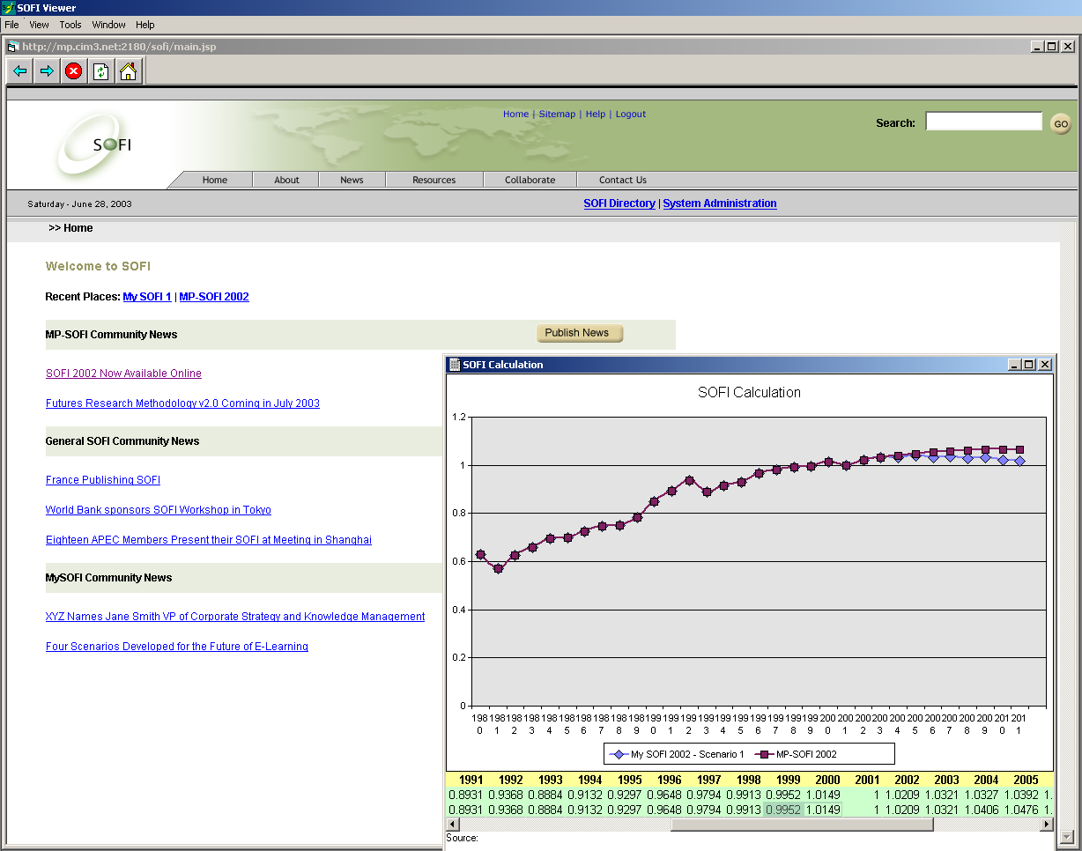

References for Appendix B

Engelbart, Douglas C., "Bootstrap" Vision and Mission (Dec. 1999)
http://bootstrap.cim3.net/vision_mission.html

Coase's Penguin, or Linux and the Nature of the Firm (Jan. 2003) http://www.benkler.org/CoasesPenguin.html

The GNU General Public License (Version 2, June 1991)
http://www.opensource.org/licenses/gpl-license.php

Web Ontology Language (OWL) Use Cases and Requirements (Draft, March 31, 2003). See: http://www.w3.org/TR/2003/WD-webont-req-20030331/#onto-def

Proceedings of the SOFI System presentation at the NASA-Ontolog-KMWG “Ontology in Knowledge Management and Decision Support (OKMDS)” virtual panel session is available at: http://ontolog.cim3.net/cgi-bin/wiki.pl?ConferenceCall_2007_12_13

Bibliography for whole chapter

Barry Hughes (ed.), International Futures: Exploring Alternative Global Possibilities, The Pardee Center, University of Denver (2009)

Glenn, J. and Gordon, T., State of the Future 2001 to 2008, Millennium Project, World Federation of United Nations Associations, Washington DC (2008)

Gordon, T., Yim, P., Cheyer, A., Bedford, D., Cassidy, P., Baclawski, K., Nickull, D. and Glenn, J., “Making Better Strategic Decisions, by Asking If It Is Going To Get Better or Worse - the SOFI Method,” NASA-Ontolog-KMWG “OKMDS” mini-series (2007), http://www.ccs.neu.edu/home/kenb/pub/2007/44/public.pdf

OECD, Handbook on Constructing Composite Indicators: Methodology and Guide, OECD, European Commission, Joint Research Center, OECD Publishing (2008). OECD Code 302008251E1

All of the descriptions of the IFs model, uses, and history are taken from the IFs literature. The original material was developed by and copyright 1988- 2008 by Barry B. Hughes and is used here with his kind permission. The model is presented at https://korbel.du.edu/pardee/

