Twitter Analytics Dashboard
Power BI Project Report | Tweet Engagement, Interaction & Content Performance
1. Project Overview
This project develops an interactive Twitter Analytics dashboard in Microsoft Power BI to analyze tweet engagement, user interactions, media performance, engagement trends, and high-performing tweets. The analysis combines data transformation, calculated columns, DAX measures, conditional filtering, time-based visibility logic, and business-focused visualizations.
2. Project Objectives
- Analyze how different tweet categories generate URL, profile, and hashtag interactions.
- Compare engagement rates for tweets with and without app opens.
- Identify day-of-week patterns in media views and media engagements.
- Compare overall replies, retweets, and likes.
- Track monthly engagement-rate trends for tweets with and without media.
- Identify the top 10 tweets based on combined retweets and likes.
3. Tools & Technologies
Tool / Technology | Purpose
Microsoft Power BI | Dashboard development and visualization
Power Query | Data preparation and transformation
DAX | Calculated columns, measures and conditional visibility
Microsoft Excel | Source dataset
4. Analytical Tasks Completed
Task 1 – Tweet Interaction Breakdown by Category
Created a clustered bar chart comparing URL clicks, user profile clicks, and hashtag clicks by tweet category, with the specified interaction, date, word-count and visibility conditions.
Task 2 – Engagement Rate Comparison
Compared engagement rates for tweets with and without app opens using weekday and tweet-time conditions, even impressions, odd tweet dates, character count above 30, exclusion of tweets containing 'D', and the required visibility windows.
Task 3 – Media Interaction by Day of Week
Created a dual-axis visualization comparing media views and media engagements by day of week, applying the specified quarter, impression, date, character-count, text-exclusion and visibility conditions.
Task 4 – Replies, Retweets & Likes Comparison
Created a comparison chart using SUM aggregation for replies, retweets and likes, restricted to tweets from June through August 2020.
Task 5 – Monthly Engagement Rate Trend
Created a line chart showing average monthly engagement rate with separate categories for tweets with media and tweets without media.
Task 6 – Top 10 Tweets by Engagement
Created a Top 10 analysis based on combined retweets and likes, excluding weekends and applying even-impression, odd-date and word-count-below-30 conditions, with 3 PM–5 PM IST visibility.
5. Dashboard Design
The final dashboard uses KPI cards, clustered bar charts, line charts, and a dual-axis visualization to present engagement patterns clearly. Required time-based visibility logic was implemented for the relevant tasks.
6. Final Dashboard Preview
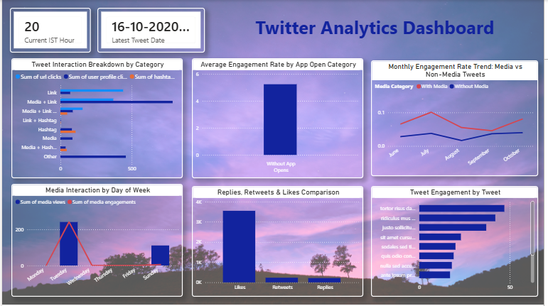
7. Data Validation & Limitations
- Task 1 – Word count: The supplied dataset contains tweet word counts in the observed range of approximately 16–36 words. Therefore, the specified word-count condition of greater than 40 does not produce qualifying records.
- Task 6 – User profile: The supplied dataset does not contain a clearly identifiable username/user-profile field. Therefore, the associated user profile could not be displayed without inventing information not present in the source data.
8. Key Takeaways
- Different tweet categories can generate different types and levels of audience interaction.
- Separating media and non-media tweets helps compare content-related engagement patterns.
- Replies, retweets and likes provide complementary indicators of audience response.
- Monthly and day-of-week analysis helps identify temporal engagement patterns.
- Top-engagement analysis helps identify tweets generating stronger audience response.
9. Conclusion
The completed project demonstrates practical skills in Power BI, Power Query, DAX, data filtering, data modeling and business-focused visualization. The six tasks translate detailed analytical requirements into a structured dashboard while transparently documenting genuine source-data limitations.

