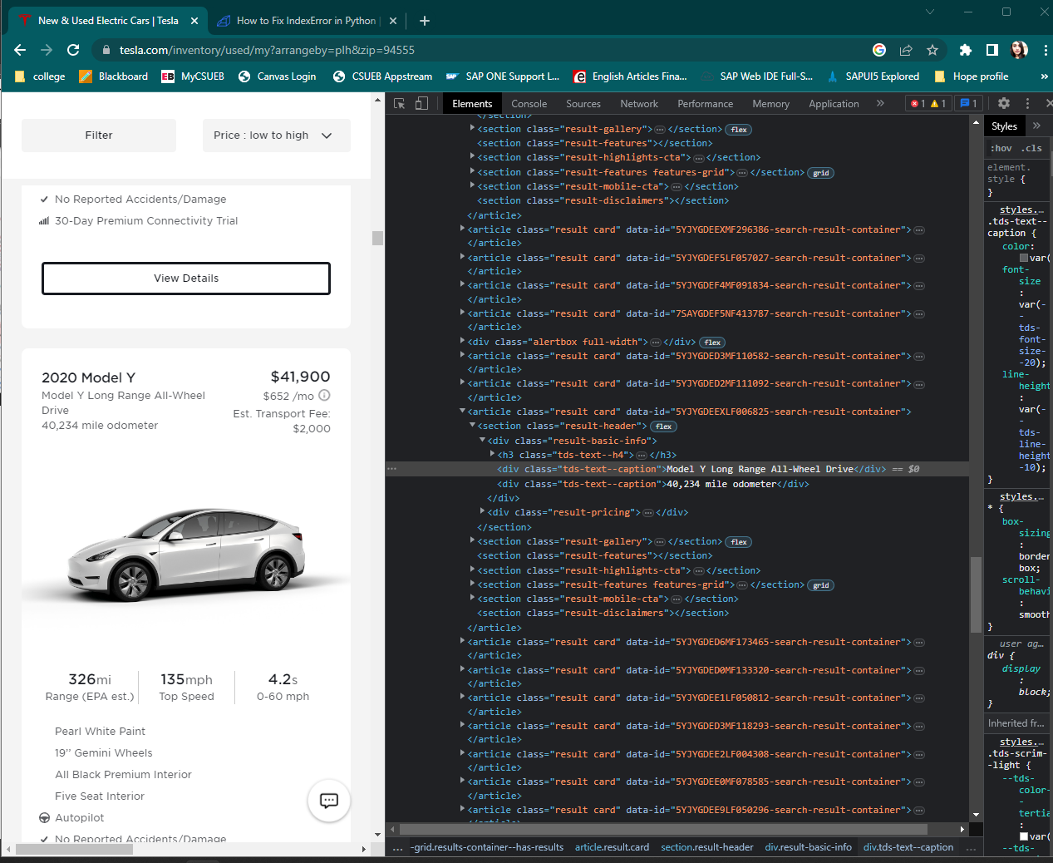

Initial code :

For a quick Fix im using Try-Catch :

After Increasing the wait time to 50 seconds I got the same output

I can separate the car type into year and model which will help with better visualizations.

Noticed discrepancy in colors and some missing data



To viz on Tableau I will change it in data cleaning