Review software

Introuduction – Review software is small tool to automate the review Queue process

Key functionality –

Artsit can forward his final shot for review using Queue_Artist

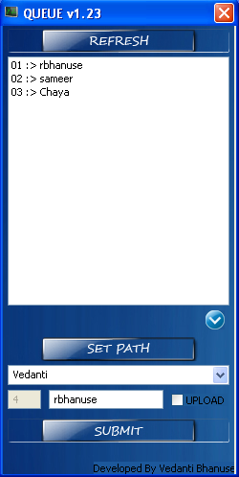

Refresh the list for current Reviewer so Artist can keep watch on which are the reviews are pending before him

(SET PATH) Artist can browse the actual final mov path which want to review

All atrist list who have already in queue for sleected supervisor

Select supervisor name from drop down who want to check the shot

Steps for Submit for review -

Artist can select the supervisor name by selecting drop down list

Select the final mov path for review

And hit the submit button

It will register the Artist Queue in Artist list for review ,its updated Artist list with actual assign number along with artist name as shown above in list eg 01:> rbhanuse is the first reviewer for the day under vedanti supervisor

QUEUE_Sup will display all Artist in Queue

Supervisor can view all the Artist list who has submitted shot for review by him

And he can check Artist shot one by one in listed Queue

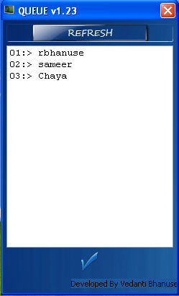

After review the shot sup can delete the Artist name so Artist Queue will keep on Updating About current Review Queue

Double click on Artist name will open the final mov path submitted for review