Real-Time Sales Analytics Pipeline

1 Project Overview
This project is a Real-Time Sales Analytics Pipeline built to ingest, process, clean, aggregate and visualize sales order data in near real time. The pipeline uses Apache Kafka for event ingestion, Apache Spark Structured Streaming with PySpark for streaming transformations, a CSV-based data lake for Bronze/Silver/Gold storage, and Power BI for business reporting.

2. Resume Project Description

Real-Time Sales Analytics Pipeline using Apache Kafka, Apache Spark, Docker and Power BI
- Designed a real-time event-driven data pipeline for streaming sales order data.
- Ingested sales events into Apache Kafka topics and consumed them through Spark Structured Streaming.
- Implemented Medallion Architecture with Bronze, Silver and Gold layers for raw, cleaned and aggregated data.
- Performed data cleansing, deduplication, timestamp conversion and business aggregations using PySpark.
- Built an interactive Power BI dashboard to track KPIs such as total revenue, total orders, average order value and city-wise sales.
- Containerized the Kafka environment using Docker Compose and maintained source code using Git/GitHub.

3. Architecture
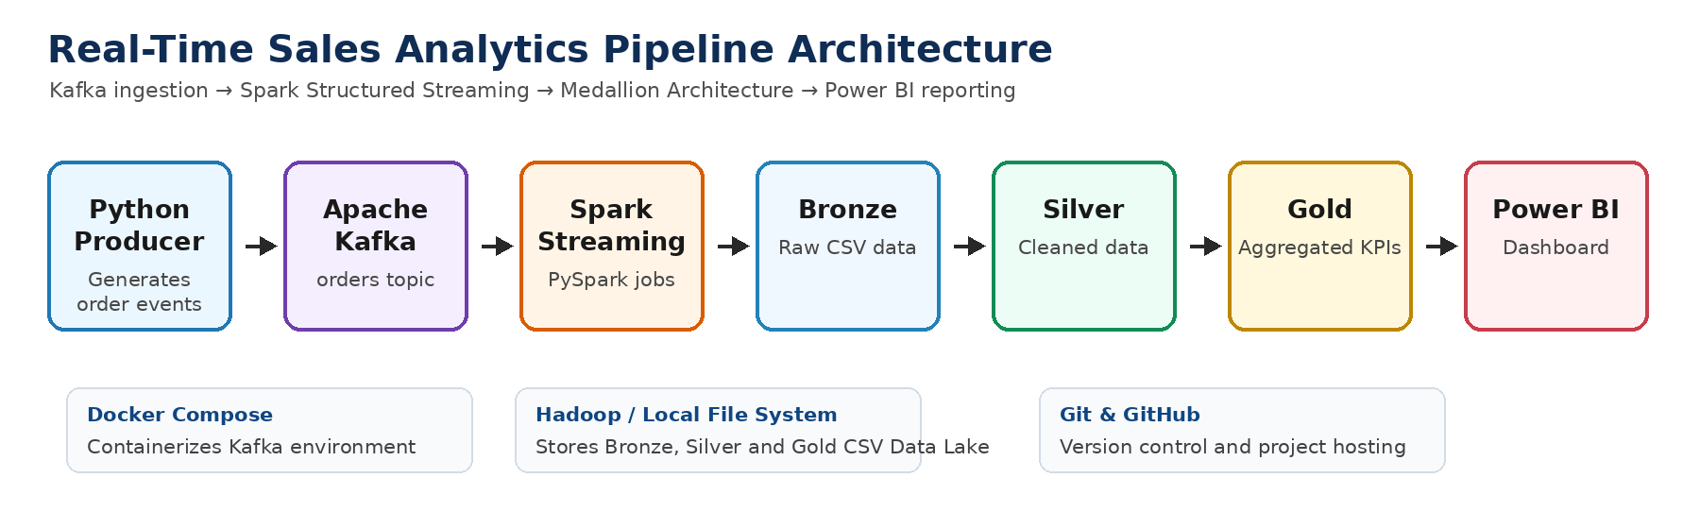

Python Producer
↓
Apache Kafka (Docker)
↓
Py spark Structured Streaming
↓
Bronze Layer - Raw Data
↓
Local-silver
↓
Gold Layer - Aggregated Data
↓
Power BI Dashboard

4. Technologies, Tools and Purpose

Technology / Tool | Purpose in Project
Python | Used to generate sales order events and run supporting scripts.
Apache Kafka | Used as the event streaming platform for ingesting real-time order data.
Apache Spark Structured Streaming | Used to process real-time data streams continuously.
PySpark | Used to write Spark jobs for cleansing, transformation and aggregation.
Docker | Used to run Kafka services in containers.
Docker Compose | Used to start Kafka-related services with one command.
Hadoop / Local File System | Used as the storage layer for CSV data lake folders.
CSV Data Lake | Used to store Bronze, Silver and Gold output data.
Power BI | Used to create dashboards and visualize business KPIs.
Git & GitHub | Used for version control and project hosting.

5. Python Libraries / Modules Used

Library / Module | Use
pyspark.sql.SparkSession | Creates Spark session for batch and streaming jobs.
pyspark.sql.functions | Used for column transformations, cleansing, timestamps, aggregations and calculations.
pyspark.sql.types | Defines schemas for incoming streaming data.
Spark Structured Streaming APIs | Reads streams from Kafka and writes data to Bronze/Silver/Gold folders.
json | Handles JSON event data where required.
random | Generates sample order values for producer simulation.
datetime / time | Generates timestamps and controls real-time event generation.

6. Medallion Architecture Layers

Bronze Layer
Stores raw sales order data received from Kafka. This layer keeps original data for backup and reprocessing.

Silver Layer
Stores cleaned and transformed data after deduplication, timestamp conversion and validation.

Gold Layer
Stores aggregated business-ready data such as total revenue, total orders and average order value for reporting.

7. Project Folder Structure
REALTIME-STREAMING/
│
├── bronze/
│ ├── checkpoint/
│ ├── checkpoint_kafka_to_bronze/
│ └── orders/
│
├── consumer/
│ └── consumer.py
│
├── docker/
│ └── docker-compose.yml
│
├── gold/
│ └── orders/
│ ├── _SUCCESS
│ ├── ._SUCCESS.crc
│ ├── part-00000-*.csv
│ └── .part-00000-*.crc
│
├── images/
│ └── Architecture1.png.png
│
├── powerbi/
│ └── OrdersDB.pbix
│
├── producer/
│ └── producer.py
│
├── silver/
│ ├── checkpoint/
│ └── orders/
│
├── spark_jobs/
│ ├── bronze_to_silver.py
│ ├── kafka_to_bronze.py
│ └── silver_to_gold.py
│
├── gitignore.txt
└── README.md

7. 1 Step-by-step project explanation

Step 1: Set up Kafka using Docker
The docker/docker-compose.yml file creates two containers:
- Kafka broker, available on port 9092
- Kafka UI, available on port 8080
The Kafka broker runs as a single-node Kafka environment. The Kafka UI lets you inspect topics and messages through a browser. A health check confirms that Kafka is ready before Kafka UI starts.
I containerized the Kafka environment using Docker Compose. This avoided installing and configuring Kafka manually and made the setup reproducible across systems.

Why Docker was used -- Docker provides:
- Consistent Kafka configuration
- Easy startup and shutdown
- Environment isolation
- Portable deployment
- Less dependency-related setup

Step 2: Generate sales data using Python

The producer/producer.py file simulates an e-commerce order-generating application. It uses:
- KafkaProducer to send messages
- Faker to generate Indian city names
- random to generate IDs, quantity, and price
- datetime to generate the order timestamp
- Portable deployment
- Less dependency-related setup

Step 3: Kafka receives and stores the events
Kafka acts as the message broker between the producer and Spark.
The Python application does not send data directly to Spark. It sends data to the Kafka orders topic, and Spark independently reads the topic.
Why Kafka was used
Kafka decouples the data producer from the processing system. It can buffer incoming events, handle high-volume streams, and allow multiple consumers to process the same data independently.
For this project, Kafka is running as a single broker because it is a local proof of concept. In production, Kafka would normally have:
- Multiple brokers
- Multiple topic partitions
- Replication
- Authentication and encryption
- Monitoring and alerting

Step 4: Validate Kafka messages using the consumer
The consumer/consumer.py file is a small testing utility.
It:
- Connects to Kafka on localhost:9092
- Subscribes to the orders topic

Step 5: Read Kafka data using Spark Structured Streaming
The spark_jobs/kafka_to_bronze.py file creates a Spark application named KafkaToBronze.
It connects to:
Kafka server: localhost:9092
Topic: orders
Starting offset: latest
Kafka messages are received in binary format. The code converts the Kafka value field into a string using:
- Reads messages from the earliest available offset
- Deserializes JSON messages
- Prints the messages to the console

Step 6: Store raw data in the Bronze layer
The Bronze layer stores the unprocessed Kafka message.
In this project, each Bronze record has one column containing the complete JSON order.
Example: {"OrderID":345678,"CustomerID":1234,"ProductID":101,...}
Purpose of the Bronze layer
- Preserve the original source data
- Support debugging
- Allow reprocessing
- Maintain an audit trail
- Avoid losing source-level information
The repository stores Bronze data under: bronze/orders/

Step 7: Use checkpointing for stream recovery
The Kafka-to-Bronze stream uses a checkpoint folder.
bronze/checkpoint/
A checkpoint stores information such as:
- Kafka offsets already processed
- Streaming batch progress
- Query state
- Recovery information
The Silver streaming job also uses its own checkpoint: silver/checkpoint/

Step 8: Parse and clean data in the Silver layer
The spark_jobs/bronze_to_silver.py job reads the raw Bronze CSV files as a streaming source.
Because every Bronze row contains a JSON string, the code first defines:

- A raw schema containing json_value
- A structured order schema containing all order fields
It then uses from_json() to convert the JSON string into individual columns.
Data types assigned :
OrderID Integer
CustomerID Integer
ProductID Integer
Quantity Integer
Price Integer
City String
OrderTime String → Timestamp

Step 9: Store cleaned data in the Silver layer
The cleaned records are stored under:
silver/orders/
Unlike Bronze, Silver has separate business columns:
OrderID, CustomerID, ProductID, Quantity, Price, City, OrderTime
Purpose of Silver
- Create clean and structured data
- Standardize data types
- Remove incomplete records
- Prepare the dataset for aggregation
- Provide reusable analytical data

Step 10: Create Gold-level aggregations
The spark_jobs/silver_to_gold.py file reads the Silver data as a batch and groups it by City.
It calculates:
TotalOrders = Number of rows per city
Revenue = Sum of Price
AverageOrderValue = Average of Price
It then writes the aggregated data to: gold/orders/
using overwrite mode.
In the Gold layer, I aggregated the cleaned Silver data at the city level. I calculated order count, revenue, and average order value. This created a small business-ready dataset that Power BI could consume efficiently.

Step 11: Connect the Gold layer to Power BI
The repository contains the Power BI file : powerbi/OrdersDB.pbix
Power BI consumes the Gold CSV output and presents sales KPIs such as:
- Total revenue
- Total orders
- Average order value
- City-wise sales
- Highest and lowest sales
- KPI cards
- Sales visualizations
I connected Power BI to the Gold-layer CSV output. Because the Gold layer already contained summarized information, the reporting model remained simple and dashboard performance was better than loading raw streaming data directly.
The Kafka-to-Silver part of the project is streaming, but the current Gold job is a batch job, and Power BI reads local CSV files.
Therefore, describe it as:
A real-time ingestion and transformation pipeline with refresh-based business reporting.
Do not claim that the Power BI dashboard updates every second unless you have configured automatic refresh or a Power BI streaming dataset.

8. Commands Used to Run the Project

8.1 Go to Project Folder
cd C:\Users\ASUS\Downloads\RealTime-streaming

8.2 Start Kafka using Docker Compose
docker-compose -f docker/docker-compose.yml up -d

8.3 Run Producer File
python producer/producer.py

8.4 Run Consumer File
python consumer/consumer.py

8.5 Run Kafka to Bronze Spark Job
spark-submit spark_jobs/kafka_to_bronze.py

8.6 Run Bronze to Silver Spark Job
spark-submit spark_jobs/bronze_to_silver.py

8.7 Run Silver to Gold Spark Job
spark-submit spark_jobs/silver_to_gold.py

8.8 Windows Spark Submit Alternative
C:\Spark\spark-3.5.8-bin-hadoop3\bin\spark-submit.cmd spark_jobs/kafka_to_bronze.py
C:\Spark\spark-3.5.8-bin-hadoop3\bin\spark-submit.cmd spark_jobs/bronze_to_silver.py
C:\Spark\spark-3.5.8-bin-hadoop3\bin\spark-submit.cmd spark_jobs/silver_to_gold.py

8.9 Open Power BI Dashboard
powerbi/OrdersDB.pbix

9. Data Processing Responsibilities
- Real-time ingestion: order data is continuously produced and sent to Kafka topics.
- Bronze processing: raw Kafka data is written to the Bronze layer without major transformation.
- Silver processing: data quality improvements are performed, including cleansing, deduplication and timestamp conversion.
- Gold processing: aggregations are created for business analysis and Power BI reporting.
- Dashboarding: Power BI is used to create KPI cards, sales visuals and analytics insights.

10. Power BI KPI Measures
Total Revenue = SUM(orders[Revenue])
Total Orders = SUM(orders[TotalOrders])
Average Order Value = DIVIDE([Total Revenue], [Total Orders], 0)
Average Revenue = AVERAGE(orders[Revenue])
Highest Sales = MAX(orders[Revenue])
Lowest Sales = MIN(orders[Revenue])
Number of Cities = DISTINCTCOUNT(orders[City])

10.1 Power BI Dashboard Creation
1.Create four KPIS’s from visuals , add Total Revenue , Total cities , Max sales , Min sales .
2.Create BarChart add cities in axis , and Total sales in Values.
3. Create Pie Chart add city in Legend , Total sales in values.
4. At Botton Create Treemap add city in Groups , Total revenue in values.
5. Then Create Table add city and total revenue .
6.Accordinly add slicers .

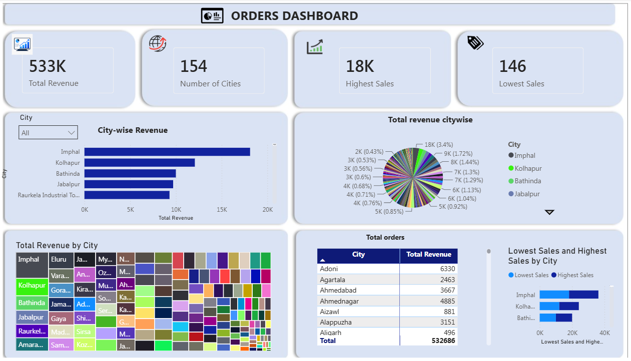

11. Git Commands Used
git status
git add .
git commit -m "Update project files"
git push

12. Business Outcome
- Provides a complete real-time data engineering workflow from ingestion to reporting.
- Improves data quality using Silver layer transformation logic.
- Generates Gold layer KPIs that are ready for Power BI dashboards.
- Demonstrates practical experience with Kafka, Spark Structured Streaming, PySpark, Docker and Power BI.

13. Interview Explanation
In this project, I designed a real-time sales analytics pipeline. First, Python was used to generate sample sales orders. The data was ingested into Apache Kafka topics. Then I used Apache Spark Structured Streaming with PySpark to read the streaming data and process it through Bronze, Silver and Gold layers. The Bronze layer stores raw data, the Silver layer stores cleaned and transformed data, and the Gold layer stores aggregated KPI data. Finally, I connected the Gold layer output to Power BI to build an interactive dashboard for revenue, orders, average order value and city-wise sales analysis. Kafka was containerized using Docker Compose, and the complete project was managed using Git and GitHub.

