Code
-- ============================================================================
-- Complete Database Setup Script (Fixed Version)
-- ============================================================================

-- Drop existing tables in correct order
DROP TABLE IF EXISTS order_products;
DROP TABLE IF EXISTS orders;
DROP TABLE IF EXISTS products;
DROP TABLE IF EXISTS aisles;
DROP TABLE IF EXISTS departments;

-- Create database
CREATE DATABASE IF NOT EXISTS instacart;
USE instacart;

-- ============================================================================
-- Enable local_infile (Required for LOAD DATA LOCAL INFILE)
-- ============================================================================

-- Method 1: Session level
SET SESSION local_infile = 1;

-- Method 2: Global level (if you have privileges)
SET GLOBAL local_infile = 1;

-- ============================================================================
-- Create Tables
-- ============================================================================

CREATE TABLE aisles (
aisle_id INT PRIMARY KEY,
aisle VARCHAR(100)
);

CREATE TABLE departments (
department_id INT PRIMARY KEY,
department VARCHAR(100)
);

CREATE TABLE products (
product_id INT PRIMARY KEY,
product_name VARCHAR(500),
aisle_id INT,
department_id INT,
FOREIGN KEY (aisle_id) REFERENCES aisles(aisle_id),
FOREIGN KEY (department_id) REFERENCES departments(department_id)
);

CREATE TABLE orders (
order_id INT PRIMARY KEY,
user_id INT,
eval_set VARCHAR(20),
order_number INT,
order_dow INT,
order_hour_of_day INT,
days_since_prior_order INT
);

CREATE TABLE order_products (
order_id INT,
product_id INT,
add_to_cart_order INT,
reordered INT,
FOREIGN KEY (order_id) REFERENCES orders(order_id),
FOREIGN KEY (product_id) REFERENCES products(product_id)
);

-- ============================================================================
-- Load Data (Update file paths)
-- ============================================================================

-- Enable local infile again after table creation
SET SESSION local_infile = 1;

-- Load aisles
LOAD DATA LOCAL INFILE 'C:/Users/YourName/Downloads/instacart/aisles.csv'
INTO TABLE aisles
FIELDS TERMINATED BY ','
ENCLOSED BY '"'
LINES TERMINATED BY '\n'
IGNORE 1 ROWS;

-- Load departments
LOAD DATA LOCAL INFILE 'C:/Users/YourName/Downloads/instacart/departments.csv'
INTO TABLE departments
FIELDS TERMINATED BY ','
ENCLOSED BY '"'
LINES TERMINATED BY '\n'
IGNORE 1 ROWS;

-- Load products
LOAD DATA LOCAL INFILE 'C:/Users/YourName/Downloads/instacart/products.csv'
INTO TABLE products
FIELDS TERMINATED BY ','
ENCLOSED BY '"'
LINES TERMINATED BY '\n'
IGNORE 1 ROWS;

-- Load orders
LOAD DATA LOCAL INFILE 'C:/Users/YourName/Downloads/instacart/orders.csv'
INTO TABLE orders
FIELDS TERMINATED BY ','
ENCLOSED BY '"'
LINES TERMINATED BY '\n'
IGNORE 1 ROWS;

-- Load order_products_prior
LOAD DATA LOCAL INFILE 'C:/Users/YourName/Downloads/instacart/order_products__prior.csv'
INTO TABLE order_products
FIELDS TERMINATED BY ','
ENCLOSED BY '"'
LINES TERMINATED BY '\n'
IGNORE 1 ROWS;

-- Load order_products_train
LOAD DATA LOCAL INFILE 'C:/Users/YourName/Downloads/instacart/order_products__train.csv'
INTO TABLE order_products
FIELDS TERMINATED BY ','
ENCLOSED BY '"'
LINES TERMINATED BY '\n'
IGNORE 1 ROWS;

-- ============================================================================
-- Verify Data
-- ============================================================================

SELECT
'Aisles' AS table_name, COUNT(*) AS record_count FROM aisles
UNION ALL
SELECT 'Departments', COUNT(*) FROM departments
UNION ALL
SELECT 'Products', COUNT(*) FROM products
UNION ALL
SELECT 'Orders', COUNT(*) FROM orders
UNION ALL
SELECT 'Order_Products', COUNT(*) FROM order_products;

-- ============================================================================
-- Test Query
-- ============================================================================

SELECT
p.product_id,
p.product_name,
COUNT(op.order_id) AS total_orders
FROM products p
JOIN order_products op ON p.product_id = op.product_id
GROUP BY p.product_id, p.product_name
ORDER BY total_orders DESC
LIMIT 10;

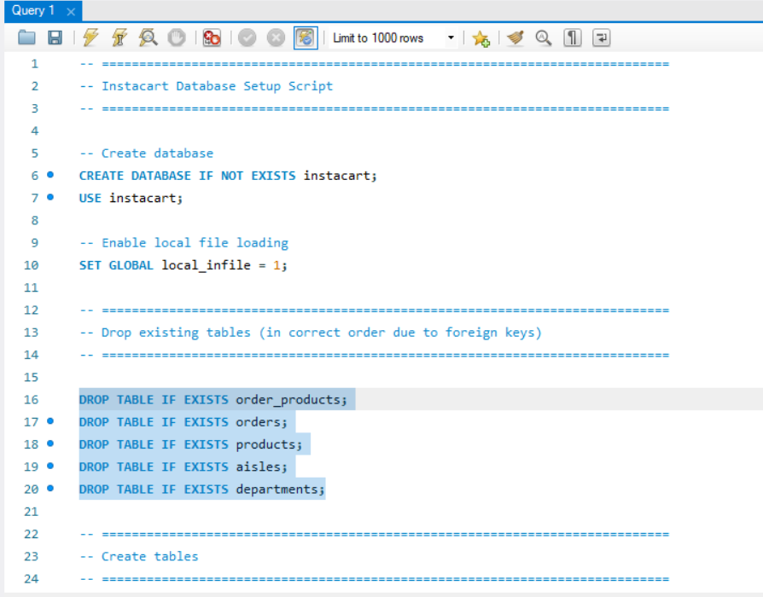
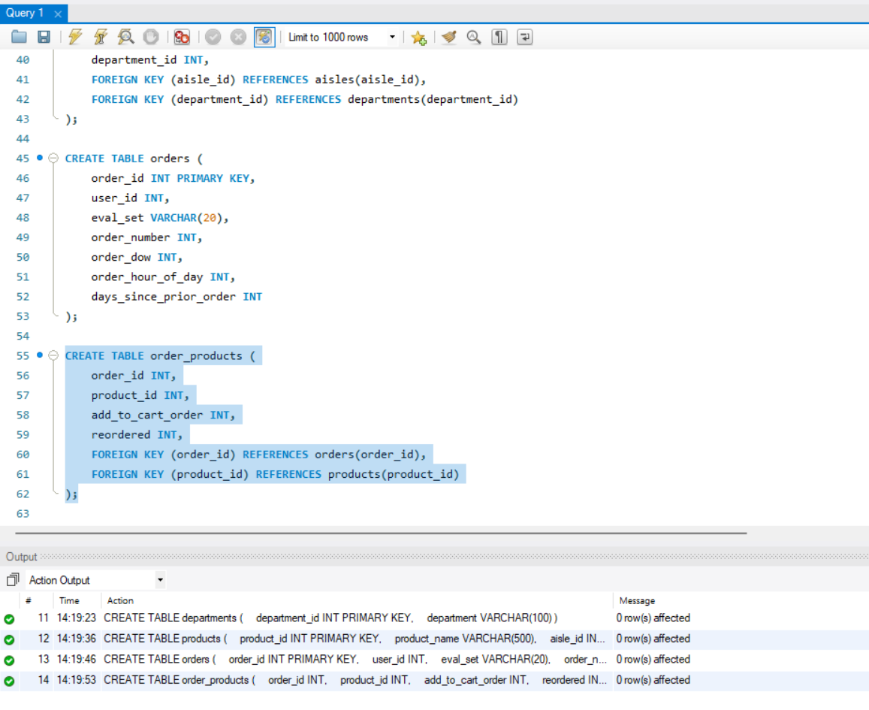

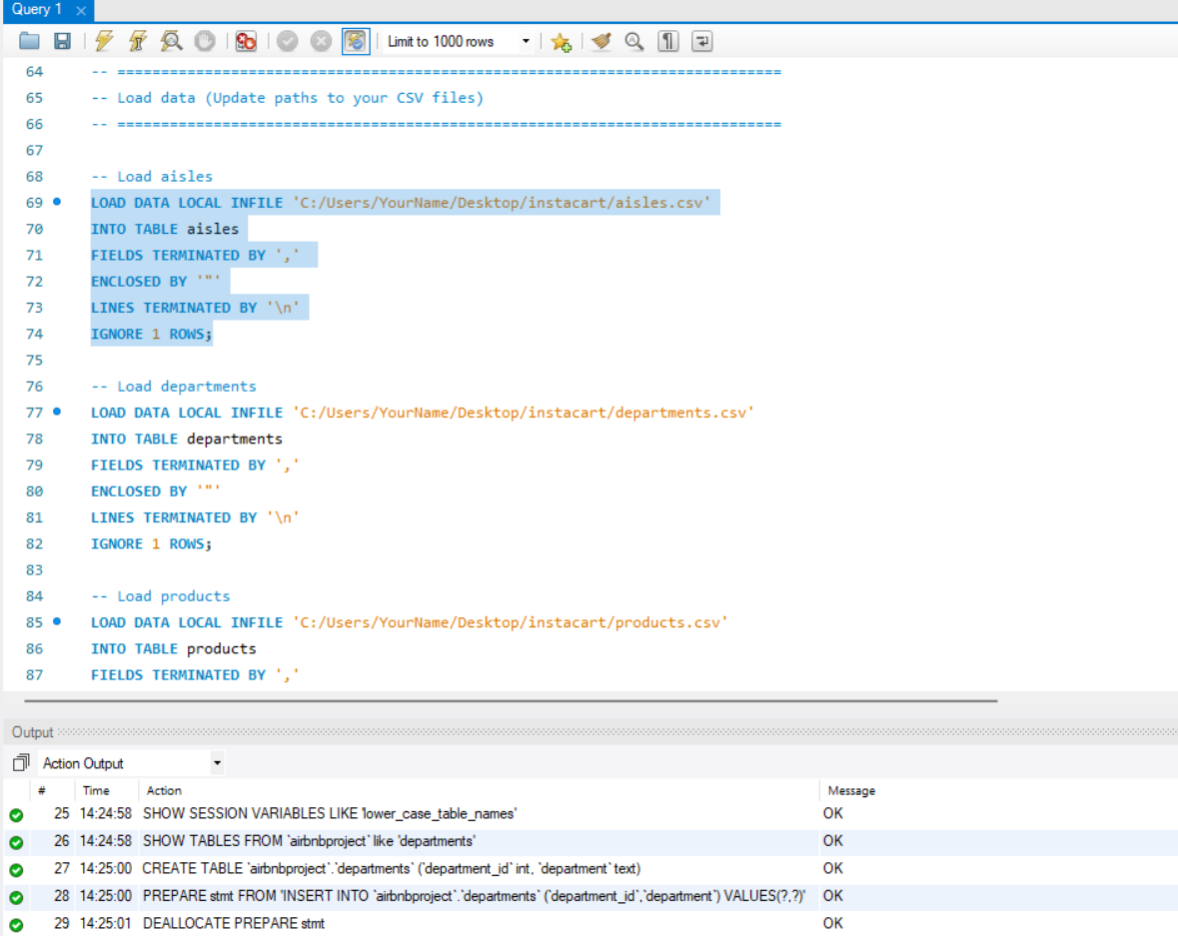
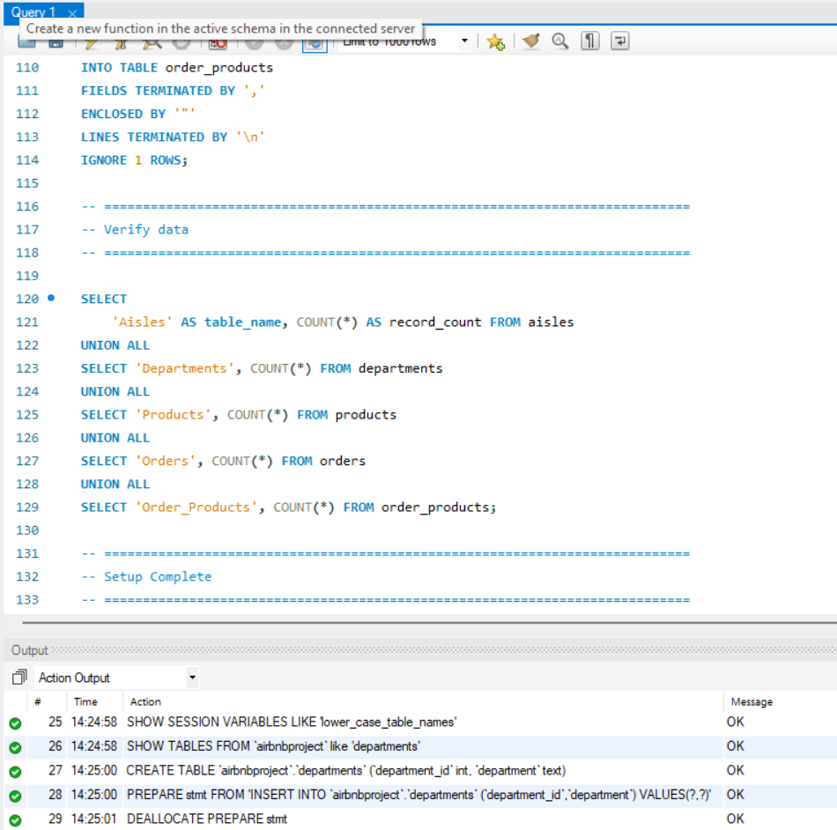
Thank You.

