 | BNM Institute of Technology  An Autonomous Institution under VTU. Approved by AICTE  Department of Artificial Intelligence and Machine Learning  TITLE: ClimaX: AI-Powered, Privacy-First Disaster Resilience Platform |  |  |   
PROBLEM STATEMENT |  | BLOCK DIAGRAM | TECHNICAL STACK
Climate disasters are becoming more frequent and unpredictable, yet governments and citizens lack a unified, intelligent platform for early warnings, coordinated emergency response, and reliable alerts. Existing systems are fragmented, slow, and often untrustworthy, with poor resource optimization and limited public engagement. There is an urgent need for a privacy-focused, AI-powered solution that delivers real-time insights, inclusive feedback, and trusted communication. |  | 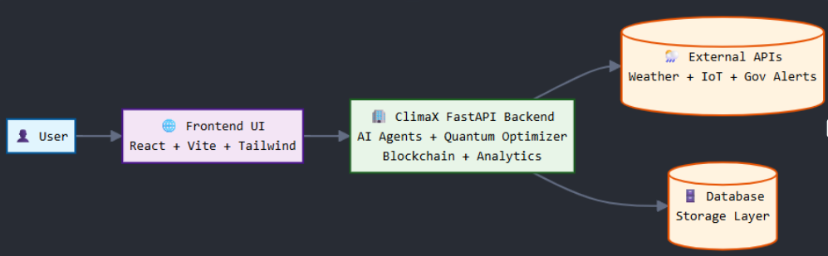 | Granite LLM for generating multilingual, real-time alerts  RAG pipelines for retrieving up-to date disaster info  IBM Environmental Intelligence Suite APIs for environmental signals  A blockchain-based feedback loop to ensure transparency
 |  |  | RESULTS
1.Improved Alert Trust & Response

2. Intelligent Automation

3.Citizen Privacy & Engagement

4.Real-Time Integration Tested

OBJECTIVE |  | FLOWCHART | CONTRIBUTORS
1.Build an AI-powered alert system using Agentic AI and RAG for real-time, contextual disaster info.  2.Ensure privacy through blockchain-based, anonymous citizen feedback.  3.Use live environmental data (e.g., weather, alerts, news) for dynamic climate response.  4.Support multilingual, inclusive access via chatbot and dashboard.  5.Develop an interactive web interface for visualizing alerts and feedback loops. |  | 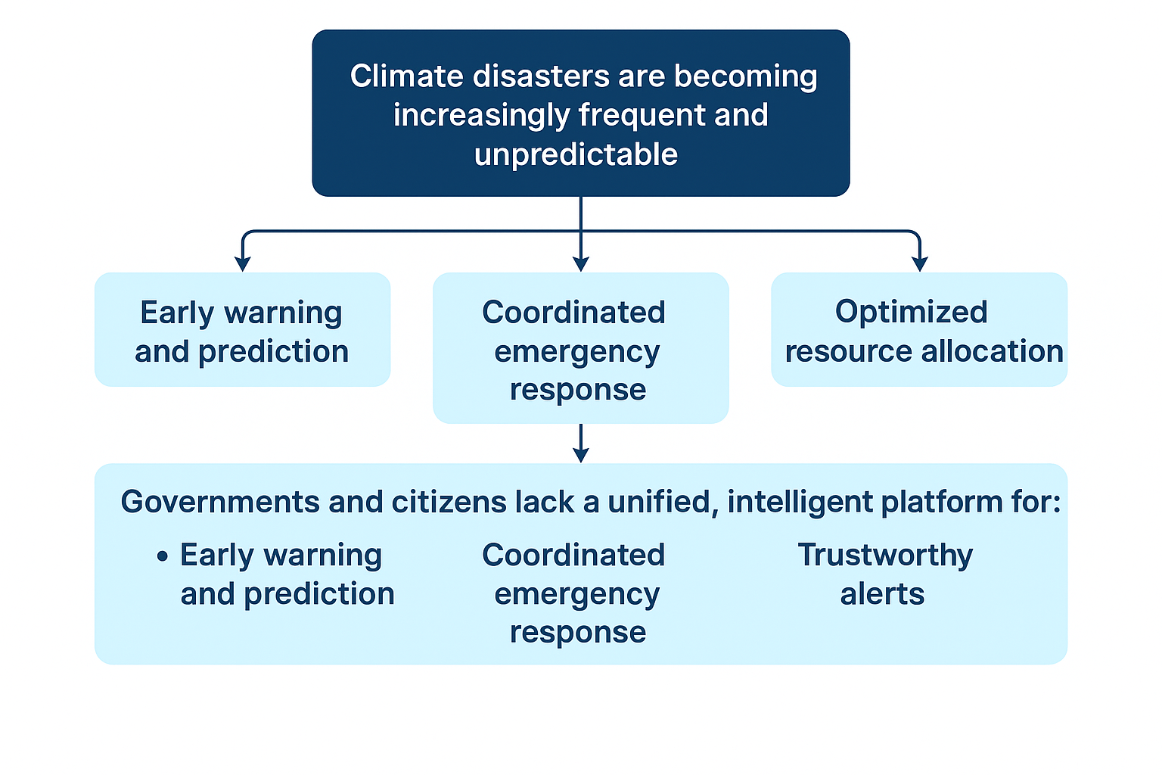 | Students Details:  Vedant jain: 1BG23AI121  Vibha Kashyap: 1BG23AI122

