**Program_1:**

Two words are anagrams if they contain all of the same letters, but in a different

order. For example, “evil” and “live” are anagrams because each contains one e, one

i, one l, and one v. Create a program that reads two strings from the user, determines

whether or not they are anagrams, and reports the result.

a=[]

X=input("First Word")

Y=input("Second Word")

if len(X)==len(Y):

for i in X:

for j in Y:

if i==j:

a.append(1)

break

else:

continue

print(a)

if len(a)==len(X)==len(Y):

if a[-1]==1:

print("its an anagram")

else :

print("no")

else:

print("no")

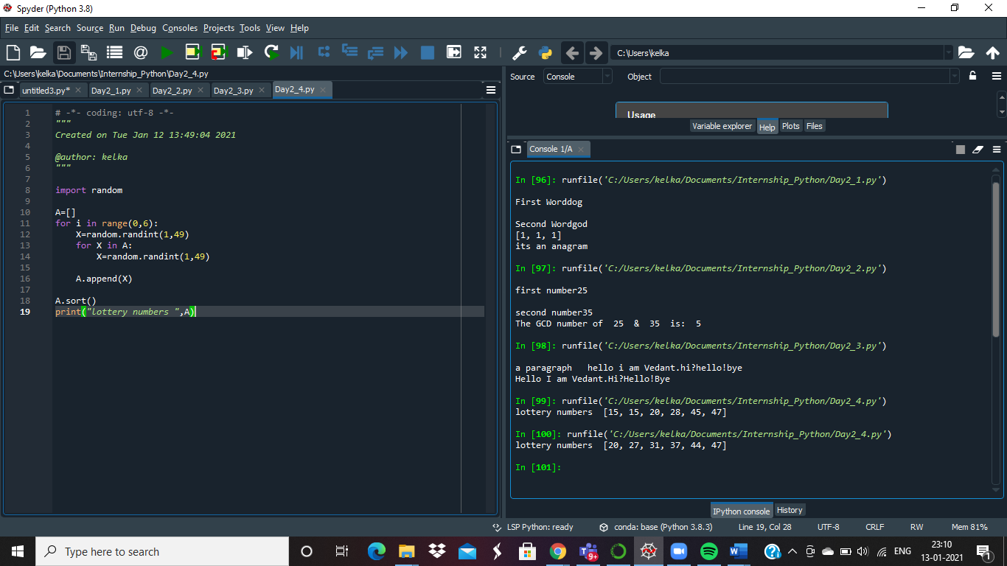

**Program_2:**

The greatest common divisor of two positive integers, *n* and *m*, is the largest number,

*d*, which divides evenly into both *n* and *m*. Create a program for calculating GCD of Two numbers.

p=int(input("first number"))

q=int(input("second number"))

for i in range (1, p + 1):

if i <= q:

if p % i == 0 and q % i == 0:

g=i

print("The GCD number of ", p, " & ", q, " is: ", g)



**Program_3:**

write a function that capitalizes the appropriate characters in a string. A lowercase “i” should be replaced with an uppercase “I” if it is both preceded and followed by a space. The ﬁrst character in the string should also be capitalized, as well as the ﬁrst non-space character after a“.”, “!” or “?”.

def change(para):

para[0].upper()

X= para.replace(" i ", " I ")

loc=X.find(".")

X=X.replace(X[loc+1],X[loc+1].upper())

loc=X.find("!")

X=X.replace(X[loc+1],X[loc+1].upper())

loc=X.find("?")

X=X.replace(X[loc+1],X[loc+1].upper())

print(X)

para=input("a paragraph ")

change(para)



**Program_4:**

In order to win the top prize in a particular lottery, one must match all 6 numbers

on his or her ticket to w the 6 numbers between 1 and 49 that are drawn by the lottery

organizer. Write a program that generates a random selection of 6 numbers for a

lottery ticket. Ensure that the 6 numbers selected do not contain any duplicates.

Display the numbers in ascending order

import random

A=[]

for i in range(0,6):

X=random.randint(1,49)

for X in A:

X=random.randint(1,49)

A.append(X)

A.sort()

print("lottery numbers ",A)

