DAY 3

**Program_1: Assessing Employee**

At a particular company, employees are rated at the end of each year. The rating scale begins at 0.0, with higher values indicating better performance and resulting in larger raises. The value awarded to an employee is either 0.0, 0.4, or 0.6 or more. Values between 0.0 and 0.4, and between 0.4 and 0.6 are never used. The meaning associated with each rating is shown in the following table. The amount of an employee’s raise is $2400.00 multiplied by their rating

|  |  |
| --- | --- |
| Rating | Meaning |
| 0.0 | Unacceptable performance |
| 0.4 | Acceptable performance |
| 0.6 | Meritorious performance |

Write a program that reads a rating from the user and indicates whether the performance was unacceptable, acceptable or meritorious. The amount of the employee’s raise should also be reported. Your program should display an appropriate error message if an invalid rating is entered

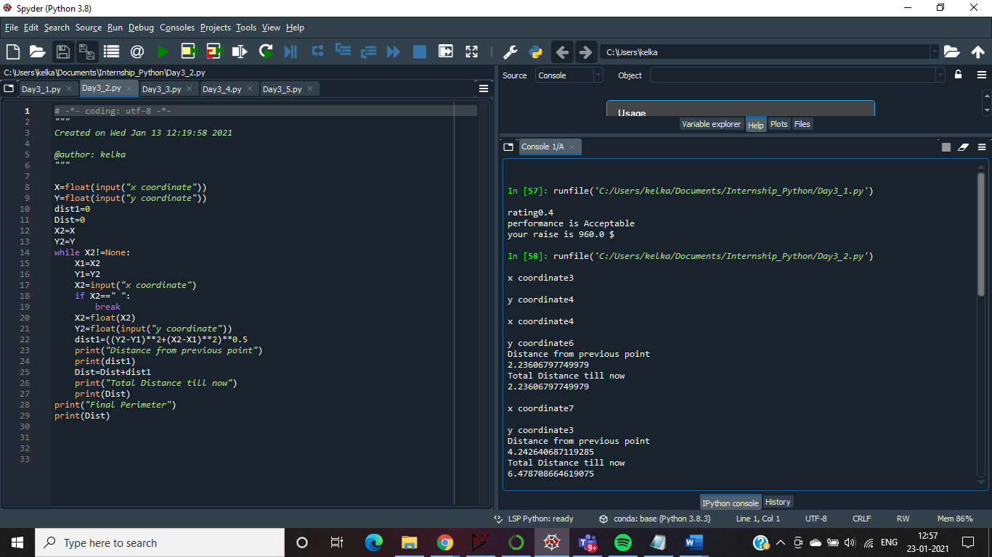

**Program_2: computes the perimeter of a polygon**

Write a program that computes the perimeter of a polygon. Begin by reading the x and y values for the first point on the perimeter of the polygon from the user. Then continue reading pairs of x and y values until the user enters a blank line for the x-coordinate. Each time you read an additional coordinate you should compute the distance to the previous point and add it to the perimeter. When a blank line is entered for the x-coordinate your program should add the distance from the last point back to the first point to the perimeter. Then it should display the total perimeter.

Sample input and output is shown below, with user input shown in bold:

Enter the x part of the coordinate: 0

Enter the y part of the coordinate: 0

Enter the x part of the coordinate: (blank to quit): 1

Enter the y part of the coordinate: 0

Enter the x part of the coordinate: (blank to quit): 0

Enter the y part of the coordinate: 1

Enter the x part of the coordinate: (blank to quit):

The perimeter of that polygon is 3.414213562373095

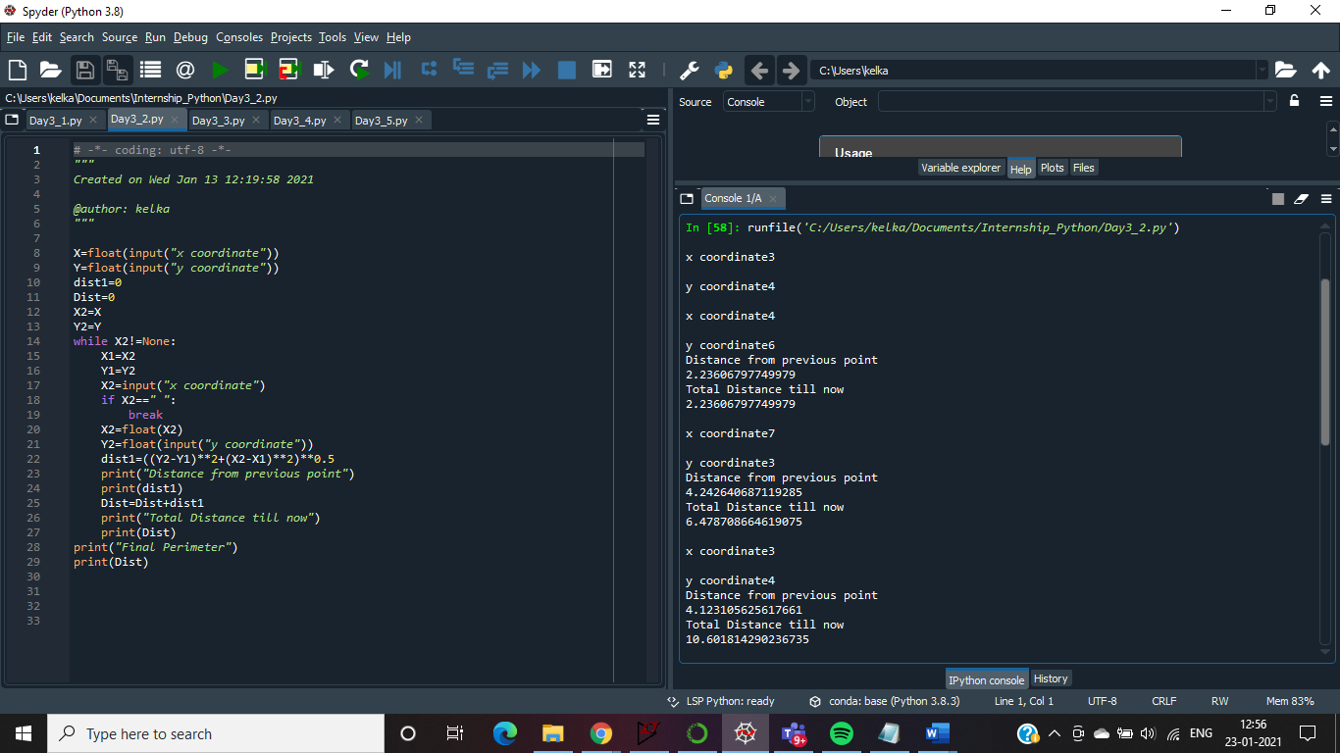

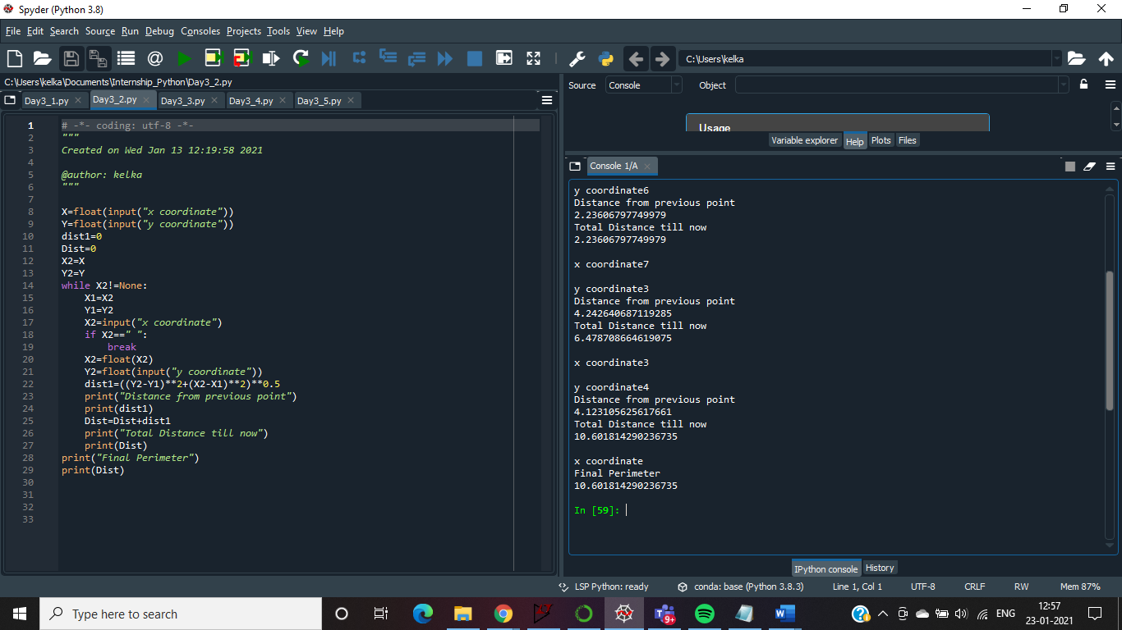

**Program_3: Admission Price**

A particular zoo determines the price of admission based on the age of the guest. Guests 2 years of age and less are admitted without charge. Children between 3 and 12 years of age cost $14.00. Seniors aged 65 years and over cost $18.00. Admission for all other guests is $23.00.

Create a program that begins by reading the ages of all of the guests in a group from the user, with one age entered on each line. The user will enter a blank line to indicate that there are no more guests in the group.

Then your program should display the admission cost for the group with an appropriate message. The cost should be displayed using two decimal places.

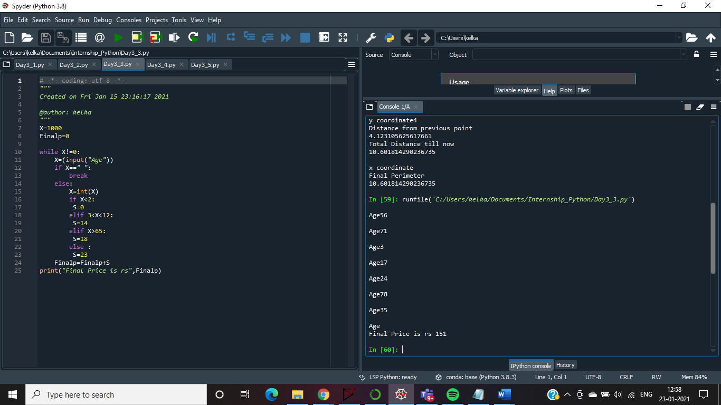

**Program 4: Spiral Traversing Animation**

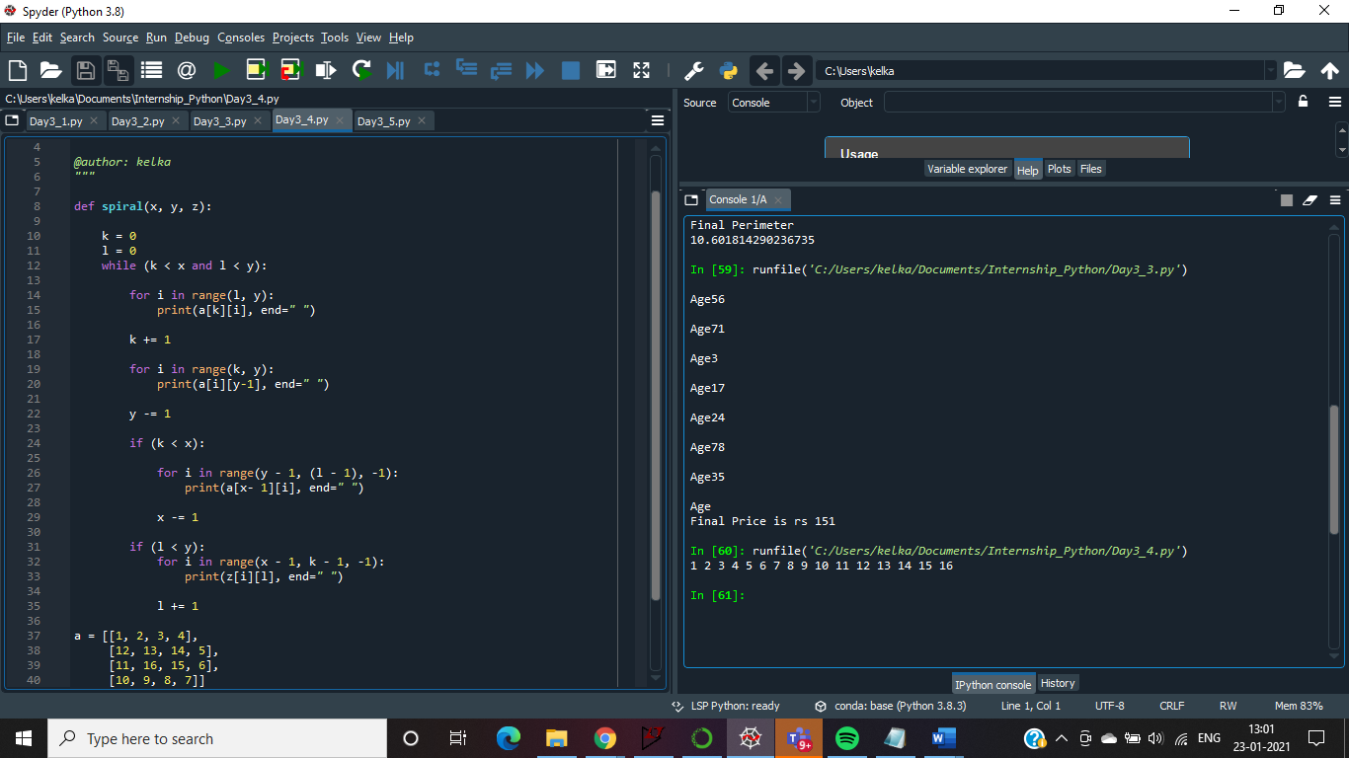

**Program 5: Snakes and Ladder:**

**You Choose your own Snakes Ladder Game**

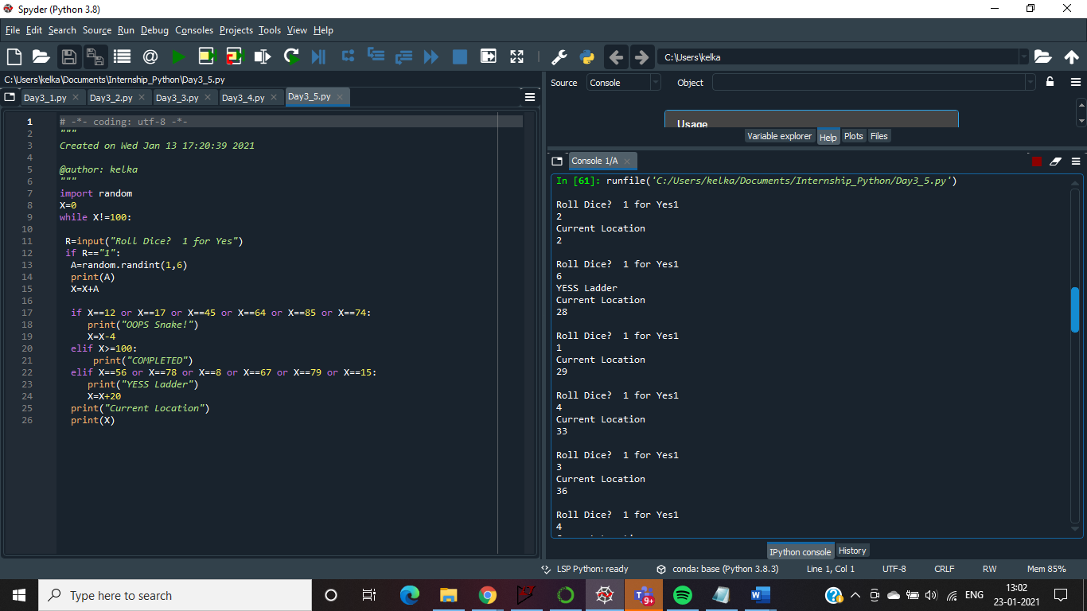

Continues till 100