DAY 4

**Internship Topic: Python Programming**

**Program_1**: Let us assume paper as the plane and a letter as a curve on the plane, then each letter divides the plane into regions. For example letters "A", "D", "O", "P", "R" divide the plane into two regions so we say these letters each have one hole. Similarly, letter "B" has two holes and letters such as "C", "E", "F", "K" have no holes. We say that the number of holes in the text is equal to the total number of holes in the letters of the text. Write a program to determine how many holes are in a given text.

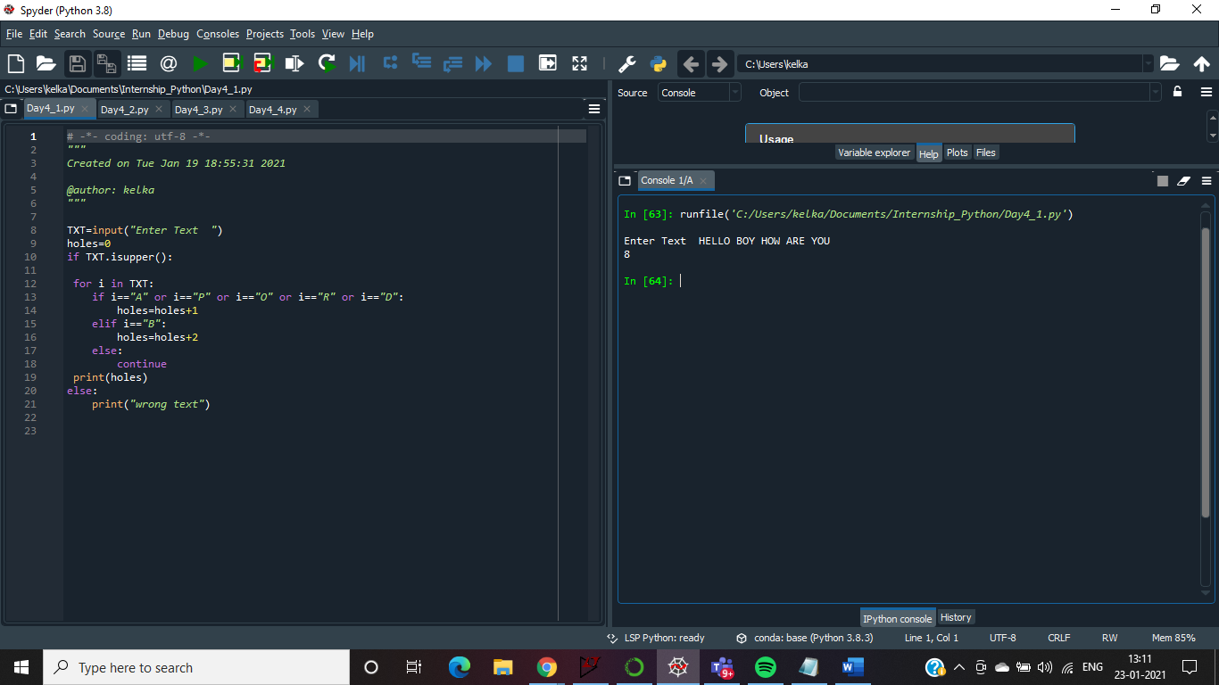

**Program_2**: Given a string **S** having characters from English alphabets ['a' - 'z'] and '.' as the special character (without quotes).   
Write a program to construct the lexicographically smallest palindrome by filling each of the faded character ('.') with a lower case alphabet.

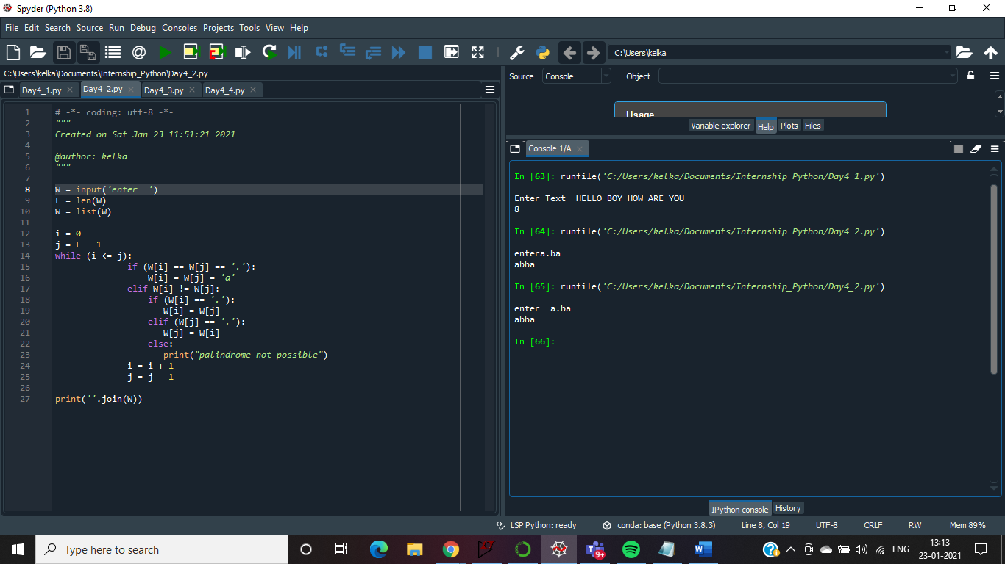

**Program_3** One day Ajit got a strange feeling of jumping from one point to another. The jumping will be done in one dimension only.   
He will start from a point **0** and from there he will perform a lot of jumps. He can only jump in a specific sequence:

**1jump, 2jump, 3jump, 1jump, 2jump, 3jump, 1jump,** and so on. (1>2>3>1>2>3>1.....)

1-jump means that if Ajit is at the point x, he will jump to the point x+1.

2-jumps mean that if Ajit is at the point x, he will jump to the point x+2.

3-jumps mean that if Ajit is at the point x, he will jump to the point x+3.

Before the start Ajit asks you: will he arrive at the point a after some number of jumps?

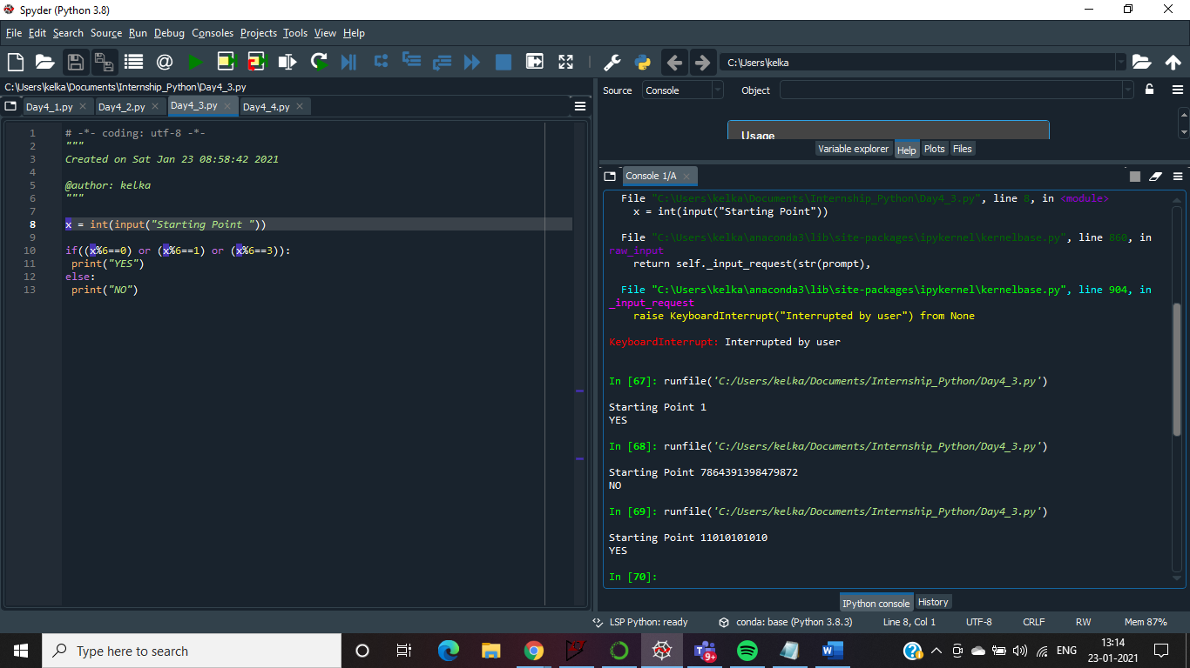

**Program_4:** You are provided with a playlist containing N songs, each has a unique positive integer length. Assume you like all the songs from this playlist, but there is a song, which you like more than others.  
It is named "Computing Paradox".  
  
You decided to sort this playlist in increasing order of songs length. For example, if the lengths of the songs in the playlist were {1, 3, 5, 2, 4} after sorting it becomes {1, 2, 3, 4, 5}.  
Before the sorting, "Computing Paradox" was on the kth position (1-indexing is assumed for the playlist) in the playlist.  
  
Your task is to find the position of "Computing Paradox" in the sorted playlist.  
  
