**K. J. Somaiya College of Engineering, Mumbai-77**

**IC-01 Application for Internship**

**Semester: July/January 2021- November/April 2021**

|  |  |  |  |  |  |
| --- | --- | --- | --- | --- | --- |
|  | |  |  | | |
| **Internship Applied** | As per College Internship Announcement No | |  | | In-house |
| **Name of the student and Roll No.** | | Vedant Kelkar  1912052 |  | | |
| **Address** | | 10 Pankaj. Sahakar colony.Brahman society . Naupada Thane (W) 400602 |  | | |
| **Email/Tel. No.** | | [Vedant.kelkar@somaiya.edu](mailto:Vedant.kelkar@somaiya.edu) 9372677532 02225424440 |  | | |
| **Year/semester of study** | | **SY** |  | **Course B. Tech** | |
| **Branch & Division** | | **ETRX B** |  | | |

|  |  |
| --- | --- |
| **Name of the Parent / Guardian** | **Swapna Amol Kelkar** |
| **Address** | 10 Pankaj. Sahakar colony.Brahman society . Naupada Thane (W) 400602 |
| **Email/Tel. No.** | [**s**wapna1408@gmail.com](mailto:swapna1408@gmail.com) |
|  |  |

|  |  |
| --- | --- |
| **Details of the internship (Attach separate sheet if required)**    **Summer 2021 Duration: 2 weeks From 5 Jan to 19 Jan Location: work from home**    **Name of the organization / institute: KJ Somaiya Vidyavihar**    **Title / Work profile:** Internship on Python | |
| **Name of the supervisor with**  **contact details**  **(Address/Email/ Tel no.)** | Sonia Joshi [soniajoshi@somaiya.edu](mailto:soniajoshi@somaiya.edu)  +91-8879542062  Deepa Jain [deepajain@somaiya.edu](mailto:deepajain@somaiya.edu)  +91-8655266772 |
| **Stipend if any (per month)** |  |

|  |  |
| --- | --- |
| **Total no of working instructional days may be missed as per the academic calendar** |  |

**Declaration**

I undersigned parent / guardian of __Vedant Kelkar__ jointly take the responsibility and liability related to all matters during the said internship period.

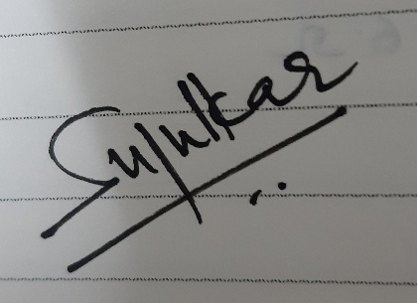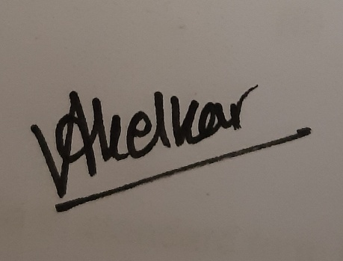

**Signature of Student Signature of Parent / Guardian**

|  |  |
| --- | --- |
| **Name and Signature of Proctor / Faculty Member** | Sonia Joshi [soniajoshi@somaiya.edu](mailto:soniajoshi@somaiya.edu)  Deepa Jain [deepajain@somaiya.edu](mailto:deepajain@somaiya.edu) |
| **Name and Signature of HOD / Coordinator** | **Dr. Jagannath Nirmal** |
| **Approved / Not approved**    **Date: IAI In charge** | |
|  | |