Name: Allan Rodrigues

Class: TE IT A

Roll no: 59

Pid:191104

St. Francis Institute of Technology, Mumbai-400 103

**Department of Information Technology**

A.Y. 2021-2022

Class: TE-ITA/B, Semester: VI

Subject: **Data Science Lab**

**Experiment – 2: To implement Data Visualization/Data Exploratory Analysis using Matplolib and Seaborn.**

1. **Aim:** To implement Data Visualization using Matplotlib and Seaborn.
2. **Objectives:** After study of this experiment, the student will be able to

* Understand Matplotlib Functions
* Understand Seaborn Functions

1. **Outcomes:** After study of this experiment, the student will be able to

* Understand data visualization /Exploratory Data Analysis using Matplolib and Seaborn.

1. **Prerequisite:** Fundamentals of Python Programming and Database Management System.
2. **Requirements:** Python Installation,Personal Computer, Windows operating system, Internet Connection, Microsoft Word.
3. **Pre-Experiment Exercise:**

**Brief Theory:**

Basic Concepts of Matplolib and Seaborn.

1. **Laboratory Exercise**
   * + 1. **Procedure:**

**import** numpy **as** np  
a=np.array([[1,2,3],[4,5,6],[7,8,9]])  
a  
  
**"""**matplotlib**  
  
Matplotlib is a comprehensive library for creating static, animated, and interactive visualizations in Python. Matplotlib makes easy things easy and hard things possible.  
  
1. Create publication quality plots.  
2. Make interactive figures that can zoom, pan, update.  
3. Customize visual style and layout.  
4. Export to many file formats .  
5. Embed in JupyterLab and Graphical User Interfaces.  
6. Use a rich array of third-party packages built on Matplotlib.  
  
**matplotlib.pyplot**  
  
matplotlib.pyplot is a collection of functions that make matplotlib work like MATLAB. Each pyplot function makes some change to a figure: e.g., creates a figure, creates a plotting area in a figure, plots some lines in a plotting area, decorates the plot with labels, etc.  
  
**numpy.pi**  
  
While both numpy.pi and math.pi provides us with the same value, the advantage of numpy.pi is that it helps us by avoiding the dependency of obtaining the constant value of pi from a different library.  
  
**np.sin**  
  
This mathematical function helps user to calculate trigonometric sine for all x(being the array elements).   
"""***# Sinusoidal plot***import** numpy **as** np  
**import** matplotlib.pyplot **as** plt  
x=np.arange(0.0,2.0,0.01)  
y=np.sin(2*np.pi*x)  
plt.plot(x,y)  
  
*#Barplot***import** numpy **as** np  
**import** matplotlib.pyplot **as** plt  
fig=plt.figure()  
x=[1,2,3,4,5,6,7]  
y=[23,43,65,32,87,45,90]  
plt.bar(x,y,color=**'orange'**)  
plt.title(**'Average Score of Students'**)  
plt.xlabel(**"Students"**)  
plt.ylabel(**"Avg. Score"**)  
fig.savefig(**"testing.jpg"**)  
  
**"""**Error Bars**  
  
An error bar is a line through a point on a graph, parallel to one of the axes, which represents the uncertainty or variation of the corresponding coordinate of the point.  
  
Error bars can communicate the following information about your data:  
  
1. How spread the data are around the mean value (small SD bar = low spread, data are clumped around the mean; larger SD bar = larger spread, data are more variable from the mean).  
  
2. The reliability of the mean value as a representative number for the data set. In other words, how accurately the mean value represents the data (small SD bar = more reliable, larger SD bar = less reliable). It's important to note that just because you have a larger SD, it does not indicate your data is not valid. ​  
3. The likelihood of there being a significant difference between data sets.   
  
**Significant Difference**  
  
A "significant difference" means that the results that are seen are most likely not due to chance or sampling error. In any experiment or observation that involves sampling from a population, there is always the possibility that an observed effect would have occurred due to sampling error alone. But if result is "significant," then the investigator may conclude that the observed effect actually reflects the characteristics of the population rather than just sampling error or chance.**

*#single barplots with error bars*N=5  
men=(20,35,30,36,27)  
women=(25,32,34,20,25)  
mstd=(2,2,2,2,2)  
i=np.arange(N)  
p1=plt.bar(i,men,width=0.35,yerr=mstd)  
p2=plt.bar(i,women,width=0.35,bottom=men,yerr=mstd)  
plt.xticks(i,(**'G1'**,**'G2'**,**'G3'**,**'G4'**,**'G5'**))  
plt.yticks(np.arange(0,90,10))  
plt.legend((p1[0],p2[0]),(**'Men'**,**'Women'**))  
  
**"""**Histogram**  
  
A histogram is a graphical representation of a grouped frequency distribution with continuous classes.   
  
A histogram is a diagram involving rectangles whose area is proportional to the frequency of a variable and width is equal to the class interval.  
  
The histogram graph is used under certain conditions. They are:  
  
1. The data should be numerical.  
2. A histogram is used to check the shape of the data distribution.   
3. Used to check whether the process changes from one period to another.  
4. Used to determine whether the output is different when it involves two or more processes.  
5. Used to analyse whether the given process meets the customer requirements.  
  
Histograms and bar charts are different. In the bar chart, each column represents the group which is defined by a categorical variable, whereas in the histogram each column is defined by the continuous and quantitative variable.  
  
**Difference Between Histogram and Bar Graph**  
  
1. It is a two-dimensional figure   
2. The frequency is shown by the area of each rectangle   
3. It shows rectangles touching each other   
  
**Bar Graph**  
  
1. It is a one-dimensional figure  
2. The height shows the frequency and the width has no significance.  
3. It consists of rectangles separated from each other with equal spaces.  
  
"""***#Histogram*m=100  
std=15  
x=m+std*np.random.randn(480)  
y=50  
plt.hist(x,y,color=**'blue'**,density=**False**)  
plt.grid(color=**'gray'**,linestyle=**'--'**,linewidth=2,axis=**'x'**)  
plt.grid(color=**'gray'**,linestyle=**'--'**,linewidth=2,axis=**'y'**)  
  
*#Pie Chart*labels=**'cricket'**,**'Hockey'**,**'Tennis'**,**'Football'**v=[40,20,10,30]  
e=(0,0,0.1,0)  
plt.pie(v,explode=e,labels=labels,autopct=**'%1.3f%%'**,shadow=**True**,startangle=0)  
  
**"""numpy.linspace(start, stop, num)  
Return evenly spaced numbers over a specified interval.  
  
Returns num evenly spaced samples, calculated over the interval [start, stop].  
  
The endpoint of the interval can optionally be excluded.  
"""**x=np.linspace(0,10,1000)  
plt.plot(x,np.sin(x))  
plt.plot(x,np.sin(x-1),color=**'g'**)  
plt.plot(x,np.sin(x-2),color=**'0.25'**)  
plt.plot(x,np.sin(x-3),color=**'red'**)  
  
x=np.linspace(0,10,1000)  
plt.plot(x,np.sin(x))  
plt.plot(x,np.sin(x-1),linestyle=**'solid'**)  
plt.plot(x,np.sin(x-2),linestyle=**'dashed'**)  
plt.plot(x,np.sin(x-3),linestyle=**'dashdot'**)  
plt.plot(x,np.sin(x-4),linestyle=**'dotted'**)  
  
*#plt.plot(x,np.sin(x))*plt.plot(x,np.sin(x-1),linestyle=**'-'**)  
plt.plot(x,np.sin(x-2),linestyle=**'--'**)  
plt.plot(x,np.sin(x-3),linestyle=**'-.'**)  
plt.plot(x,np.sin(x-4),linestyle=**':'**)  
  
*#Scatterplot*x=np.linspace(0,10,50)  
y=np.sin(x)  
plt.scatter(x,y)  
  
x=np.linspace(0,10,50)  
plt.plot(x,np.sin(x),**'-o'**)

**#Seaborn**

**import** seaborn **as** sns  
data=sns.load_dataset(**"iris"**)  
sns.lineplot(x=**"sepal_length"**, y=**"sepal_width"**,data=data)  
  
sns.scatterplot(x=**"sepal_length"**, y=**"sepal_width"**,data=data)  
  
sns.stripplot(x=**"species"**, y=**"sepal_length"**,data=data)  
  
  
  
sns.violinplot(x=**"species"**, y=**"sepal_length"**,data=data)  
  
sns.swarmplot(x=**"species"**, y=**"sepal_length"**,data=data)

Paste Screenshots of above commands.

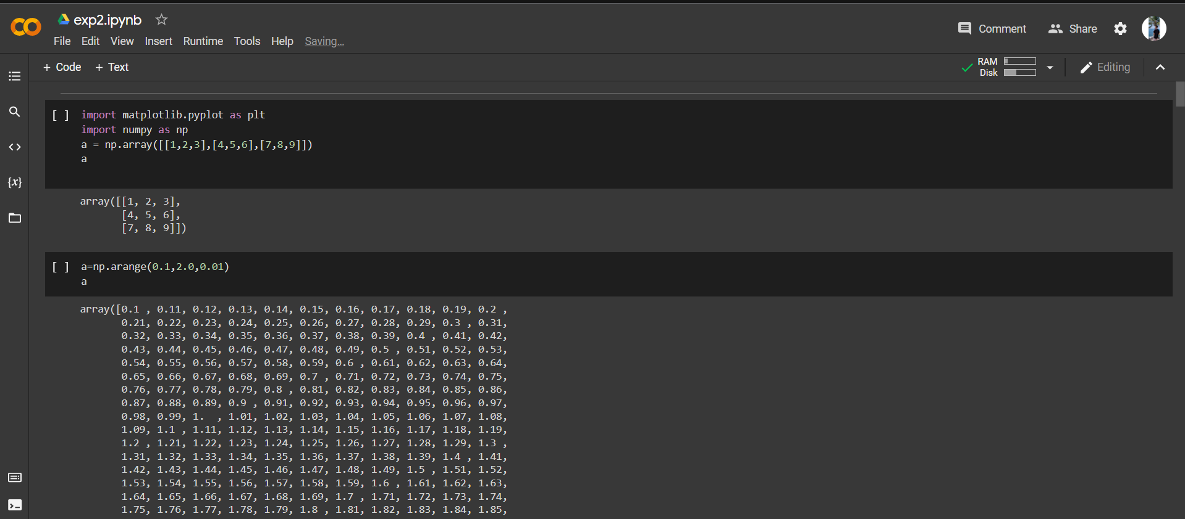

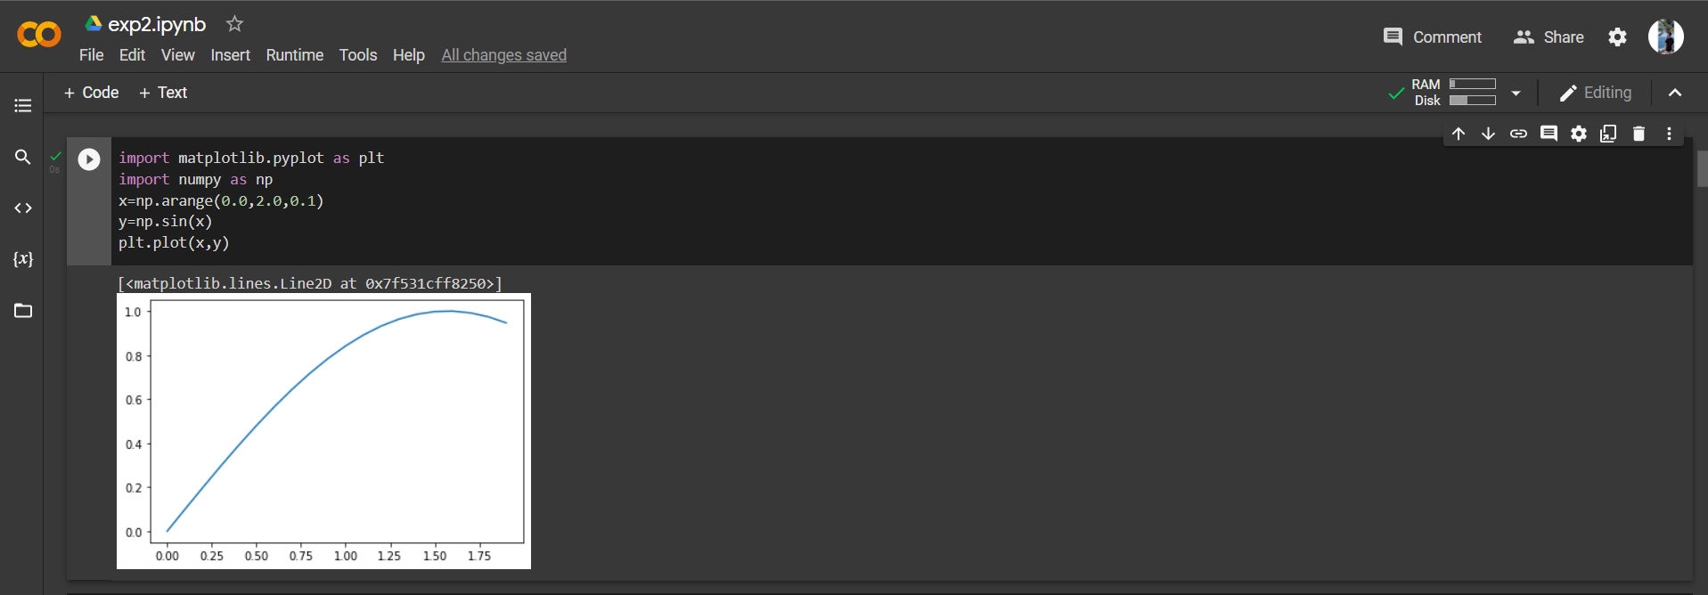

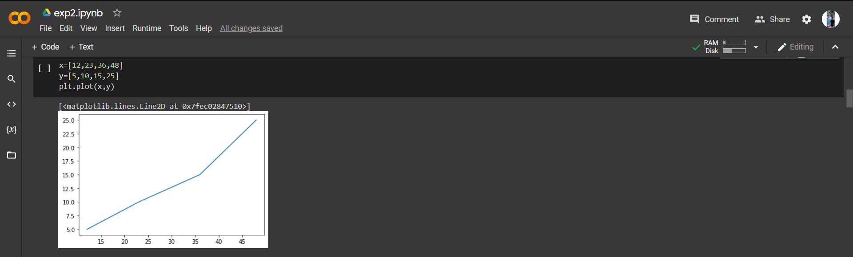

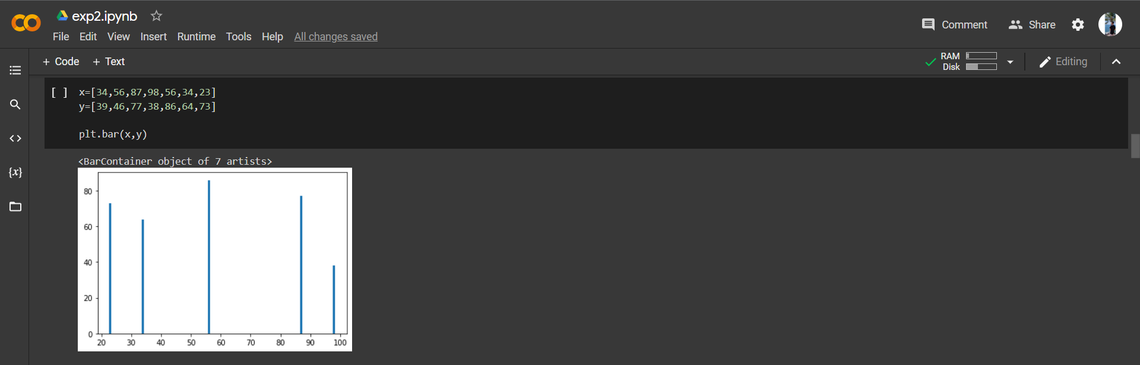

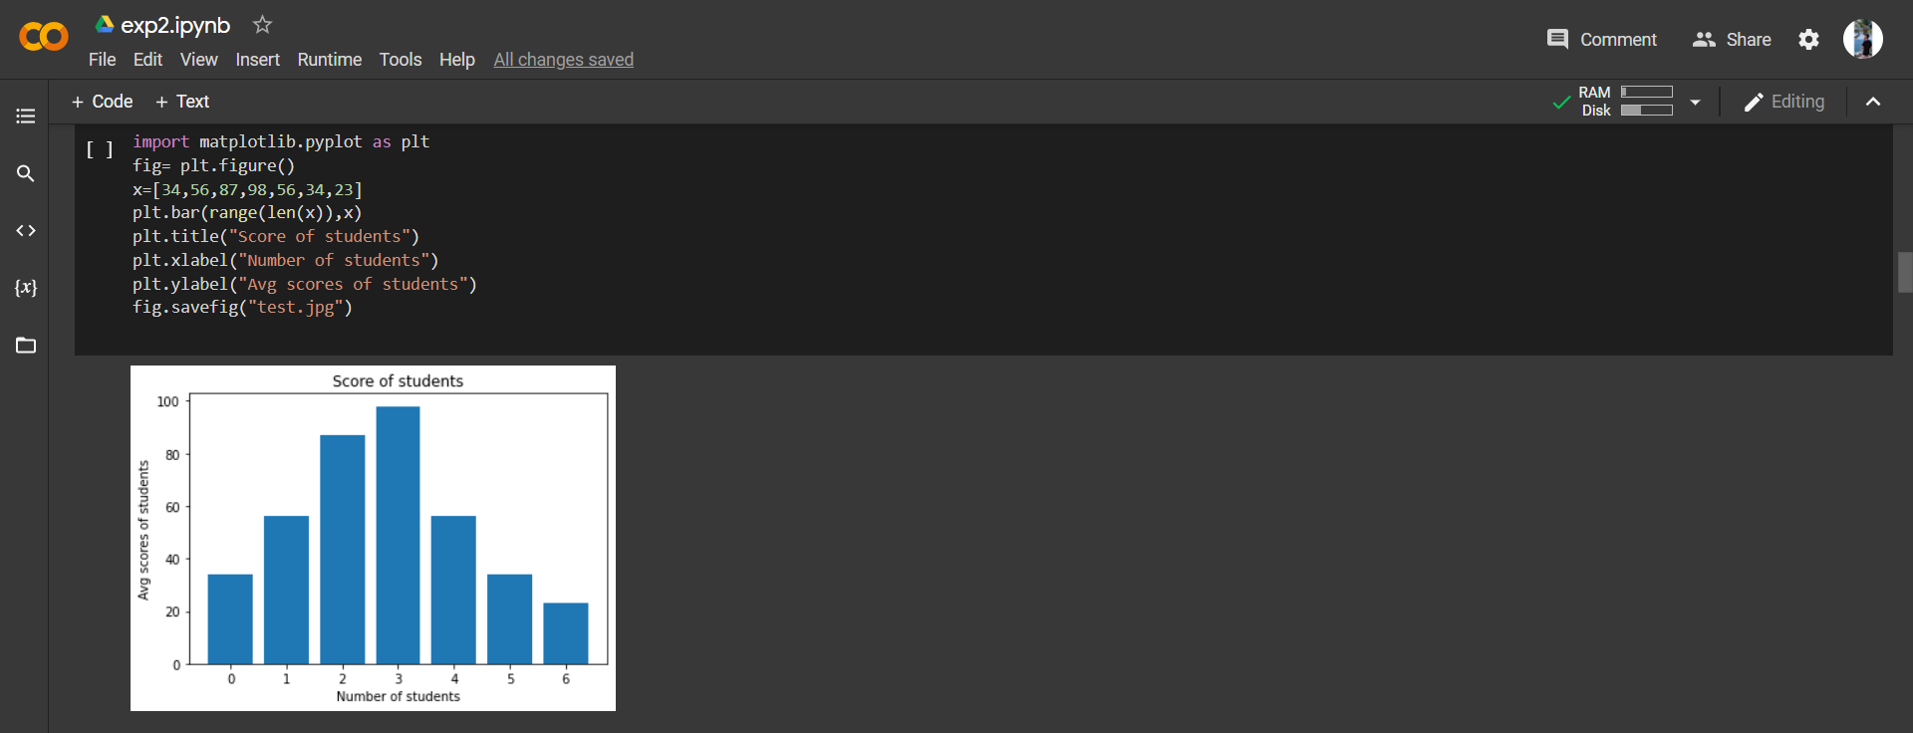

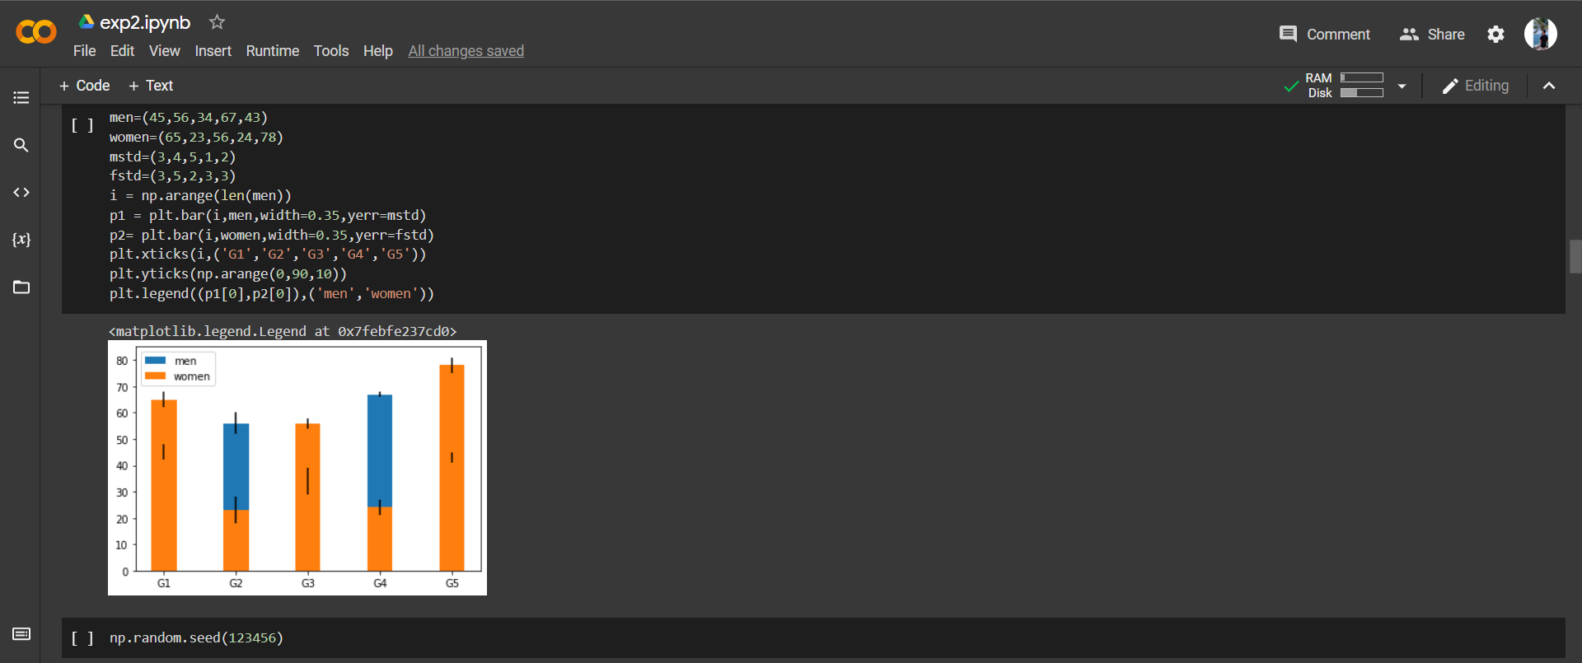

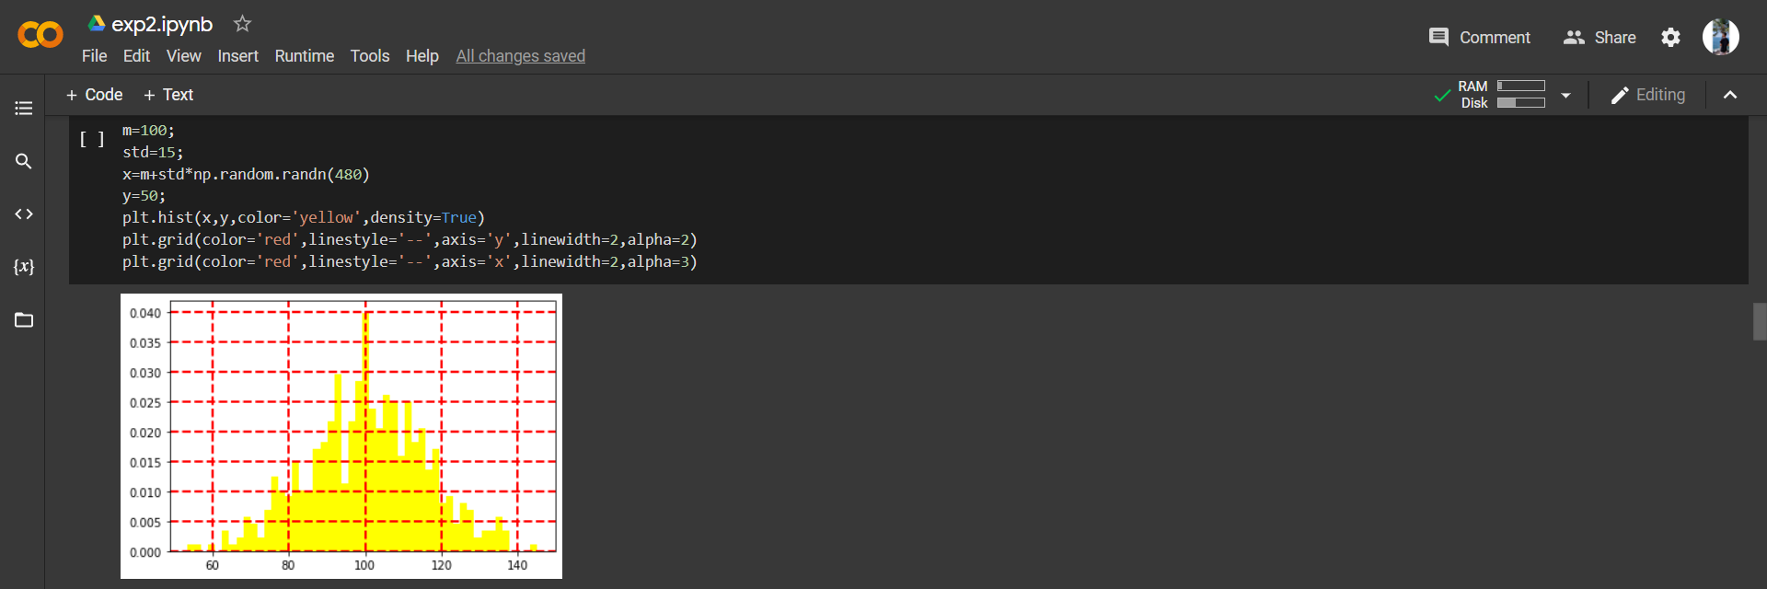

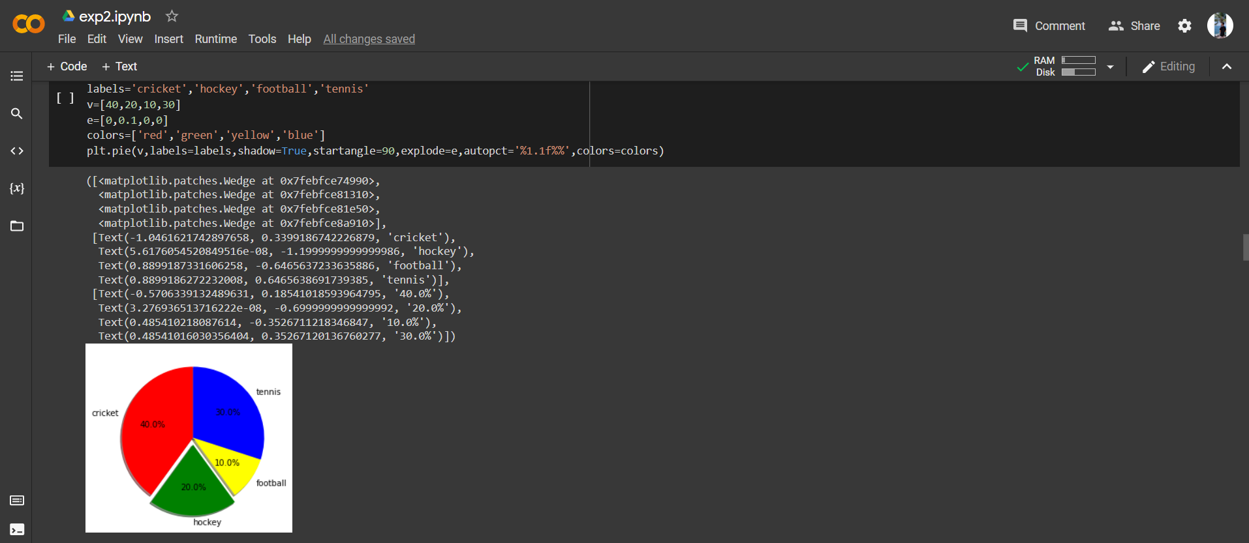

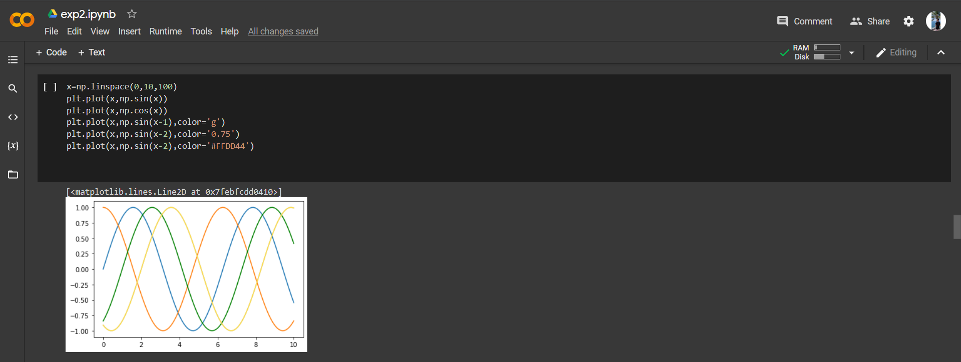

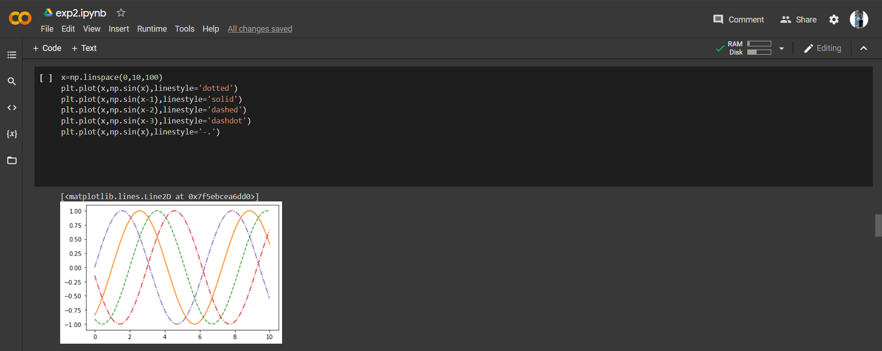

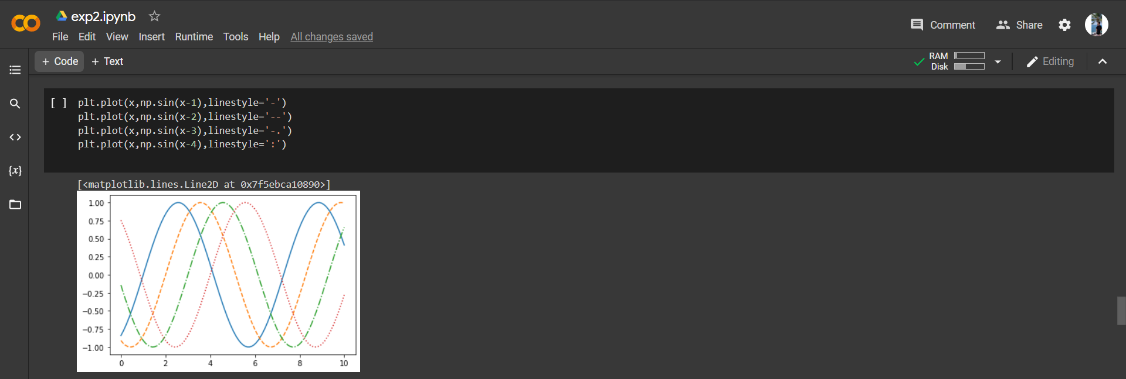

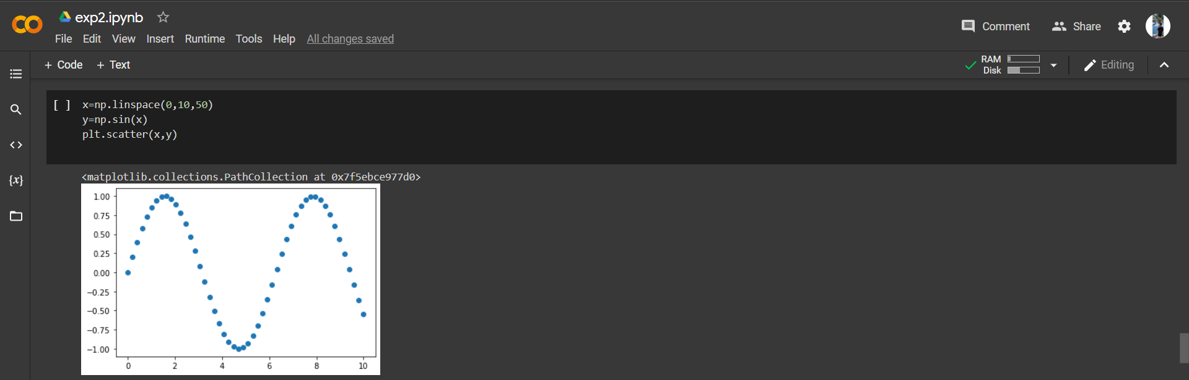

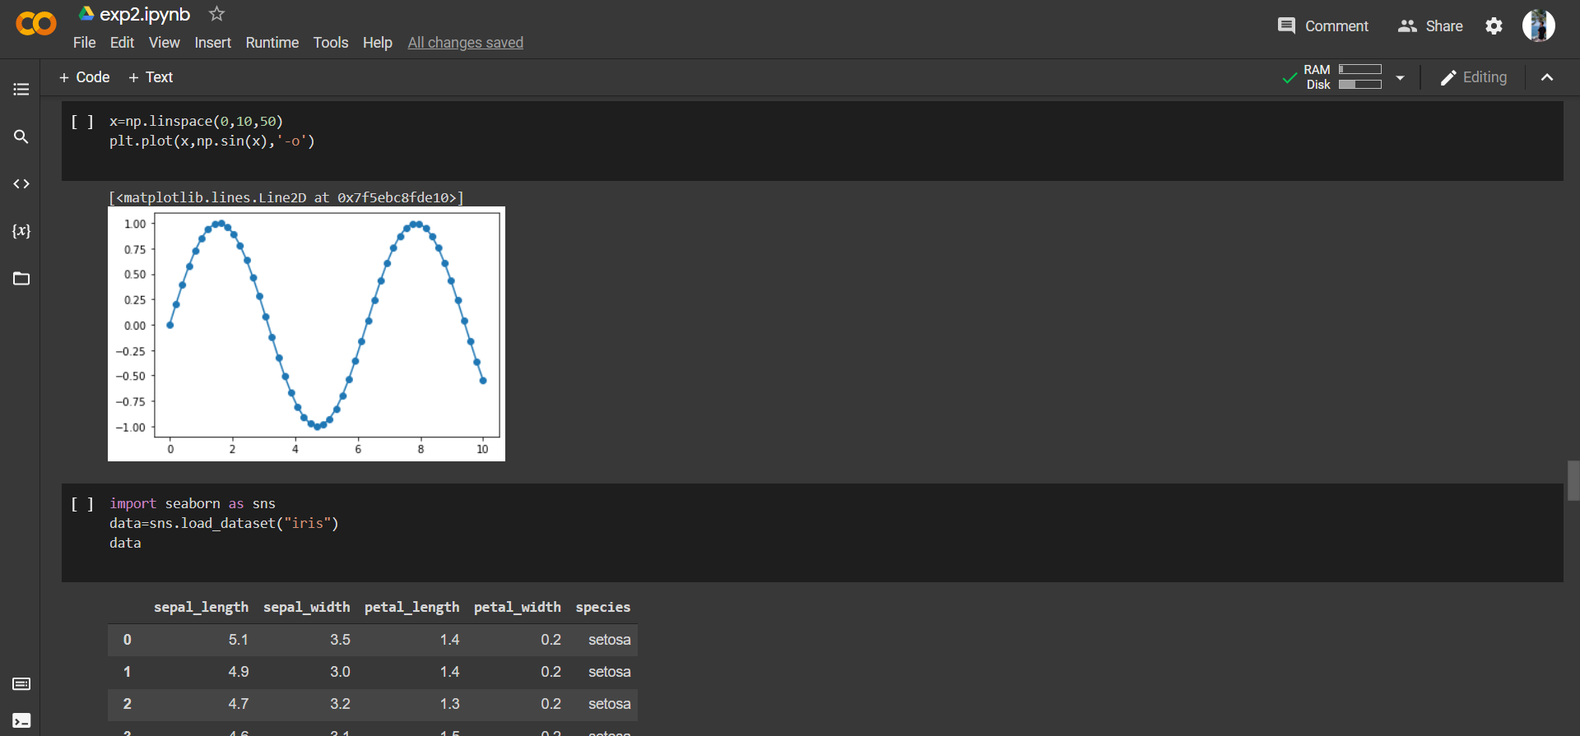

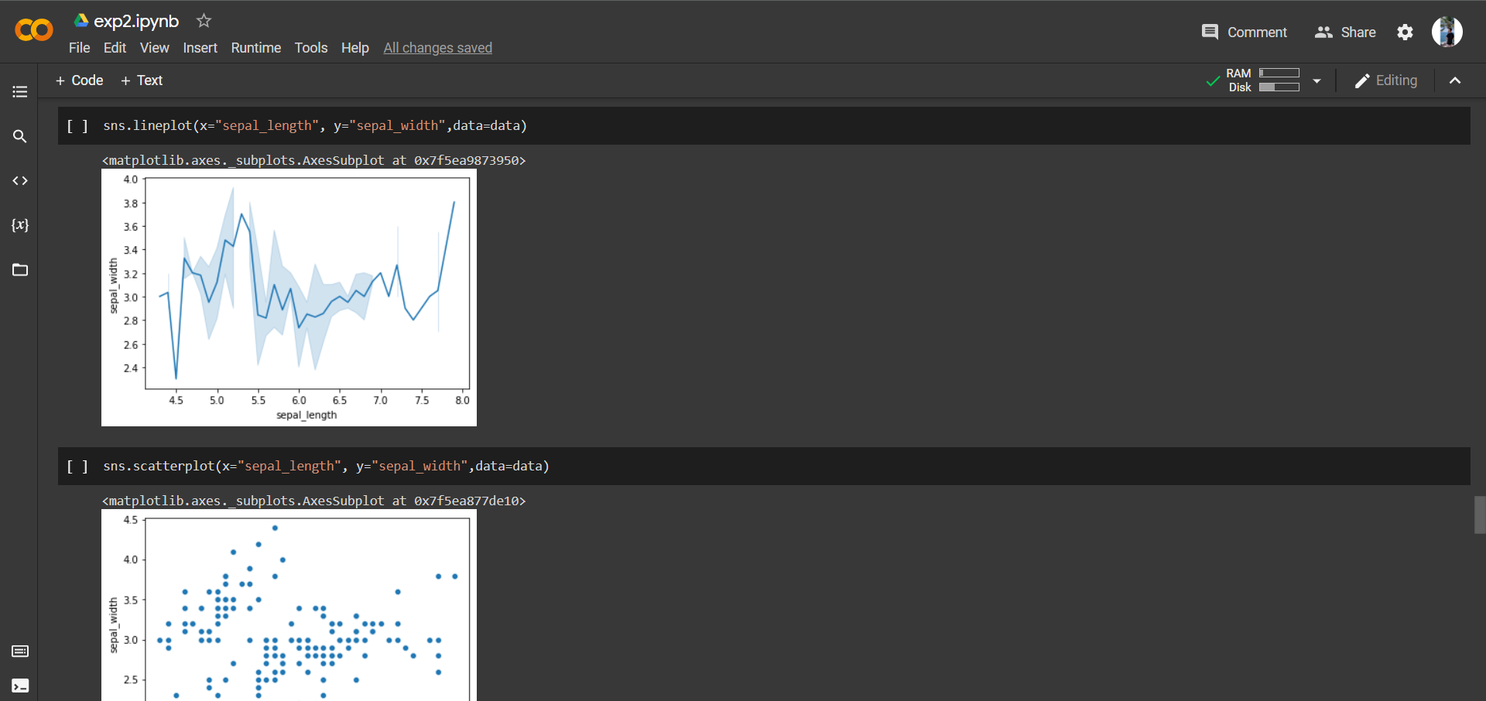

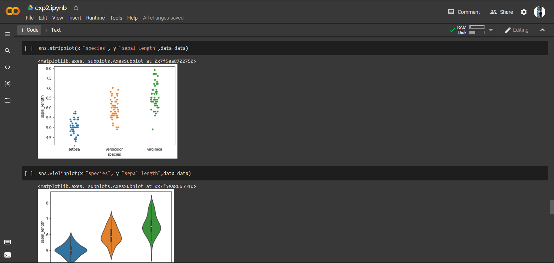

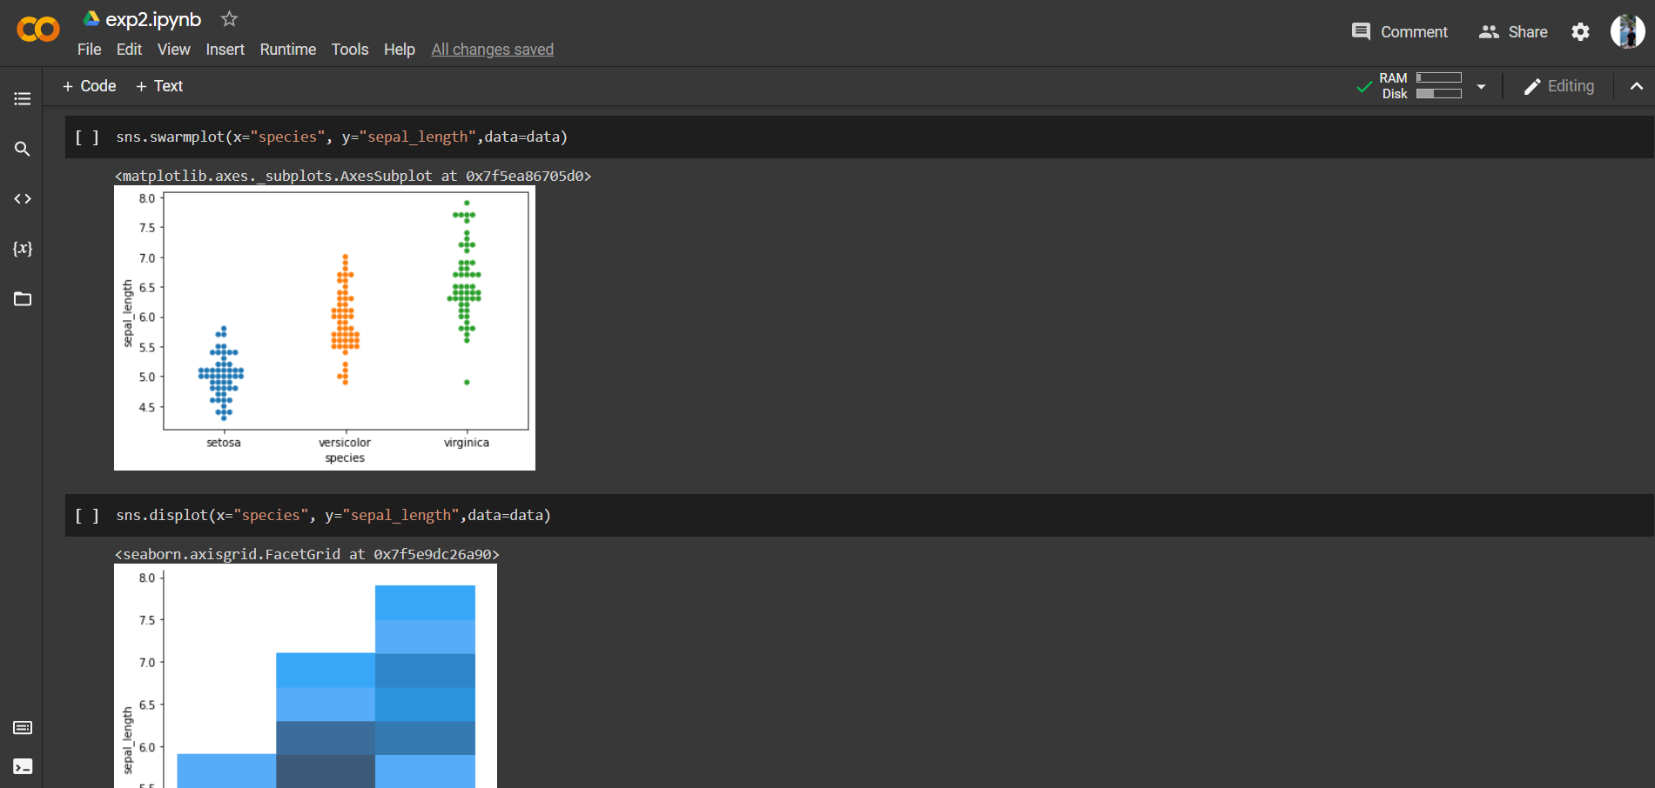

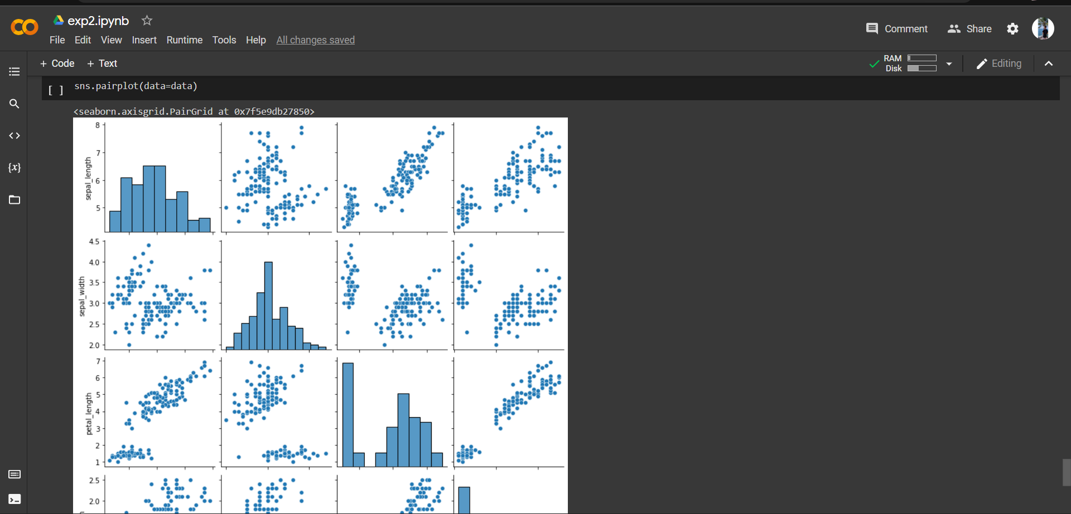

**8. Post-Experiments Exercise**

**A. Extended Theory: (Soft Copy)**

What is difference between table and graph? (Ref Link 1)

|  |  |
| --- | --- |
| Table | Graph |
| A table is a method of representing data in the form of row and columns to get a quick overview of data. | A Graph is a method of representing data in varied forms to a comprehensible understanding of concepts. |
| A table doesn’t make use of symbols because it depicts the details of the data in a formal structure. | A graph makes use of different symbols such as slices, lines, bars, etc to depict the concepts in a better way. |
| The content is represented in the form of rows and columns. It is predominantly used to present data in the form of numbers, quantities, names, etc. | The content is presented in the form of pie charts, flowcharts, line charts, bars, etc to explain the larger concepts of the data that is presented. It is used to make data understandable. |
| The table is used to make data brief and quick to overview. | Graphs make the given data or the concept comprehensible. |

**B. Questions:**

What is the difference between Matplotlib and Seaborn? (Refer Link 2)

|  |  |
| --- | --- |
| Matplotlib | Seaborn |
| It is utilized for making basic graphs. Datasets are visualised with the help of bargraphs, histograms, piecharts, scatter plots, lines and so on. | Seaborn contains a number of patterns and plots for data visualization. It uses fascinating themes. It helps in compiling whole data into a single plot. It also provides distribution of data. |
| It uses comparatively complex and lengthy syntax. Example: Syntax for bargraph- matplotlib.pyplot.bar(x_axis, y_axis). | It uses comparatively simple syntax which is easier to learn and understand. Example: Syntax for bargraph- seaborn.barplot(x_axis, y_axis). |
| We can open and use multiple figures simultaneously. However they are closed distinctly. Syntax to close one figure at a time: matplotlib.pyplot.close(). Syntax to close all the figures: matplotlib.pyplot.close(“all”) | Seaborn sets time for the creation of each figure. However, it may lead to (OOM) out of memory issues |
| Matplotlib is well connected with Numpy and Pandas and acts as a graphics package for data visualization in python. Pyplot provides similar features and syntax as in MATLAB. Therefore, MATLAB users can easily study it. | Seaborn is more comfortable in handling Pandas data frames. It uses basic sets of methods to provide beautiful graphics in python. |
| Matplotlib is a highly customized and robust | Seaborn avoids overlapping of plots with the help of its default themes |
| Matplotlib plots various graphs using Pandas and Numpy | Seaborn is the extended version of Matplotlib which uses Matplotlib along with Numpy and Pandas for plotting graphs |

**C. Conclusion:**

Write the significance of the topic studied in the experiment.

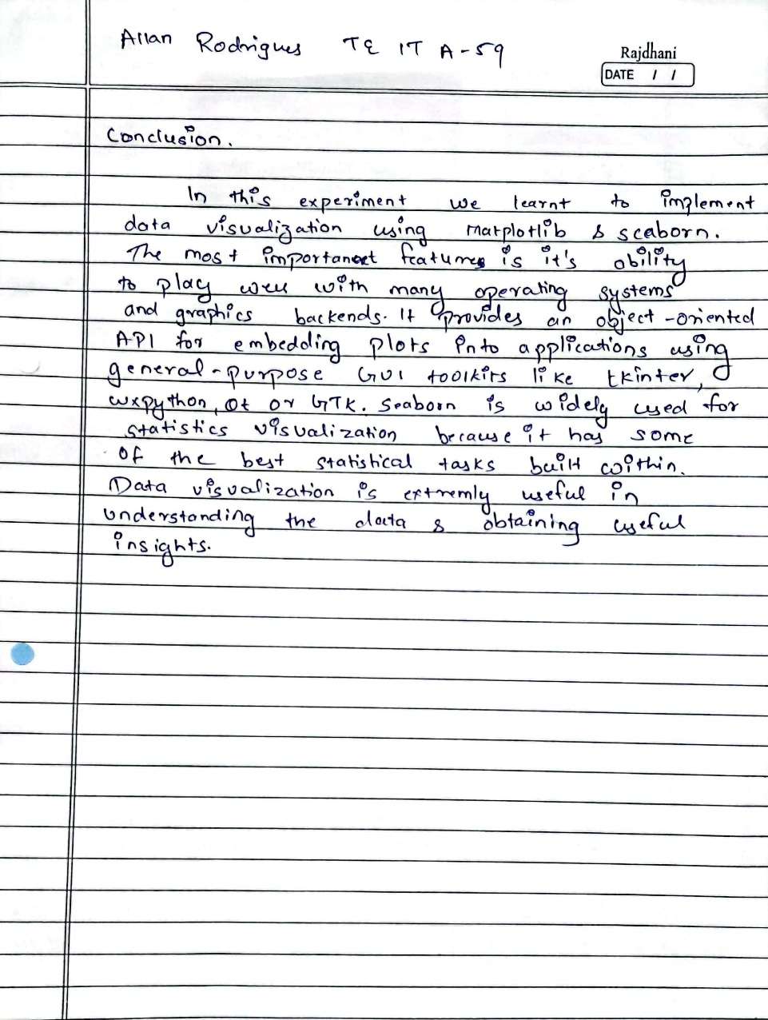

**D. References:**

1. <https://www.wallstreetmojo.com/graphs-vs-charts/>
2. <https://www.geeksforgeeks.org/difference-between-matplotlib-vs-seaborn/>
3. <https://matplotlib.org/stable/tutorials/index>
4. <https://seaborn.pydata.org/>