Name: Allan Rodrigues

Class: TE IT A

Roll no: 59

Pid:191104

St. Francis Institute of Technology, Mumbai-400 103

**Department of Information Technology**

A.Y. 2021-2022

Class: TE-ITA/B, Semester: VI

Subject: **Data Science Lab**

**Experiment – 5: To implement Regression.**

1. **Aim:** To implement Linear and Logistic Regression to find out relation between variables. 
2. **Objectives:** After study of this experiment, the student will be able to

* Understand linear regression
* Understand logistic regression

1. **Outcomes:** After study of this experiment, the student will be able to

* Understand concepts of regression

1. **Prerequisite:** Fundamentals of Python Programming and Database Management System.
2. **Requirements:** Python Installation,Personal Computer, Windows operating system, Internet Connection, Microsoft Word.
3. **Pre-Experiment Exercise:**

**Brief Theory:**

* Concept of regression in machine learning**.**

**Laboratory Exercise**

* + - 1. **Procedure:** (the sheet for commands in attached with the file)
      2. Paste Screenshots of above commands.

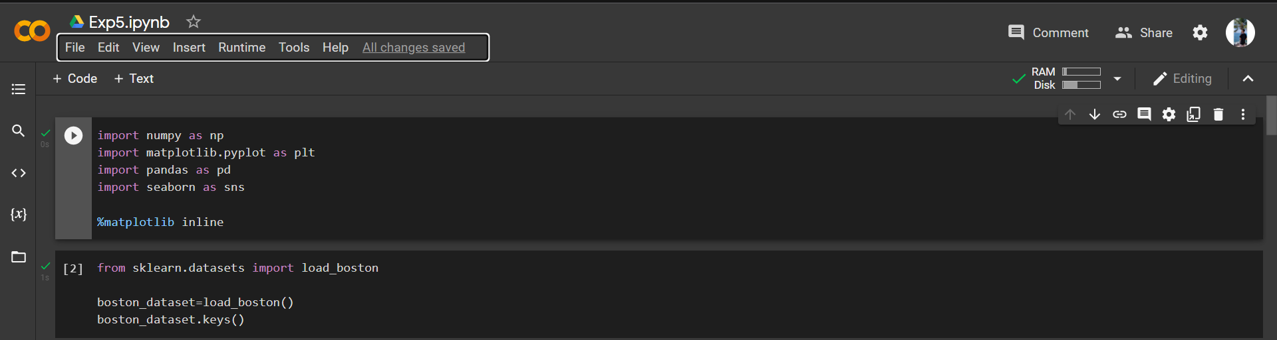

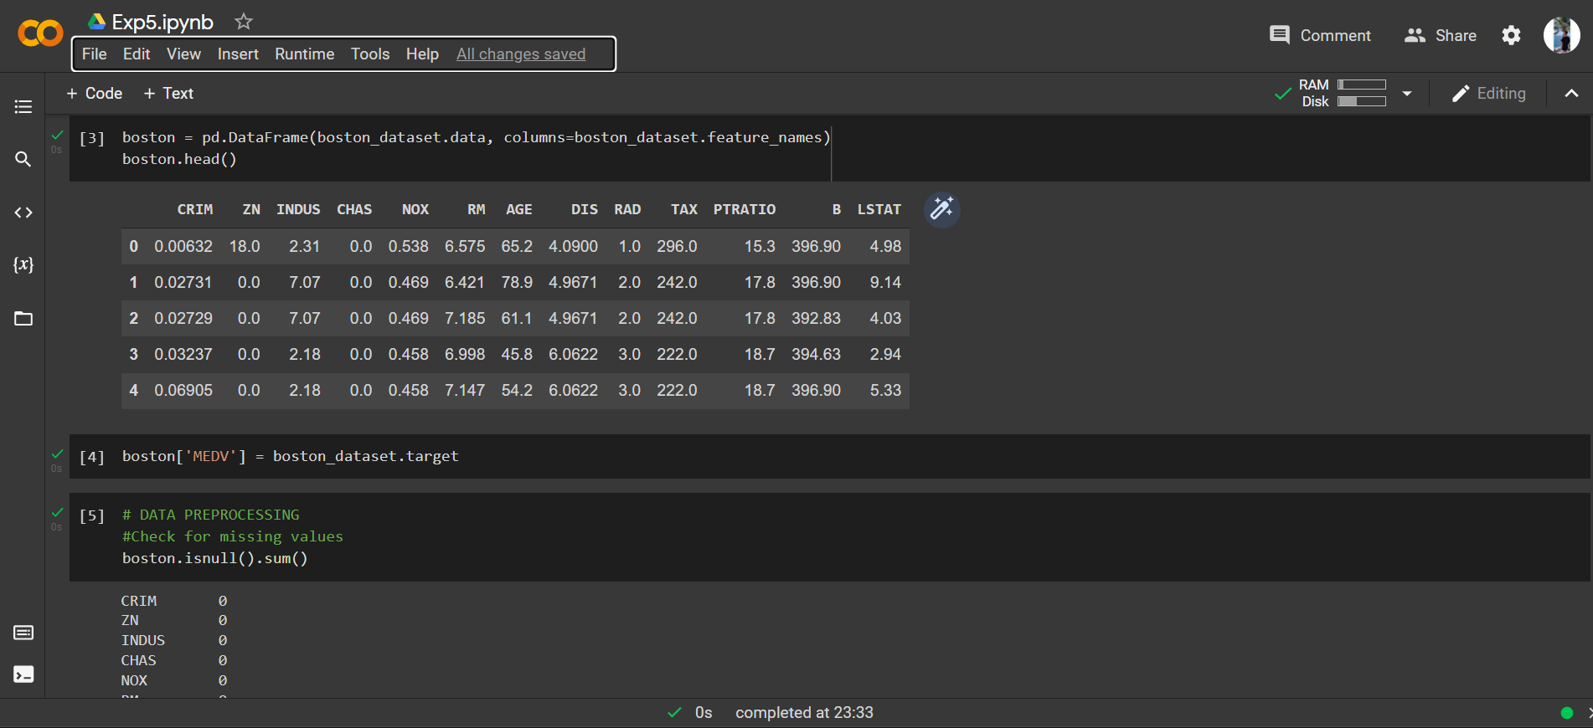

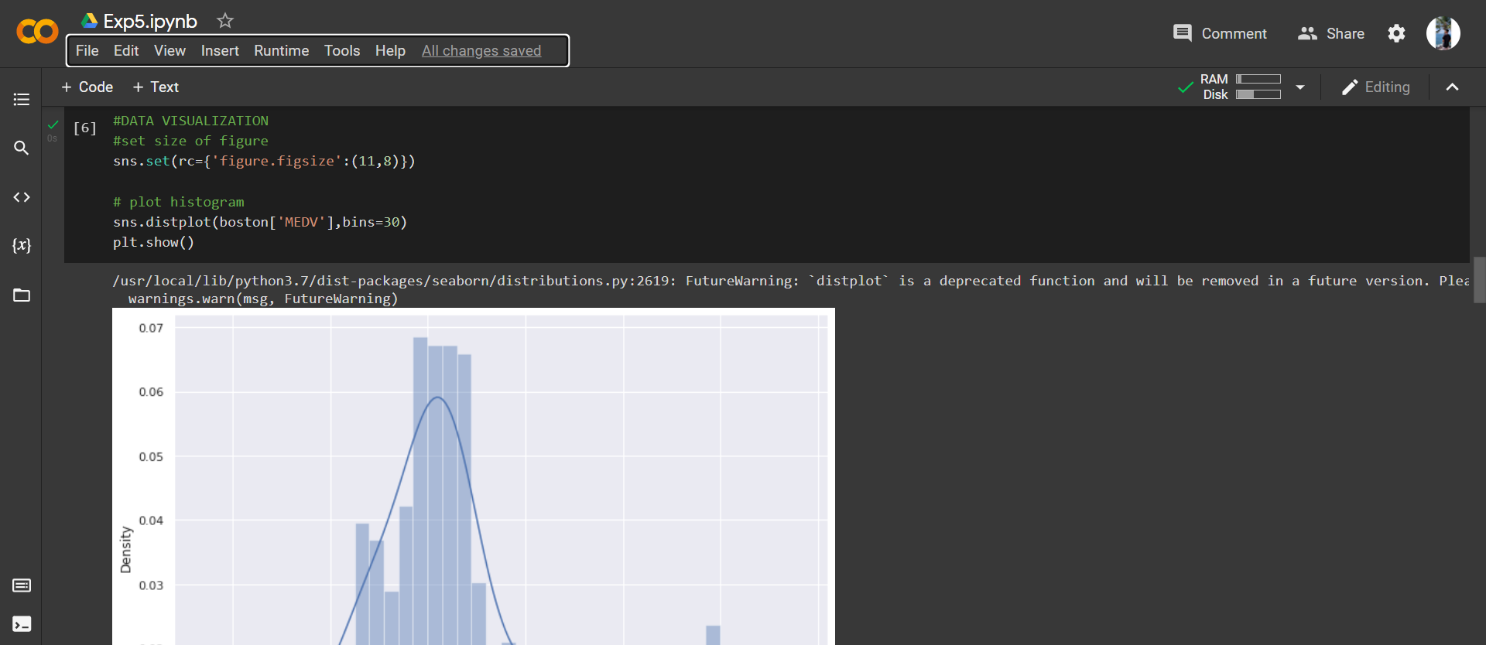

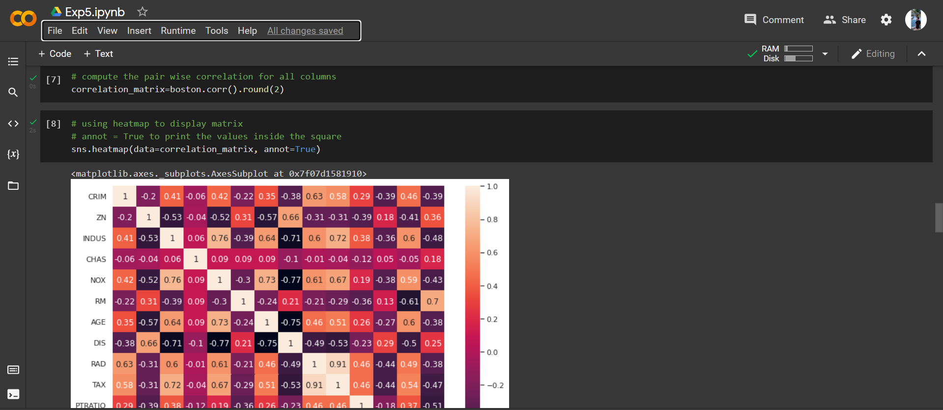

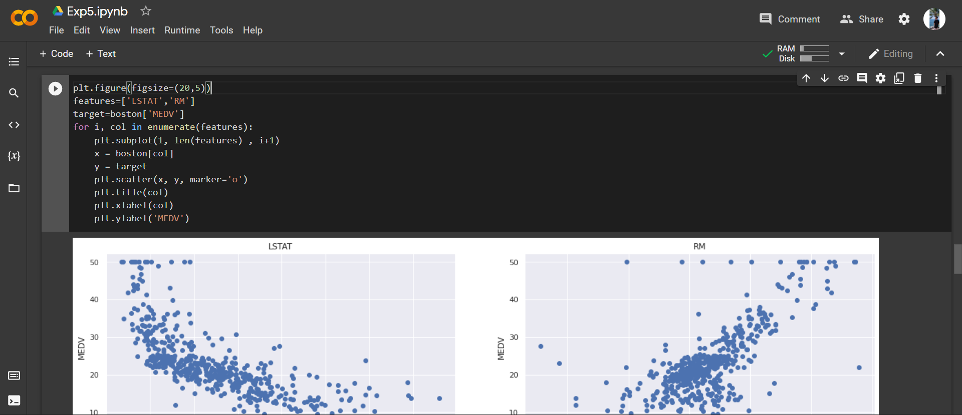

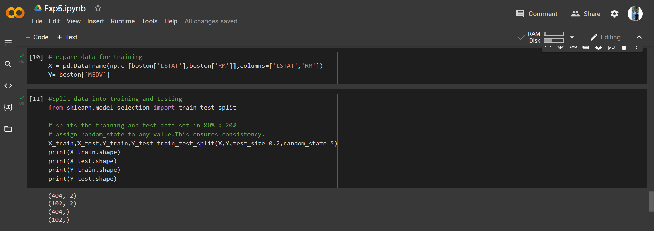

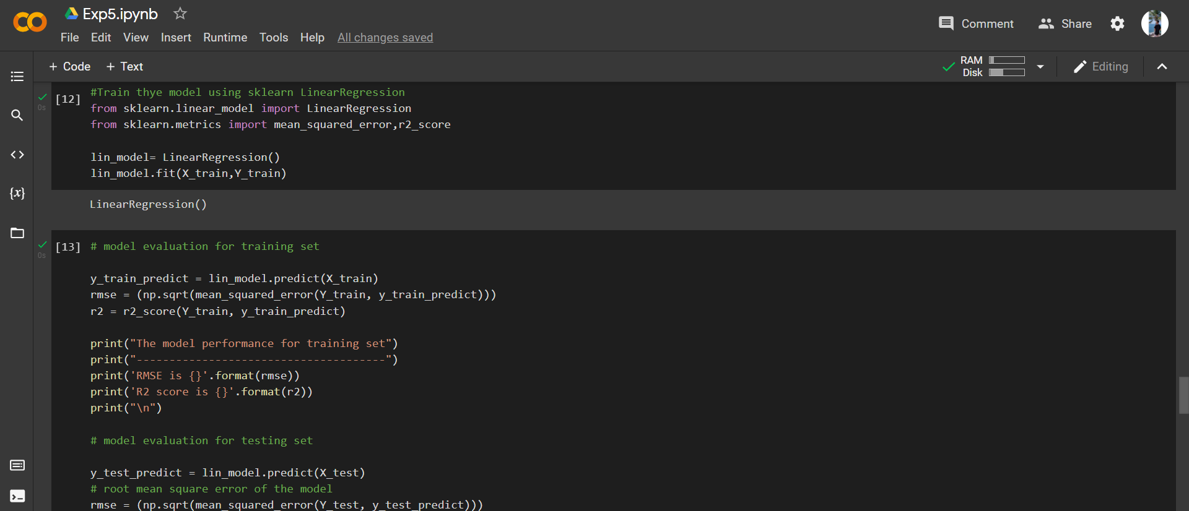

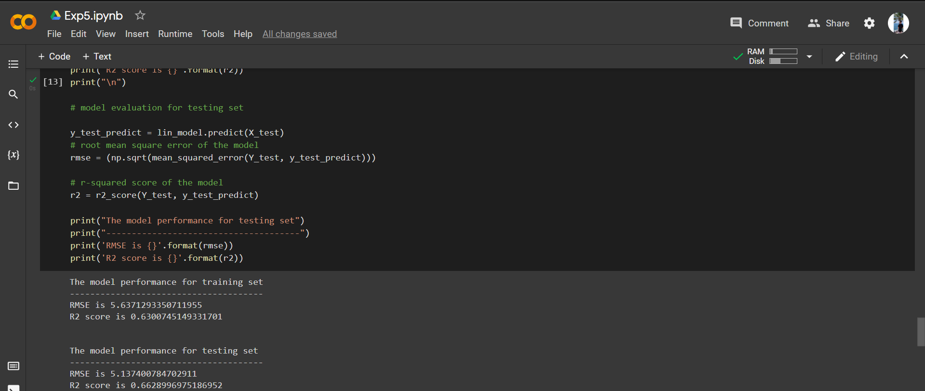

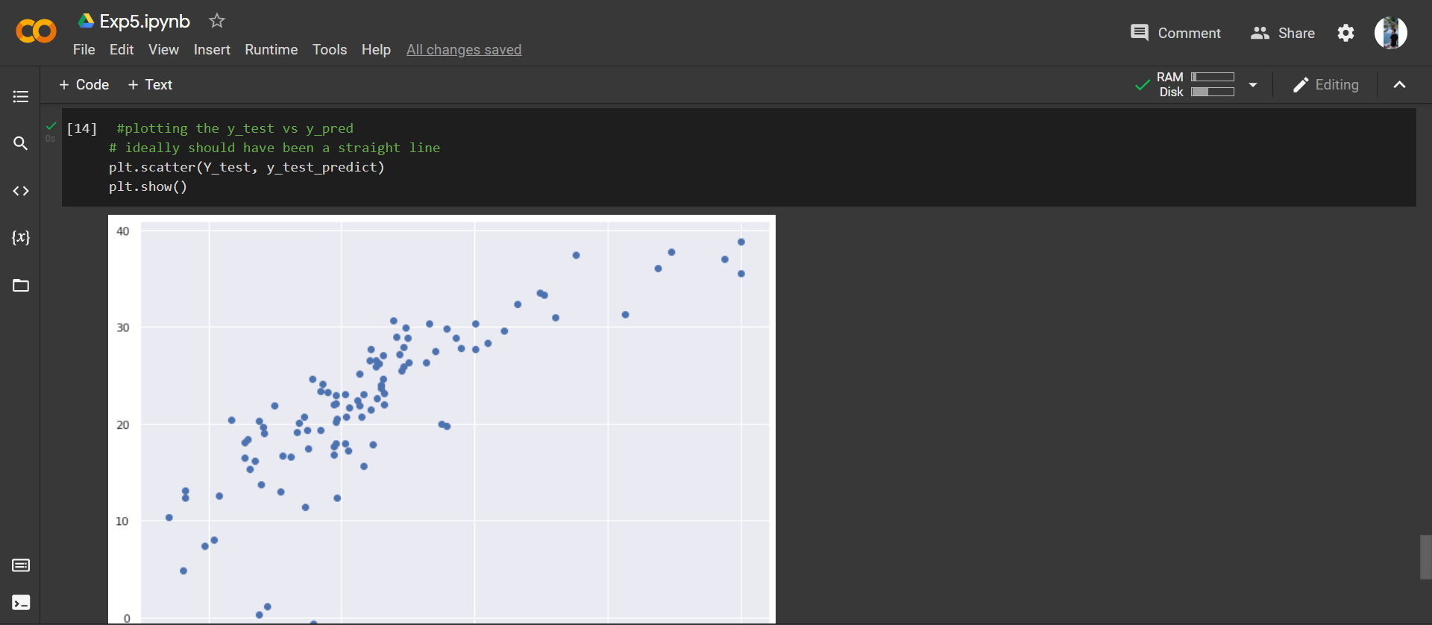

**8. Post-Experiments Exercise**

**A. Extended Theory: (Soft Copy)**

* Logistic regression

Logistic Regression is a kind of parametric classification model, despite having the word ‘regression’ in its name.

This means that logistic regression models are models that have a certain fixed number of parameters that depend on the number of input features, and they output categorical prediction, like for example if a plant belongs to a certain species or not.

In Logistic Regression, we don’t directly fit a straight line to our data like in linear regression. Instead, we fit a S shaped curve, called Sigmoid, to our observations.

**B. Questions:**

* + - Use MNIST Dataset and apply logistic regression.

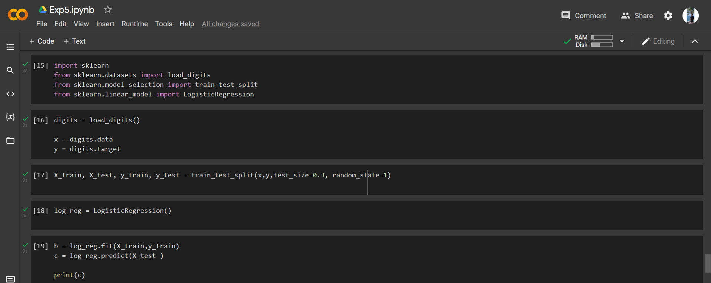

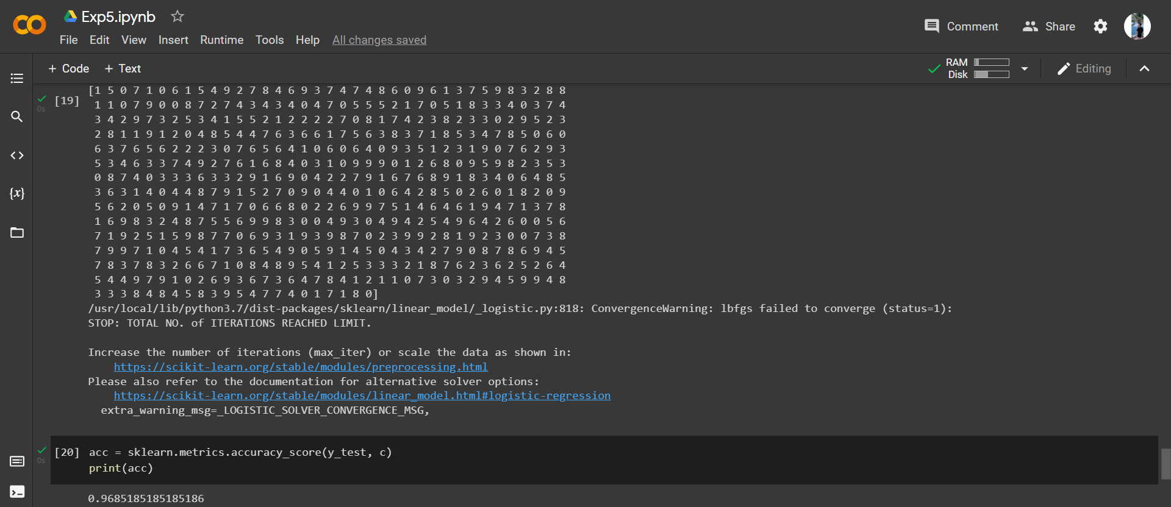

**C. Conclusion:**

Write the significance of the topic studied in the experiment.

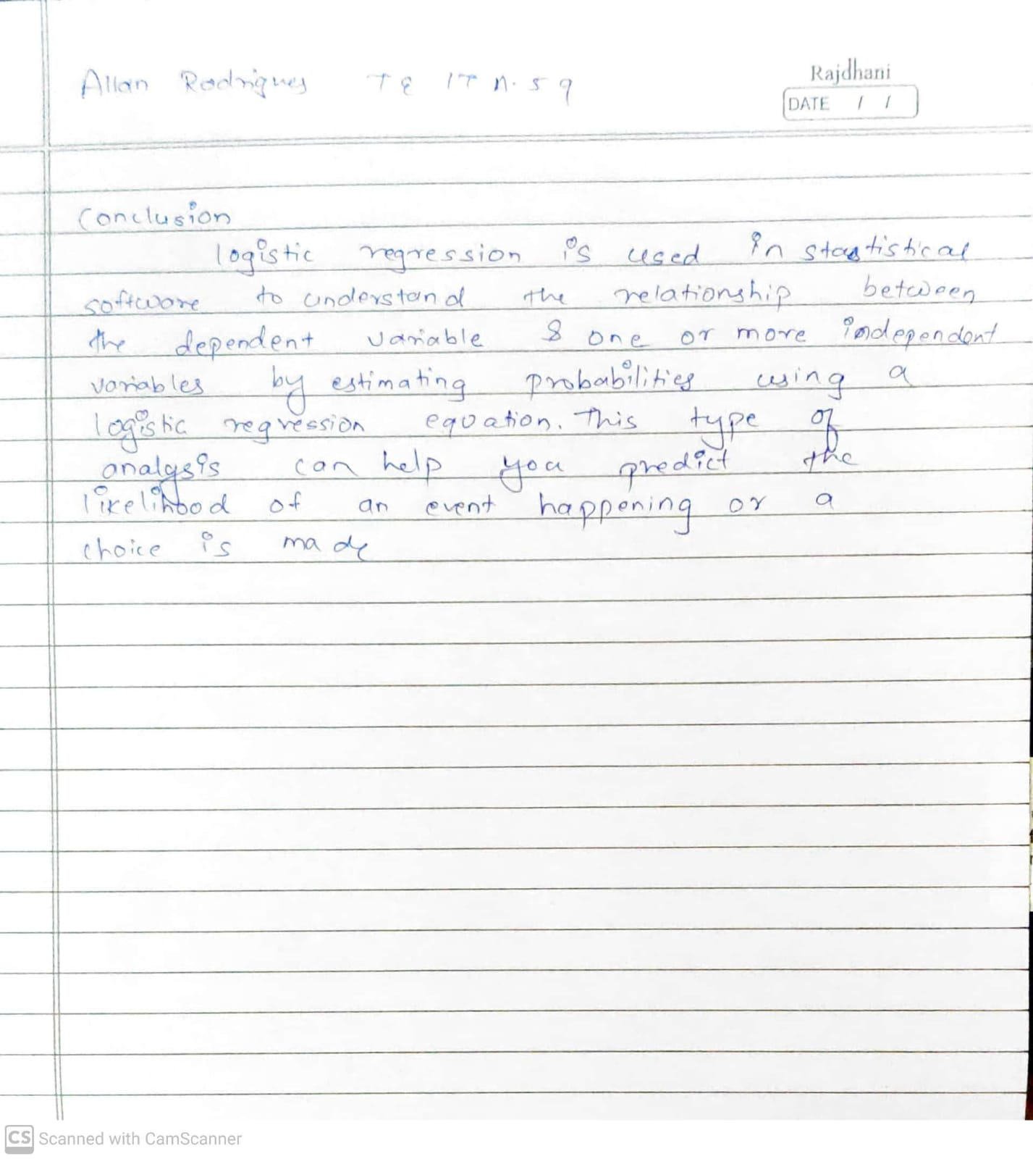

**D. References:**

1. [Logistic Regression using Python (scikit-learn) | by Michael Galarnyk | Towards Data Science](https://towardsdatascience.com/logistic-regression-using-python-sklearn-numpy-mnist-handwriting-recognition-matplotlib-a6b31e2b166a)

2. [Logistic Regression in Python | Techniques for Logistic Regression (educba.com)](https://www.educba.com/logistic-regression-in-python/)