SFIT, Department of Information Technology **2022**

Name: Allan Rodrigues

Class: TE IT A

Roll no: 59

Pid:191104

# St. Francis Institute of Technology, Mumbai-400 103

Department Of Information Technology

# A.Y. 2021-2022

Class: TE-ITA/B, Semester: VI Subject: **Business Intelligence Lab**

## Experiment – 4: To Implement any one of the classifiers using WEKA (Decision Tree, Naïve Bayes, Random Forest)

1. **Aim:** To Implement any one of the classifiers using WEKA (Decision Tree, Naïve Bayes, Random Forest)
2. **Objectives:** After study of this experiment, the students will be able to Understand and knew about all the three classifiers.
3. **Outcomes:** After study of this experiment, the students will be able to

CO4: Design and Implement the appropriate data mining methods like classification, clustering or Frequent Pattern mining on large data sets.

CO5: Define and apply metrics to measure the performance of various data mining algorithms

1. **Prerequisite:** Introduction to all the three classifiers through algorithms & Problem solving approach.
2. **Requirements:** Personal Computer, Windows XP operating system/Windows 7, Internet Connection, Microsoft Word, WEKA tool, Java/R/Python.

## Theory:

* 1. What is Classification Data Mining?
  2. Difference between supervised and unsupervised
  3. Solve numerical on decision tree

1. **Laboratory Exercise:** Implementation of Classification Algorithm in WEKA, Printout of Implementation along with coding and snapshot.

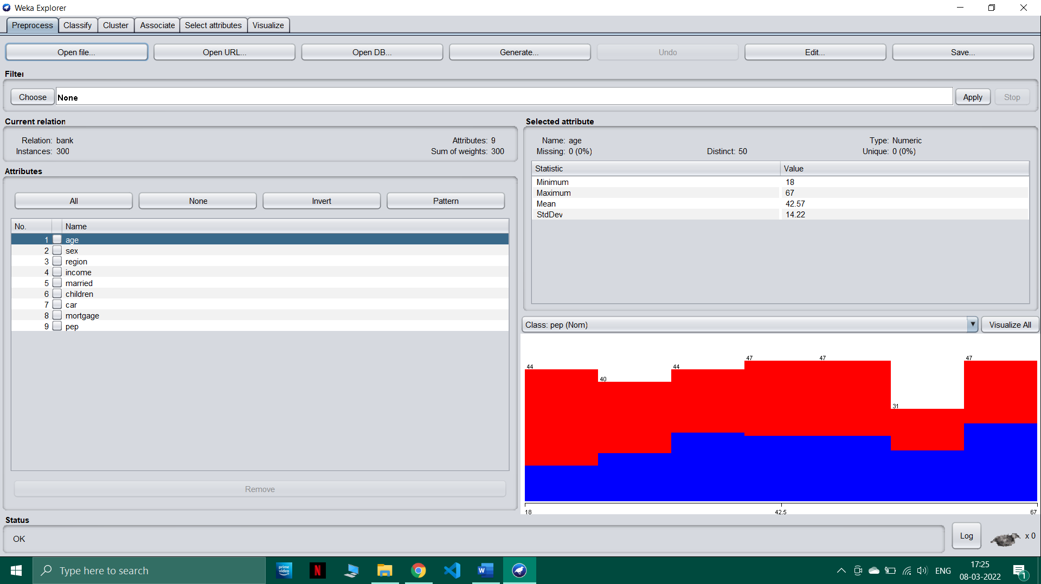

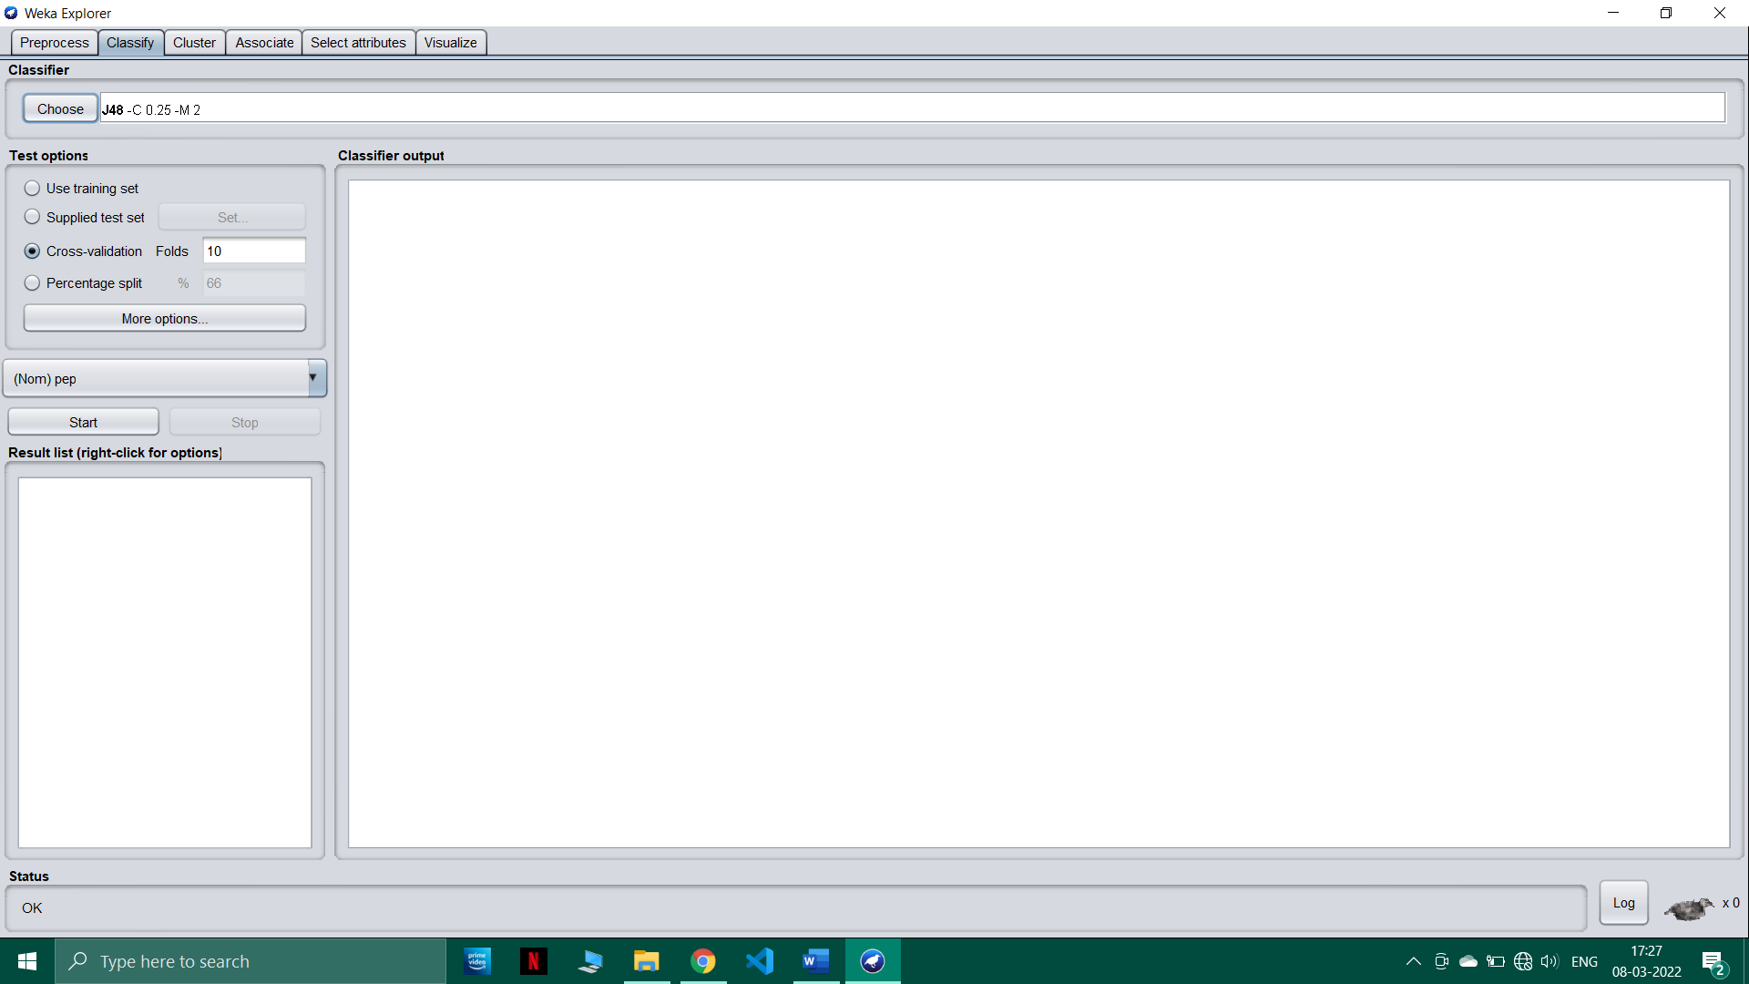

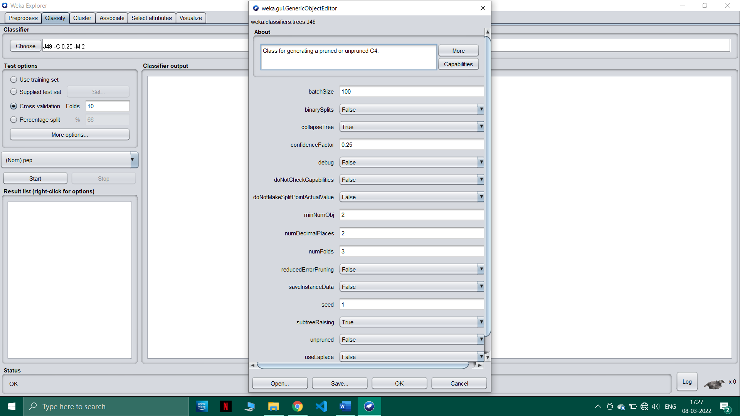

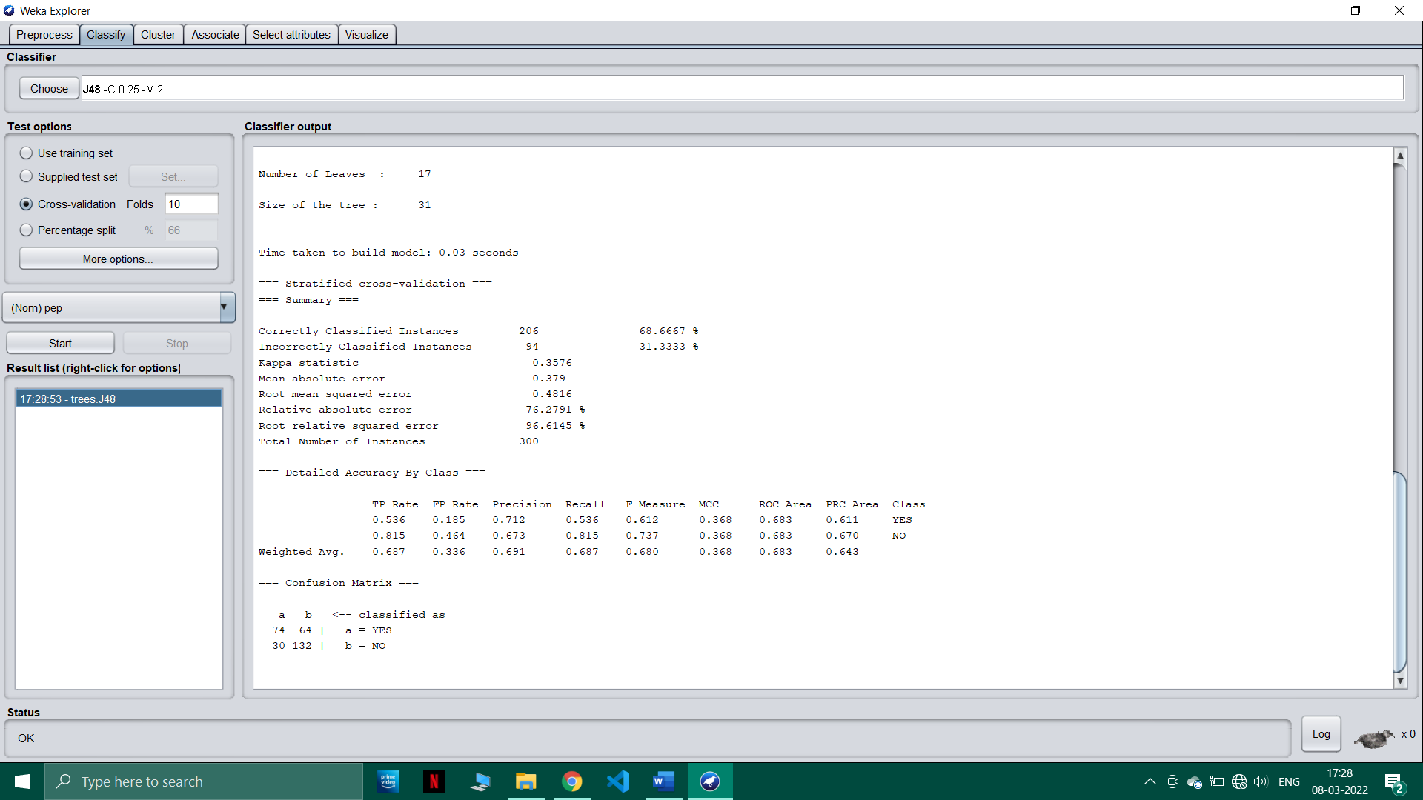

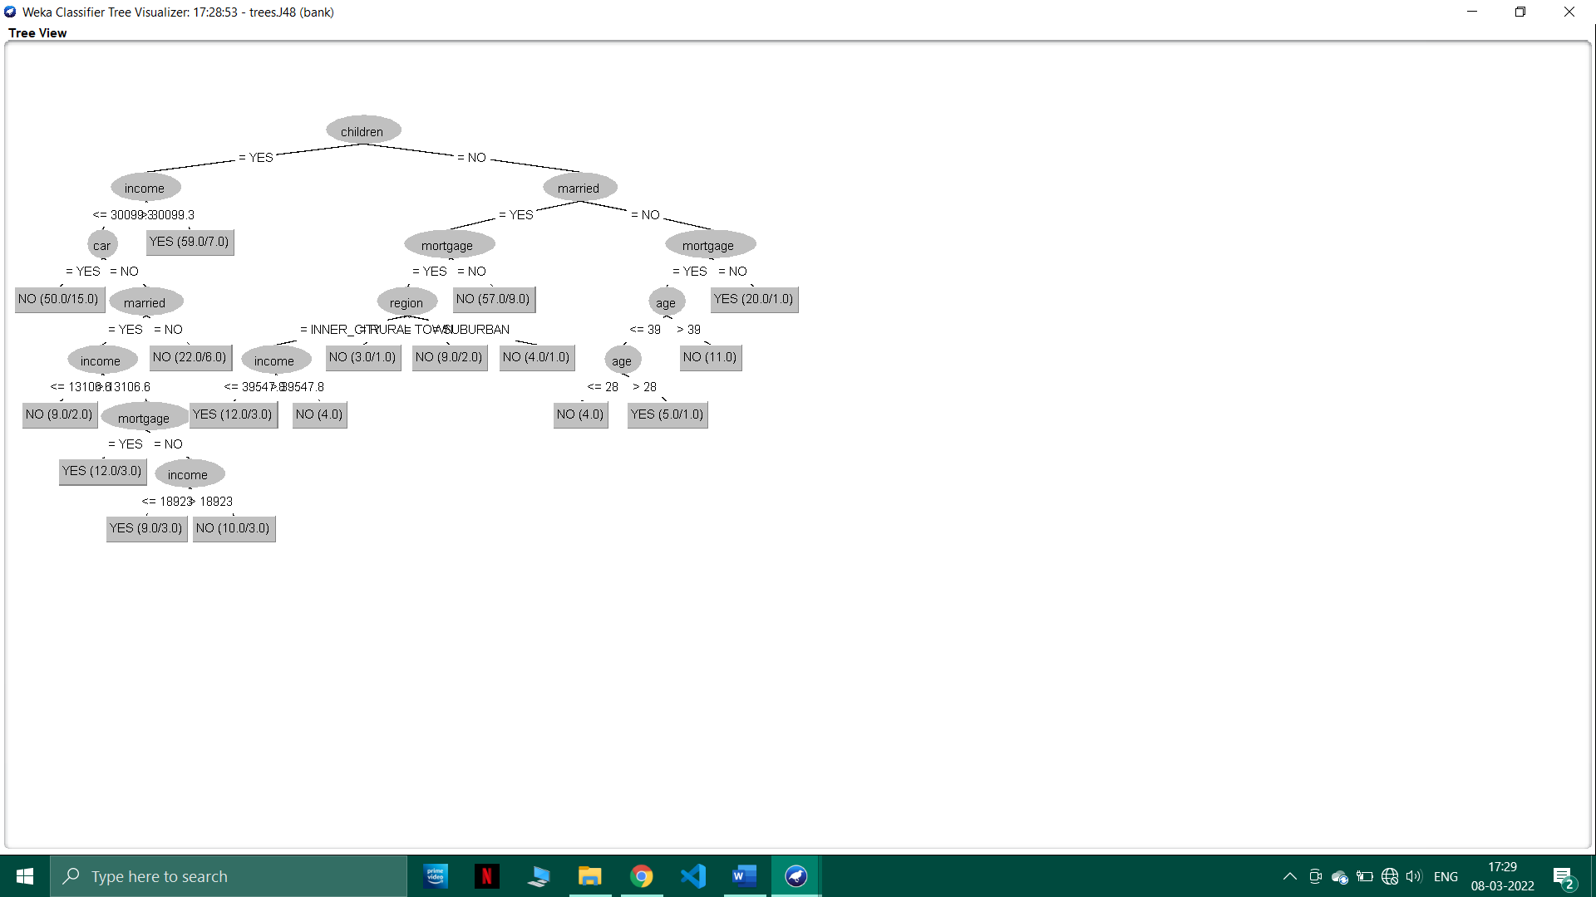

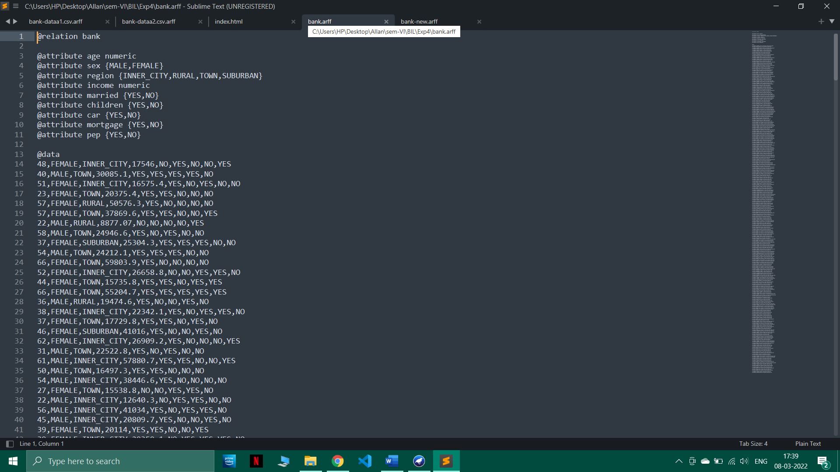

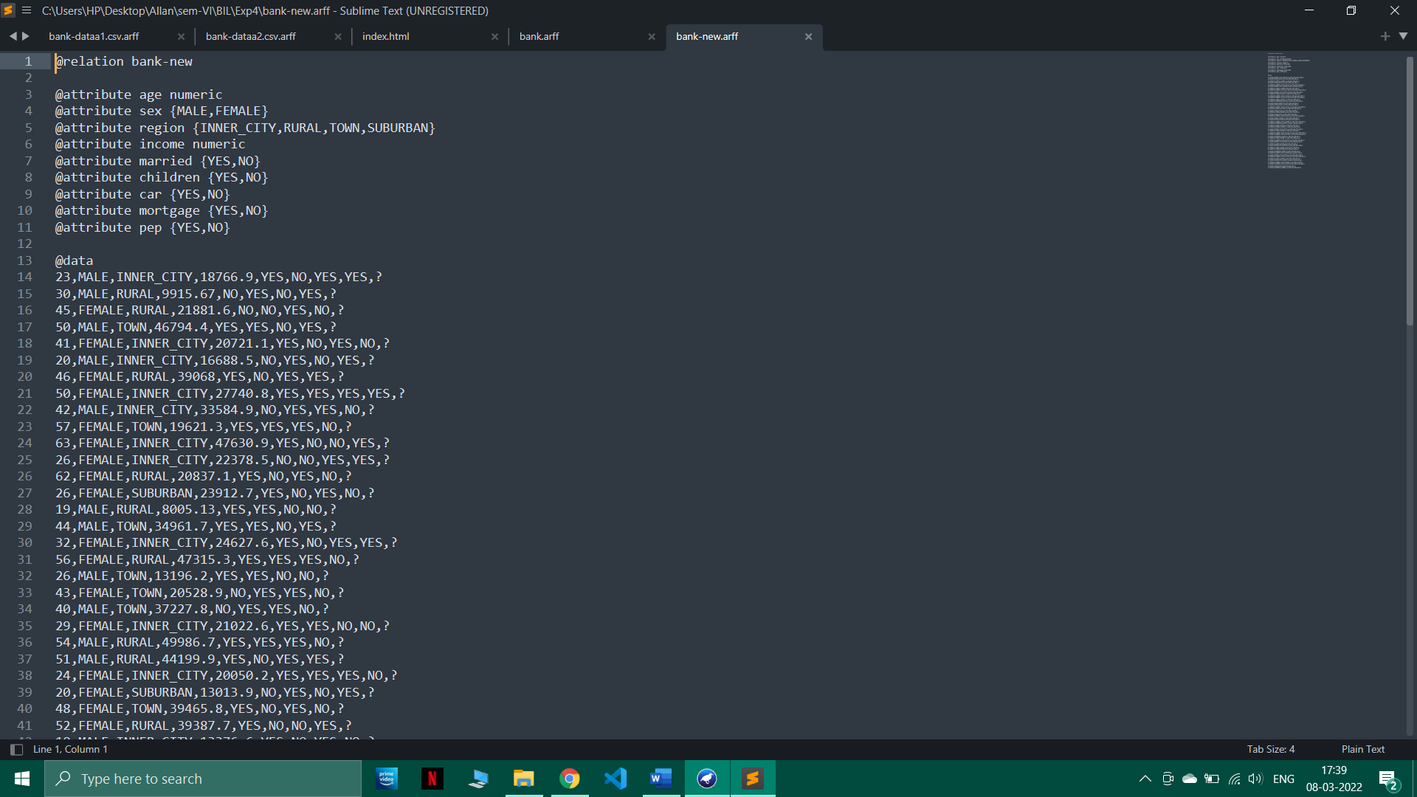

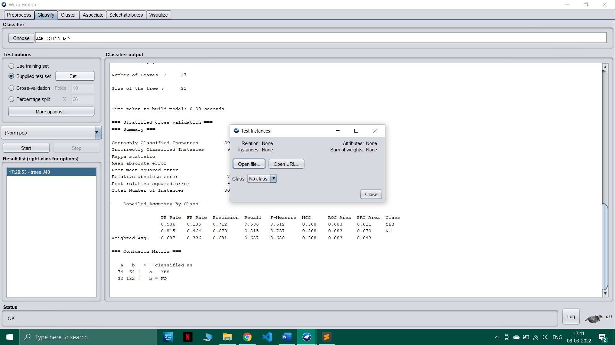

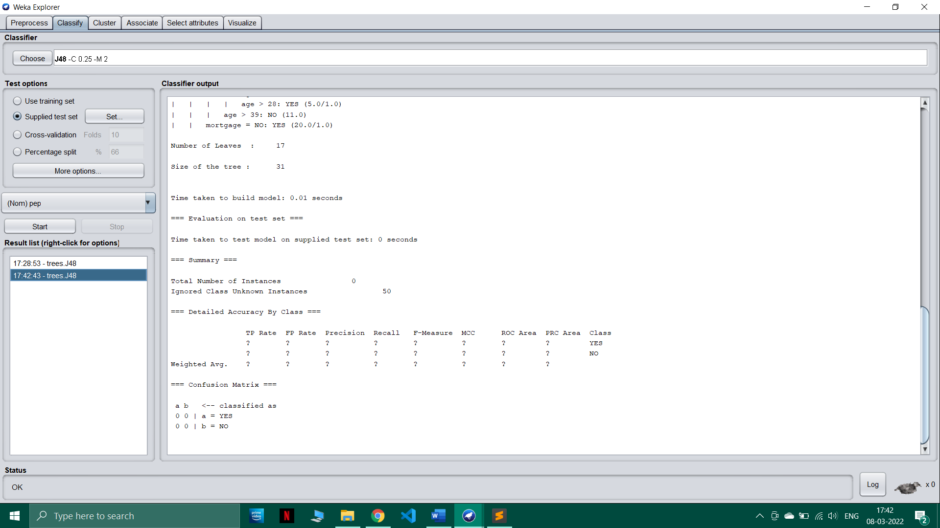

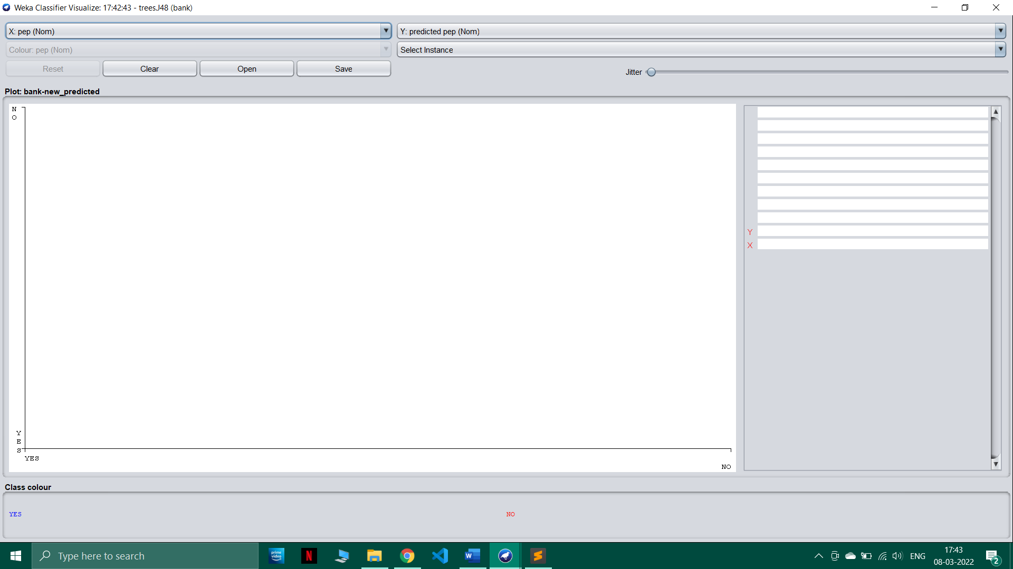

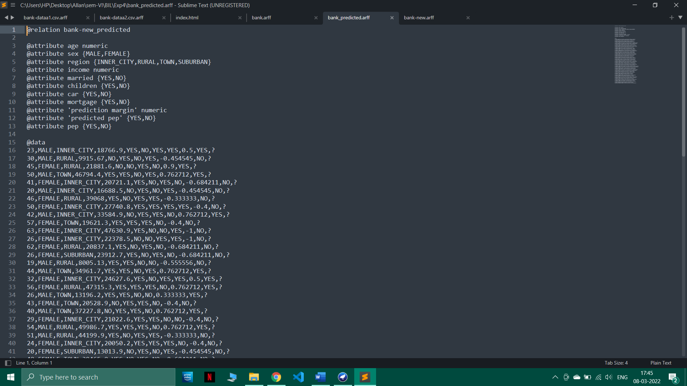

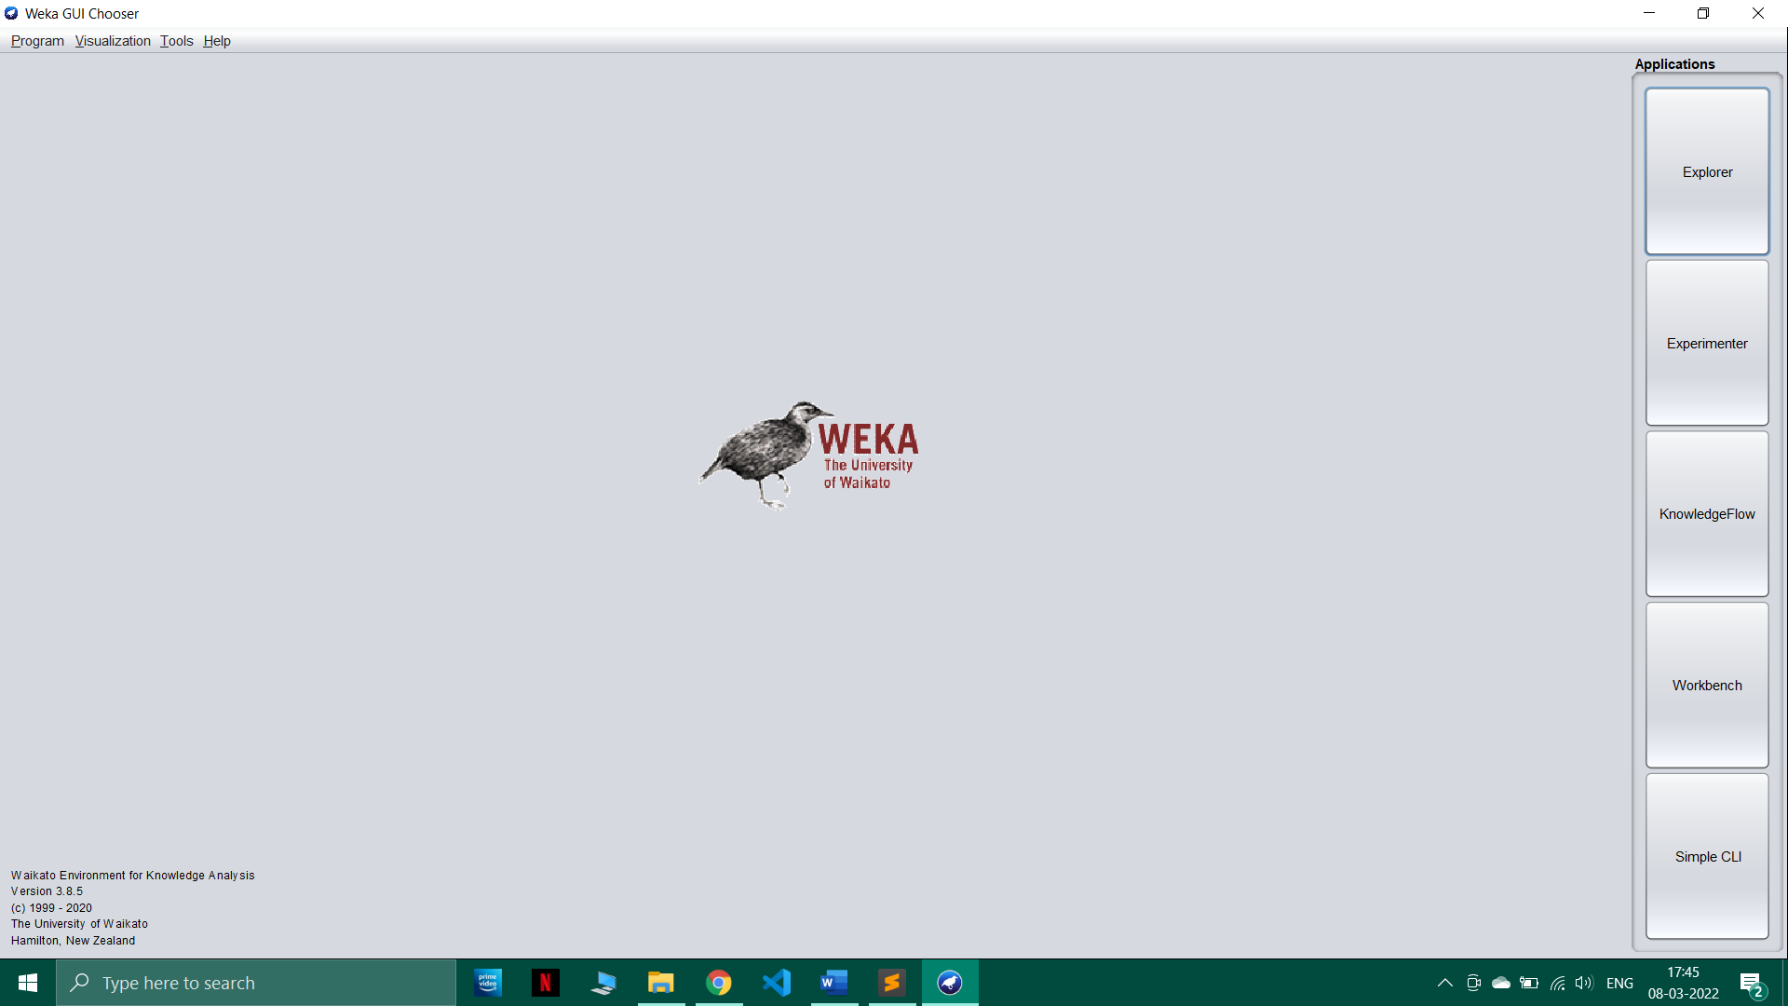

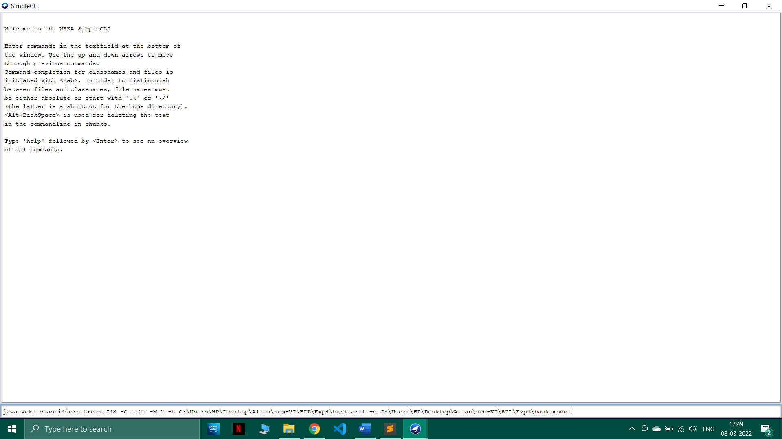

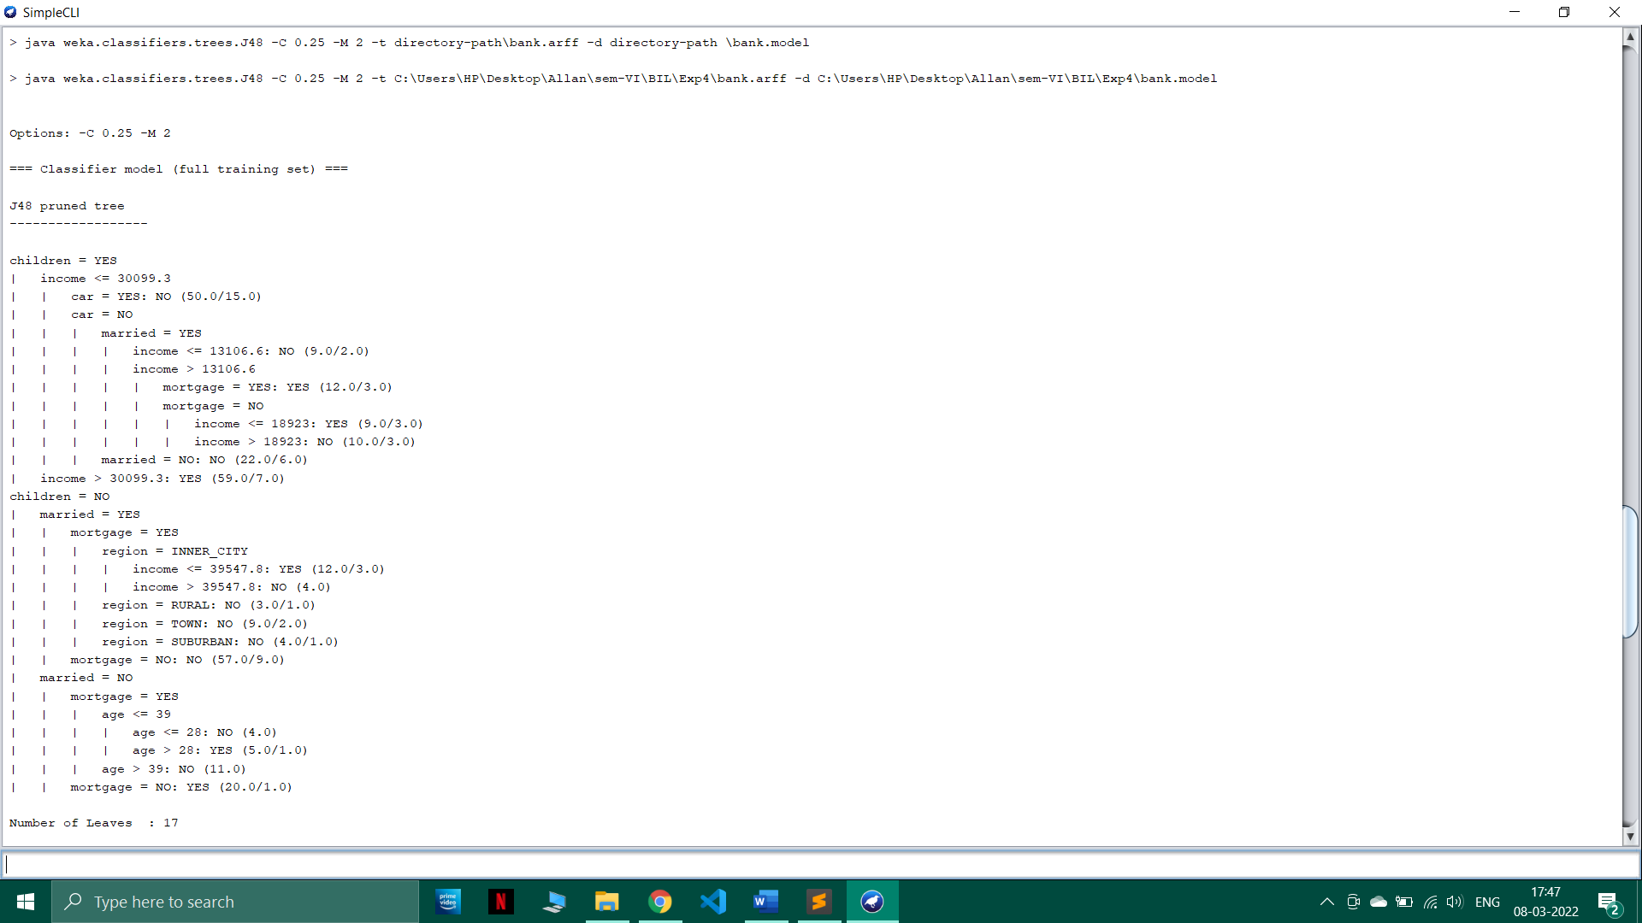

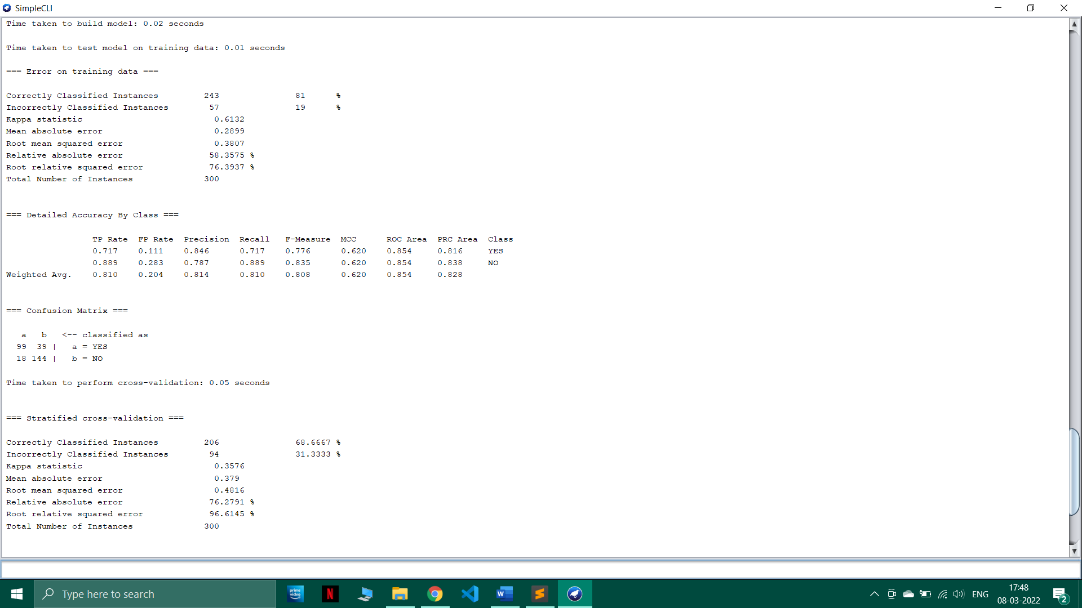

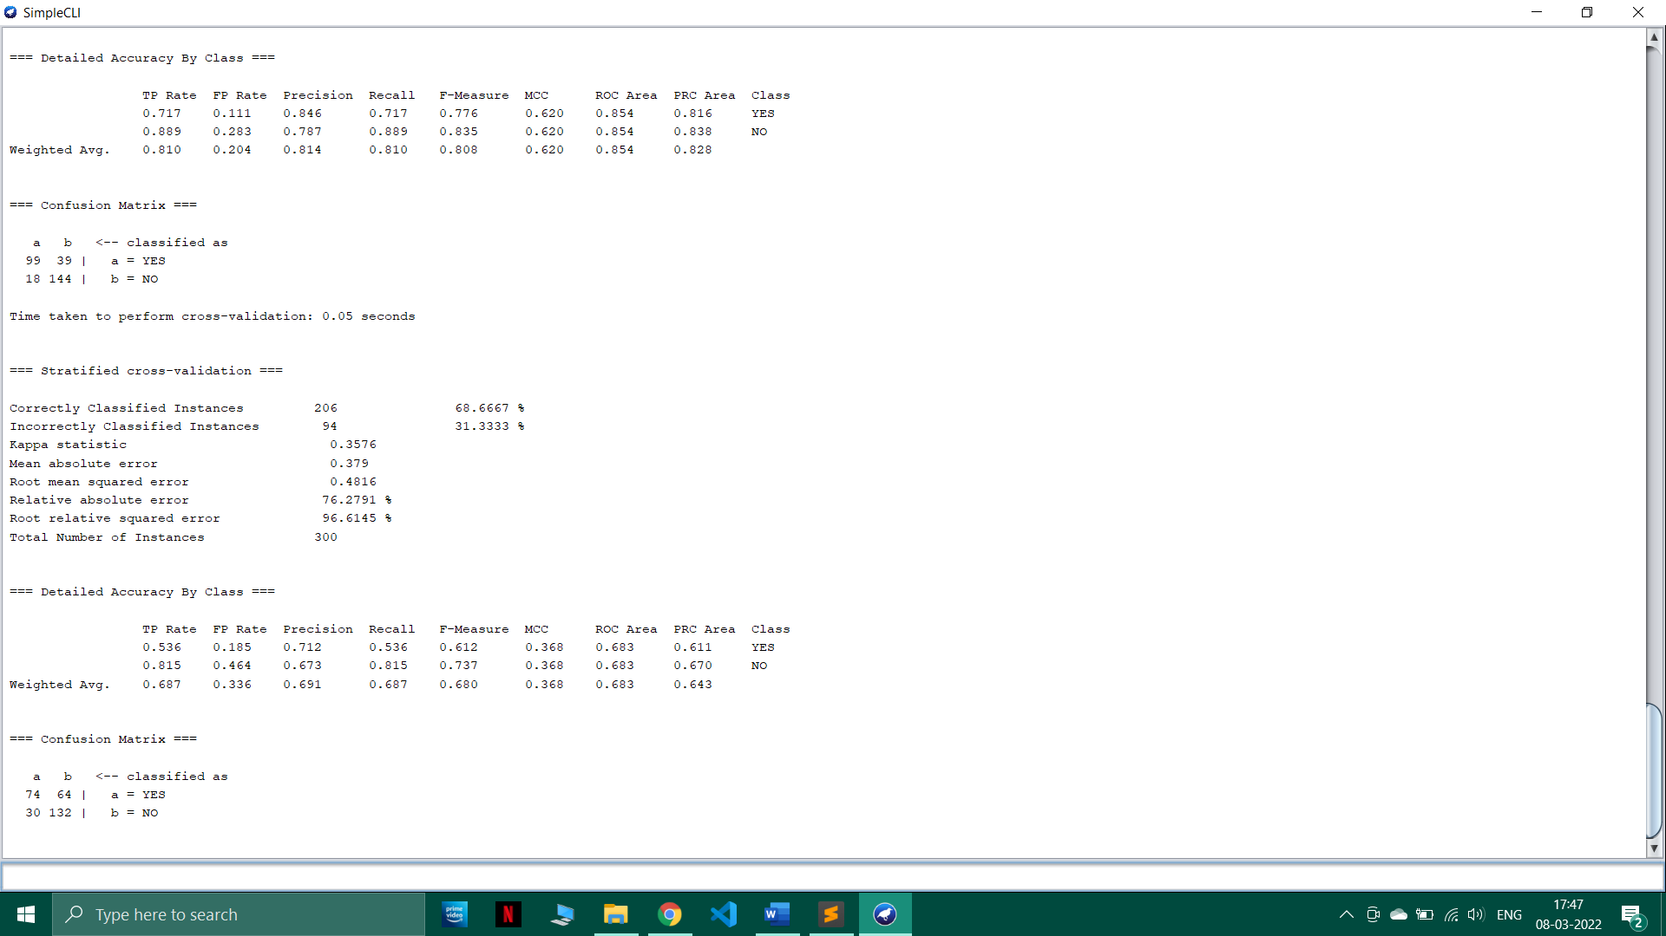

## Post-Experiments Exercise

* 1. **Extended Theory:**
     + Write about Decision Tree and SVM

## Questions:

* Compare and Contrast between Decision Tree and SVM

## Conclusion:

* + - Summary of Experiment
* Importance of Experiment
* Application of Experiment

1. **Reference:** Data Mining: Concept & Techniques, 3rd Edition, Jiawei Han, Micheline Kamber, Jian Pei, Elsevier.