Name: Allan Rodrigues

Class: TE IT A

Roll no: 59

Pid:191104

St. Francis Institute of Technology, Mumbai-400 103

**Department of Information Technology**

A.Y. 2021-2022

Class: TE-ITA/B, Semester: VI

Subject: **M AD & PWA LAB**

# Experiment – 2: Designing and Developing Flutter User Interface.

1. **Aim:** To design and develop Flutter UI by including common widgets.
2. **Objectives:** After study of this experiment, the student will be able to
   1. Develop the App UI by incorporating widgets
3. **Outcomes:** After study of this experiment, the student will be able to
   1. Design and Develop interactive Flutter App by using widgets. (L604.2)
4. **Prerequisite:** Dart Programming Language.
5. **Requirements:** Android Studio, Flutter framework, Internet Connection.

## Pre-Experiment Exercise: Brief Theory:

In Flutter, everything is a widget. Widgets are the building blocks of a Flutter app, and each widget is an immutable declaration of the user interface. A widget describes what the view of the app would look like in the given state.

Some of the common widgets are:

1. Scaffold—Implements the Material Design visual layout, allowing the use of Flutter’s Material Components widgets
2. AppBar—Implements the toolbar at the top of the screen.
3. Divider—Draws a horizontal line with padding above and below
4. Padding—This adds left, top, right, and bottom padding.
5. Column—This displays a vertical list of child widgets.
6. Row—This displays a horizontal list of child widgets.
7. Container—This widget can be used as an empty placeholder (invisible) or can specify height, width, color, transform (rotate, move, skew), and many more properties.
8. Expanded—This expands and fills the available space for the child widget that belongs to a Column or Row widget.
9. Text—The Text widget is a great way to display labels on the screen. It can be configured to be a single line or multiple lines.
10. FloatingActionButton- This is a simple button floating above the body at the bottom right corner.

## Laboratory Exercise

* 1. **Program**
     1. Design UI for mobile app using the following widgets.

MaterialApp, Scaffold, AppBar, Text, Center, FloatingActionButton, TextStyle.

## Result/Observation

* + 1. Print out of program code and output.

import 'package:flutter/material.dart';

void main() {

  runApp(MaterialApp(

    home: Scaffold(

      appBar: AppBar(

        title: Text('My First app'),

        centerTitle: true,

        backgroundColor: Colors.blue[300],

      ),

      body: Center(

        child: Text('Flutter app',

            style: TextStyle(

                fontSize: 20.0,

                fontWeight: FontWeight.bold,

                letterSpacing: 2.0,

                color: Colors.blue[600])),

      ),

      floatingActionButton: FloatingActionButton(

        onPressed: () {},

        child: Text('click'),

        backgroundColor: Colors.blue[600],

        hoverColor: Colors.orange,

      ),

    ),

  ));

}

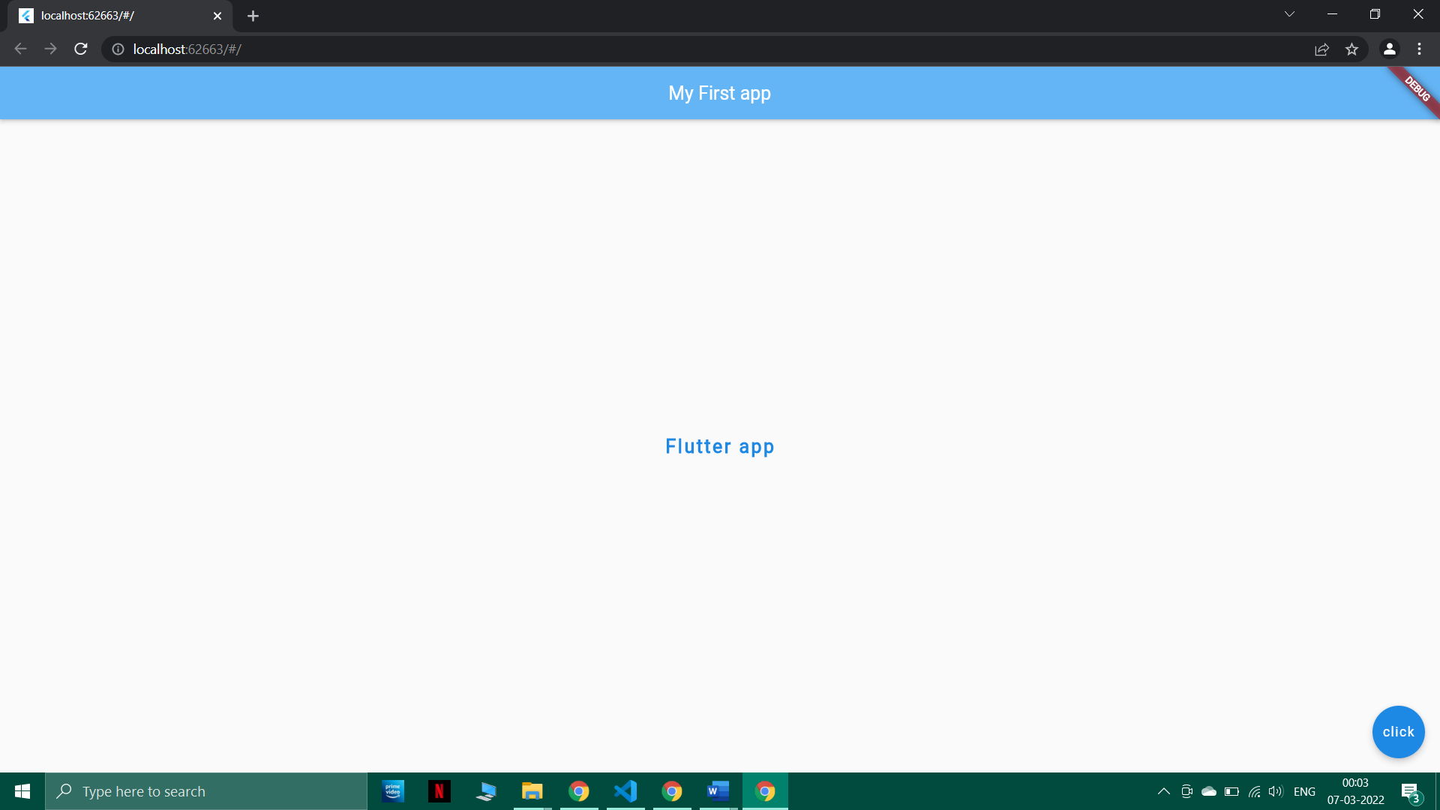

## Post-Experiments Exercise

* 1. **Questions:**

1. Modify the app UI to include two more widgets and show the output.
2. import 'package:flutter/material.dart';
3. void main() {
4. var column = Column(
5. children: [],
6. );
7. runApp(MaterialApp(
8. home: Scaffold(
9. appBar: AppBar(
10. title: Text(
11. 'My First App',
12. style: TextStyle(
13. fontSize: 30.0,
14. fontWeight: FontWeight.bold,
15. color: Colors.red,
16. fontFamily: 'IndieFlower',
17. ),
18. ),
19. centerTitle: true,
20. backgroundColor: Colors.yellowAccent,
21. ),
22. body: Center(
23. child: Padding(
24. padding: EdgeInsets.all(150),
25. child: Column(children: [
26. Card(
27. child: Container(
28. height: 100,
29. width: 300,
30. margin: const EdgeInsets.all(3),
31. color: Colors.red[600],
32. child: Padding(
33. padding: EdgeInsets.fromLTRB(120, 30, 40, 20),
34. child: Text(
35. "Box 1",
36. style: TextStyle(
37. color: Colors.blue[900],
38. fontSize: 30,
39. fontFamily: 'IndieFlower',
40. fontWeight: FontWeight.bold,
41. ),
42. ),
43. ),
44. ),
45. ),
46. Divider(
47. height: 20,
48. thickness: 2,
49. indent: 350,
50. endIndent: 350,
51. color: Colors.white,
52. ),
53. Card(
54. child: Container(
55. height: 100,
56. width: 300,
57. margin: const EdgeInsets.all(3),
58. color: Colors.purple,
59. child: Padding(
60. padding: EdgeInsets.fromLTRB(120, 30, 40, 20),
61. child: Text(
62. "Box 2",
63. style: TextStyle(
64. color: Colors.blue[900],
65. fontSize: 30,
66. fontFamily: 'IndieFlower',
67. fontWeight: FontWeight.bold,
68. ),
69. ),
70. ),
71. ),
72. ),
73. ]),
74. ),
75. ),
76. backgroundColor: Colors.black,
77. floatingActionButton: FloatingActionButton(
78. onPressed: () {},
79. child: Text('Close'),
80. backgroundColor: Colors.red[600],
81. hoverColor: Colors.blue[800],
82. ),
83. ),
84. ));
85. }

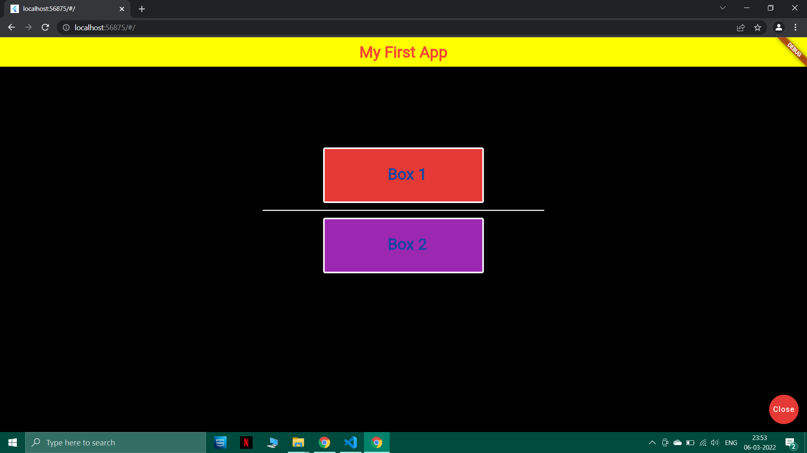

## Conclusion:

1. Write what you have learnt in the experiment.
2. Write the significance of widgets in designing UI.

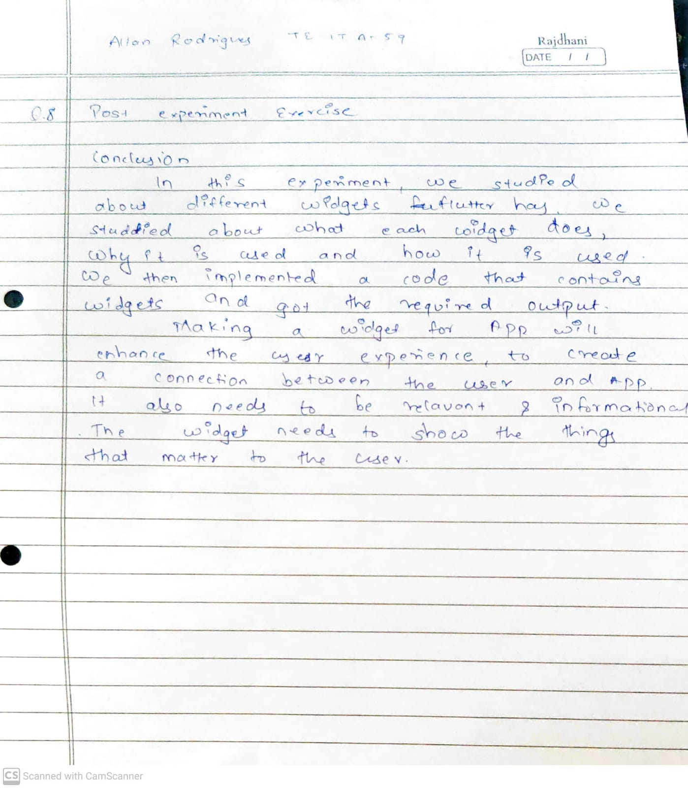

## References:

1. <https://docs.flutter.dev/development/ui/widgets-intro>
2. Beginning App Development with Flutter: Create Cross-Platform Mobile Apps, By Rap Payne, 2019.