Name: Allan Rodrigues

Class: TE IT A

Roll no: 59

Pid:191104

St. Francis Institute of Technology, Mumbai-400 103

**Department of Information Technology**

A.Y. 2021-2022

Class: TE-ITA/B, Semester: VI

Subject: **M AD & PWA LAB**

# Experiment – 3: Creation of Forms for mobile Apps.

1. **Aim:** To create interactive form using form widget
2. **Objectives:** After study of this experiment, the student will be able to
   * Develop the App UI by incorporating form widget
3. **Outcomes:** After study of this experiment, the student will be able to

* Design and Develop interactive Flutter App by using widgets (L604.2)

1. **Prerequisite:** Dart Programming Language
2. **Requirements:** Android Studio, Flutter framework, Internet Connection.

## Pre-Experiment Exercise: Brief Theory:

* The Form widget is an optional container for grouping together multiple form field widgets.
* The benefit of using a Form widget is to validate each text field as a group.
* You can group TextFormField widgets to manually or automatically validate them.
* The TextFormField widget wraps a TextField widget to provide validation when enclosed in a Form widget.
* If all text fields pass the FormState validate method, then it returns true. If any text fields contain errors, it displays the appropriate error message for each text field, and the FormState validate method returns false. This process gives you the ability to use FormState to check for any validation errors instead of checking each text field for errors and not allowing the posting of invalid data.
* The Form widget needs a unique key to identify it and is created by using GlobalKey. This GlobalKey value is unique across the entire app.
* We can create and validate a form using the following steps:

1. Create a Form with a GlobalKey.
2. Add a TextFormField with validation logic.
3. Create a button to validate and submit the form.

## Laboratory Exercise

1. **Program**
   1. Create a form for the mobile app having two text fields: person’s name and contact number. The form should be able to accept the input when the user

submits the form. Also validate the form for null values and display appropriate messages.

## Result/Observation

* 1. Print out of program code and output.

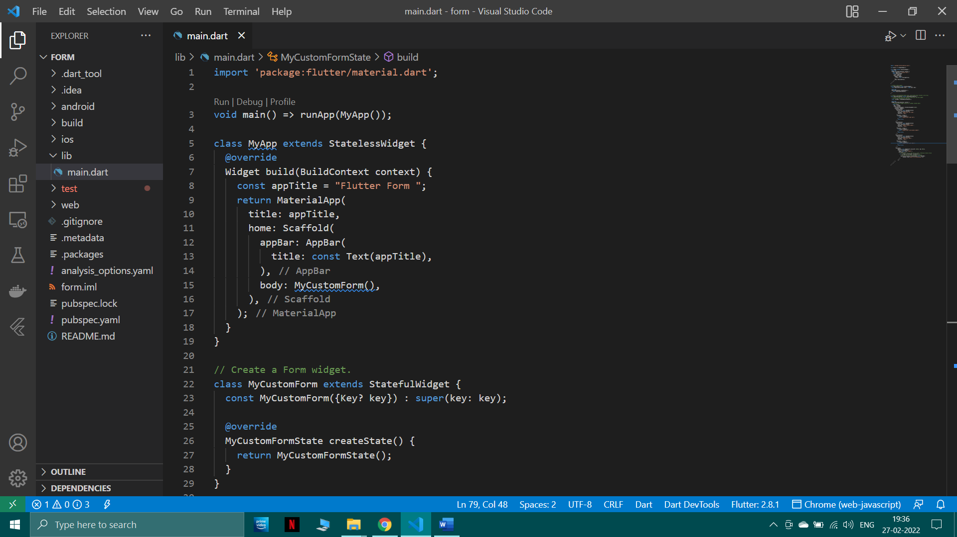

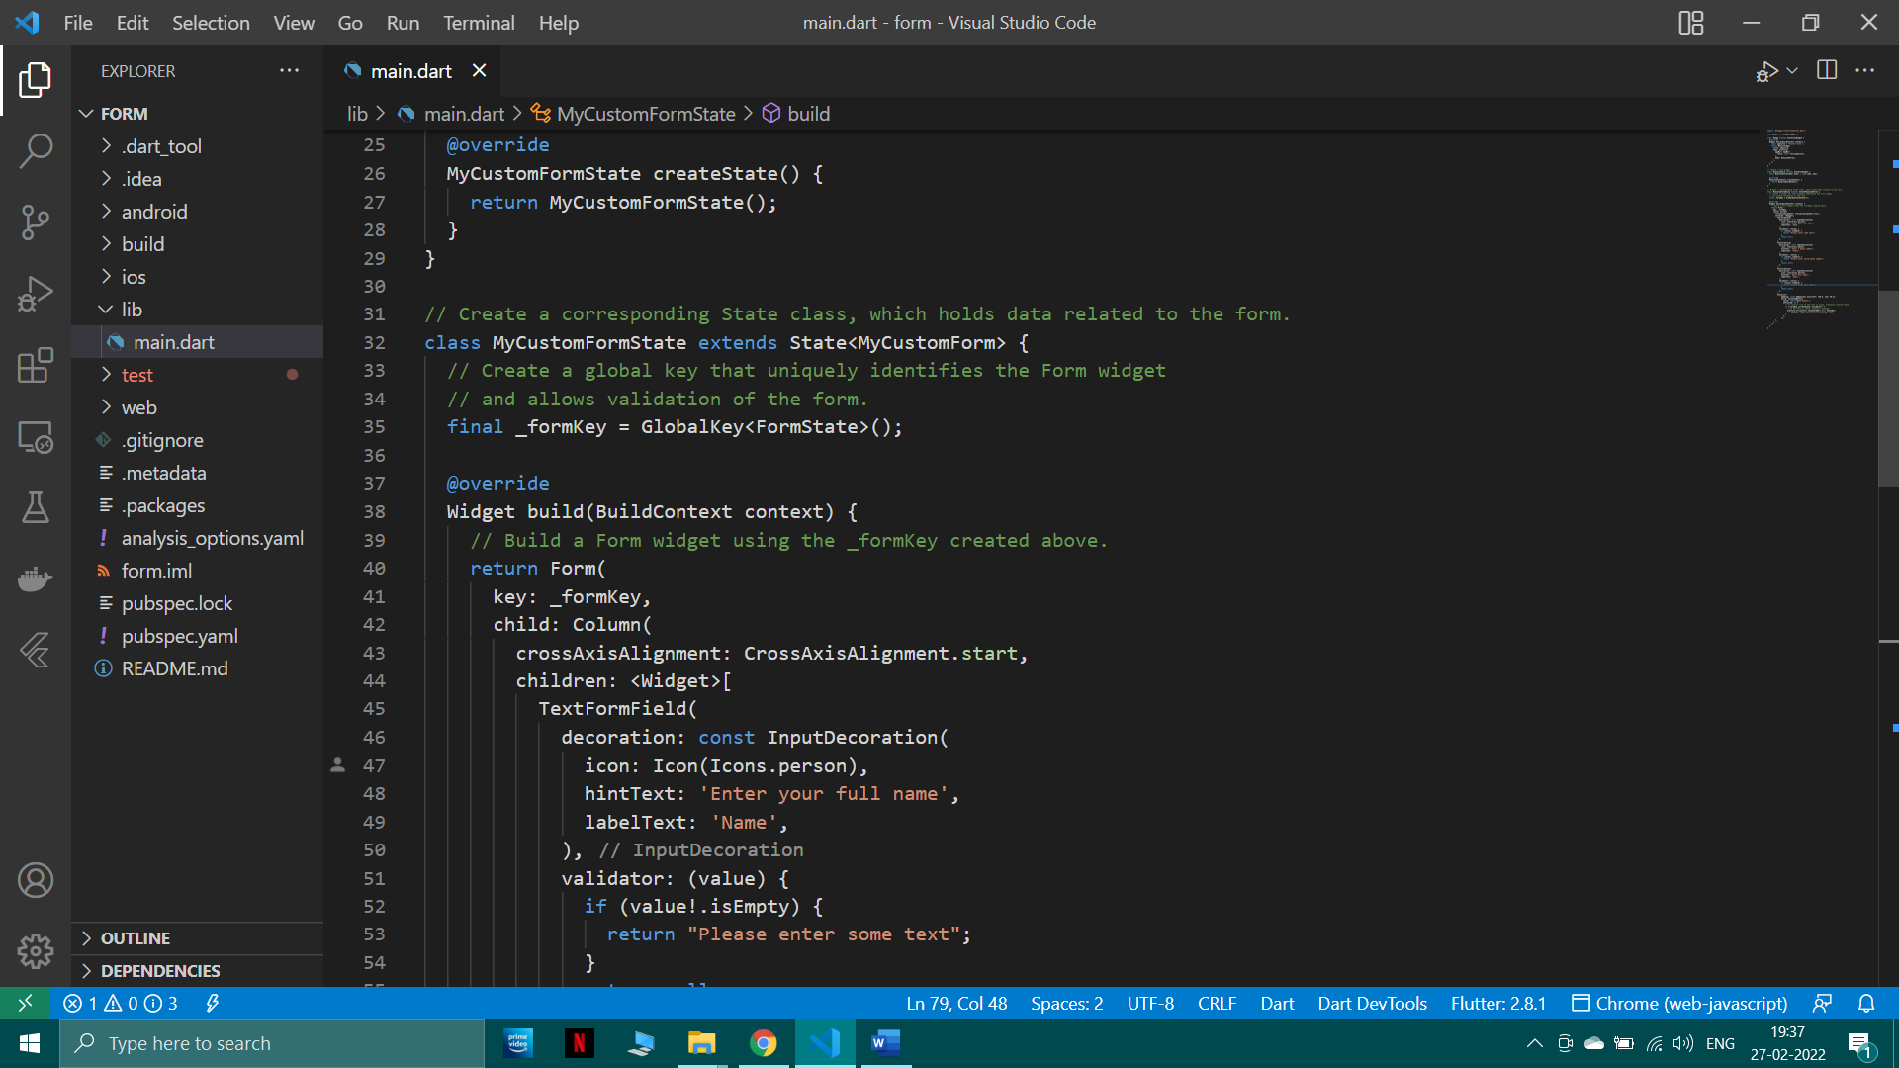

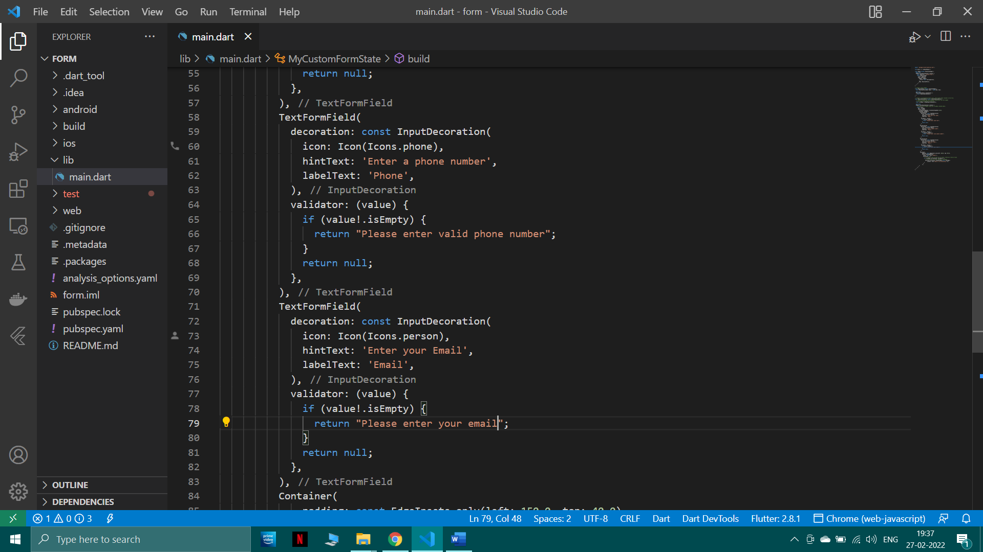

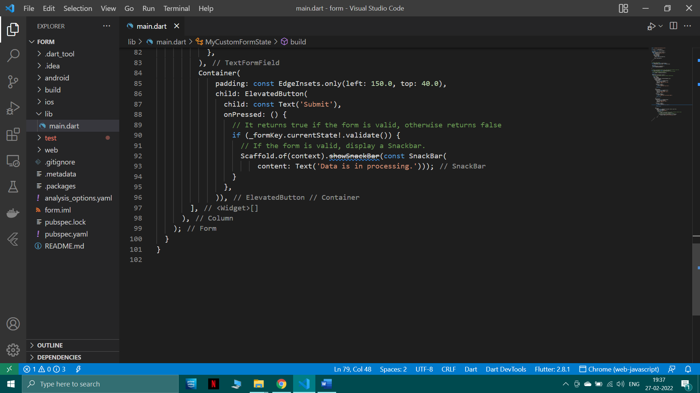

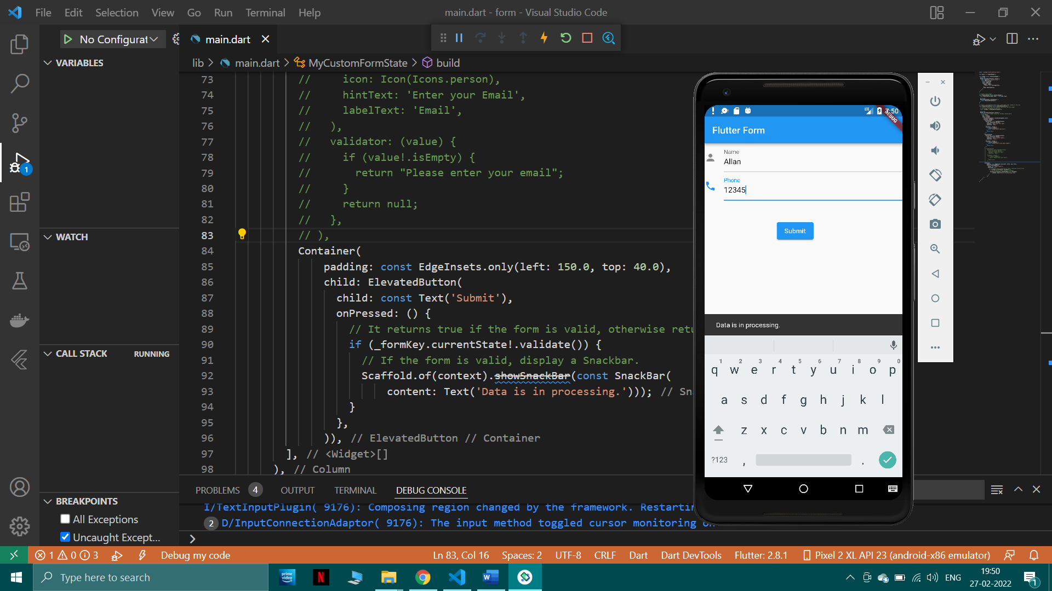

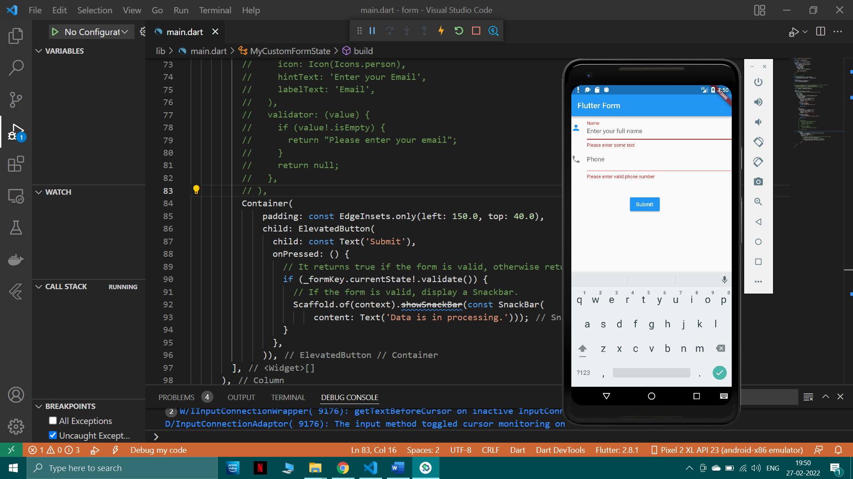

## Post-Experiments Exercise

1. **Questions:**
   1. Add one more text field along with validation, and show the output. Also validate the ‘phone number’ field to ensure that only numeric value is accepted in the

‘phone number’ field.

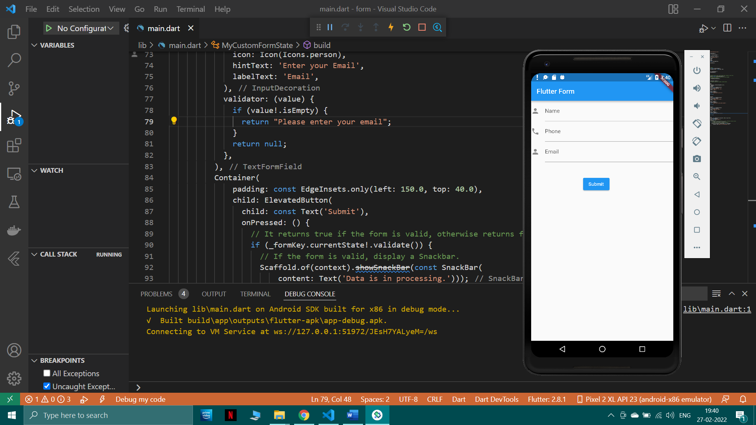

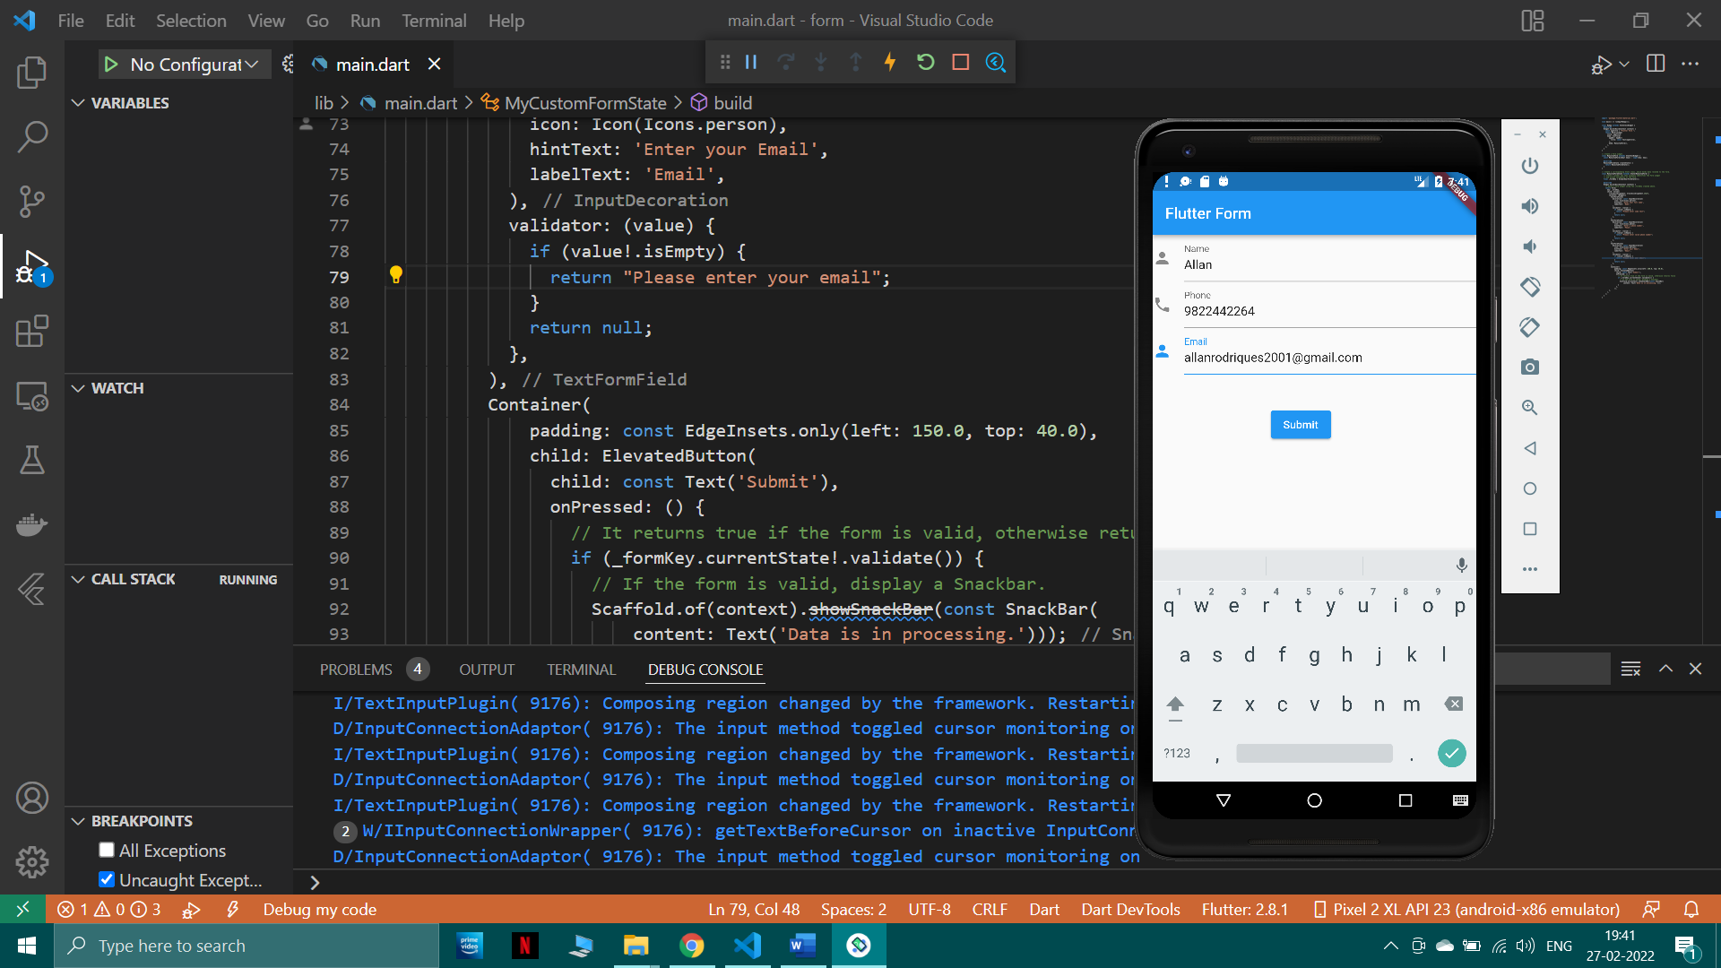

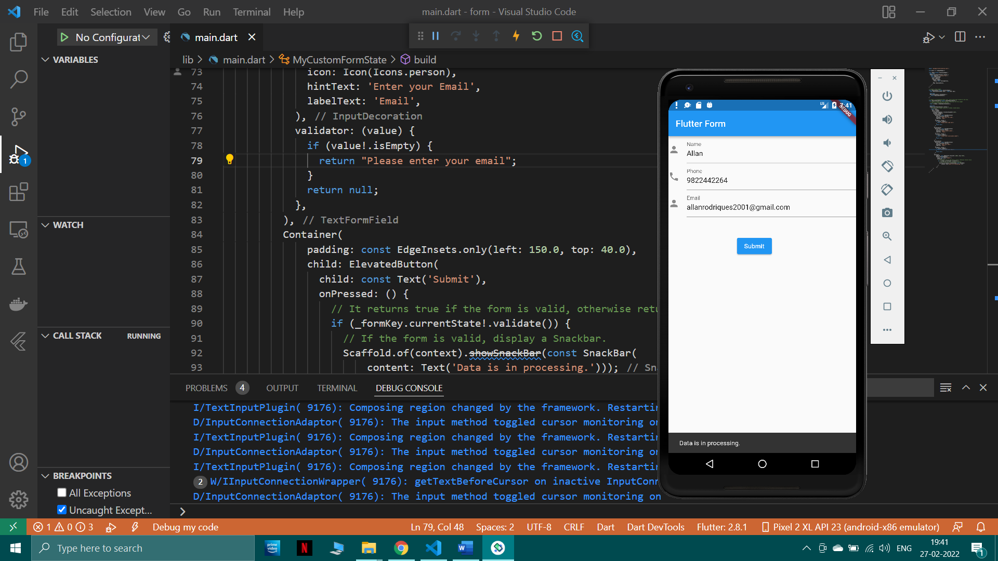

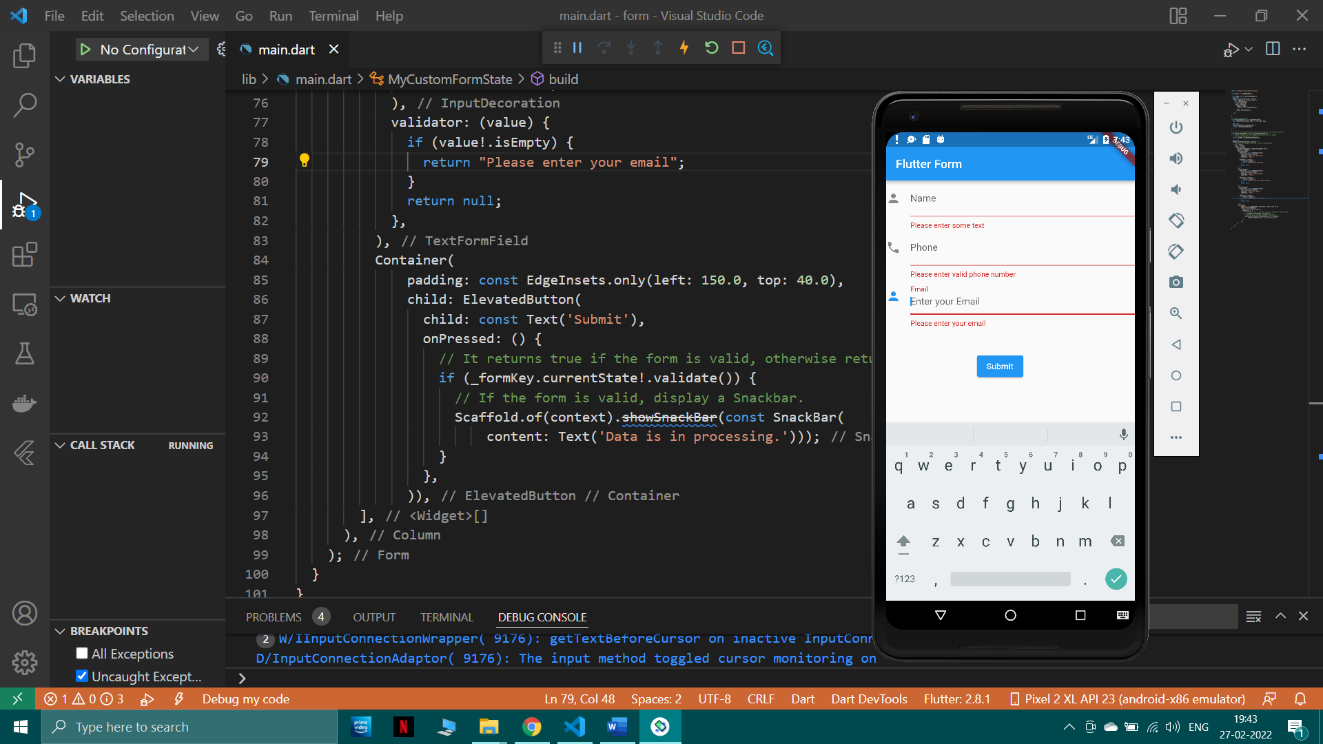

## Conclusion:

* 1. Write what you have learnt in the experiment.

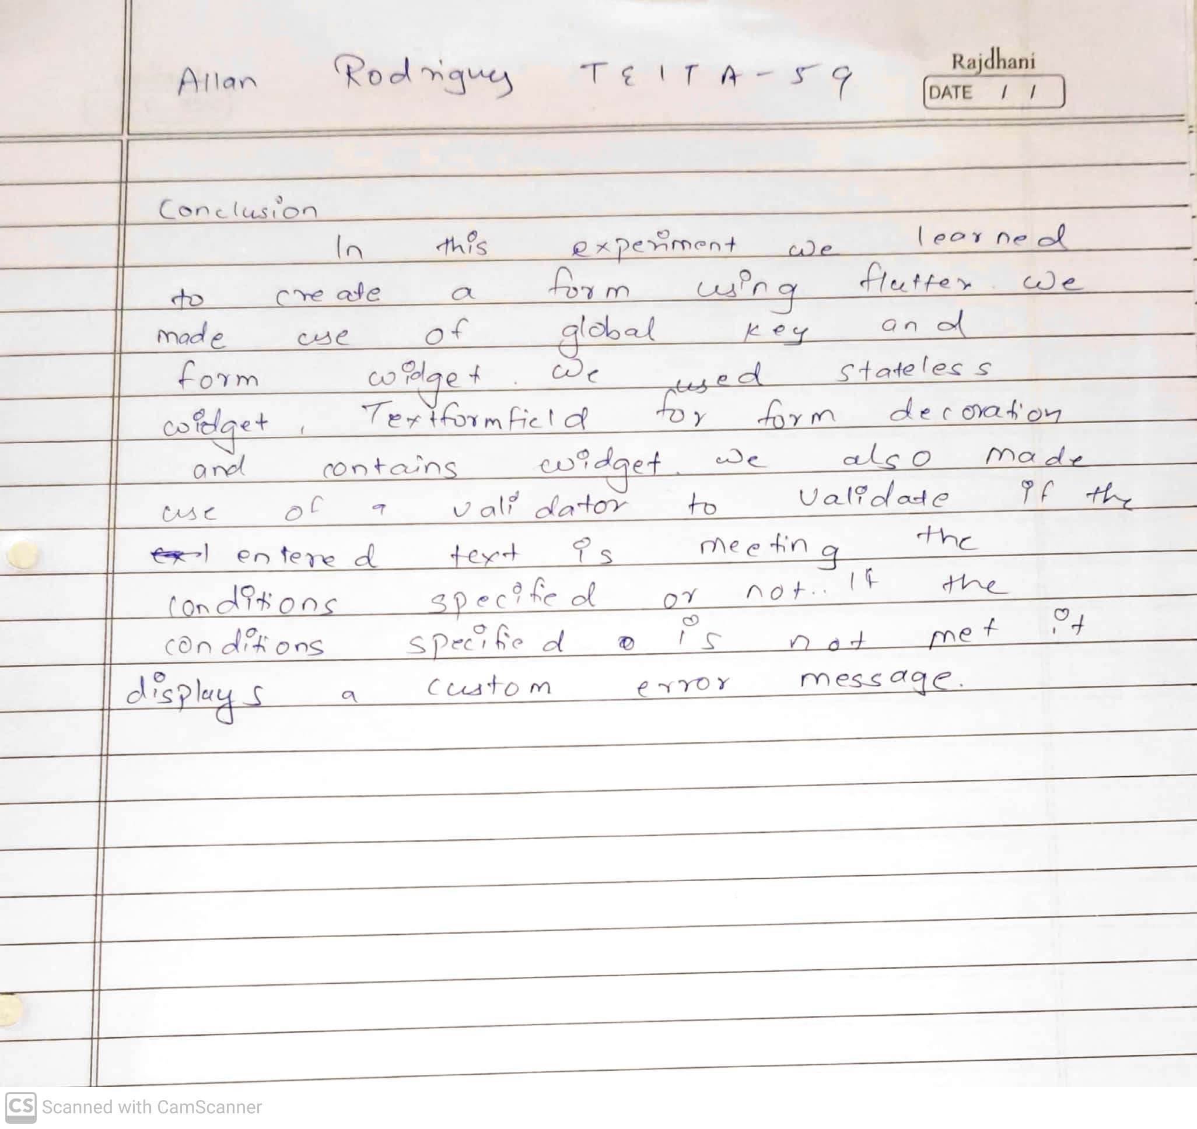

## References:

* 1. <https://api.flutter.dev/flutter/widgets/Form-class.html>
  2. <https://docs.flutter.dev/cookbook/forms/validation>