Name: Allan Rodrigues

Class: TE IT A

Roll no: 59

Pid:191104

St. Francis Institute of Technology, Mumbai-400 103

**Department of Information Technology**

A.Y. 2021-2022

Class: TE-ITA/B, Semester: VI

Subject: **M AD & PWA LAB**

# Experiment – 4: Designing the App layout for mobile Apps.

1. **Aim:** To design a layout of Flutter App using layout widgets.
2. **Objectives:** After study of this experiment, the student will be able to
   * Develop the App UI by using layout widgets.
3. **Outcomes:** After study of this experiment, the student will be able to

* Design and Develop an interactive Flutter App by using widgets. (L604.2)

1. **Prerequisite:** Dart Programming Language.
2. **Requirements:** Android Studio, Flutter framework, Internet Connection.

## Pre-Experiment Exercise: Brief Theory:

For proper UI design, we have to do 5 things.

1. Layout the entire screen (aka scene)
2. Position widgets above and below each other or side by side.
3. Handle extra space in the scene.
4. Handle situations when we run out of space and overflow the scene.
5. Make finer adjustments in positioning.

The Flutter API provides an extensive set of widgets that can be used to layout the design elements on the app screen, in the form of Layout widgets. Using the layout widgets, we can place widgets side by side or above and beneath, making them scrollable, making them wrap, determining the space around widgets so that they don’t feel crowded, and so on. The layout widgets are listed in Figure 1.

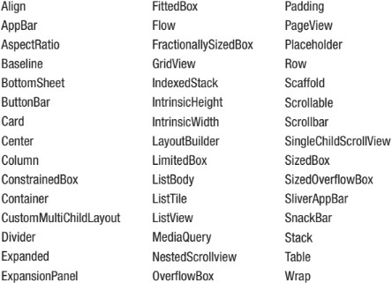

**Figure 1**. Layout widgets in Flutter

## Laboratory Exercise

1. **Program**
   1. Design the layout of the mobile app by using the following widgets.

Material App, Scaffold, Container, Row, Column, ListView, GridView, Table.

## Result/Observation

* 1. Print out of program code and output.

import 'package:flutter/material.dart';

void main() {

  runApp(MaterialApp(

    title: 'Flutter Navigation',

    theme: ThemeData(

      // This is the theme of your application.

      primarySwatch: Colors.green,

    ),

    home: FirstRoute(),

  ));

}

class FirstRoute extends StatelessWidget {

  @override

  Widget build(BuildContext context) {

    return Scaffold(

      drawer: Drawer(

        child: ListView(

          // Important: Remove any padding from the ListView.

          padding: EdgeInsets.zero,

          children: [

            const DrawerHeader(

              decoration: BoxDecoration(

                color: Colors.deepPurpleAccent,

              ),

              child: Text('Drawer Header'),

            ),

            ListTile(

              title: const Text('Go to page 2'),

              onTap: () {

                Navigator.push(

                  context,

                  MaterialPageRoute(builder: (context) => SecondRoute()),

                );

              },

            ),

            ListTile(

              title: const Text("Home,First Page"),

              onTap: () {

                Navigator.push(

                  context,

                  MaterialPageRoute(builder: (context) => FirstRoute()),

                );

              },

            ),

          ],

        ),

      ),

      appBar: AppBar(

        title: Text('First Screen'),

      ),

      body: Center(

        child: RaisedButton(

          child: Text('Tap Here'),

          color: Colors.green,

          onPressed: () {

            Navigator.push(

              context,

              MaterialPageRoute(builder: (context) => SecondRoute()),

            );

          },

        ),

      ),

    );

  }

}

class SecondRoute extends StatelessWidget {

  @override

  Widget build(BuildContext context) {

    return Scaffold(

      appBar: AppBar(

        title: Text("Second Screen"),

      ),

      body: Center(

        child: RaisedButton(

          color: Colors.green,

          onPressed: () {

            showDialog(

                context: context,

                builder: (BuildContext context) => new AlertDialog(

                      backgroundColor: Colors.lightBlueAccent,

                      actions: <Widget>[

                        new IconButton(

                            icon: new Icon(Icons.close),

                            onPressed: () {

                              Navigator.pop(context);

                            })

                      ],

                      title: new Text('Notice'),

                      content: new Text('This button is tapped '),

                    ));

            ;

          },

          child: Text('TAP here'),

        ),

      ),

    );

  }

}

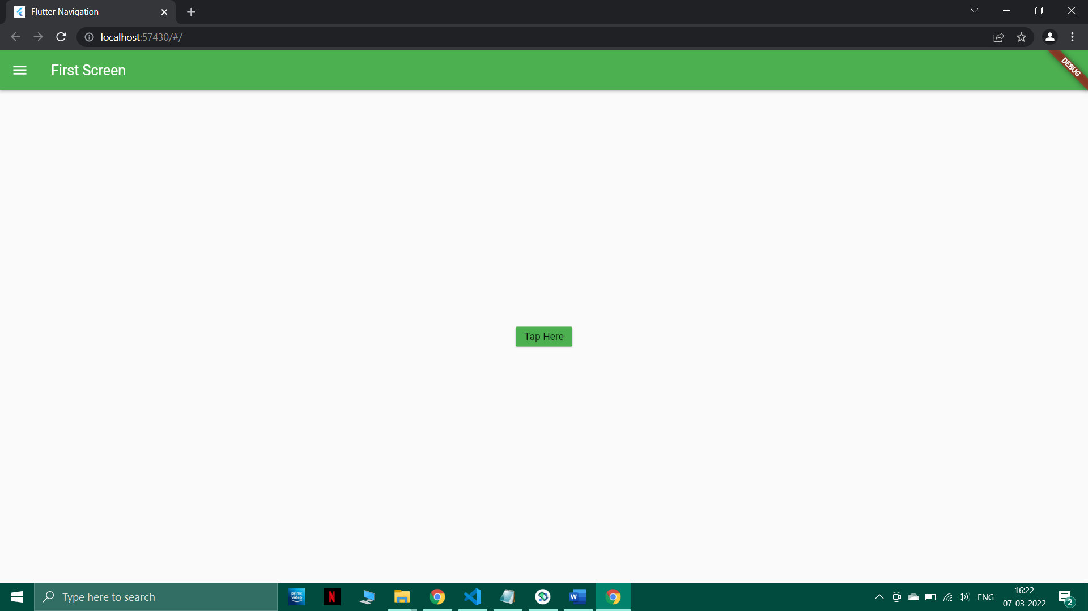

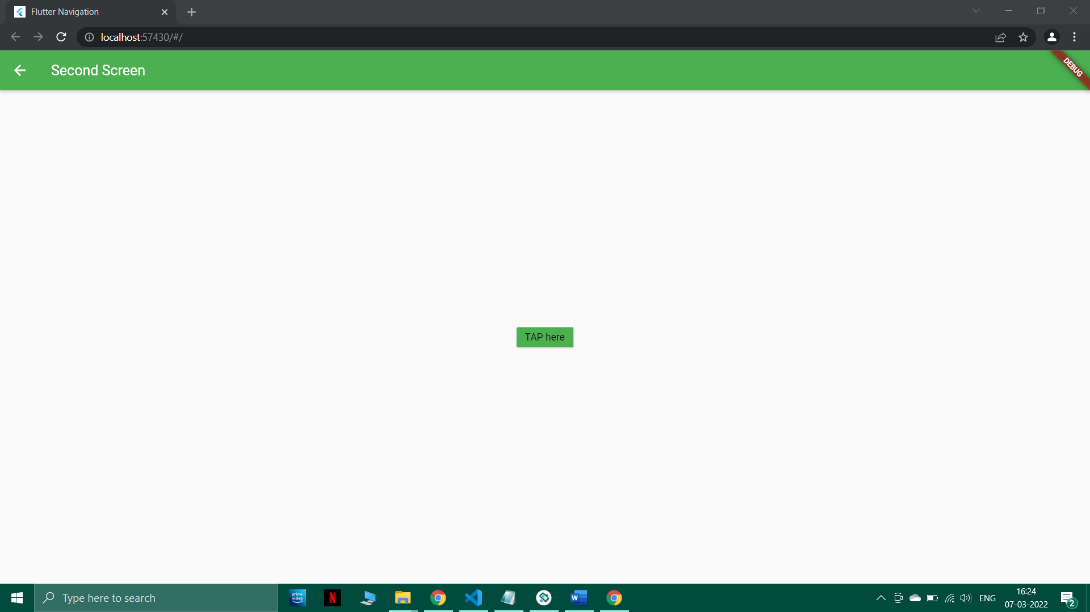

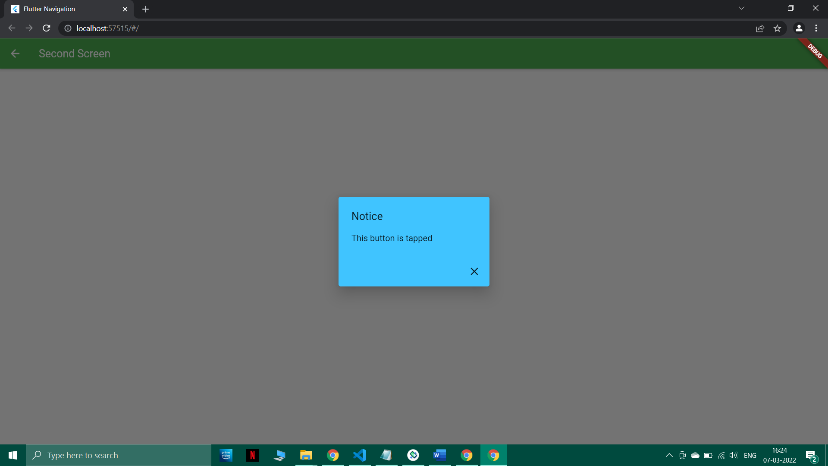

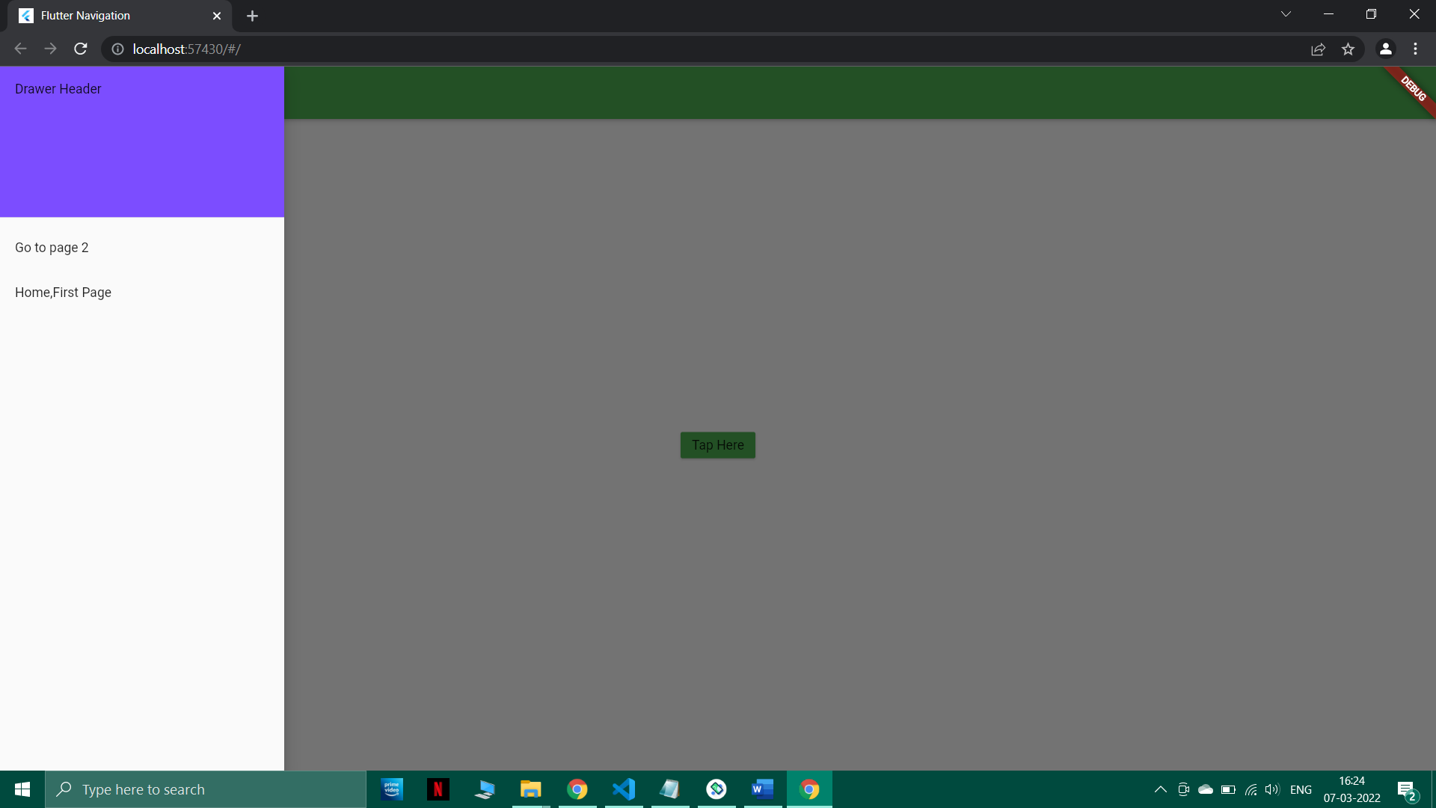

## Post-Experiments Exercise

1. **Questions:**
   1. Explain the following layout widgets. Scaffold, Container, Row, Column, Expanded, ListView, GridView, Table, Snackbar.

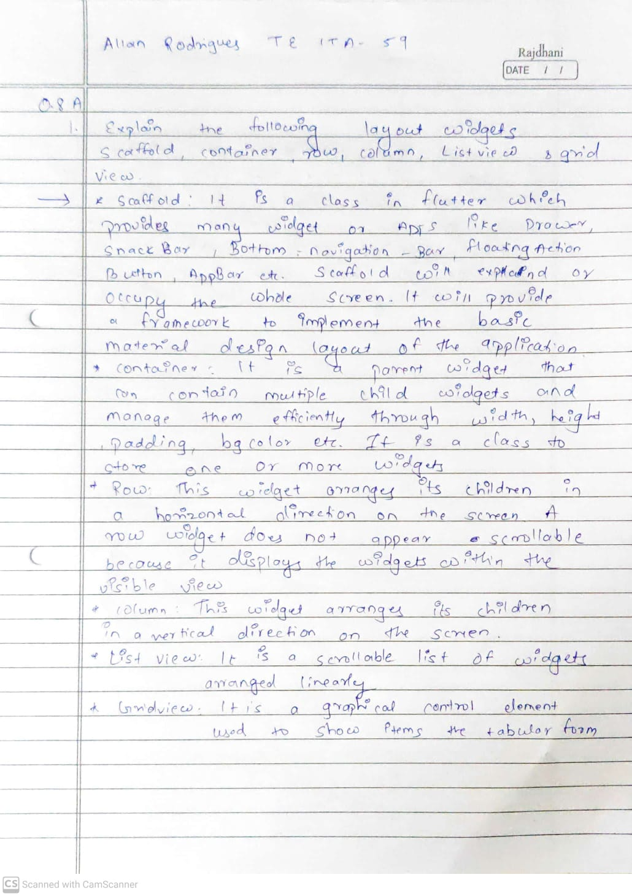

## Conclusion:

* 1. Write what you have learnt in the experiment.

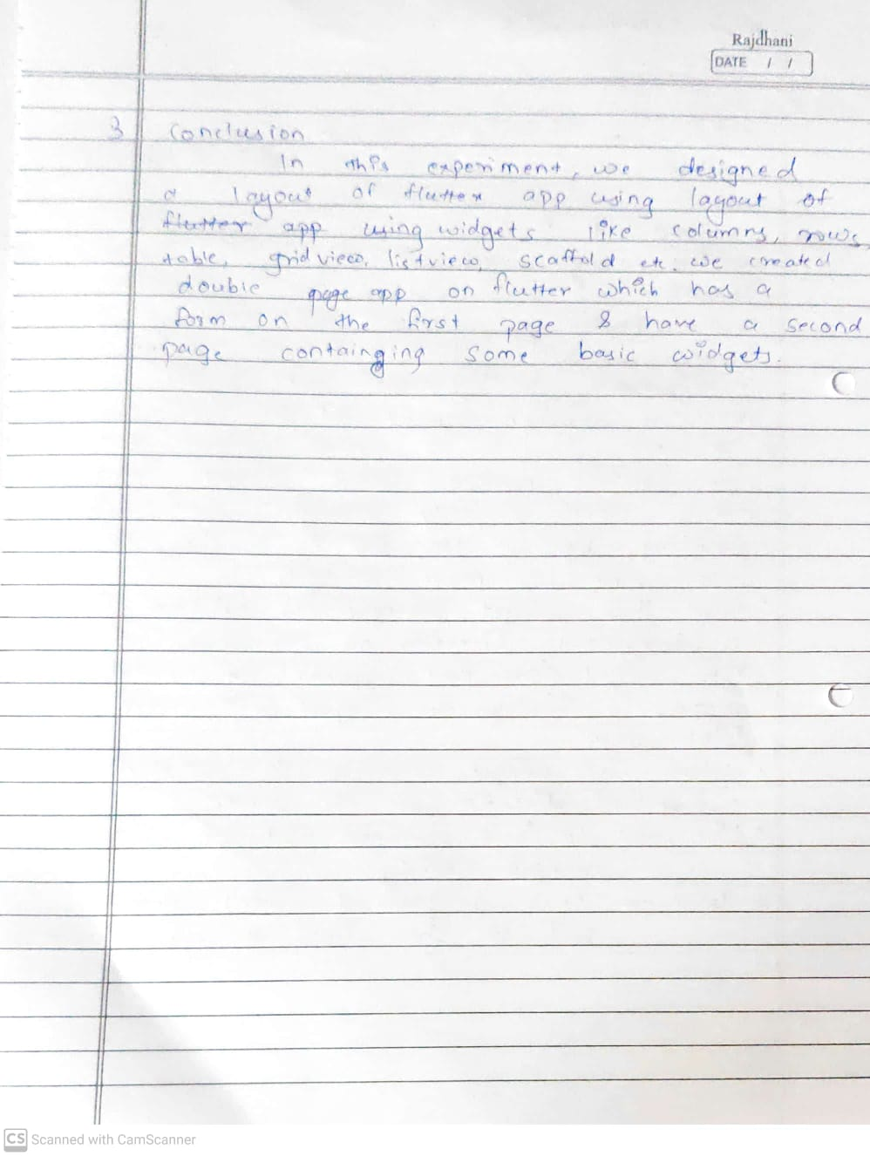

## References:

* 1. Beginning App Development with Flutter: Create Cross-Platform Mobile Apps, By Rap Payne, 2019.
  2. Google Flutter Mobile Development Quick Start Guide, Packt Publishing, 2019.