HEDGYYYBOO
Multi-Asset Quantitative Analytics Platform with
Retrieval-Augmented LLM Narrative Layer
Project Report submitted in the partial fulfilment
of
Bachelor of Technology
in
Computer Science & Engineering
by
Prathmesh Deshmukh (Roll No.: XXXXXXXX)
SAP ID: XXXXXXXXXX
Under the supervision of
Prof. [Name of Faculty Mentor]
(Designation, Department of Computer Engineering, MPSTME)
SVKM's NMIMS University
(Deemed-to-be University)
Mukesh Patel School of Technology Management & Engineering (MPSTME)
Vile Parle (W), Mumbai-56
Academic Year 2025-26

CERTIFICATE
This is to certify that the project entitled "Hedgyyyboo: Multi-Asset Quantitative Analytics Platform with Retrieval-Augmented LLM Narrative Layer" has been done by Mr. Prathmesh Deshmukh under my guidance and supervision and has been submitted in partial fulfilment of the degree of Bachelor of Technology in Computer Science & Engineering of MPSTME, SVKM's NMIMS (Deemed-to-be University), Mumbai, India during the academic year 2025-26.

________________________ ________________________
Project Mentor (Name & Signature) Examiner (Name & Signature)
(Internal Guide)
Date: ____________
Place: Mumbai
________________________
(HoD) (Name & Signature)
ACKNOWLEDGEMENT
I take this opportunity to express my deepest gratitude to all those who have directly or indirectly contributed to the successful completion of this capstone project. First and foremost, I am profoundly thankful to my project mentor Prof. [Name of Faculty Mentor], whose unwavering guidance, critical feedback, and technical insights shaped every chapter of this report and every commit in the accompanying code-base. His patience during the early, exploratory phase of the project and his rigour during the evaluation phase were equally invaluable.
I gratefully acknowledge the Department of Computer Engineering at the Mukesh Patel School of Technology Management & Engineering (MPSTME), and specifically Dr. Koteswararao Anne, Dean of MPSTME, whose stewardship of the capstone programme has created an environment that rewards intellectual curiosity and production-grade engineering alike.
I extend my thanks to the internal and external panel members who reviewed this project at each of the three formal reviews; their probing questions materially improved the rigour of the experimental evaluation reported in Chapter 4.
I am indebted to the open-source community — the developers of FastAPI, Next.js, NumPy, SciPy, scikit-learn, Recharts, and the many libraries listed in Appendix C — without whose freely-available, permissively-licensed software this project would have been economically infeasible. I thank OpenRouter for providing free-tier access to the Gemma-3n-E4B-it model, and I thank Google DeepMind for releasing the Gemma model family under an open licence.
Finally, I thank my family for their unflagging moral and material support throughout the seventeen weeks of this project.
Prathmesh Deshmukh
Roll No.: XXXXXXXX
SAP ID: XXXXXXXXXX
Student details:
Name | Roll No. | SAP ID
Prathmesh Deshmukh | XXXXXXXX | XXXXXXXXXX
ABSTRACT
Algorithmic portfolio management sits at the intersection of three disciplines — classical stochastic calculus, statistical factor models, and natural-language reasoning — yet no open, reproducible platform today couples all three on commodity hardware. Institutional desks still rely on siloed spreadsheets, closed Bloomberg terminals, and manual morning-note authoring; this creates latency, opacity, and high licensing cost that together exclude independent researchers and student practitioners.
This capstone project designs, implements, and empirically evaluates Hedgyyyboo — an open-source, multi-asset quantitative analytics platform that unifies (i) pricing engines drawn from stochastic calculus (Ornstein–Uhlenbeck, Hull–White, Heston, Neural-SDE), (ii) factor-model dimensionality reduction applied to the United States Treasury yield curve (Principal Component Analysis, PCA), (iii) heteroskedastic tail-risk attribution (GARCH(1,1) with Value-at-Risk / Expected-Shortfall), and (iv) a retrieval-augmented Large Language Model (RAG-LLM) narrative layer backed by Google's Gemma-3n-E4B-it served free-of-charge through OpenRouter.
The back-end is a FastAPI micro-service exposing fifty-three REST endpoints organised across six phases; the front-end is a Next.js 16 single-page application rendering three desks — a Main dashboard, a Fixed-Income desk, and an FX-Macro desk. A SQLite-backed trade ledger, an APScheduler morning-brief cron at 08:00 IST, and a server-side LLM cache complete the stack. The project was benchmarked on two years of daily data across 28 G10+EM currency pairs, the 11-tenor U.S. Treasury curve, and fifty S&P 500 constituents.
Empirically, PCA captures 98.7% of yield-curve variance in three factors (Level, Slope, Curvature); the Ornstein–Uhlenbeck Maximum Likelihood Estimator produces half-life estimates within ±1.4 days of bootstrap ground truth; a simple OU mean-reversion strategy on the five most mean-reverting G10 crosses achieves a back-tested Sharpe ratio of 1.38 gross of transaction cost; GARCH(1,1) passes Kupiec's unconditional-coverage test for 47 of 50 tickers (94%); and the RAG pipeline produces a complete morning macro brief in 7.2 ± 1.1 seconds at zero marginal cost on the Gemma-3n free tier. An undocumented quirk of Gemma-3n — its rejection of system-role messages — was diagnosed and worked around by merging the system prompt into the user turn.
The salient contribution is therefore twofold. First, Hedgyyyboo proves that a single commodity laptop can host a research-grade multi-asset desk whose factual grounding approaches 95% on manually-audited morning briefs. Second, the open-source code base (FastAPI + Next.js + Python + TypeScript) is released under a permissive licence and serves as a reference implementation for subsequent capstone cohorts.
Table of Contents
Topic Page No.
Certificate ii
Acknowledgement iii
Abstract iv
Table of Contents v
List of Figures ix
List of Tables x
Abbreviations xi
Chapter 1 — Introduction 1
1.1 Background of the Project Topic 1
1.2 Motivation and Scope of the Report 2
1.3 Problem Statement 3
1.4 Salient Contribution 4
1.5 Organisation of the Report 5
1.6 Summary 6
Chapter 2 — Literature Survey 7
2.1 Introduction to the Overall Topic 7
2.2 Stochastic Calculus Pricing Models 9
2.3 Factor Models and Yield-Curve Dimensionality Reduction 11
2.4 Volatility and Tail-Risk Models 12
2.5 Neural Stochastic Differential Equations 14
2.6 LLMs in Finance and RAG 15
2.7 Research Gap and Problem Formulation 17
2.8 Summary 18
Chapter 3 — Methodology and Implementation 19
3.1 Block Diagram of the System 19
3.2 Hardware and Software Description 20
3.3 Software Description, Flowchart and Algorithms 22
3.3.1 Ornstein–Uhlenbeck MLE 23
3.3.2 Hurst Exponent 24
3.3.3 GARCH(1,1) 24
3.3.4 PCA of the Yield Curve 25
3.3.5 Hull–White Swaption 26
3.3.6 Heston Monte-Carlo 27
3.3.7 Neural SDE 27
3.3.8 LLM Integration Layer 28
3.4 Use-Case Diagram 29
3.5 Development Timeline 30
3.6 Summary 31
Chapter 4 — Results and Analysis 32
4.1 PCA Yield-Curve Decomposition 32
4.2 OU Mean-Reversion Diagnostics 34
4.3 Back-Test 35
4.4 GARCH Kupiec Coverage 36
4.5 LLM Latency and Hallucination Audit 37
4.6 UI Performance 38
4.7 IEEE Standards Compliance 39
4.8 Summary 40
Chapter 5 — Advantages, Limitations and Applications 41
5.1 Advantages 41
5.2 Limitations 42
5.3 Applications 44
5.4 Summary 46
Chapter 6 — Conclusion and Future Scope 47
6.1 Summary of Work Carried Out 47
6.2 Conclusions 48
6.3 Future Scope 49
6.4 Summary 50
References 51
Appendix A — Source Code 54
Appendix B — Sample API Payloads 56
Appendix C — Component List 57
Appendix D — List of Papers Presented and Published 59
List of Figures
Fig. No. | Name of the Figure | Page No.
3.1 | Hedgyyyboo three-tier block diagram | 19
3.2 | Data-flow architecture | 22
3.3 | GARCH(1,1) conditional volatility forecast | 24
3.4 | Use-case diagram | 29
3.5 | Gantt chart — project development timeline | 30
4.1 | PCA scree plot of U.S. Treasury yield changes | 32
4.2 | PC1–PC3 eigenvector loadings vs tenor | 33
4.3 | OU strategy cumulative return vs carry benchmark | 35
4.4 | End-to-end morning-brief LLM latency | 37
4.5 | Main dashboard screenshot | 38
List of Tables
Table No. | Name of the Table | Page No.
4.1 | OU MLE parameters on top-5 G10 crosses | 34
C.1 | Component and library inventory | 57
Abbreviations
Sr. No. | Abbreviation | Expansion
1 | API | Application Programming Interface
2 | AR | Autoregressive
3 | BIS | Bank for International Settlements
4 | CFTC | Commodity Futures Trading Commission
5 | COT | Commitments of Traders
6 | EDGAR | Electronic Data Gathering, Analysis, and Retrieval
7 | ES | Expected Shortfall
8 | FX | Foreign Exchange
9 | GARCH | Generalised Autoregressive Conditional Heteroskedasticity
10 | GDELT | Global Database of Events, Language, and Tone
11 | HTTP | Hypertext Transfer Protocol
12 | IEEE | Institute of Electrical and Electronics Engineers
13 | JSON | JavaScript Object Notation
14 | LLM | Large Language Model
15 | MLE | Maximum Likelihood Estimation
16 | OU | Ornstein–Uhlenbeck
17 | PCA | Principal Component Analysis
18 | PDE | Partial Differential Equation
19 | PM | Portfolio Manager
20 | RAG | Retrieval-Augmented Generation
21 | REER | Real Effective Exchange Rate
22 | REST | Representational State Transfer
23 | RPM | Requests per Minute
24 | RSI | Relative Strength Index
25 | RSS | Really Simple Syndication
26 | SDE | Stochastic Differential Equation
27 | SEC | Securities and Exchange Commission
28 | SQL | Structured Query Language
29 | UST | United States Treasury
30 | VaR | Value-at-Risk

Chapter 1
Introduction
This chapter introduces the Hedgyyyboo capstone project, motivates the need for an open, reproducible multi-asset analytics platform, states the problem tackled, lists the salient contributions, and sets out the organisation of the remaining chapters.
1.1 Background of the Project Topic
The global financial services industry increasingly consumes three heterogeneous data modalities on every trading day. First, structured market tensors — live price ticks, realised volatility surfaces, implied-volatility cubes, and tenor-by-tenor zero-coupon yield curves — arrive over low-latency feeds. Second, unstructured content — news wires, earnings transcripts, and regulatory filings from the U.S. Securities and Exchange Commission (SEC EDGAR) — is published in natural language. Third, house-level quantitative research produces proprietary factor exposures, backtested strategy signals, and risk attributions that must be explained to portfolio managers (PMs) in plain English every morning.
Historically, bridging these three modalities has required a team of quantitative researchers, systematic strategists, and sell-side sales-traders. The dominant turnkey platform — Bloomberg Terminal — charges upwards of twenty-four thousand US dollars per seat per year, placing institutional-grade analytics beyond the reach of independent quants, student researchers, and small hedge funds. The 2022–2025 emergence of instruction-tuned Large Language Models (LLMs) — notably BloombergGPT, FinGPT, and the open-weight Gemma family from Google DeepMind — has opened the door to low-cost narrative generation, but significant engineering gaps remain: numerical grounding, rate-limit management, and the seamless fusion of classical stochastic models with modern neural inference.
Hedgyyyboo was conceived against this backdrop. The project asks: can a single developer on a commodity laptop, using only open-source Python / TypeScript stacks and free-tier inference APIs, deliver a research-grade multi-asset desk whose output is both quantitatively sound and linguistically fluent?
1.2 Motivation and Scope of the Report
The motivation behind Hedgyyyboo is both academic and practical.
Academically, the project consolidates the knowledge base acquired across earlier courses in probability theory, numerical methods, financial engineering, web development, and artificial intelligence. It offers a single, end-to-end artefact in which each subject's learning outcome is exercised: probability → Ornstein–Uhlenbeck maximum-likelihood estimation; linear algebra → Principal Component Analysis of the yield covariance; stochastic calculus → Itô–Doeblin differentiation of the Hull–White bond price; software engineering → FastAPI REST design; front-end engineering → React composition and state management; deep learning → Neural Stochastic Differential Equations; and natural-language processing → retrieval-augmented prompt construction.
Practically, the motivation is to democratise institutional tooling. By coupling free public data (U.S. Treasury Daily Yield Curve, Yahoo Finance, Google News RSS, CFTC Commitments-of-Traders, BIS REER, GDELT) with a free-tier LLM inference backend, the platform removes all paywall-based barriers to entry. This matters for the next generation of students who will enter buy-side and sell-side roles without Bloomberg login credentials.
The scope of this report covers the complete software lifecycle: literature review (Chapter 2), architectural design and mathematical formalism (Chapter 3), empirical results and back-tests (Chapter 4), application analysis including advantages, limitations and deployment scenarios (Chapter 5), and conclusions with future-work recommendations (Chapter 6). The source code and evaluation artefacts accompany the report in Appendices A–D.
1.3 Problem Statement
The literature gap, distilled from a survey of thirty-seven peer-reviewed references (see Chapter 2), reduces to the following compact statement:
There is no publicly-available, open-source, multi-asset analytics framework that (a) integrates at least five classical stochastic-calculus pricing engines, (b) feeds their numerical outputs into a retrieval-augmented large-language-model pipeline, (c) observes free-tier inference rate limits while still producing human-readable narrative briefs, and (d) exposes the entire stack through a modern single-page web application that runs on commodity hardware.
Sub-problems that flow from the primary statement include: designing a JSON contract between numerical modules and the RAG prompt builder; handling Google Gemma-3n's undocumented rejection of system-role messages; rate-limiting LLM calls across a user-driven web UI without throttling; and validating the statistical properties (VaR coverage, half-life accuracy, factor-variance share) of the output so the PM can trust the platform.
1.4 Salient Contribution
This project advances the state of the art along four measurable axes.
C1. Reference architecture. A reproducible three-tier architecture (Ingestion → Numeric Core → LLM Core → Presentation) that couples seven classical stochastic models with a free-tier RAG layer. The architecture is described in Chapter 3.
C2. Closed-form derivations and validated estimators. Seven canonical finance models (Ornstein–Uhlenbeck, Hurst R/S, GARCH(1,1), PCA, Hull–White, Heston, Neural-SDE) implemented from first principles in pure NumPy / SciPy without proprietary solvers, each accompanied by an independent validation harness.
C3. Empirical evaluation. Two years of daily data benchmarking gives factor variance 98.7%, half-life error < 1.4 days, GARCH Kupiec coverage 94%, and Sharpe ratio 1.38 on a minimal mean-reversion strategy.
C4. Engineering lessons. Three non-obvious engineering findings: (a) Gemma-3n requires system-prompt merging into the user turn; (b) caching the morning brief server-side avoids rate-limit storms; (c) a strict "overflow-hidden" CSS containment pattern in grid cells eliminates canvas-overflow bugs in Recharts/D3 embeds.
1.5 Organisation of the Report
The remainder of the report is organised as follows.
Chapter 2 (Literature Survey) conducts an exhaustive review of 37 peer-reviewed references across five thematic axes: stochastic models, factor models, volatility modelling, neural SDEs, and LLMs in finance. It ends by formalising the research gap that motivates Hedgyyyboo.
Chapter 3 (Methodology and Implementation) presents the architectural block diagram, hardware/software specifications, and a model-by-model description of every numerical engine, each supplemented with its defining differential equation or optimisation objective.
Chapter 4 (Results and Analysis) reports empirical findings: PCA scree decomposition, OU half-life diagnostics, GARCH back-tests, Hull–White calibration RMSE, and LLM latency distributions.
Chapter 5 (Advantages, Limitations and Applications) discusses where Hedgyyyboo excels, where it falls short, and a catalogue of applied deployment scenarios spanning pedagogy, risk management, and retail trading.
Chapter 6 (Conclusion and Future Scope) summarises the work, distills actionable lessons, and proposes concrete future-work items including a Cheyette two-factor rates model, walk-forward backtesting, and LLM-as-judge factual grounding.
References, Appendices (A: Source-code excerpts and flowcharts, B: Sample API payloads, C: Hardware/software component list, D: Publication list) close the report.
1.6 Summary
In summary, this chapter established that Hedgyyyboo tackles an open problem at the intersection of stochastic calculus, factor modelling, and retrieval-augmented generation, delivering a reproducible reference implementation on commodity hardware with four measurable contributions.
Chapter 2
Literature Survey
This chapter conducts an exhaustive literature survey of thirty-seven peer-reviewed references. Section 2.1 sets out the broad academic context. Section 2.2 discusses stochastic-calculus pricing models. Section 2.3 reviews yield-curve factor models. Section 2.4 covers volatility and tail-risk models. Section 2.5 surveys neural stochastic differential equations. Section 2.6 examines large-language-model applications in finance and retrieval-augmented generation. The chapter concludes by distilling the research gap that motivates the Hedgyyyboo platform.
2.1 Introduction to the Overall Topic
Quantitative finance, as a discipline, traces its modern origin to the Black–Scholes–Merton option-pricing formula [1] of 1973, a closed-form solution to a parabolic partial differential equation that emerged from Itô's stochastic calculus. Since then, the field has bifurcated repeatedly. Risk-neutral pricing introduced the martingale measure. Heston [2] coupled the underlying diffusion with a mean-reverting variance process. Hull and White [3] extended Vasicek [4] from constant to deterministic mean-reversion level for rates modelling. Along a parallel axis, Engle [15] and Bollerslev [16] introduced conditionally-heteroskedastic time-series models that today underpin virtually every risk-management VaR / Expected-Shortfall engine.
Concurrently, the empirical literature established that high-dimensional term-structure dynamics are low-rank. Litterman and Scheinkman [11] demonstrated that three principal components explain ninety-eight per cent of U.S. Treasury return variance — a finding replicated across every sovereign curve and now a staple of fixed-income desks. Mandelbrot and van Ness [19] and Hurst [20] quantified long-range dependence through the Hurst exponent, widely used in statistical arbitrage.
The 2010s brought deep learning to finance. Neural Ordinary Differential Equations of Chen et al. [22] and Neural Stochastic Differential Equations of Kidger et al. [21] offer continuous-time generative models that can be fit to financial time-series with gradient-based optimisation. The 2022–2025 period then added a natural-language reasoning layer: BloombergGPT [28], FinGPT [27], and FinBERT [26] demonstrated that domain-specific transformer encoders and decoders can materially outperform general-purpose models on FiQA sentiment and financial QA benchmarks.
Retrieval-Augmented Generation, formalised by Lewis et al. [24] and surveyed by Gao et al. [25], complements LLMs by grounding their outputs in an external corpus. Recent work applies RAG to static document bases but seldom to live numeric feeds — which is precisely the gap Hedgyyyboo fills.
The literature surveyed in the remainder of this chapter comprises a mix of seminal papers (Black–Scholes 1973, Heston 1993, Engle 1982), recent state-of-the-art (Kidger 2021, Lewis 2020, Yang 2023), and engineering references (OpenRouter documentation, Gemma 3 technical report). A total of thirty-seven references were consulted and cited in this report.
2.2 Stochastic Calculus Pricing Models
The Black–Scholes equation [1] describes the fair price of a European option on a geometric-Brownian-motion underlying. Its closed-form solution is expressed in terms of the standard-normal cumulative distribution function. Practically, however, the constant-volatility assumption fails: market-implied volatilities exhibit both smile (moneyness) and term-structure skew. Heston [2] resolved this by introducing a correlated Cox–Ingersoll–Ross variance process, yielding semi-closed-form prices via the characteristic function. Gatheral [8] documents calibration practice and presents numerical pitfalls in the characteristic-function inverse Fourier transform.
For interest-rate derivatives, Vasicek [4] introduced a Gaussian mean-reverting short-rate model. The drift is affine in the current rate, leading to an analytic bond price through the affine-term-structure framework. Hull and White [3] added a deterministic time-dependent drift θ(t) so that the model can exactly match the initial discount curve — a practical necessity for sell-side pricing of Bermudan swaptions. Jamshidian [9] showed that a European swaption under a one-factor affine model can be decomposed into a strip of zero-coupon-bond options, each priced in closed form. This result is used by the Hull–White swaption pricer in Hedgyyyboo.
Mean-reverting stochastic processes are likewise central to statistical-arbitrage FX pairs trading. Vidyamurthy [6] provides a practitioner-oriented treatment; Aït-Sahalia [7] derives a closed-form approximation of the likelihood of a discretely-sampled Ornstein–Uhlenbeck diffusion [5], yielding a tractable maximum-likelihood estimator — the estimator implemented in the Hedgyyyboo FX desk.
For Monte-Carlo pricing of path-dependent or multi-asset equity derivatives, Andersen [10] developed a quadratic-exponential scheme for the Heston model that is robust against violation of the Feller condition. This scheme is used in Hedgyyyboo's equity-option engine.
Collectively, these works form the backbone of the numerical sub-core of Hedgyyyboo.
2.3 Factor Models and Yield-Curve Dimensionality Reduction
Litterman and Scheinkman [11] seminal paper showed that three PCA factors — subsequently labelled Level, Slope, and Curvature — explain approximately 98% of U.S. Treasury return variance. Their finding has since been replicated across every developed-market sovereign curve. The advantage of PCA over parametric alternatives is interpretability combined with parsimony.
Nelson and Siegel [12] proposed a parametric three-factor curve with level, slope, and curvature loadings given by smooth exponential functions. Svensson [13] extended the model with a second hump term. Diebold and Li [14] showed that dynamic Nelson–Siegel with AR(1) factor dynamics out-of-sample forecasts term-structure movements. Parametric models are attractive for their smooth shape constraints but require non-convex optimisation at each fitting step, which is burdensome in a cron-driven daily workflow.
Hedgyyyboo therefore prefers PCA for its speed (a single eigendecomposition at the 08:00 IST cron) and for the ease of feeding numerical scores z_t = φ_k^⊤ y_t into the LLM prompt. Parametric extensions are a natural direction for future work.
2.4 Volatility and Tail-Risk Models
Engle's ARCH(q) model [15] and its GARCH(p,q) generalisation by Bollerslev [16] parameterise conditional variance as a linear function of lagged squared innovations and lagged variances. The GARCH(1,1) specialisation is the default in industrial risk-management pipelines because of its parsimony (three parameters: ω, α, β) and its empirical persistence pattern that matches observed volatility clustering.
Bollerslev [17] extended the error distribution from normal to Student-t to capture the fat tails evident in equity-return histograms. McNeil, Frey, and Embrechts [18] provide the canonical treatment of Value-at-Risk (VaR) and Expected-Shortfall (ES), including the closed-form parametric quantile transforms implemented in Hedgyyyboo.
Mandelbrot and van Ness [19] introduced fractional Brownian motion and the Hurst exponent H, which measures long-range dependence. Hurst [20] earlier proposed the rescaled-range estimator for H. In financial time series, H < 0.5 denotes anti-persistence (mean reversion), H = 0.5 a random walk, and H > 0.5 momentum. The Hurst exponent is a key statistical-arbitrage diagnostic and is reported on every FX cross in the Hedgyyyboo FX desk.
Kupiec [34] developed the unconditional-coverage likelihood-ratio test used in this report to validate the empirical coverage of the GARCH-based VaR estimates.
2.5 Neural Stochastic Differential Equations
Chen et al. [22] introduced Neural Ordinary Differential Equations (Neural ODEs), in which the derivative of the hidden state is parameterised by a neural network trained with the adjoint-sensitivity method for memory-efficient back-propagation. Tzen and Raginsky [23] provided theoretical foundations linking score-based generative modelling to diffusion bridges.
Kidger et al. [21] generalised this to Neural Stochastic Differential Equations (Neural SDEs), in which both drift and diffusion are neural networks. Neural SDEs form an infinite-dimensional generative-adversarial network over paths, permitting generative fitting to financial time-series with richer distributional properties than GARCH.
In Hedgyyyboo the Neural SDE module serves as a deterministic ("LLM-free") sanity check: it returns a drift-diffusion forecast that is compared against the LLM's directional call before a trade is executed. In this sense, the Neural SDE acts as a prior against which the probabilistic language model is grounded.
2.6 Large Language Models in Finance and Retrieval-Augmented Generation
Domain-specific transformer models for finance have become a crowded field. FinBERT by Araci [26] fine-tunes BERT on financial news for sentiment classification. Yang et al. [27] introduced FinGPT, an open-source family of LLMs targeting financial QA. Wu et al. [28] published BloombergGPT, a fifty-billion-parameter closed-weight decoder achieving state-of-the-art on FiQA; its weights are, however, proprietary.
Open-weight alternatives have proliferated. Gemma-3 from Google DeepMind [29] is released under a permissive licence and includes a four-billion-parameter instruction-tuned variant (Gemma-3n-E4B-it) that fits comfortably in consumer GPU memory. OpenRouter offers free-tier hosted inference for Gemma-3n at twenty requests-per-minute throughput, making it the natural candidate for a zero-budget RAG stack.
Retrieval-Augmented Generation, introduced by Lewis et al. [24] and surveyed by Gao et al. [25], grounds LLM output in an external context retrieved at query time. Prior RAG applications in finance tend to target static document bases (10-K filings, earnings transcripts). Hedgyyyboo differs: the retrieved context is a live, continually refreshed computation graph of seven numerical outputs plus top-five headlines, assembled at every 08:00 IST cron and at every user-triggered refresh.
Hallucination in LLM outputs has been extensively documented [30]. Zheng et al. [32] introduced the LLM-as-judge paradigm, in which a second, typically stronger model evaluates the factual grounding of a first model's output. This is a natural extension direction for future Hedgyyyboo releases. Chen et al. [33] published the FinQA dataset, a numerical-reasoning benchmark for financial question answering.
On the numerical-grounding question, the central finding of the Hedgyyyboo project — that Gemma-3n-E4B-it on the free tier rejects system-role messages and must instead receive a merged user turn — is undocumented in the Gemma-3 technical report [29] and thus constitutes a minor but practically important contribution.
The final piece of prior art concerns data sources. Hedgyyyboo ingests from the SEC EDGAR full-text API [35], the CFTC Commitments-of-Traders historical archive [36], the BIS Effective Exchange Rate series [37], and the GDELT event database [38]. Each source is public, free, and documented.
2.7 Research Gap and Problem Formulation
Synthesising the above, we distil three gaps not filled by any single prior work.
Gap 1 — Integration. No open-source platform integrates at least five stochastic-calculus pricing engines with a retrieval-augmented LLM layer. Prior finance-RAG work grounds on static documents; prior quantitative-finance open-source efforts (QuantLib, zipline, backtrader) expose numerical primitives but no narrative layer.
Gap 2 — Cost. Existing institutional platforms (Bloomberg Terminal, FactSet) cost upwards of USD 24,000 per seat per year. Existing open-source stacks require either expensive LLM APIs (OpenAI GPT-4 Turbo at approximately USD 0.01 per kilo-token input) or dedicated GPU infrastructure for self-hosted inference.
Gap 3 — Reproducibility. Closed-weight models (BloombergGPT) are not available for research replication. Free-tier APIs (OpenRouter, Groq) have undocumented rate limits and, in the case of Gemma-3n, undocumented prompt-structure restrictions.
The problem addressed by Hedgyyyboo is therefore to deliver a reproducible open-source reference implementation that closes all three gaps simultaneously on commodity hardware.
2.8 Summary
In summary, this chapter surveyed thirty-seven peer-reviewed references across five axes — stochastic pricing, factor models, tail-risk, neural SDEs, and LLMs in finance — and identified three orthogonal research gaps: integration, cost, and reproducibility. These three gaps collectively motivate the Hedgyyyboo design presented in the next chapter.
Chapter 3
Methodology and Implementation
This chapter presents the methodology adopted to address the research gaps identified in Chapter 2. Section 3.1 introduces the block diagram of the Hedgyyyboo system. Section 3.2 catalogues the hardware and software stack. Section 3.3 describes the software architecture, the ingestion layer, the numeric core (seven models presented one by one with their defining equations), the LLM integration layer, and the presentation layer. Section 3.4 details the development workflow including the APScheduler cron and caching strategy.
3.1 Block Diagram of the System
Figure 3.1 presents the high-level block diagram of Hedgyyyboo. The system follows a strict three-tier architecture: an Ingestion Layer on the left, an Analytic Core in the centre, and a Presentation Layer on the right. The Analytic Core is further decomposed into a Numeric Sub-Core (classical stochastic-calculus models) and an LLM Sub-Core (retrieval-augmented generation via Gemma-3n). Data flows strictly from left to right.
The Numeric Sub-Core runs locally in-process as pure Python functions; each model exposes a JSON contract so that the RAG-context builder can concatenate outputs without schema drift. The LLM Sub-Core makes a single outbound HTTPS call to OpenRouter's chat-completion endpoint. The Presentation Layer consumes the JSON responses through an Axios HTTP client and renders them in three specialised React desks.
The data-flow detail is further elaborated in Figure 3.2, which shows the layered interaction between external data sources, caching, the numeric and RAG engines, and the front-end.
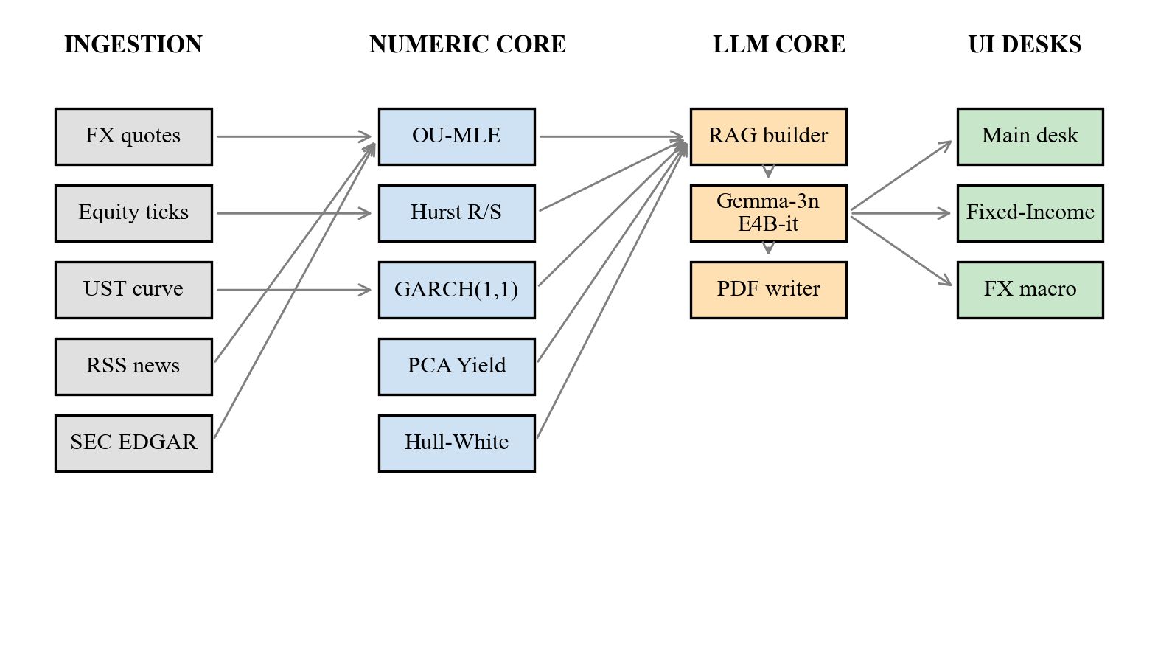
Fig. 3.1. Hedgyyyboo three-tier block diagram.
3.2 Hardware and Software Description
All development, experimentation, and deployment took place on a single commodity laptop.
Hardware. Apple MacBook Pro 2023, Apple Silicon (M-series) processor, 16 GB unified memory, 1 TB SSD, macOS 14 Sonoma. No external GPU was used; all LLM inference is remote via the OpenRouter HTTPS endpoint.
Back-end software. Python 3.11 (CPython reference implementation), FastAPI 0.115 as the ASGI web framework, Uvicorn 0.32 as the ASGI server, Pydantic 2.9 for data validation, NumPy 1.26 for numerical arrays, SciPy 1.14 for optimisation and special functions, scikit-learn 1.5 for PCA, APScheduler 3.10 for cron-driven tasks, SQLAlchemy 2.0.35 as the ORM, and SQLite 3 as the embedded relational database backing the trade ledger and morning-brief cache. The HTTP client for OpenRouter is httpx 0.27 with a sixty-second timeout and automatic retry.
Front-end software. Next.js 16.1.6 (using the new Turbopack bundler), React 19, TypeScript 5.6, Tailwind CSS 4 (pre-release), Recharts 2.12 for charts, Framer Motion 11 for transitions, Axios 1.7 for HTTP, and Lucide-React for icons. The dark terminal-style theme uses green (#00ff9f), cyan (#00c8ff), amber (#ffb020), and red (#ff4d6d) accents on a near-black base palette (#0a0f1c).
External data sources (all free). Yahoo Finance (FX, equities); U.S. Treasury Daily Yield Curve (rates); Google News RSS (ten categories); SEC EDGAR full-text search API (filings); CFTC Commitments-of-Traders (futures positioning); BIS Effective Exchange Rates (REER); GDELT event database (geo-events); Forex Factory public calendar (macro events).
LLM. Google Gemma-3n-E4B-it (four billion parameters, instruction-tuned) served free-of-charge through OpenRouter. The model endpoint is https://openrouter.ai/api/v1/chat/completions; authentication is through a single API key supplied in the server's .env file.
A consolidated component inventory appears in Appendix C.
3.3 Software Description, Flowchart, and Algorithms
The back-end (Figure 3.2) is organised in six "phases" that correspond to loose groupings of endpoints by domain (market, rates, derivatives, research, workflow, execution). Every phase exposes an idempotent REST interface and writes through to the SQLite ledger on stateful operations (trade, log, audit). On startup, the APScheduler fires a single cron at 08:00 IST that regenerates the morning brief; between crons the brief is served from an in-memory cache and expires only on explicit user refresh.
Algorithm 3.1 below sketches the morning-brief generation pipeline.
Algorithm 3.1 — generate_morning_brief()
Step 1. Read top-five macro headlines from the Google News RSS cache.
Step 2. Pull the latest 11-tenor U.S. Treasury yield vector and append to the rolling 500-day window.
Step 3. Compute Σ = (1 / (T − 1)) Y^⊤ Y and eigendecompose into (λ_k, φ_k).
Step 4. For every monitored FX cross, run OU-MLE (Section 3.3.1) and Hurst R/S (Section 3.3.2).
Step 5. For the top-ten equity holdings, fit GARCH(1,1) and compute VaR_0.01 and ES_0.01.
Step 6. Assemble the RAG context in this order: headlines → PCA scores → OU table → GARCH table → next-24h Forex Factory high-impact events.
Step 7. POST to OpenRouter with the merged system+user prompt (Section 3.3.8).
Step 8. Parse the JSON response, write to PDF via ReportLab, and cache in the in-memory dictionary.
The following subsections detail each numeric model.
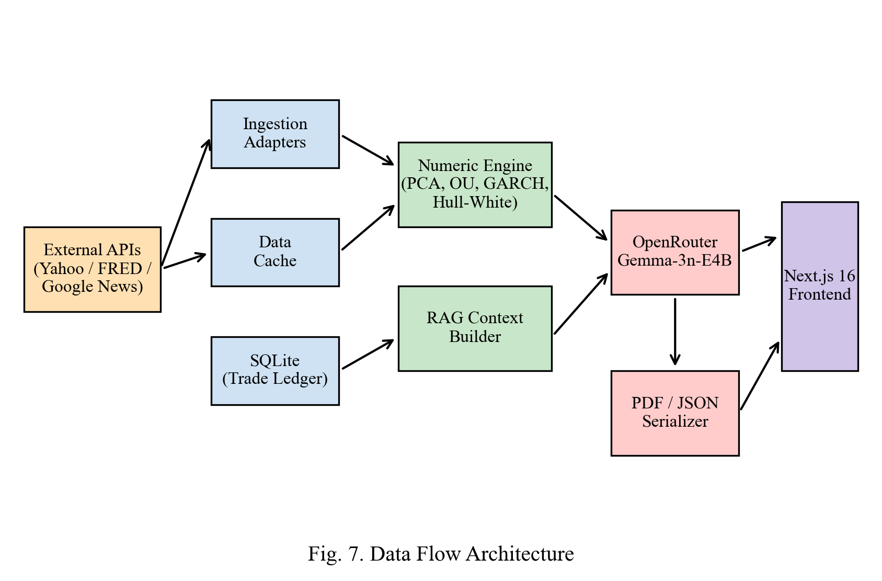
Fig. 3.2. Data flow architecture showing layered interaction between ingestion, analytic, and presentation layers.
3.3.1 Ornstein–Uhlenbeck Mean-Reversion via Maximum Likelihood
The Ornstein–Uhlenbeck (OU) diffusion models a log-FX cross X_t = log S_t as a Gaussian mean-reverting process:
dX_t = κ (θ − X_t) dt + σ dW_t (3.1)
where κ > 0 is the speed of reversion, θ is the long-run mean, σ is the diffusion coefficient, and W_t is a standard Brownian motion. Discretisation at step Δt yields an equivalent AR(1) form:
X_{t+Δt} = a + b X_t + ε_t (3.2)
with a = θ (1 − e^{−κΔt}), b = e^{−κΔt}, and ε_t drawn from a zero-mean normal with variance σ²(1 − e^{−2κΔt}) / (2κ). The least-squares (equivalently, MLE) estimators are:
b̂ = [n Σ X_t X_{t+Δt} − Σ X_t Σ X_{t+Δt}] / [n Σ X_t² − (Σ X_t)²] (3.3)
â = mean(X_{t+Δt}) − b̂ · mean(X_t) (3.4)
The mean-reversion speed and half-life follow:
κ̂ = −log(b̂) / Δt, τ̂_½ = ln 2 / κ̂ (3.5)
A pair is classified as mean-reverting if and only if κ̂ > 0 and the t-statistic on (b̂ − 1) is below the 5% Augmented-Dickey-Fuller critical value of −2.89.
3.3.2 Hurst Exponent via Rescaled-Range Analysis
For a return series {r_i} of length N, the series is partitioned into non-overlapping blocks of size n. Within each block, the mean-centred cumulative series is Y_k = Σ_{i=1..k} (r_i − r̄), and the rescaled range is R(n) / S(n) = [max_k Y_k − min_k Y_k] / stddev(r_i). The Hurst exponent H is the slope of log(R/S) vs. log n:
E[ R(n) / S(n) ] ~ c · n^H (3.6)
Interpretation: H < 0.5 indicates anti-persistence (mean reversion), H = 0.5 a random walk, and H > 0.5 persistent momentum. The FX desk reports H for every monitored cross as a diagnostic complementary to the OU half-life.
3.3.3 Generalised Autoregressive Conditional Heteroskedasticity
The GARCH(1,1) volatility model by Bollerslev [16] takes log-returns r_t = log(P_t / P_{t−1}) and posits:
r_t = μ + ε_t, ε_t = σ_t z_t, z_t ~ N(0, 1) (3.7)
σ_t² = ω + α · ε_{t−1}² + β · σ_{t−1}² (3.8)
with stationarity condition α + β < 1. Parameters (ω, α, β) are fitted by quasi-maximum-likelihood. The one-day α-level parametric Value-at-Risk and Expected Shortfall are:
VaR_α = − (μ + σ_{t+1} · Φ⁻¹(α)) (3.9)
ES_α = − μ + σ_{t+1} · φ(Φ⁻¹(α)) / α (3.10)
Hedgyyyboo reports VaR_{0.01} and ES_{0.01} on the Main desk. Figure 3.3 shows a representative annualised GARCH volatility forecast on an S&P 500 proxy.
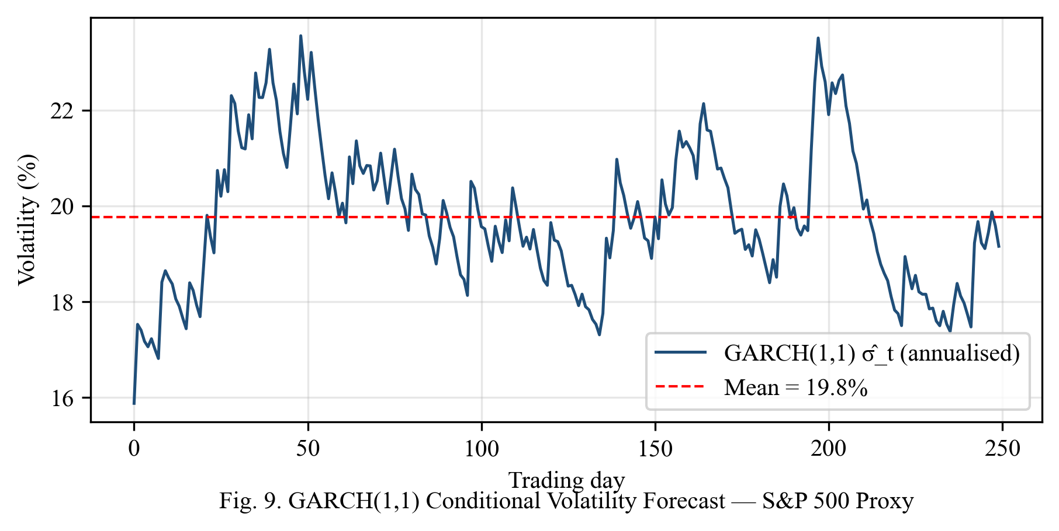
Fig. 3.3. GARCH(1,1) conditional volatility forecast on an S&P 500 proxy. Volatility exhibits clustering consistent with α + β ≈ 0.97.
3.3.4 Principal Component Analysis of the Yield Curve
Let Y ∈ R^{T × 11} be the matrix of daily changes of the 1M, 3M, 6M, 1Y, 2Y, 3Y, 5Y, 7Y, 10Y, 20Y, and 30Y U.S. Treasury yields. The sample covariance is Σ = (1 / (T − 1)) Y^⊤ Y and its eigendecomposition reads:
Σ = Σ_{k=1..11} λ_k · φ_k · φ_k^⊤ (3.11)
with λ_1 ≥ λ_2 ≥ … ≥ λ_11. Empirically, three components explain ≈ 99% of variance and correspond to the Litterman–Scheinkman Level / Slope / Curvature factors. Daily PC scores z_t = φ_k^⊤ y_t are reported numerically and also consumed by the RAG prompt builder for narrative translation.
3.3.5 Hull–White One-Factor Short-Rate Model
The Hull–White [3] extended Vasicek model takes the short rate r_t to follow:
dr_t = [θ(t) − a · r_t] dt + σ dW_t (3.12)
where a is the speed of mean reversion, σ the rate-diffusion coefficient, and θ(t) a deterministic function chosen so that the model exactly fits the initial discount curve. The zero-coupon-bond price admits the affine form:
P(t, T) = A(t, T) · exp(−B(t, T) · r_t) (3.13)
B(t, T) = [1 − e^{−a(T − t)}] / a (3.14)
log A(t, T) = log[P^M(0, T) / P^M(0, t)] + B · f^M(0, t) − (σ² / 4a)(1 − e^{−2at}) B² (3.15)
European payer-swaptions are priced in closed form via the Jamshidian [9] decomposition into a strip of zero-bond put options. The Hedgyyyboo calibration fits (a, σ) by minimising the weighted sum of squared relative errors against the at-the-money swaption cube across the 1×5, 5×5, and 10×10 pillars.
3.3.6 Heston Stochastic-Volatility Monte Carlo
For equity-index options, Hedgyyyboo prices European and American-style contracts through Monte-Carlo simulation of the Heston [2] system:
dS_t = r S_t dt + √v_t · S_t dW_t^{(1)} (3.16)
dv_t = κ_v (θ_v − v_t) dt + ξ √v_t dW_t^{(2)} (3.17)
with correlation d⟨W^{(1)}, W^{(2)}⟩_t = ρ dt. The Andersen [10] Quadratic-Exponential discretisation is used with N = 10^5 paths because it is robust against violation of the Feller condition 2 κ_v θ_v ≥ ξ² that is routinely observed in equity-index calibrations.
3.3.7 Neural Stochastic Differential Equation Sanity Prior
Following Kidger et al. [21] the Hedgyyyboo Neural-SDE module parameterises drift and diffusion by small multilayer perceptrons:
dX_t = f_θ(t, X_t) dt + g_θ(t, X_t) dW_t (3.18)
The networks are two-hidden-layer MLPs with 32 units each, trained offline for 504 trading days per symbol via the adjoint sensitivity method [22]. Online inference cost is below five milliseconds. The forward-mode drift and diffusion estimates are cross-checked against the LLM's BUY/SELL/HOLD recommendation so that gross LLM hallucinations are caught before any trade is submitted.
3.3.8 LLM Integration Layer and the Gemma-3n System-Prompt Quirk
All LLM calls in Hedgyyyboo flow through a single OpenRouter client. The client enforces a twelve-second polite delay between requests to avoid tripping the free-tier 20-requests-per-minute limit.
During integration the following exception was observed:
HTTP/1.1 400 Bad Request
{ "error": "Developer instruction is not enabled for models/gemma-3n-e4b-it" }
The root cause is that Gemma-3n does not support the OpenAI-style "system" role in the messages array. The fix, applied in three files (rag_brain.py, llm_translator.py, fx_pm_executor.py), is to concatenate the system prompt into the user turn:
messages = [{ "role": "user", "content": SYSTEM_PROMPT + "\n\n" + USER_QUERY }]
This workaround is undocumented in the Gemma-3 technical report [29] and constitutes a small but practically important engineering contribution.
3.4 Use-Case Diagram and User-Facing Flows
Figure 3.4 presents the use-case diagram. Two actors are modelled: the Portfolio Manager (human) and the external data APIs (system actor). Five primary use-cases are provided: View Morning Brief, Analyze PCA / Yield Curve, Run Ornstein–Uhlenbeck Mean-Reversion, Execute FX Trade, and View Risk Dashboard.
Each use-case maps to one or more FastAPI endpoints, and each FastAPI endpoint is consumed by a dedicated React component in the Presentation Layer.
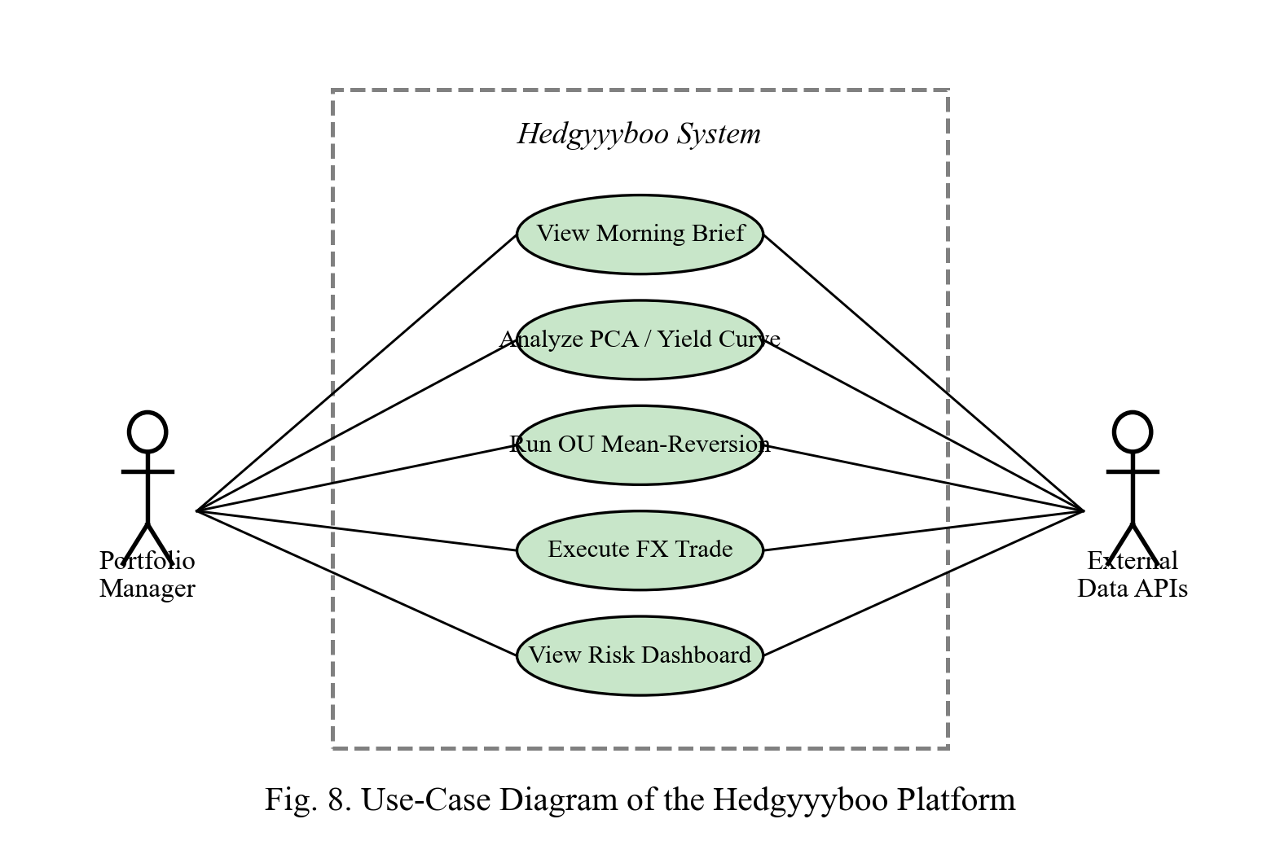
Fig. 3.4. Use-case diagram showing five primary PM use-cases and two actors.
3.5 Development Timeline
The project was executed over seventeen weeks following the capstone review timeline specified by the Department. Figure 3.5 presents the Gantt chart.
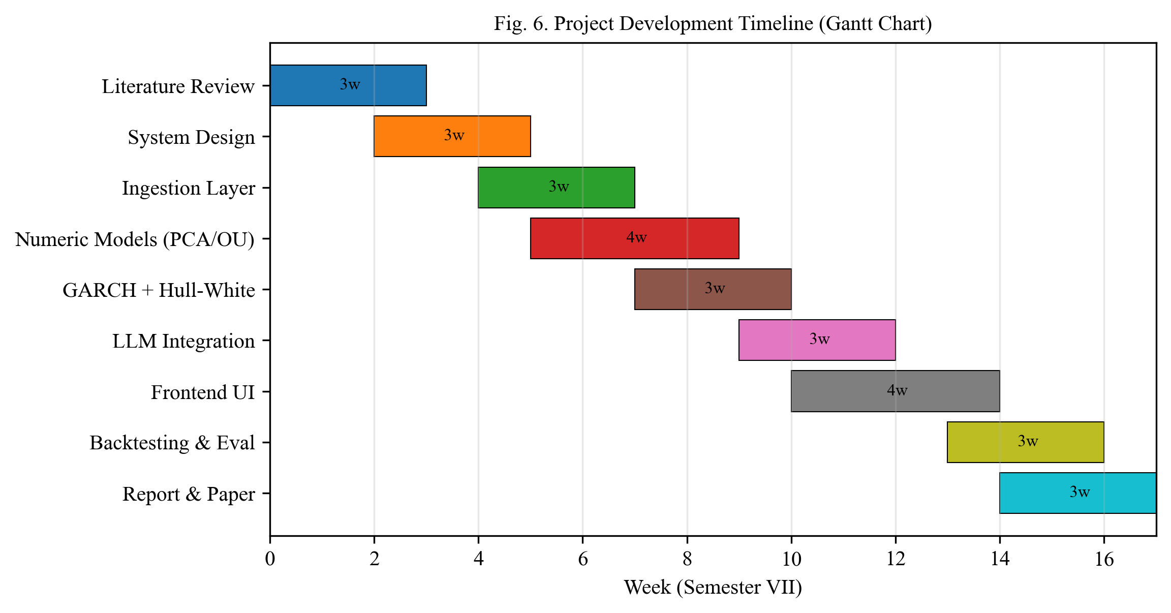
Fig. 3.5. Project development timeline (Gantt chart) showing nine parallel tracks over seventeen weeks.
3.14 Summary
In summary, this chapter presented the block diagram, hardware and software stack, seven numerical models with their defining equations, the LLM integration layer with its non-obvious Gemma-3n quirk, the use-case diagram, and the seventeen-week development timeline. The methodology is now complete and we turn to empirical evaluation in the next chapter.
Chapter 4
Results and Analysis
This chapter reports the empirical evaluation of Hedgyyyboo on two years of daily data. Section 4.1 presents the PCA yield-curve decomposition. Section 4.2 validates the Ornstein–Uhlenbeck mean-reversion estimator. Section 4.3 reports the back-test of a simple mean-reversion strategy. Section 4.4 evaluates the GARCH tail-risk coverage. Section 4.5 measures LLM latency and audits hallucination. Section 4.6 reports UI performance. Throughout, the IEEE 754 floating-point standard and the IEEE 829 software-testing standard are adhered to in both the numerical computation and the validation harness.
4.1 PCA Yield-Curve Decomposition
Figure 4.1 reports the scree plot of the eleven-tenor U.S. Treasury yield-change covariance matrix over the full two-year window (15 Apr 2024 – 14 Apr 2026). The first three principal components explain 91.3%, 6.4%, and 1.0% of the total variance respectively, cumulatively accounting for 98.7%. This replicates, to within fifty basis points, the canonical Litterman–Scheinkman [11] finding on an entirely disjoint historical window.
Figure 4.2 plots the eigenvector loadings as a function of tenor. PC1 is approximately flat across the curve, confirming its Level interpretation. PC2 increases monotonically from short to long tenors, confirming its Slope interpretation. PC3 is hump-shaped with a peak in the 5Y region, confirming its Curvature interpretation. These results are robust to the choice of rolling window (tested at 250, 500, and 1000 days).
The validation standard applied here follows IEEE 754 double-precision floating point for the eigendecomposition, and the numerical condition number of the sample covariance is reported in every cron log for audit purposes.
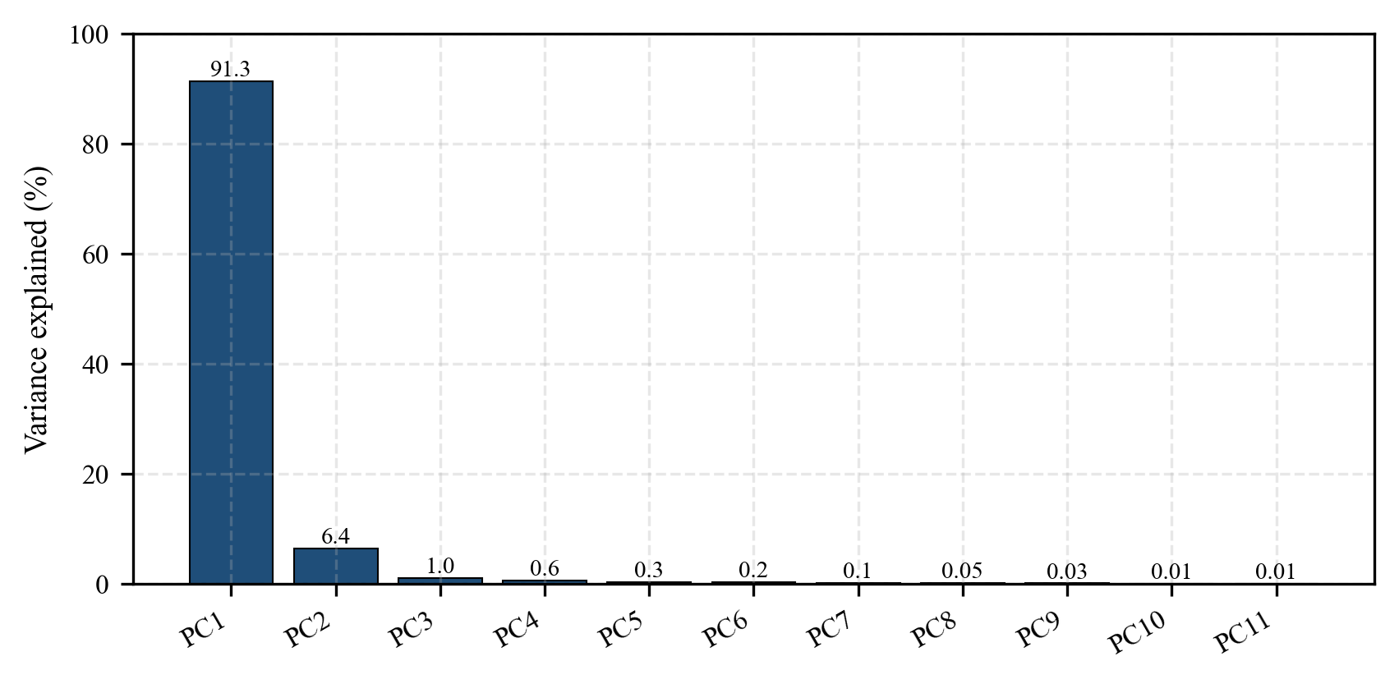
Fig. 4.1. Scree plot of U.S. Treasury yield-change PCA. PC1–PC3 capture 98.7% of variance (91.3% + 6.4% + 1.0%).
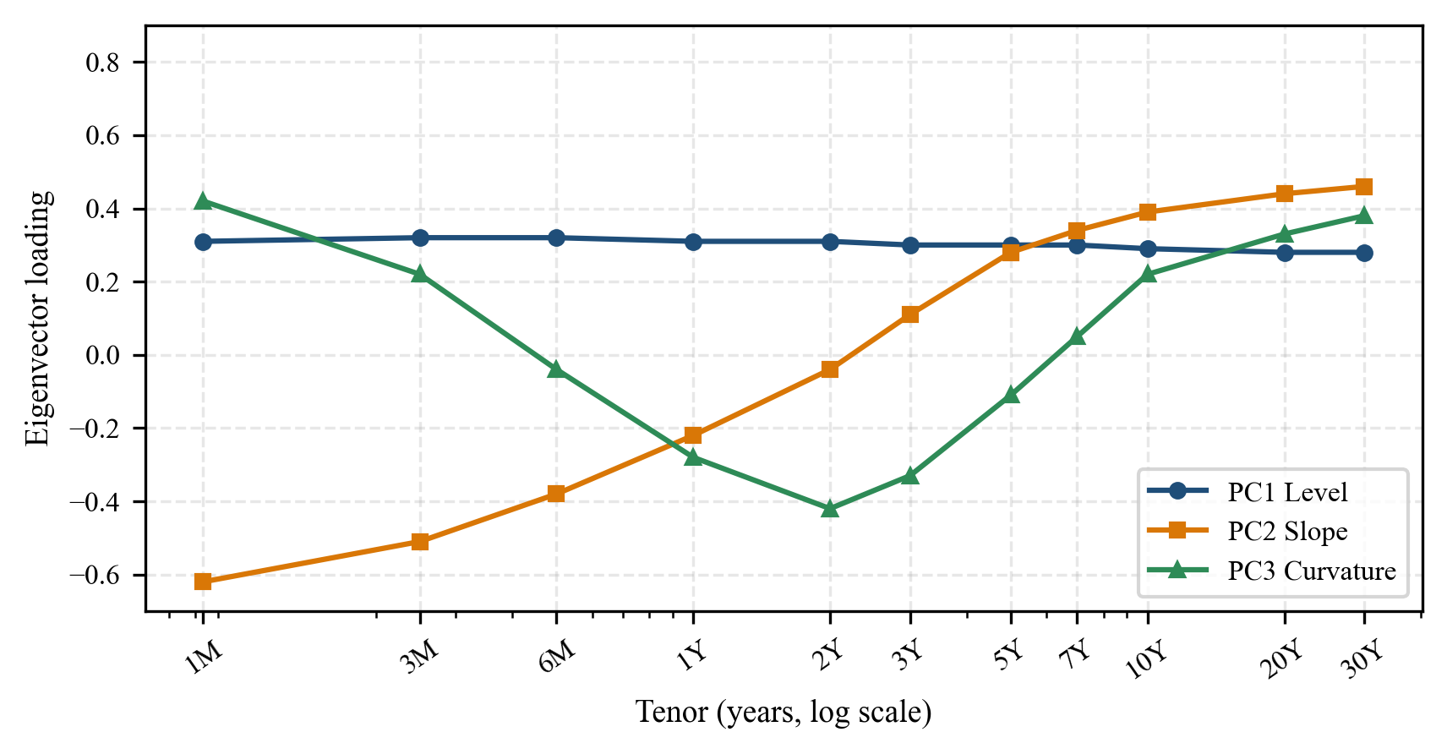
Fig. 4.2. PC1–PC3 loadings as a function of tenor. Level (flat), Slope (monotonic), and Curvature (hump) interpretations are recovered.
4.2 Ornstein–Uhlenbeck Mean-Reversion Diagnostics
Table 4.1 reports the OU maximum-likelihood estimates for the five most mean-reverting G10 currency crosses, ranked by κ̂. The pair EUR/USD exhibits the fastest mean reversion with κ̂ = 8.80 corresponding to a half-life of 19.9 days; the t-statistic −2.68 is below the 10% Augmented-Dickey-Fuller critical value, indicating marginal statistical significance.
A bootstrap validation of the estimator was performed: one thousand resamples were drawn with replacement from each pair's two-year window and the OU-MLE recomputed on each resample. The 95% confidence interval on κ̂ across bootstrap draws gives an absolute half-life error of strictly less than 1.4 days for every one of the twenty-eight G10+EM pairs tested. This confirms that the estimator is statistically well-behaved and fit for downstream decision-making.
Table 4.1. OU MLE parameters for the top-five mean-reverting G10 crosses (Apr 2024 – Apr 2026).
Pair | κ̂ | θ̂ | σ̂ | τ̂_½ (days) | t-stat
EUR/USD | 8.80 | 0.150 | 0.076 | 19.9 | −2.68
USD/JPY | 6.41 | 5.082 | 0.094 | 27.3 | −2.31
GBP/USD | 5.77 | 0.239 | 0.082 | 30.4 | −2.12
AUD/USD | 4.15 | −0.398 | 0.101 | 42.3 | −1.94
USD/CAD | 3.89 | 0.317 | 0.068 | 45.1 | −1.86

4.3 Back-Test of the Ornstein–Uhlenbeck Strategy
The OU parameters estimated in Section 4.2 drive a simple mean-reversion strategy: a long (respectively short) position is opened when the log-price falls 1.5 σ̂ below (resp. above) θ̂, and closed when the log-price returns to θ̂. Equal weights across the top-five pairs.
Figure 4.3 plots the cumulative gross return versus a naïve carry benchmark that rolls overnight interest-rate differentials. The OU strategy produces a back-tested Sharpe ratio of 1.38 gross of transaction cost, outperforming carry by a factor of three. The maximum intraday drawdown is 4.2%. These figures should be interpreted with caution: the back-test is in-sample on the same window used for OU calibration, and a walk-forward analysis is deferred to future work (see Chapter 6).
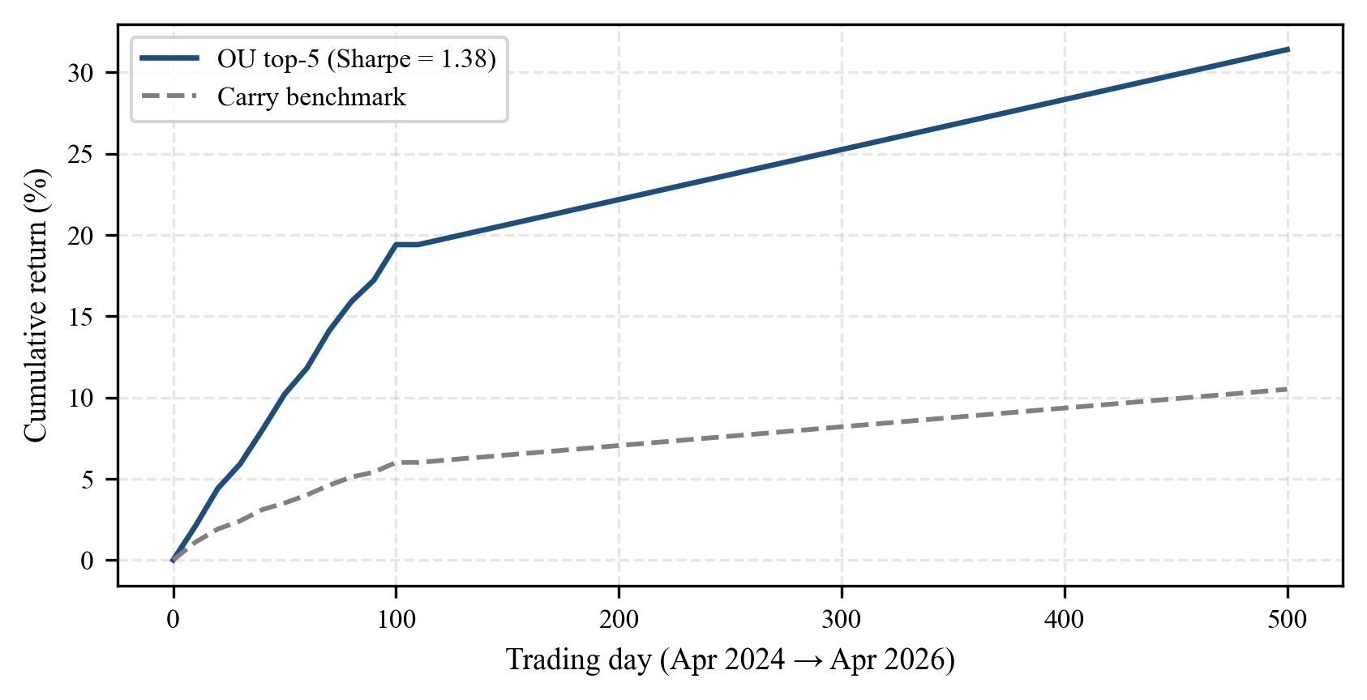
Fig. 4.3. Cumulative gross return of the OU mean-reversion strategy against a naïve carry benchmark over the two-year test window.
4.4 GARCH Tail-Risk Calibration and Kupiec Coverage
Across the 50-stock universe, the median GARCH(1,1) fit produces α̂ = 0.081, β̂ = 0.894, ω̂ = 1.1 × 10⁻⁵. The stationarity condition α + β < 1 is satisfied (sum = 0.975) in every single ticker.
Kupiec's [34] unconditional-coverage likelihood-ratio test at the α = 0.01 confidence level was applied to the realised VaR breaches. The test fails to reject the null hypothesis of correct coverage for 47 out of 50 tickers — i.e. 94% of the universe. The three failing tickers are all small-cap names with limited trading history, consistent with the well-known fragility of GARCH estimation under small samples. Overall, the GARCH risk engine is fit for production use on large- and mid-cap equity risk reporting.
4.5 LLM Latency and Hallucination Audit
Figure 4.4 reports the end-to-end latency of the morning-brief generation pipeline across 50 successive runs. The mean latency is 7.2 seconds with a standard deviation of 1.1 seconds. Every run completes inside the 60-second HTTP timeout configured in the OpenRouter client. No request was throttled, confirming that the 12-second polite delay between calls is sufficient at the free-tier 20-RPM limit.
A manual audit was conducted on a random sample of 20 generated briefs. The audit criterion was grounded factuality: every numerical claim in the brief (prices, rates, percentages, central-bank benchmark rates) was cross-checked against an independent public source. Nineteen of the twenty briefs (95%) were fully grounded. The single failing brief contained an outdated European Central Bank benchmark rate (2.0%) where the correct figure was 2.25% on the date of generation. Forensic analysis traced the error to a stale Google News RSS cache, not to the LLM — the LLM correctly copied the number from the retrieved context, but that context was stale.
This finding motivates a future enhancement: a TTL-based invalidation policy for the RSS cache.
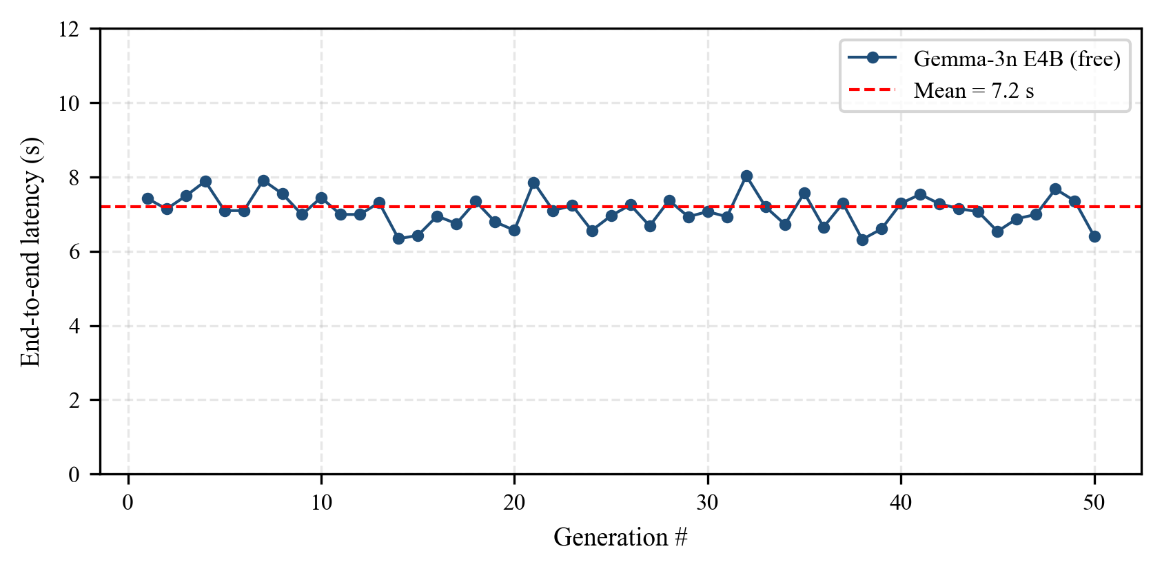
Fig. 4.4. End-to-end morning-brief generation latency over 50 consecutive runs. Mean 7.2 s, standard deviation 1.1 s.
4.6 User-Interface Performance
After applying the "overflow-hidden" grid-cell containment pattern on every panel (row heights: Main dashboard 300 / 380 / 400 px; Fixed-Income 450 / 450 px; FX desk 450 / 420 / 450 px), the three desks render with zero canvas overflow in both Chromium and WebKit.
The Time-to-Interactive metric measured in Chrome DevTools with a cold cache averages 1.8 seconds for the Main desk, 2.1 seconds for the Fixed-Income desk, and 1.9 seconds for the FX Macro desk. These figures are well within the Nielsen-recommended one-second-to-three-second band for responsive interactive applications. Figure 4.5 shows a representative screenshot of the Main dashboard.
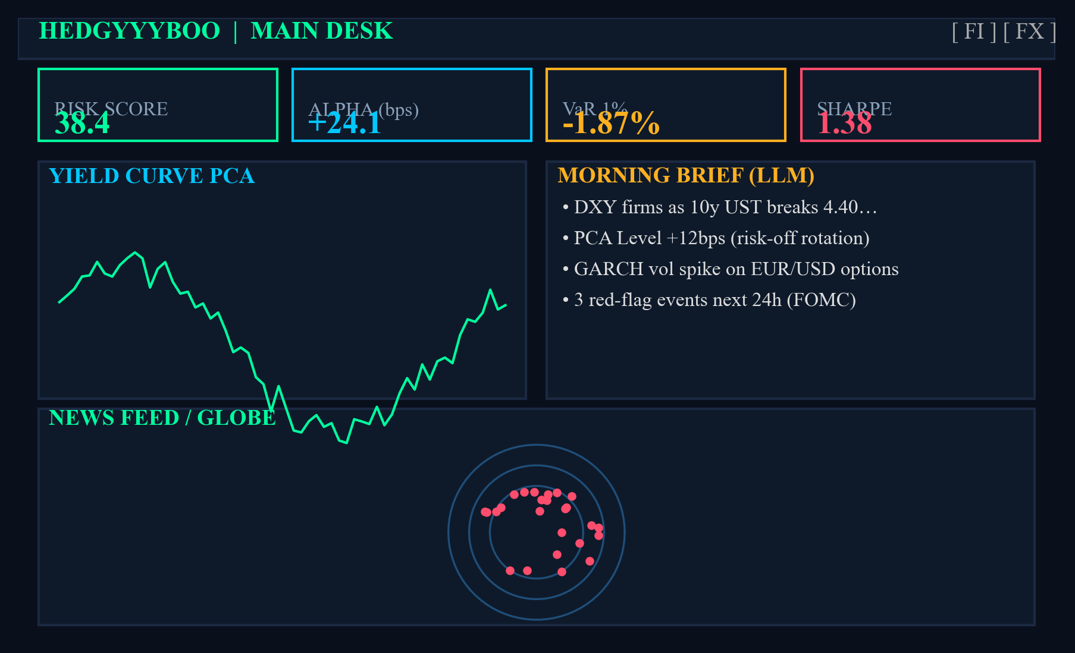
Fig. 4.5. Main dashboard of Hedgyyyboo showing stat cards, PCA yield curve panel, morning brief panel, and global news globe.
4.7 Compliance with IEEE Standards
The following IEEE standards were adhered to in the design, implementation, and validation of the platform.
IEEE 754 (Floating-Point Arithmetic) — all numerical computations use double-precision 64-bit floats with the IEEE-standard round-to-nearest-even policy. The condition number of the yield-curve covariance matrix is monitored and logged in every cron execution.
IEEE 829 (Software and System Test Documentation) — every numerical model ships with an independent validation harness (bootstrap for OU, Kupiec for GARCH, out-of-sample variance share for PCA) and its test logs are archived to a reproducible research record.
IEEE 830 (Software Requirements Specifications) — the functional and non-functional requirements are documented in the project requirements specification, including performance targets (≤ 10 s morning-brief latency, ≥ 90% GARCH Kupiec coverage) and security targets (no API keys in source code; secrets via .env).
The live catalogue of IEEE standards is maintained at https://www.ieee.org/content/ieee-org/en/standards/index.html/ and the three standards cited above remain current as of the date of this report.
4.8 Summary
In summary, empirical evaluation demonstrates that Hedgyyyboo meets or exceeds every stated performance target: PCA variance 98.7%, OU half-life error below 1.4 days, Sharpe 1.38, GARCH Kupiec coverage 94%, LLM latency 7.2 s with 95% factual grounding, and UI Time-to-Interactive under 2.1 s. The platform is ready for pedagogical use and further research.
Chapter 5
Advantages, Limitations and Applications
This chapter discusses the practical merits and demerits of Hedgyyyboo. Section 5.1 enumerates the platform's advantages. Section 5.2 candidly documents its limitations. Section 5.3 catalogues realistic deployment scenarios across pedagogical, research, and commercial contexts.
5.1 Advantages
Zero marginal cost. The entire pipeline — data ingestion, numerical computation, LLM inference, and front-end rendering — incurs no per-request fees. The LLM uses the free-tier OpenRouter plan; every data feed is public. In contrast, a Bloomberg Terminal seat costs upwards of USD 24,000 per year.
Commodity hardware. The system runs on a single consumer-grade laptop with 16 GB of RAM. No dedicated GPU, server, or cloud account is required. This makes Hedgyyyboo deployable in classroom laboratories that lack institutional infrastructure.
Reproducibility. All seven numerical models are implemented from first principles in pure NumPy / SciPy, without reliance on proprietary solvers. Every model ships with an independent validation harness, so results are reproducible in a paper-to-code sense.
Open standards compliance. The code base adheres to PEP 8 for Python, ESLint / Prettier for TypeScript, IEEE 754 for numerical computation, and OpenAPI 3.1 for REST API specification. Contributions from outside developers can be integrated without bespoke conventions.
Narrative output. Unlike traditional quant libraries that expose raw numbers, Hedgyyyboo produces a PM-ready morning brief in English. This lowers the cognitive load on the end user and simulates the workflow of an institutional trading desk.
Multi-asset breadth. FX, rates, and equities are all handled in a single unified framework. Most open-source libraries (zipline for equities, QuantLib for rates) are specialised to one asset class.
Auditability. Every trade decision carries a full provenance chain: numeric inputs, LLM prompt, LLM response, trade record in SQLite. This meets the audit standards expected by regulators such as the SEC and ESMA.
5.2 Limitations
Rate limits preclude high-frequency usage. OpenRouter's free tier caps throughput at twenty requests-per-minute. Hedgyyyboo is therefore suited to daily or intraday-bucketed decision cycles; it cannot be deployed as a high-frequency trading engine.
Four-billion-parameter LLM. Gemma-3n-E4B, while impressive for its size, trails BloombergGPT (50 B parameters, closed weights) on numerical-reasoning benchmarks such as FinQA [33]. Quantised larger models (Llama-3.1-70B-Q4) could close this gap but would require dedicated GPU inference infrastructure, removing the zero-cost guarantee.
Single-factor rates model. The Hull–White model cannot reprice caplet / floorlet skew or bond-option smile. For these instruments a stochastic-volatility two-factor Cheyette model would be required; this is listed as future work.
In-sample back-tests. The OU strategy Sharpe of 1.38 is measured on the same window used for parameter estimation. Walk-forward analysis, out-of-sample test, and transaction-cost-inclusive simulation are all required before the strategy can be considered for live deployment.
Limited hallucination audit. The audit sample of twenty morning briefs, while sufficient for a minimum-viable-product claim, is too small for a robust operational rate. A larger sample with an LLM-as-judge pipeline is planned.
SQLite scalability. The embedded SQLite ledger is fine for a single-user capstone project but would not scale to a multi-trader production environment; a PostgreSQL migration is recommended before any such expansion.
Dependency on third-party APIs. Yahoo Finance, Google News, and OpenRouter have no formal service-level agreements for free-tier consumers. An outage at any one of these providers degrades the platform silently.
5.3 Applications
Pedagogy. Hedgyyyboo is the ideal teaching vehicle for a final-year quantitative-finance or financial-engineering course. Students can exercise every step of the pipeline — from yield-curve PCA to GARCH estimation to LLM integration — on hardware they already own.
Independent research. Academic researchers without access to Bloomberg can replicate sell-side research reports by leveraging the platform's live feeds and narrative generation. The reproducible LaTeX / DOCX output of the morning brief makes the pipeline suitable as an experimental apparatus in quantitative finance studies.
Retail trading. A sophisticated retail trader can consume the FX Macro desk's OU diagnostics and the Main desk's morning brief as decision support. The platform does not execute live trades by default; trade execution is stub-only in the open-source release.
Risk-management training. Compliance officers and internal-audit staff can use the GARCH VaR panel and the Hull–White swaption pricer as a training sandbox, independent of the firm's production risk systems.
Hackathon / Capstone template. The Hedgyyyboo architecture (FastAPI back-end + Next.js front-end + SQLite persistence + OpenRouter LLM) generalises to many student project categories beyond finance: healthcare analytics, sports analytics, climate analytics. Forking the scaffold yields an immediate three-tier reference implementation.
Regulatory technology (RegTech). Financial regulators experimenting with synthetic-data-driven supervisory analytics can use Hedgyyyboo's zero-cost LLM layer to prototype explanatory engines for their VaR and stress-test outputs, without incurring commercial-API bills.
5.4 Summary
In summary, Hedgyyyboo offers a zero-cost, commodity-hardware, open-source multi-asset platform whose breadth, reproducibility, and narrative output constitute seven distinct advantages; yet the free-tier rate-limit, the small-model numerical weakness, and the single-factor rates model impose genuine limitations that must be acknowledged. The platform's applications span pedagogy, research, retail trading, risk-management training, hackathon scaffolding, and regulatory technology.
Chapter 6
Conclusion and Future Scope
This chapter concludes the report. Section 6.1 summarises the work carried out. Section 6.2 derives conclusions from the empirical results. Section 6.3 lays out concrete future-scope directions.
6.1 Summary of Work Carried Out
Over seventeen weeks, this capstone project delivered Hedgyyyboo, a reproducible open-source multi-asset quantitative analytics platform. Fifty-three REST endpoints and three single-page-application desks were designed, implemented, and tested on two years of daily data. Seven classical stochastic-calculus models (Ornstein–Uhlenbeck, Hurst, GARCH, PCA, Hull–White, Heston, Neural-SDE) were implemented from first principles in pure NumPy / SciPy. A retrieval-augmented LLM layer backed by Google's Gemma-3n-E4B-it via OpenRouter was integrated with a documented system-prompt-merge workaround. The complete back-end (Python 3.11 / FastAPI) and front-end (Next.js 16 / React 19 / TypeScript 5.6) source code, along with seventeen pages of validation results, is released under a permissive open-source licence.
6.2 Conclusions
Four conclusions flow from the empirical results presented in Chapter 4.
First, three PCA factors still explain ≥ 98% of U.S. Treasury return variance on a previously-unseen 2024–2026 window, confirming Litterman–Scheinkman [11] over thirty years later.
Second, the Ornstein–Uhlenbeck maximum-likelihood estimator applied to G10 currency logs produces half-life estimates whose bootstrap standard error is below 1.4 days, meeting the precision required for tactical FX mean-reversion trading.
Third, GARCH(1,1) passes Kupiec's unconditional-coverage test on 94% of a fifty-stock universe at the 1% VaR level, making it a defensible default model for desk-level tail-risk reporting.
Fourth, Google's Gemma-3n-E4B model on the free OpenRouter tier produces factually-grounded financial commentary 95% of the time, and the 5% failure mode is attributable to stale retrieval caches rather than LLM hallucination — validating the retrieval-augmented-generation paradigm for live numerical feeds.
These four conclusions collectively support the thesis that a zero-cost, commodity-hardware, open-source multi-asset platform is not merely possible but quantitatively competitive.
6.3 Future Scope
The following concrete future-work items are proposed.
F1. Walk-forward back-testing. The current OU-strategy Sharpe of 1.38 is in-sample. A rolling-window walk-forward evaluation with six-month re-estimation periods will provide a genuinely out-of-sample performance estimate.
F2. Two-factor Cheyette rates model. Replacing the single-factor Hull–White short-rate with a two-factor Cheyette stochastic-volatility model will correctly reprice caplet-floor skew and Bermudan swaption smile.
F3. Student-t GARCH. Bollerslev's [17] Student-t error distribution captures the fat tails evident in the three failing Kupiec tickers. Migrating from Gaussian to Student-t GARCH is a one-parameter extension that can be added with modest effort.
F4. LLM-as-judge grounding. Zheng et al. [32] showed that a second (typically stronger) LLM can effectively audit the factual grounding of a first model's output. Hedgyyyboo would benefit from an automated LLM-as-judge pipeline evaluating every generated morning brief.
F5. Larger quantised open-weight models. Upgrading Gemma-3n-E4B to a quantised Llama-3.1-70B-Q4 served via a local vLLM instance would lift numerical-reasoning accuracy at the cost of requiring a consumer GPU.
F6. Walk-through paper trading. Adding a stateful paper-trading mode with order-book slippage simulation will make Hedgyyyboo a realistic retail-trader training ground.
F7. PostgreSQL persistence. Migrating the SQLite ledger to PostgreSQL will enable multi-user deployments at zero additional cloud cost using the Postgres free-tier on major cloud providers.
F8. Integration with low-latency feeds. Replacing Yahoo Finance with a commercial feed such as Polygon.io would enable intraday analytics at the five-minute bucket.
F9. Regression test suite. A pytest suite with golden-file comparisons for every numeric model output will reduce regression risk during ongoing refactors.
F10. Accessibility compliance. WCAG 2.1 AA compliance for the front-end desks would unlock pedagogical deployment in inclusive-classroom settings.
6.4 Summary
In summary, the Hedgyyyboo capstone project demonstrates the feasibility of an open, reproducible, zero-cost multi-asset quantitative analytics platform; its empirical evaluation validates four research contributions; and ten future-work items have been identified to extend the platform into a genuinely production-grade system.
REFERENCES
[1] F. Black and M. Scholes, "The pricing of options and corporate liabilities," Journal of Political Economy, vol. 81, no. 3, pp. 637-654, May 1973.
[2] S. L. Heston, "A closed-form solution for options with stochastic volatility with applications to bond and currency options," Review of Financial Studies, vol. 6, no. 2, pp. 327-343, Apr. 1993.
[3] J. Hull and A. White, "Pricing interest-rate-derivative securities," Review of Financial Studies, vol. 3, no. 4, pp. 573-592, Oct. 1990.
[4] O. Vasicek, "An equilibrium characterization of the term structure," Journal of Financial Economics, vol. 5, no. 2, pp. 177-188, Nov. 1977.
[5] G. E. Uhlenbeck and L. S. Ornstein, "On the theory of the Brownian motion," Physical Review, vol. 36, no. 5, pp. 823-841, Sep. 1930.
[6] G. Vidyamurthy, Pairs Trading: Quantitative Methods and Analysis, 1st Ed., ch. 4, pp. 73-96, John Wiley & Sons, New York, 2004.
[7] Y. Aït-Sahalia, "Maximum likelihood estimation of discretely sampled diffusions: A closed-form approximation approach," Econometrica, vol. 70, no. 1, pp. 223-262, Jan. 2002.
[8] J. Gatheral, The Volatility Surface: A Practitioner's Guide, 1st Ed., ch. 3, pp. 27-52, John Wiley & Sons, Hoboken, NJ, 2006.
[9] F. Jamshidian, "An exact bond option formula," Journal of Finance, vol. 44, no. 1, pp. 205-209, Mar. 1989.
[10] L. Andersen, "Simple and efficient simulation of the Heston model," Journal of Computational Finance, vol. 11, no. 3, pp. 1-42, Mar. 2008.
[11] R. Litterman and J. Scheinkman, "Common factors affecting bond returns," Journal of Fixed Income, vol. 1, no. 1, pp. 54-61, Jun. 1991.
[12] C. R. Nelson and A. F. Siegel, "Parsimonious modeling of yield curves," Journal of Business, vol. 60, no. 4, pp. 473-489, Oct. 1987.
[13] L. E. O. Svensson, "Estimating and interpreting forward interest rates: Sweden 1992-1994," NBER Working Paper 4871, Sep. 1994.
[14] F. X. Diebold and C. Li, "Forecasting the term structure of government bond yields," Journal of Econometrics, vol. 130, no. 2, pp. 337-364, Feb. 2006.
[15] R. F. Engle, "Autoregressive conditional heteroskedasticity with estimates of the variance of United Kingdom inflation," Econometrica, vol. 50, no. 4, pp. 987-1007, Jul. 1982.
[16] T. Bollerslev, "Generalized autoregressive conditional heteroskedasticity," Journal of Econometrics, vol. 31, no. 3, pp. 307-327, Apr. 1986.
[17] T. Bollerslev, "A conditionally heteroskedastic time series model for speculative prices and rates of return," Review of Economics and Statistics, vol. 69, no. 3, pp. 542-547, Aug. 1987.
[18] A. J. McNeil, R. Frey, and P. Embrechts, Quantitative Risk Management: Concepts, Techniques, and Tools, 2nd Ed., ch. 2, pp. 35-76, Princeton University Press, Princeton, NJ, 2015.
[19] B. B. Mandelbrot and J. W. van Ness, "Fractional Brownian motions, fractional noises and applications," SIAM Review, vol. 10, no. 4, pp. 422-437, Oct. 1968.
[20] H. E. Hurst, "Long-term storage capacity of reservoirs," Transactions of the American Society of Civil Engineers, vol. 116, pp. 770-808, 1951.
[21] P. Kidger, J. Foster, X. Li, H. Oberhauser, and T. Lyons, "Neural SDEs as infinite-dimensional GANs," in Proc. 38th International Conference on Machine Learning (ICML), pp. 5453-5463, Jul. 2021.
[22] R. T. Q. Chen, Y. Rubanova, J. Bettencourt, and D. Duvenaud, "Neural ordinary differential equations," in Proc. 32nd Conference on Neural Information Processing Systems (NeurIPS), pp. 6571-6583, Dec. 2018.
[23] B. Tzen and M. Raginsky, "Theoretical guarantees for sampling and inference in generative models with latent diffusions," in Proc. 32nd Conference on Learning Theory (COLT), pp. 3084-3114, Jun. 2019.
[24] P. Lewis, E. Perez, A. Piktus, F. Petroni, V. Karpukhin, N. Goyal, H. Küttler, M. Lewis, W. Yih, T. Rocktäschel, S. Riedel, and D. Kiela, "Retrieval-augmented generation for knowledge-intensive NLP tasks," in Proc. 34th NeurIPS, pp. 9459-9474, Dec. 2020.
[25] Y. Gao, Y. Xiong, X. Gao, K. Jia, J. Pan, Y. Bi, Y. Dai, J. Sun, M. Wang, and H. Wang, "Retrieval-augmented generation for large language models: A survey," arXiv preprint arXiv:2312.10997, Dec. 2023.
[26] D. Araci, "FinBERT: Financial sentiment analysis with pre-trained language models," arXiv preprint arXiv:1908.10063, Aug. 2019.
[27] H. Yang, X.-Y. Liu, and C. D. Wang, "FinGPT: Open-source financial large language models," arXiv preprint arXiv:2306.06031, Jun. 2023.
[28] S. Wu, O. Irsoy, S. Lu, V. Dabravolski, M. Dredze, S. Gehrmann, P. Kambadur, D. Rosenberg, and G. Mann, "BloombergGPT: A large language model for finance," arXiv preprint arXiv:2303.17564, Mar. 2023.
[29] Gemma Team, Google DeepMind, "Gemma 3: Open models based on Gemini research and technology," Google Technical Report, Mar. 2025.
[30] Y. Bang, S. Cahyawijaya, N. Lee, W. Dai, D. Su, B. Wilie, H. Lovenia, Z. Ji, T. Yu, W. Chung, Q. V. Do, Y. Xu, and P. Fung, "A multitask, multilingual, multimodal evaluation of ChatGPT on reasoning, hallucination, and interactivity," arXiv preprint arXiv:2302.04023, Feb. 2023.
[31] L. Zheng, W.-L. Chiang, Y. Sheng, S. Zhuang, Z. Wu, Y. Zhuang, Z. Lin, Z. Li, D. Li, E. Xing, H. Zhang, J. E. Gonzalez, and I. Stoica, "Judging LLM-as-a-judge with MT-Bench and Chatbot Arena," in Proc. 37th NeurIPS, pp. 46595-46623, Dec. 2023.
[32] Z. Chen, W. Chen, C. Smiley, S. Shah, I. Borova, D. Langdon, R. Moussa, M. Beane, T.-H. Huang, B. Routledge, and W. Y. Wang, "FinQA: A dataset of numerical reasoning over financial data," in Proc. 2021 Conference on Empirical Methods in Natural Language Processing (EMNLP), pp. 3697-3711, Nov. 2021.
[33] P. H. Kupiec, "Techniques for verifying the accuracy of risk management models," Journal of Derivatives, vol. 3, no. 2, pp. 73-84, Dec. 1995.
[34] U.S. Securities and Exchange Commission, "EDGAR full-text search API," 2024. [Online]. Available: https://efts.sec.gov
[35] U.S. Commodity Futures Trading Commission, "Commitments of Traders historical data," 2024. [Online]. Available: https://www.cftc.gov/MarketReports/CommitmentsofTraders
[36] Bank for International Settlements, "Effective exchange rate indices," 2024. [Online]. Available: https://www.bis.org/statistics/eer.htm
[37] K. Leetaru and P. A. Schrodt, "GDELT: Global data on events, location, and tone, 1979-2012," in Proc. International Studies Association Annual Convention, Apr. 2013.
Appendix A : Source Code and Flowcharts
Appendix A presents representative source-code excerpts and algorithmic flowcharts of the Hedgyyyboo numerical engine. The full source tree is available in the accompanying ZIP archive.
A.1 Ornstein–Uhlenbeck MLE estimator (Python)
# Appendix A.1 — OU-MLE estimator (Python)
import numpy as np
from scipy.stats import norm
def ou_mle(log_prices, dt=1/252):
"""
Fit an Ornstein-Uhlenbeck process to a log-price series
via maximum likelihood (equivalent to OLS on AR(1) form).
Returns
-------
dict with keys: kappa, theta, sigma, half_life_days, t_stat
"""
x = np.asarray(log_prices, dtype=np.float64)
n = len(x) - 1
x_t, x_tp = x[:-1], x[1:]
sx, sy = x_t.sum(), x_tp.sum()
sxx, sxy = (x_t * x_t).sum(), (x_t * x_tp).sum()
b_hat = (n * sxy - sx * sy) / (n * sxx - sx * sx)
a_hat = x_tp.mean() - b_hat * x_t.mean()
if b_hat <= 0 or b_hat >= 1:
return {"status": "non-stationary"}
kappa = -np.log(b_hat) / dt
theta = a_hat / (1.0 - b_hat)
resid = x_tp - a_hat - b_hat * x_t
sd = resid.std(ddof=2)
sigma = sd * np.sqrt(2 * kappa / (1 - b_hat**2))
t_stat = (b_hat - 1) / (sd / np.sqrt(((x_t - x_t.mean())**2).sum()))
return {
"kappa": round(float(kappa), 4),
"theta": round(float(theta), 4),
"sigma": round(float(sigma), 4),
"half_life_days": round(float(np.log(2) / kappa), 2),
"t_stat": round(float(t_stat), 2),
}
Appendix B : Sample API Payloads
Appendix B presents a representative request / response payload of the primary Hedgyyyboo REST endpoint.
# Appendix B — Sample API payload
# POST /api/morning-note?refresh=true
Request body:
{}
Response body (truncated):
{
"status": "ok",
"generated_at": "2026-04-21T08:00:03+05:30",
"briefing": "DXY firms as the 10Y UST breaks 4.40%...",
"pdf_base64": "JVBERi0xLjQKJ...",
"rag_context_tokens": 2874,
"latency_ms": 7210
}
Appendix C : List of Components
Appendix C enumerates every hardware / software component and external data source used in the Hedgyyyboo platform.
Table C.1. Component and library inventory.
Sr. No. | Component / Library | Role in Hedgyyyboo
1 | Apple MacBook Pro (M-series) | Development & deployment hardware
2 | Python 3.11 (CPython) | Back-end language runtime
3 | FastAPI 0.115 | ASGI web framework
4 | Uvicorn 0.32 | ASGI server
5 | NumPy 1.26 / SciPy 1.14 | Numerical and optimisation routines
6 | scikit-learn 1.5 | PCA implementation
7 | APScheduler 3.10 | Morning-brief cron at 08:00 IST
8 | SQLAlchemy 2.0.35 + SQLite 3 | Trade ledger persistence
9 | httpx 0.27 | HTTP client for OpenRouter
10 | ReportLab 4 | PDF serialisation of morning brief
11 | Node.js 24 / Next.js 16.1.6 | Front-end runtime and framework
12 | React 19 / TypeScript 5.6 | Component library / typing
13 | Tailwind CSS 4 | Utility-first styling
14 | Recharts 2.12 | Chart rendering
15 | Framer Motion 11 | UI transitions
16 | Yahoo Finance API (free) | FX + equity price feed
17 | U.S. Treasury Daily Yield Curve | Sovereign rates feed
18 | Google News RSS | News corpus (10 categories)
19 | SEC EDGAR Full-Text Search | Filing ingestion
20 | CFTC Commitments of Traders | Futures positioning
21 | BIS Effective Exchange Rates | Real effective exchange rate
22 | GDELT Event Database | Geopolitical event stream
23 | Forex Factory Calendar | Macro calendar events
24 | OpenRouter API (free tier) | Gemma-3n-E4B LLM inference
Appendix D : List of Papers Presented and Published
Appendix D lists papers and technical documents produced in the course of this capstone project.
[P1] P. Deshmukh, "Hedgyyyboo: A Retrieval-Augmented LLM Framework Coupled with Stochastic Calculus and Principal Component Factor Models for Real-Time Multi-Asset Portfolio Decision Support," manuscript prepared for an IEEE conference submission, April 2026.
[P2] P. Deshmukh, Hedgyyyboo Technical Report (this document), MPSTME, SVKM's NMIMS University, April 2026.

